Support Information file
Half dome carbon nitride structures

A. La Torre^{1,2,3}

- ALT Carbotecnologia srls and Carbastrial limited, Via Del Nuovo Tiro a Segno 15/1 Pescara, 65128, Italy, virtual office at 16 Bridge Street Kington Herefordshire HR5 3DJ, UK.
- Institut de Physique et Chimie des Matériaux de Strasbourg, UMR 7504 CNRS, Université de Strasbourg, 23 rue du Loess, 67034 Strasbourg, France.
- University of Nottingham, School of Chemistry, University Park, Nottingham, NG72RD, UK.

Figure S1: (a) Bright field TEM images of an FLBN flake, (b) associated SADP showing hexagonal symmetry, typical for h-BN phase, and (c) Raman spectrum of the FLBN flake.

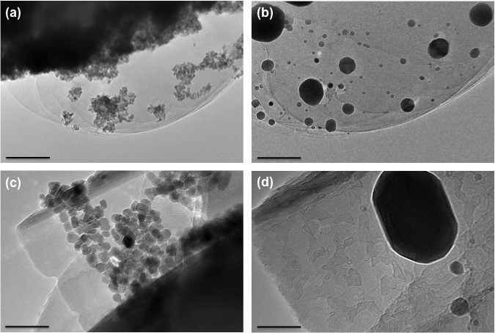

Figure S2: Shows the transformation of Fe₂O₃ nanoplates to Fe nanoparticles at 850 °C. (b,d). Fe₂O₃ present a nanopletelets shape. (a,c) The iron nanoparticles ripened post their reduction and between particles can be observed the particle migration. The shape of the nanoplatelets iron oxide nanoparticles changed to round during the reduction process.

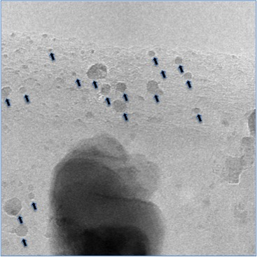

Figure S3: TEM image showing the particle migration process. During the particle migration the nanoparticles/small clusters forms the half dome structures at the FLBN step edges.

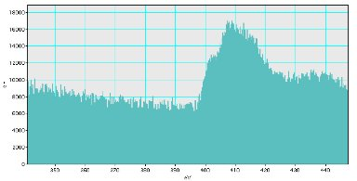

Figure S4: STEM-EELS on half dome structure grown on few layers graphene was performed solely to be certain that nitrogen of the organic capping agent was retained, the measurement is very noise as we were analysing the sample on graphene and the contribution of the carbon species was huge compared to just the nitrogen present in the capping agent. The peak Π* and σ* peak of Nitrogen position should not be taken into consideration as the measurement was carried out to ascertain that the presence of nitrogen in this control experiment.

Figure S5: EELS of FLBN. The Boron peak is at 192 eV, 204 eV, and 218 eV. Nitrogen 408 eV and 418 eV. The carbon peak is absent

Figure S6: EELS of half dome structure grown on FLBN. The boron peaks are at 192 eV, 204 eV, 218eV and the nitrogen peak are at 400 eV and 408 eV and the carbon peaks are 284,5 eV (weak K-edge) and at 292 eV the broadness of the carbon K-edge is unusual for pure sp²-hybridised carbon and is comparable to that observed for materials containing sp¹ and or sp² carbon and carbon nitride. The sigma edge is weak due to the presence of nitrogen.

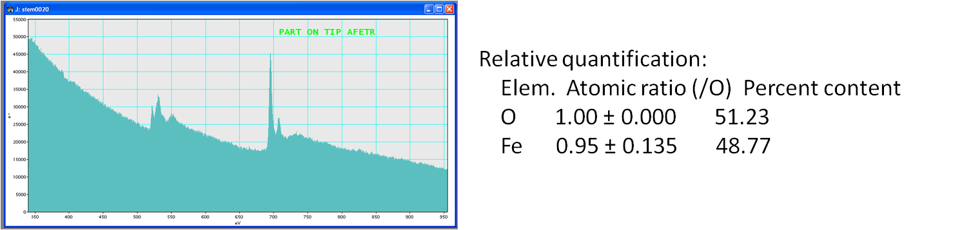

Figure S7: EELS of the Fe₂O₃ nanoparticles: The three oxygen peaks are at 500, 530, 550, respectively and the iron peaks are at 700 nm.

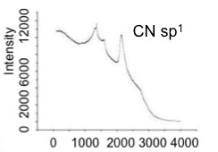

Figure S8: Stretching of the Ciano group of the CN sp¹ chain at 2200 cm⁻¹.

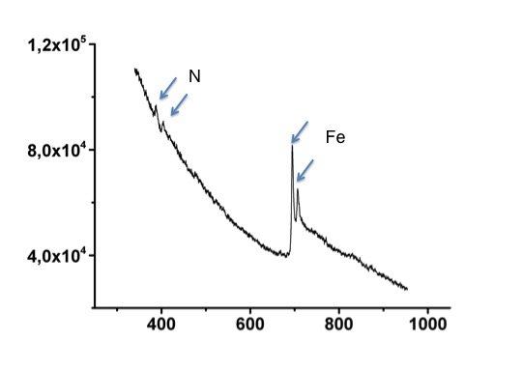

Figure S9: EELS carried out on half dome structure protruding from Iron nanoparticles showing the presence of nitrogen peaks at 400 and 408 eV. The EELS clearly show the formation of iron as the two peaks at c.a. 700 eV, the O peak that was expected to be at 530 eV is absent. The Π at 400 and σ peak of Nitrogen might indicate that the presence sp¹ CN chain free standing and embedded in an sp² CN domain.²³

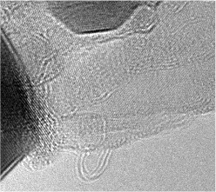

Figure 10: Bright field TEM images of the CN half dome structure images supported by video file.

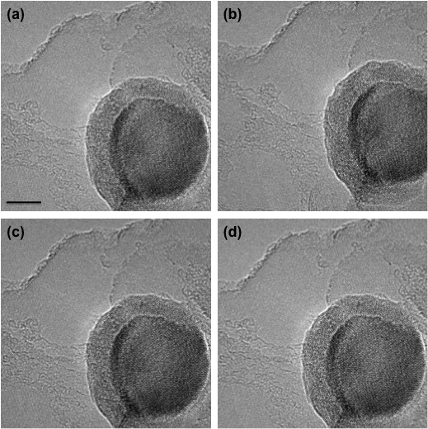

Figure 11: Time series images during the formation of half dome structure, It can be seen the formation of chains protruding the iron particle figure supported by video file.

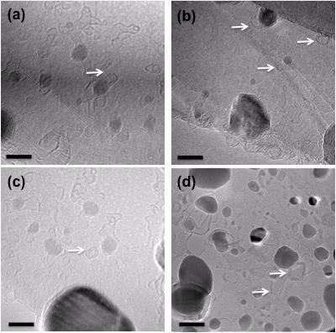

Figure 12: (a-c) Bright field TEM images of the BN half dome structure protruding the particles, (d) BN multi layer half dome structures.

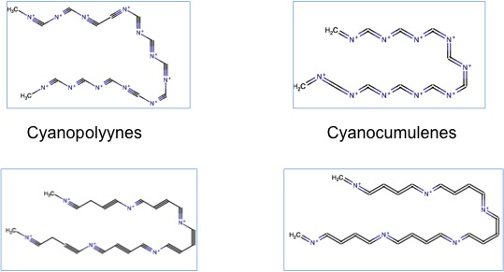

Figure 13: Cyanopolyynes chains.

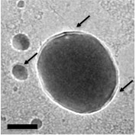
Figure 14: CN@HDS surrounding the metal core of FeNP. The arrows indicate the CN@HDS.

