Table S1. Repeatability results for (a) [⁶⁸Ga]GaFAPI-46 and (b) [^{nat}Ga]GaFAPI-46.
(a)
Injection | Acitvity (MBq/mL) | Inj. Time | Δt (min) | Corrected Activity | Peak Area | RF ¹
[⁶⁸Ga]GaFAPI-46 | 46,88 | 20:48 | 96 | 0,3524 | 89014,3 | 252595,5
[⁶⁸Ga]GaFAPI-46 |  | 21:05 | 113 | 0,2963 | 78107,2 | 263581,1
[⁶⁸Ga]GaFAPI-46 |  | 21:21 | 129 | 0,2517 | 69723,4 | 276969,8
[⁶⁸Ga]GaFAPI-46 |  | 21:37 | 145 | 0,2139 | 55882,1 | 261310,9
[⁶⁸Ga]GaFAPI-46 |  | 21:54 | 162 | 0,1795 | 43717,5 | 243106,8
[⁶⁸Ga]GaFAPI-46 |  | 22:11 | 179 | 0,1512 | 41455,1 | 274143,3
%RSD |  |  |  |  |  | 4,89
(b)
Injection | Area
[^{nat}Ga]GaFAPI-46 | 97,59
[^{nat}Ga]GaFAPI-46 | 104,38
[^{nat}Ga]GaFAPI-46 | 101,67
[^{nat}Ga]GaFAPI-46 | 103,79
[^{nat}Ga]GaFAPI-46 | 106,10
[^{nat}Ga]GaFAPI-46 | 107,52
%RSD | 3,40
¹ $RF=\frac{Peak area}{Radioactivity injection time}$
Injection | Area of [⁶⁸Ga]GaFAPI-46 (%)
[⁶⁸Ga]GaFAPI-46 | 99.94
[⁶⁸Ga]GaFAPI-46 | 99.91
[⁶⁸Ga]GaFAPI-46 | 99.78
[⁶⁸Ga]GaFAPI-46 | 99.88
[⁶⁸Ga]GaFAPI-46 | 99.94
[⁶⁸Ga]GaFAPI-46 | 99.63
%RSD | 0.12
Table S2. Repeatability results of radioTLC method for [⁶⁸Ga]GaFAPI-46.

Table S3. Repeatability results of radioTLC method for ethanol content in [⁶⁸Ga]GaFAPI-46.
Injection | Area of [⁶⁸Ga]GaFAPI-46 (%)
[⁶⁸Ga]GaFAPI-46 | 2491.00
[⁶⁸Ga]GaFAPI-46 | 2341.50
[⁶⁸Ga]GaFAPI-46 | 2529.10
[⁶⁸Ga]GaFAPI-46 | 2589.40
[⁶⁸Ga]GaFAPI-46 | 2594.40
[⁶⁸Ga]GaFAPI-46 | 2589.30
%RSD | 3.88

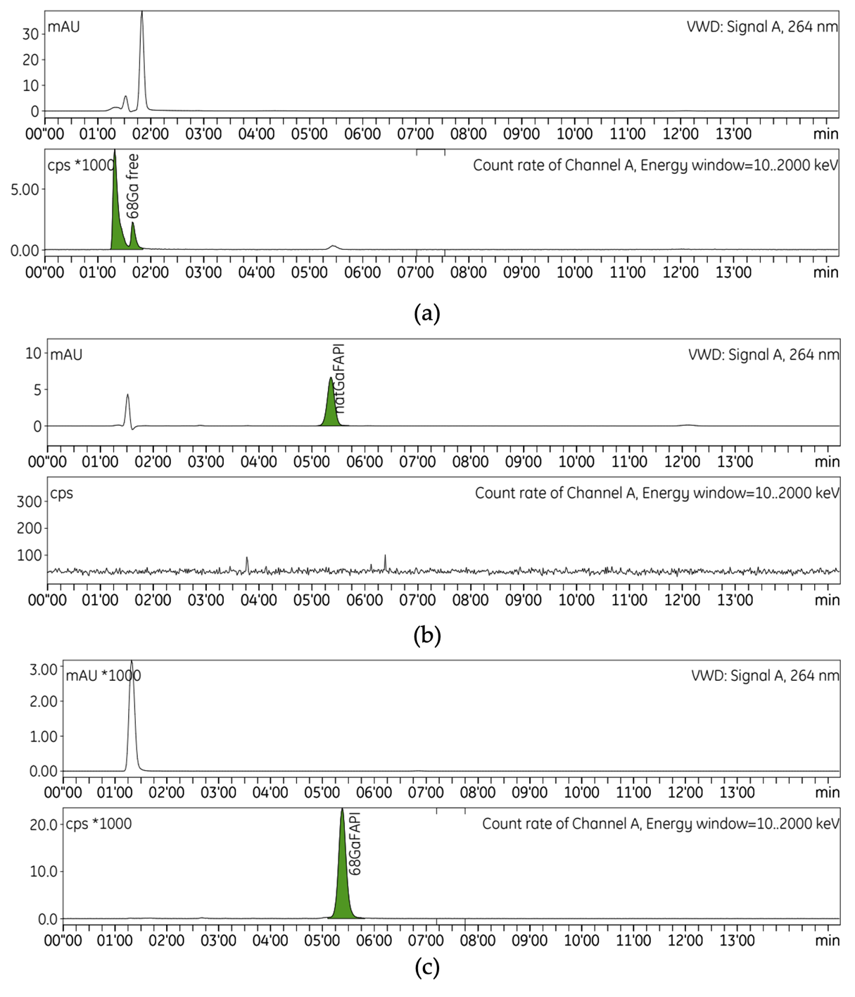
Figure S1. Representative HPLC chromatograms of each solution: (a) [⁶⁸Ga]GaCl₃, (b) [^{nat}Ga]GaFAPI-46, and (c) [⁶⁸Ga]GaFAPI-46.

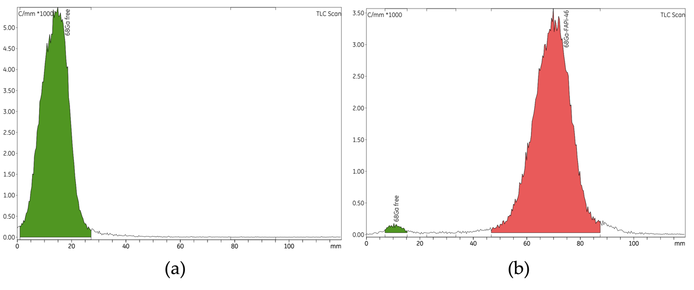
Figure S2. Representative radioTLC chromatograms of each solution: (a) [⁶⁸Ga]GaCl₃ and (b) [⁶⁸Ga]GaFAPI-46.

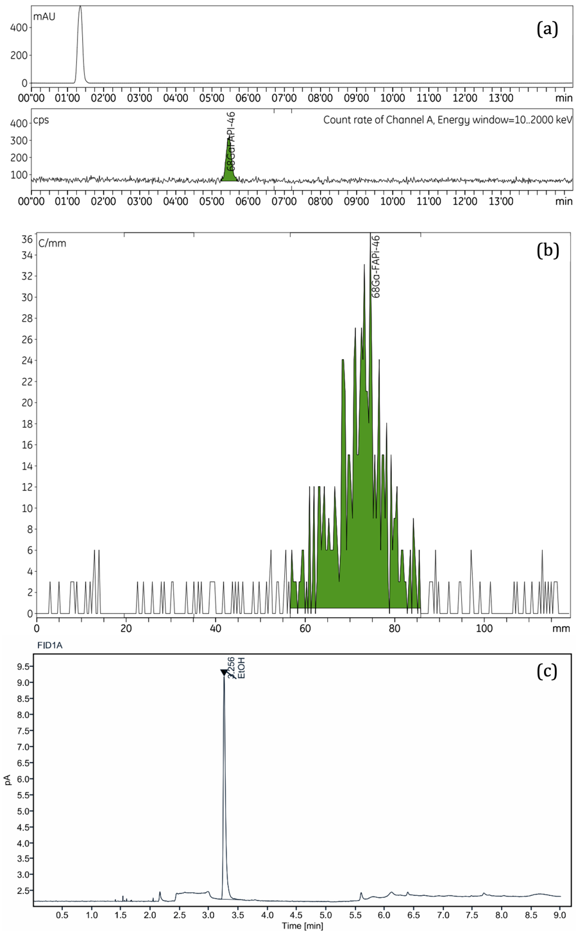
Figure S3. LOQ Representative chromatograms of HPLC, TLC and GC methods.
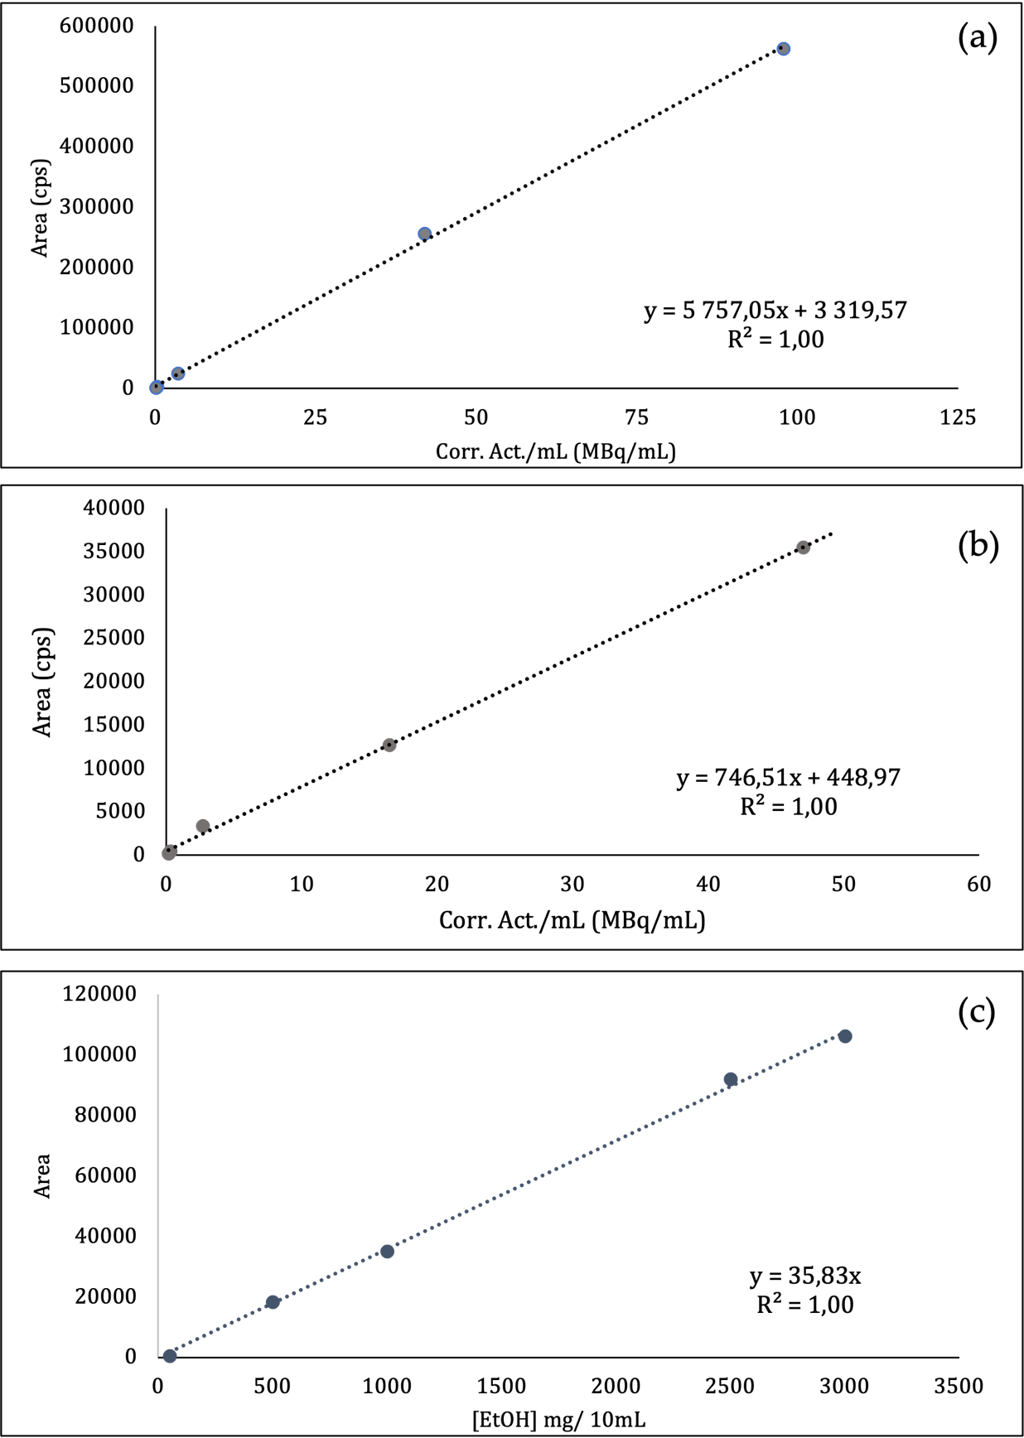
Figure S4. Linearity plot of (a) HPLC, (B) TLC and (C) GC methods.

