Supplemental Figure 1

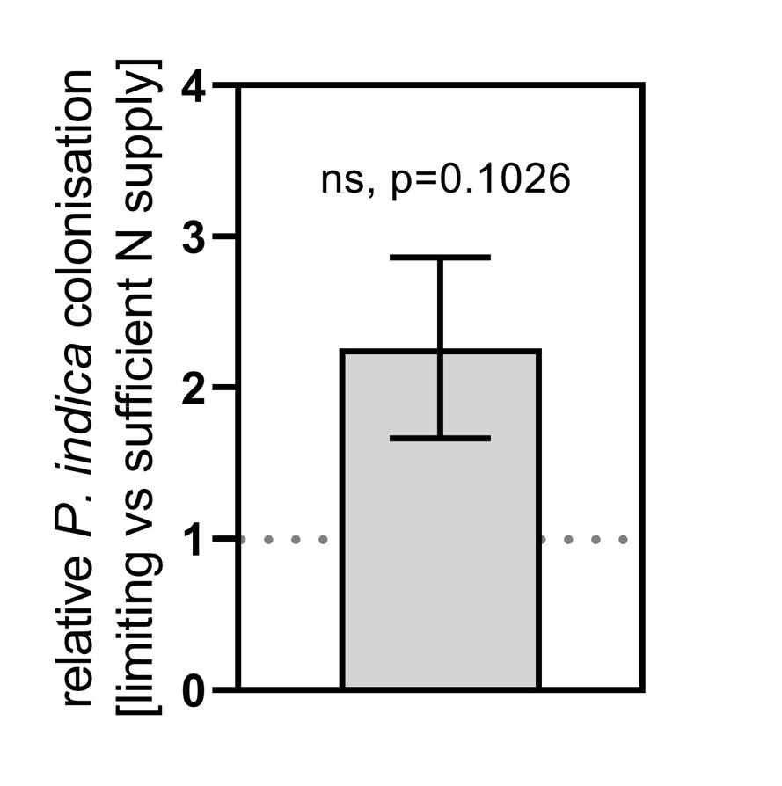

Figure S1. P. indica colonization of A. thaliana WT roots under different N conditions. Shown is the ratio of fungus colonization of plants grown on N-free medium (-N) vs. full medium (+N) after 5 days of co-culture, N=3. Fungus colonization was analysed by comparing expression of the fungus housekeeping gene vs. the plants housekeeping gene, see methods for details. Statistics analyses was done by t-test and the obtained p value is indicated in the graph.

