Supplementary material -on “Estimating the trade-offs between wildfires and carbon stocks across landscape types to inform NBS in Mediterranean regions”.
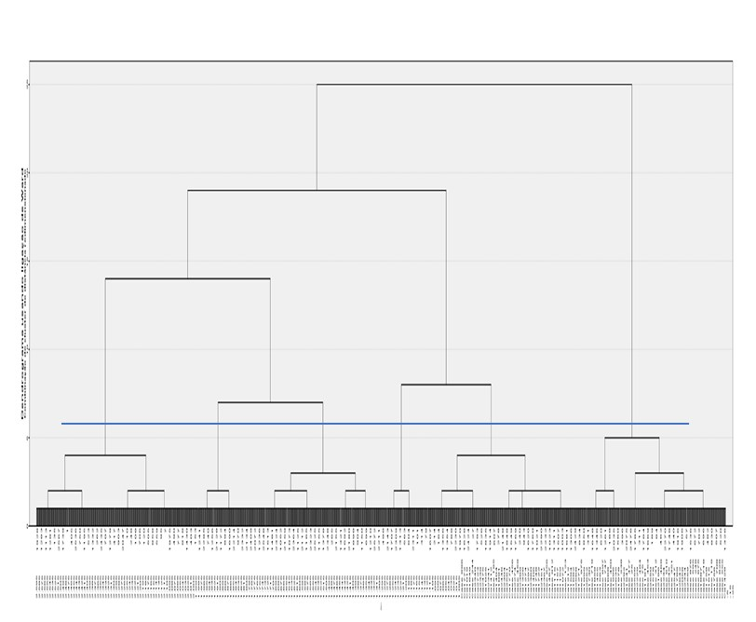
Figure S1. Dendrogram of hierarchical cluster analysis. Cutt-off done at 6 clusters.

Table S1-Results of multiple logistic regression analysis for the most hazardous fire and LULC model
Variable | Beta | p
(Intercept) | 1,54 | 0,000
FAR % | -0,07 | 0,000
AGF % | -0,06 | 0,000
FOR % | -0,04 | 0,000
SHR % | -0,01 | 0,000

Table S2 - Results of multiple linear regression analysis (dependent variable: CS) with simultaneous entry

Variable | Beta | p
(Intercept) | 26,09 | 0,000
FAR % | -0,22 | 0,000
AGF % | -0,11 | 0,000
FOR % | -0,02 | 0,000
SHR % | -0,15 | 0,000
Note: [F (4,2761) =1251,644 ;p<0,001;R²=0,645]

