Supplementary Materials:
Pengchu Bai ¹, Yan Wang ¹, Hao Zhang ¹, Xuan Zhang ¹, Lulu Zhang ^{2,3 *}, Atsushi Matsuki ³, Seiya Nagao ³, Bin Chen ^{4,5,6} and Ning Tang ^{3,7,8 *}
2010/03
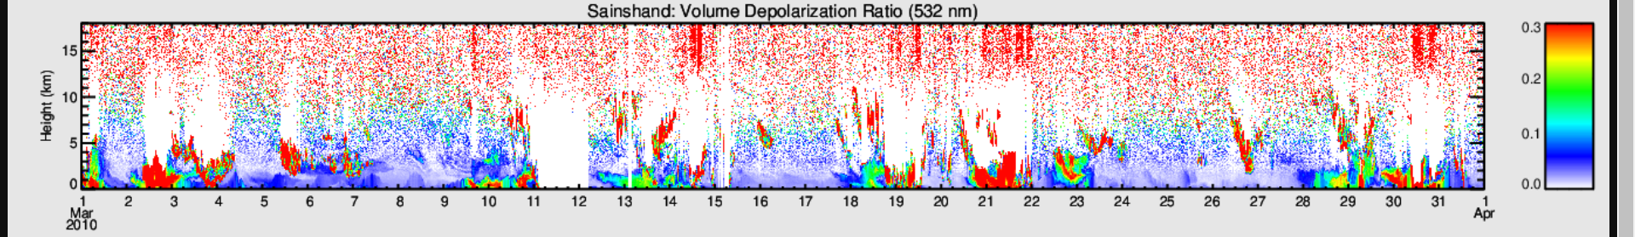
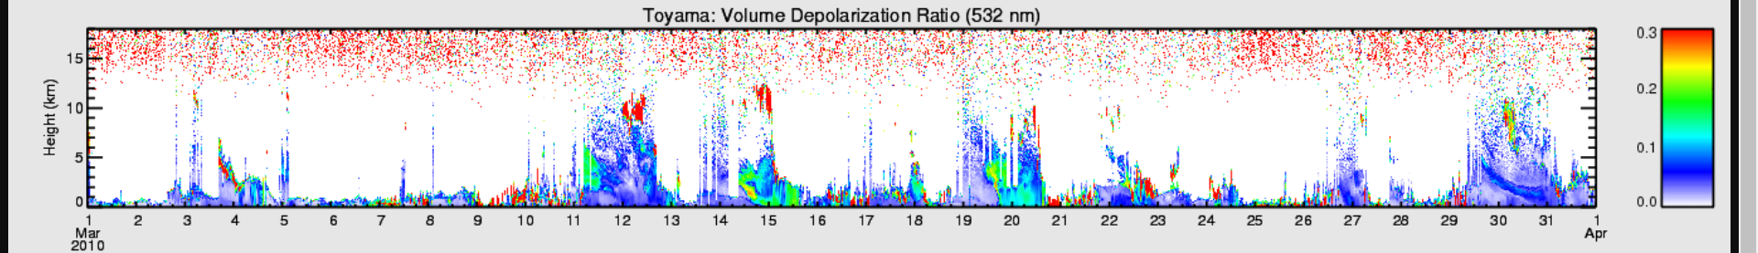
2010/04
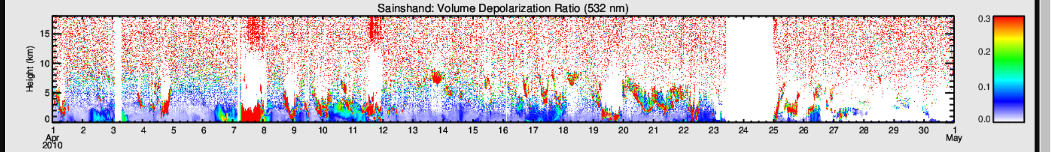
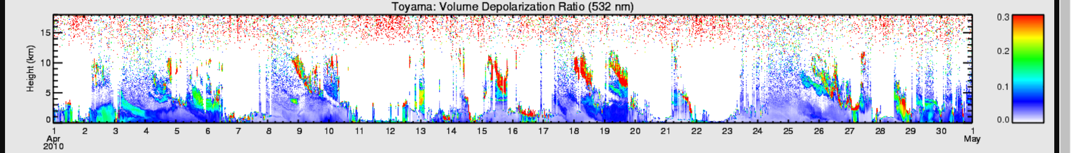
2010/05
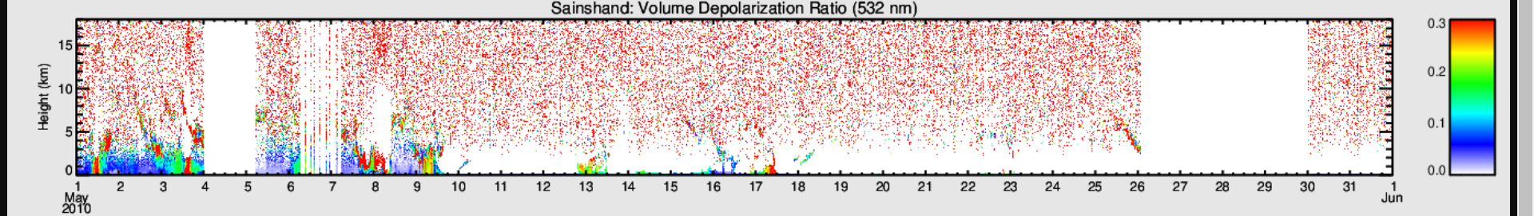
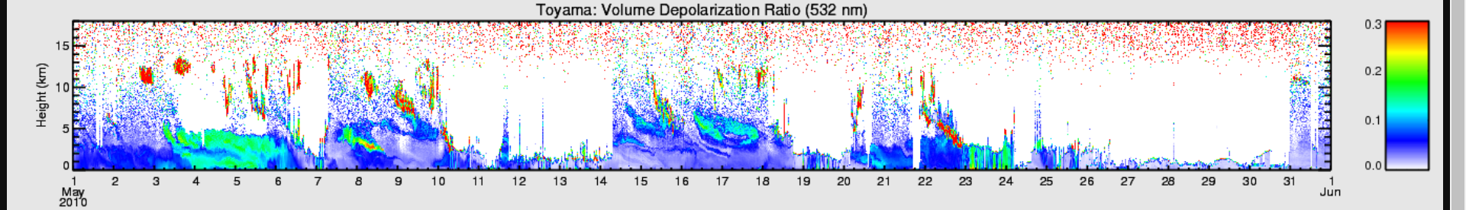
2010/11
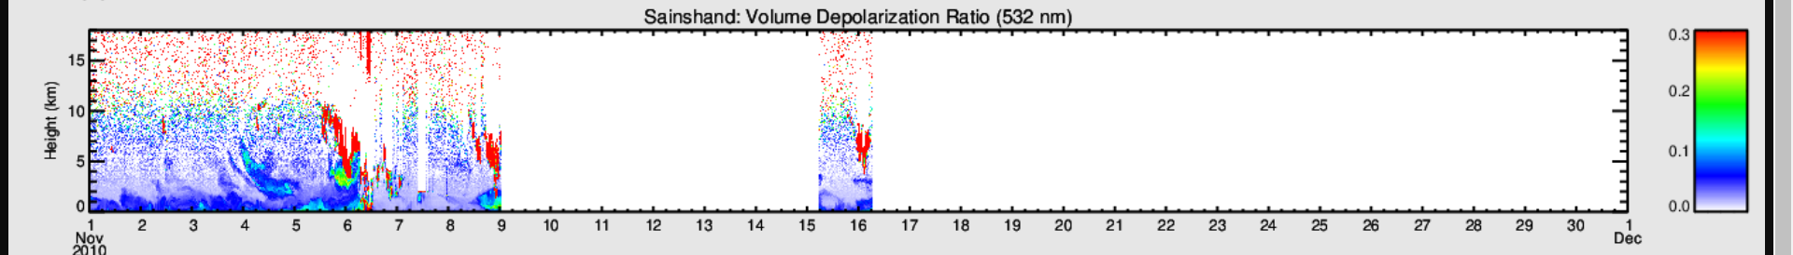
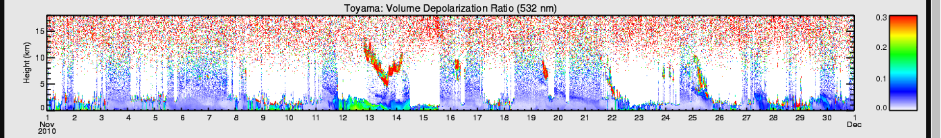
2011/05
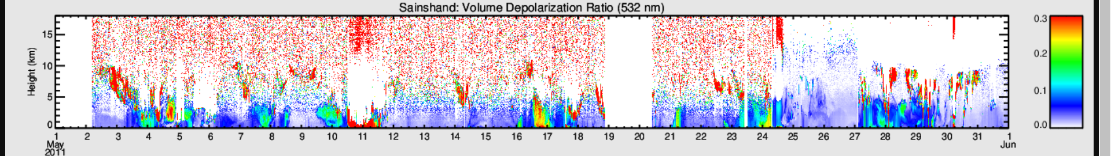

c
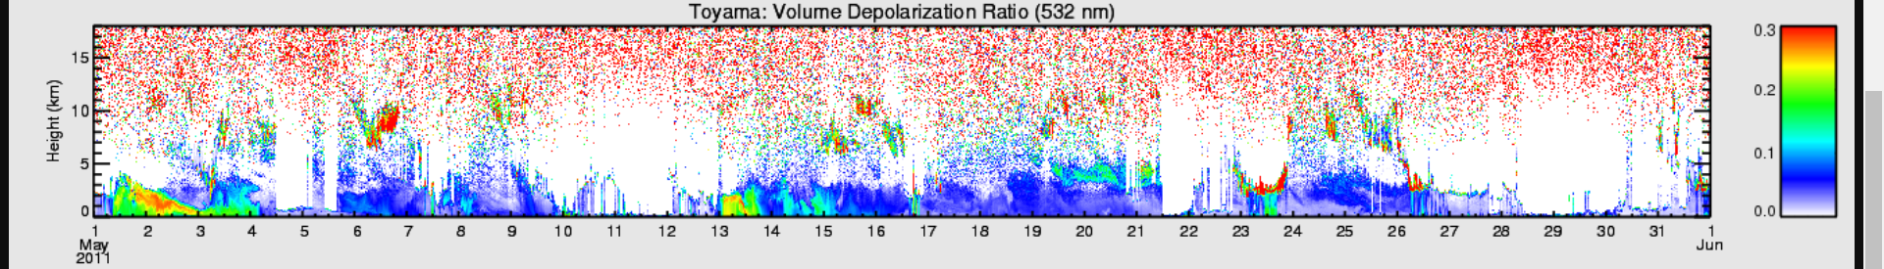

c
c
2012/04
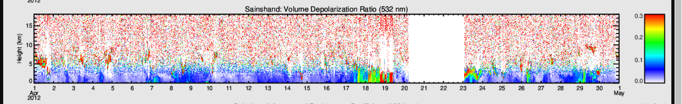
c
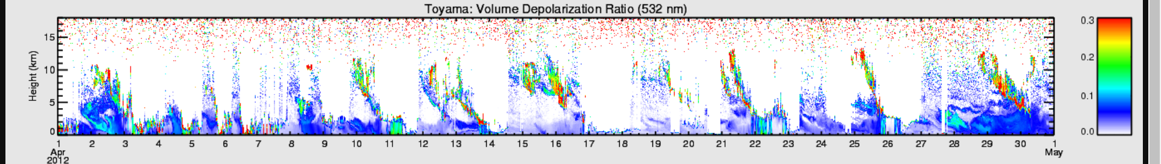
c

2012/05
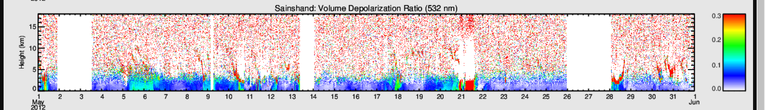
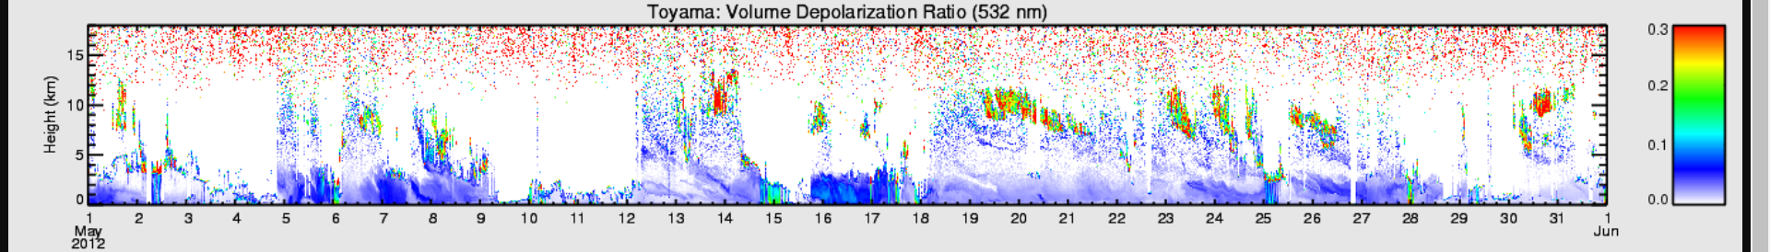

2013/03
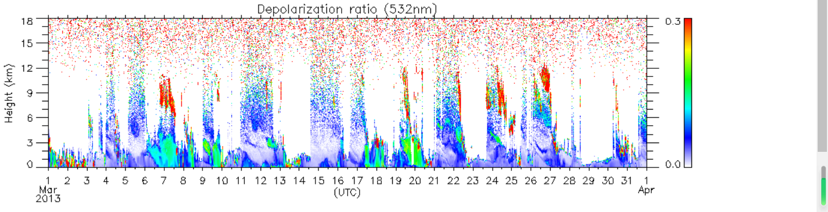

2013/04
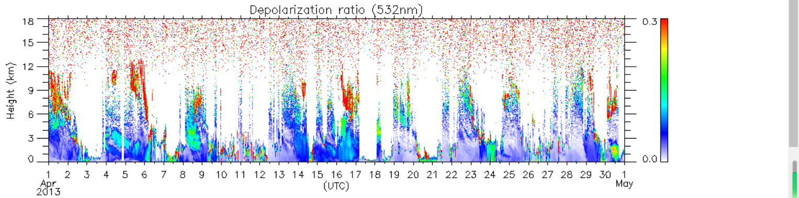

c
2014/05
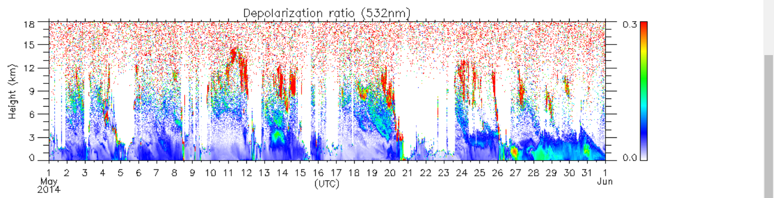

2015/02
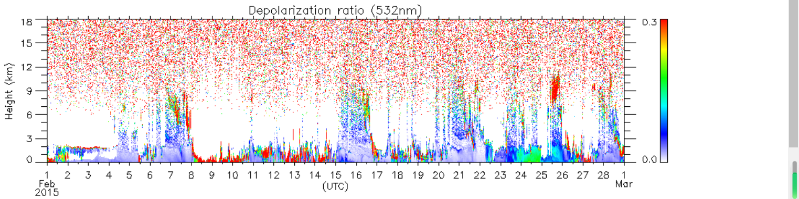
c
2015/03
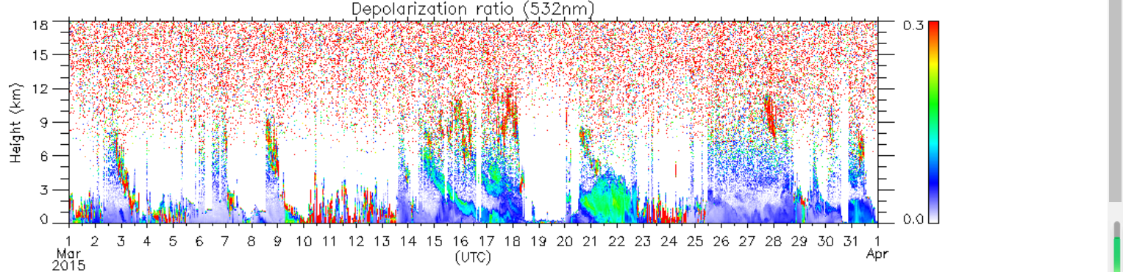
c
2015/04
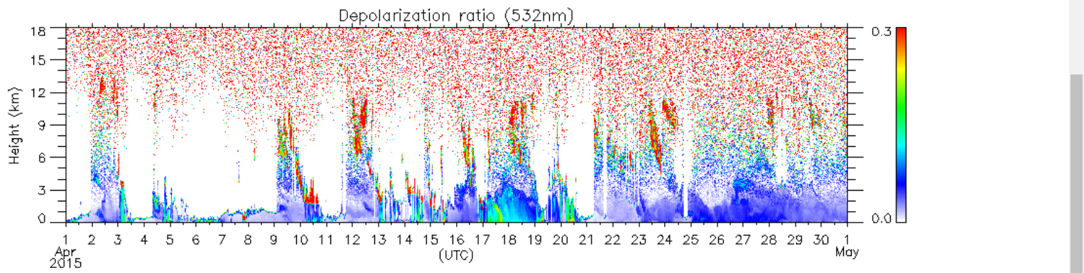

2015/05
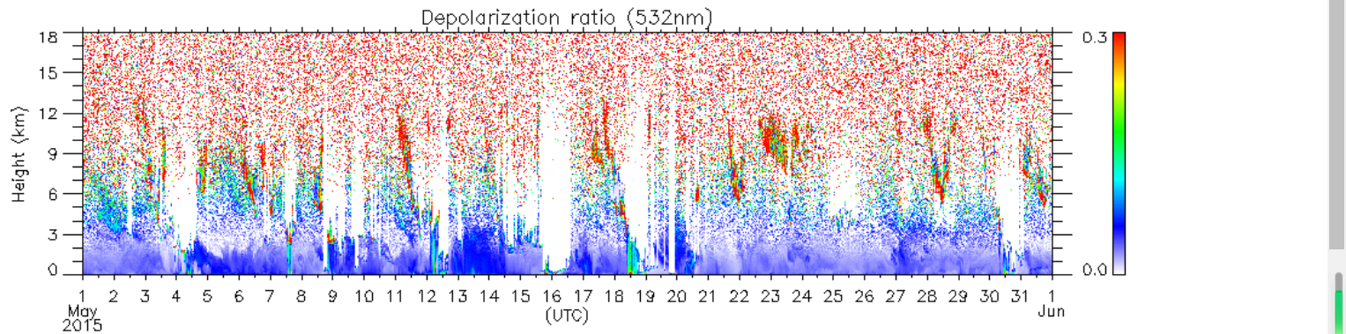

2016/04
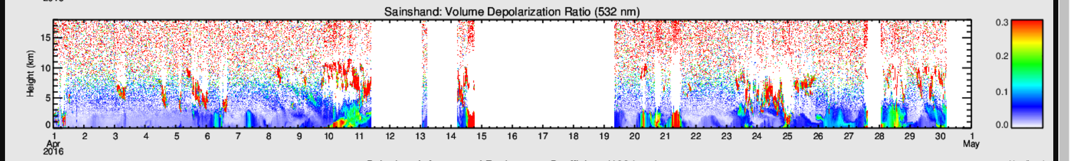
c
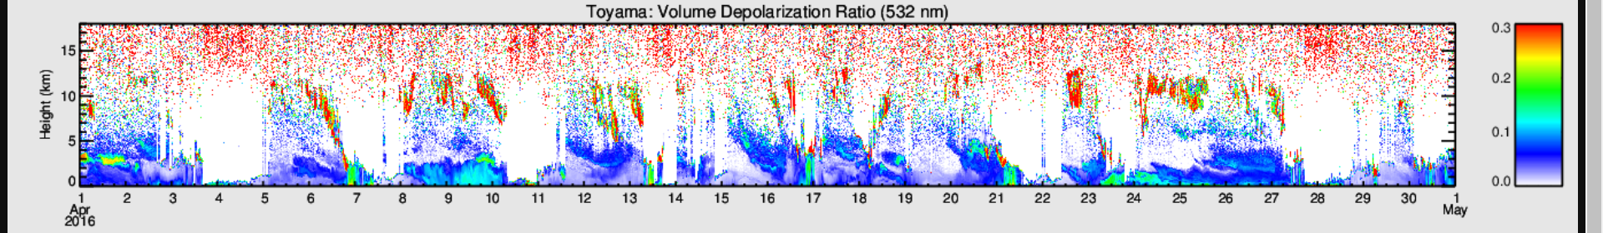
c
c
2016/05
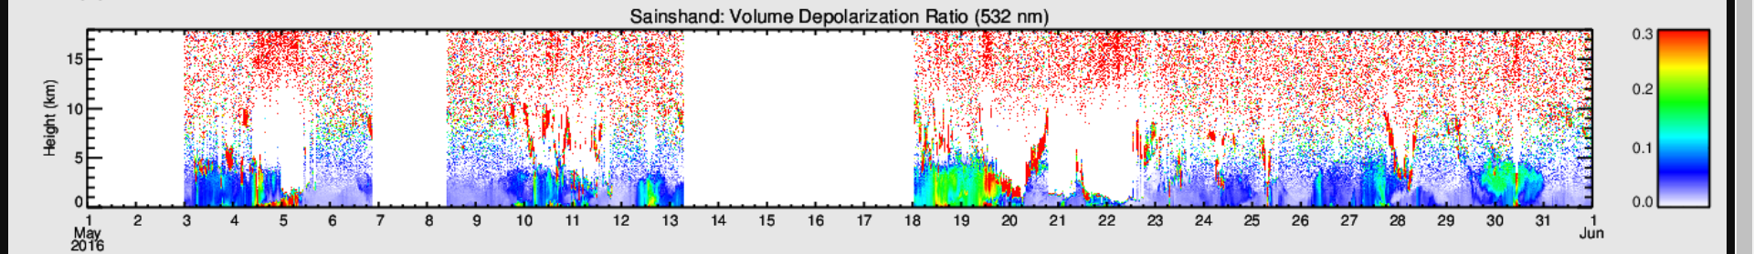
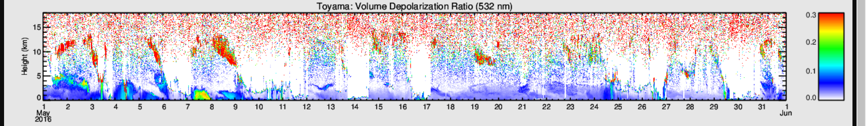
c
2017/04
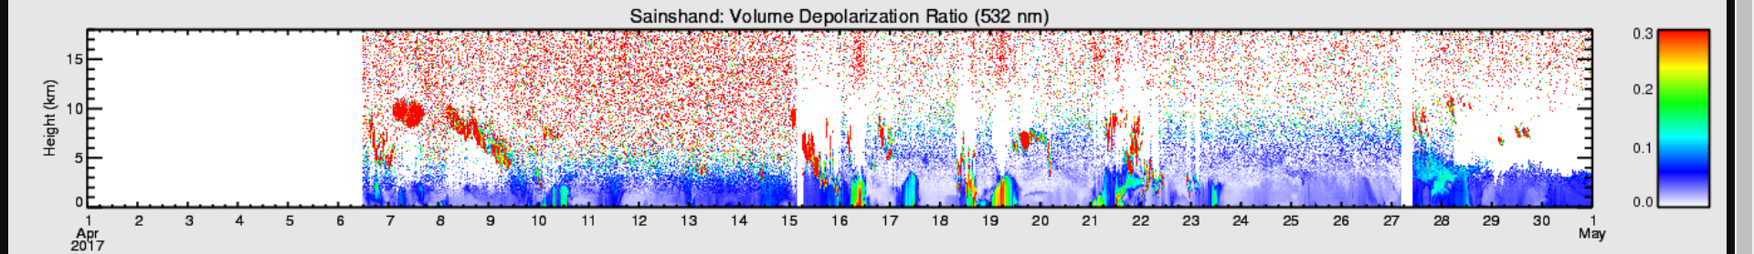

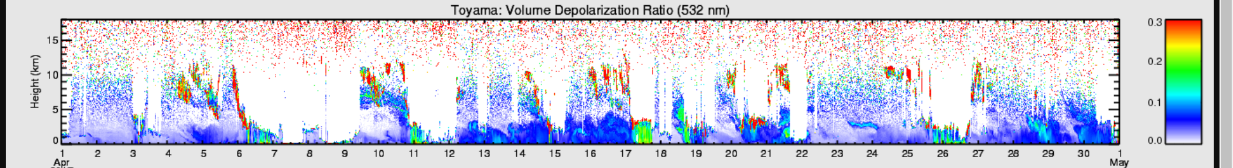
c
2017/05
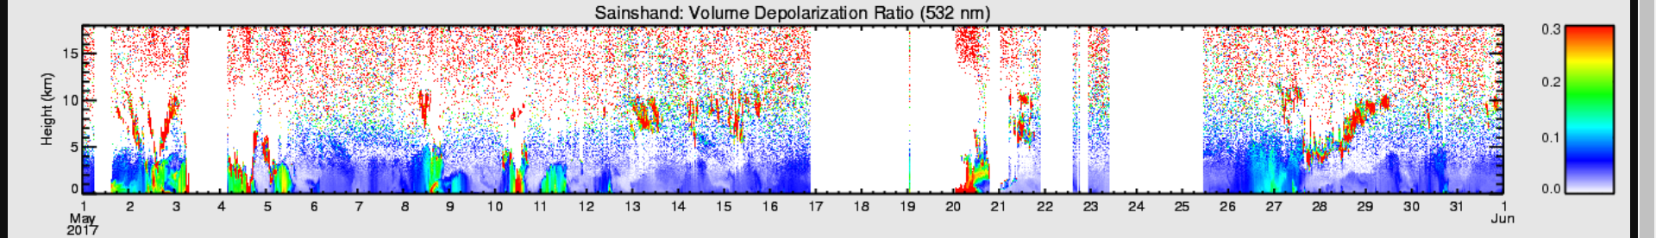
c
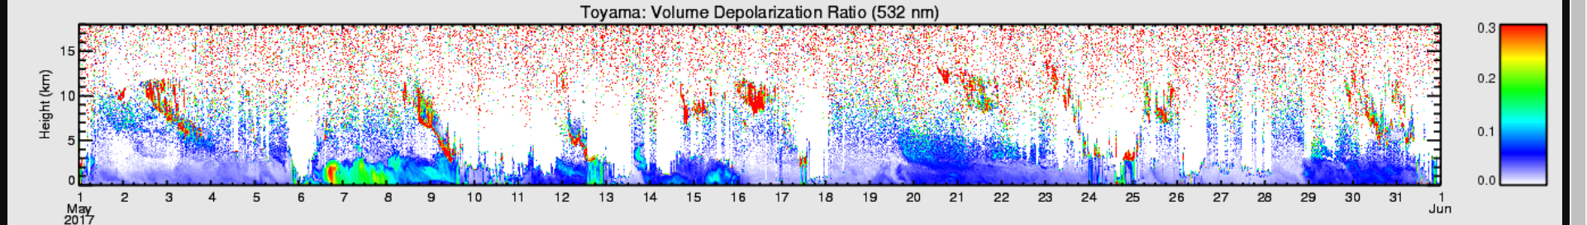
c
2018/04
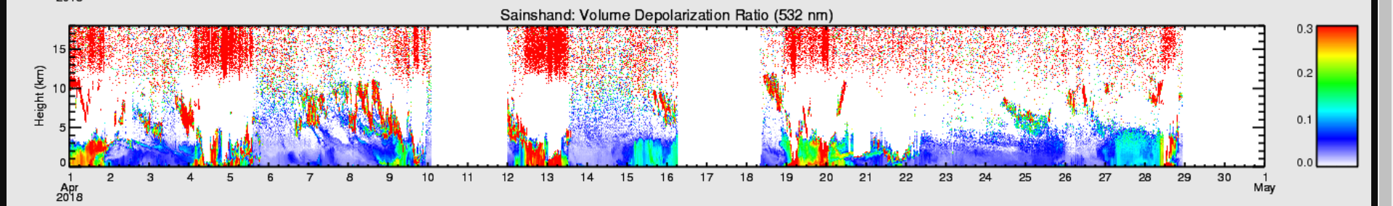
c
c

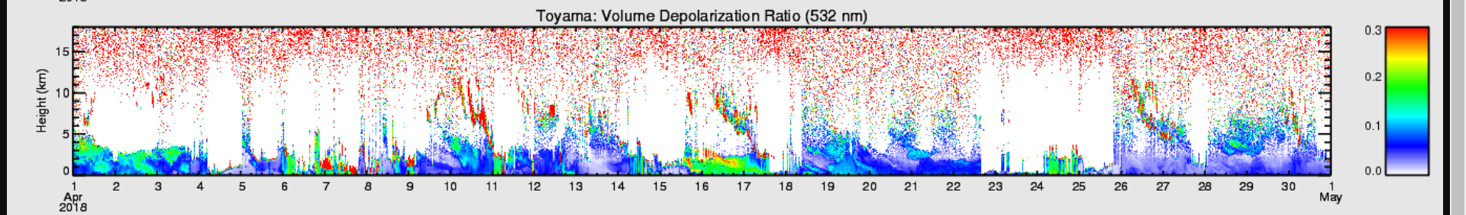

c
c
2018/05
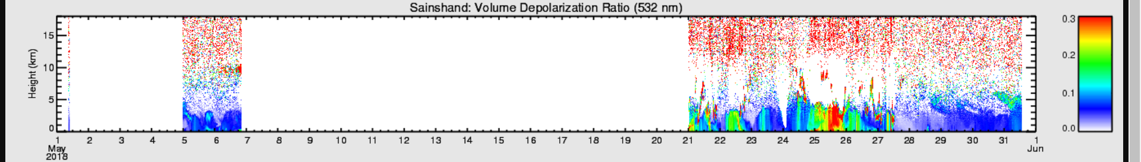
c
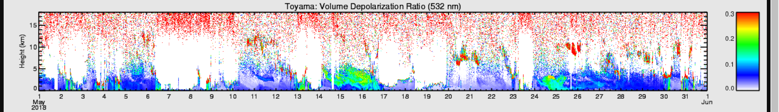
c

2020/02
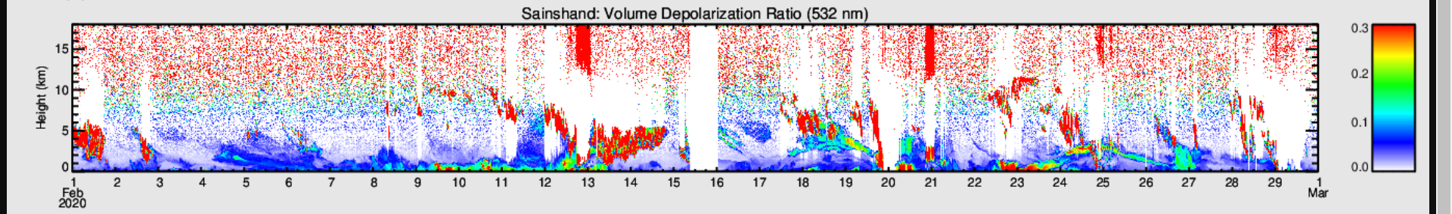
c
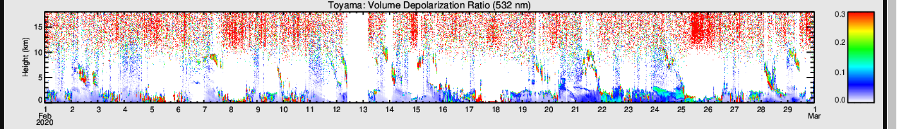
c
c
2020/03
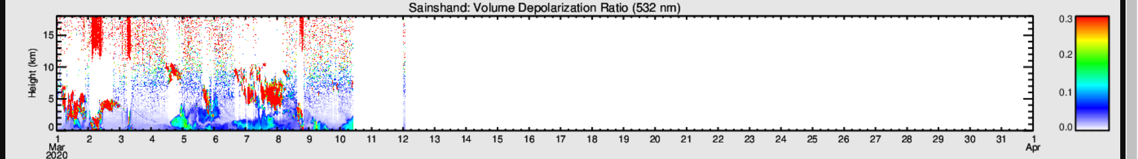
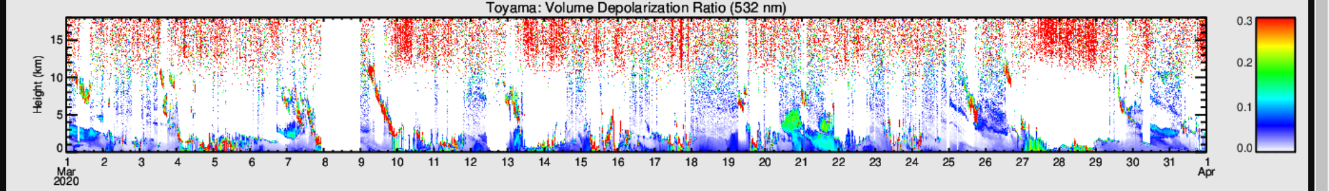
c
c
2021/01
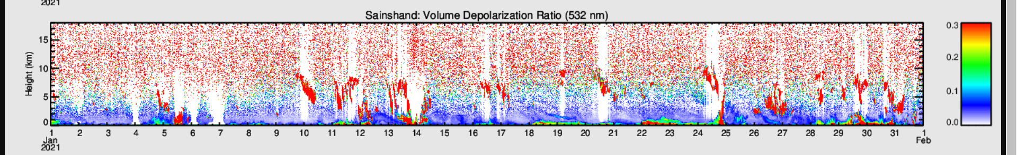
c
c
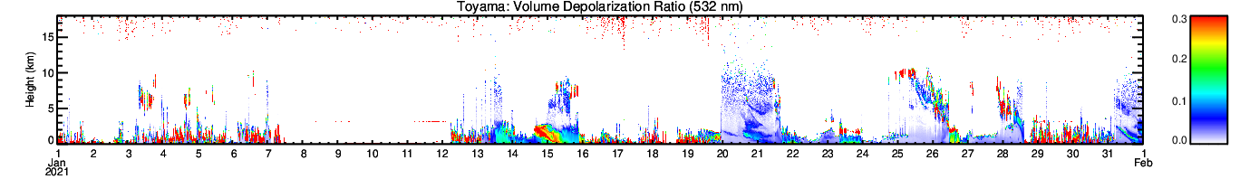
c
c
2021/02
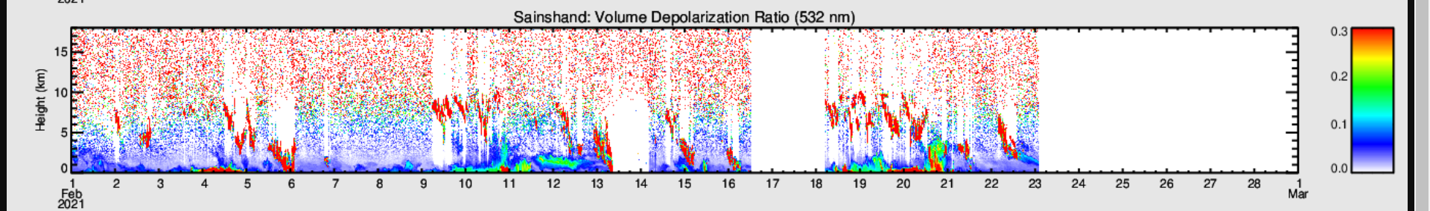
c
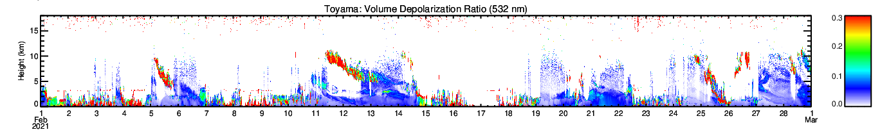
c
2021/03
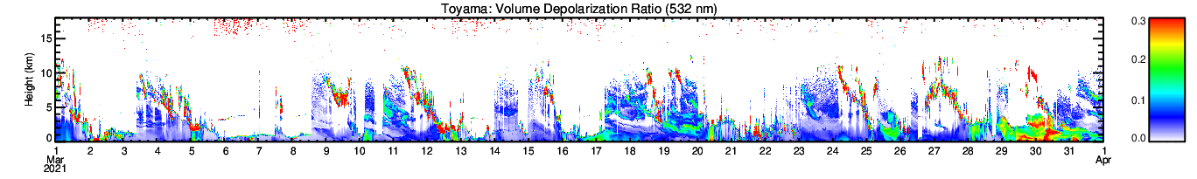
c
c
2021/04
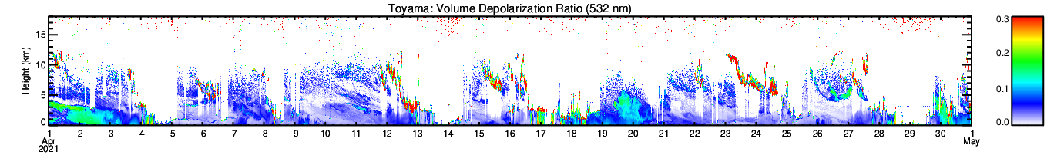

c
c
c
2021/05
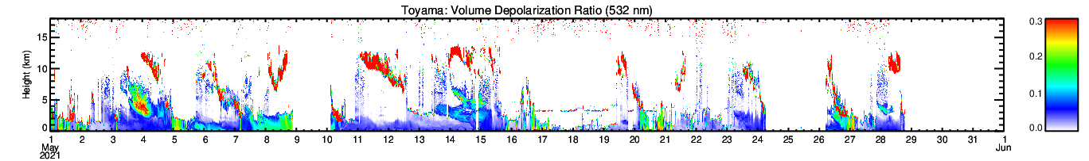
c
c
Figure S1. Lidar observation of Volume Depolarization Ratio (532 nm) during AD events from 2010 to 2021 at Sainshand (44.5 °N, 110.8 °E) and Toyama (36.70°N, 137.10°E). The green color in lidar observation images shows the dust aerosol, the blue color represents for spherical aerosol and the red color represents for ice cloud. Each AD event is marked in black block. The absence of the lidar observation images at Sainshand during 2013 (03, 04), 2014 (05), 2015 (02, 03, 04), 2021 (03, 04, 05) here is due to the lack of data in the official website. Red box represents for AD-high events, blue box represents for AD-low events and black box represents for AD events observed in Sainshand.
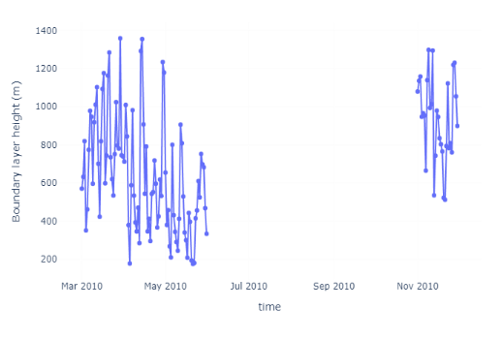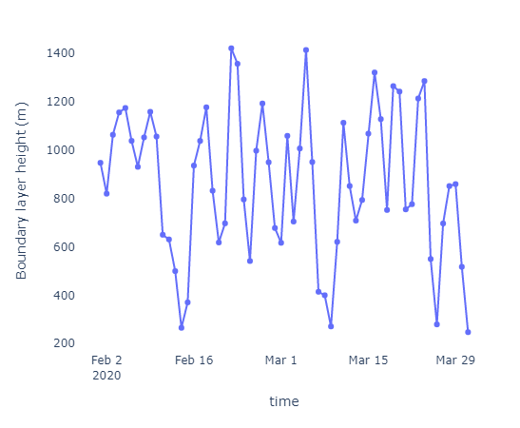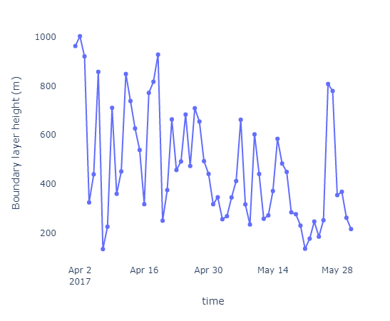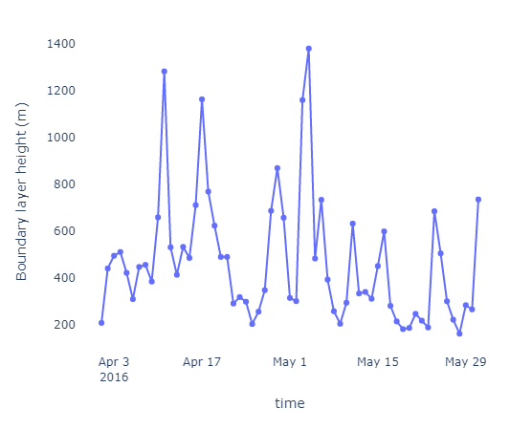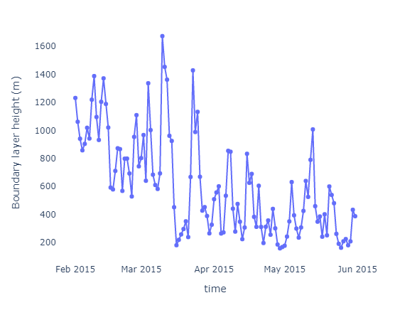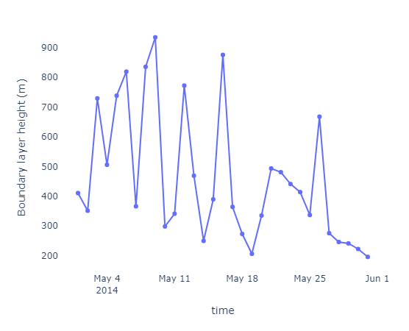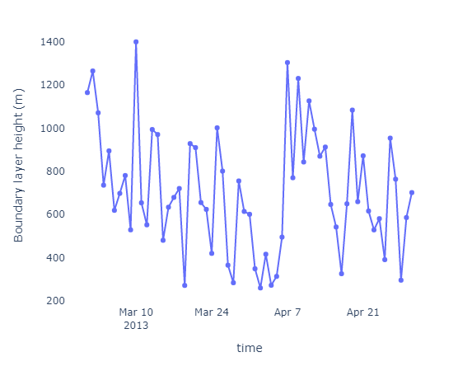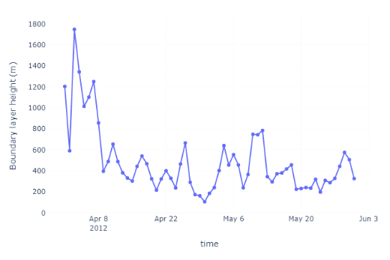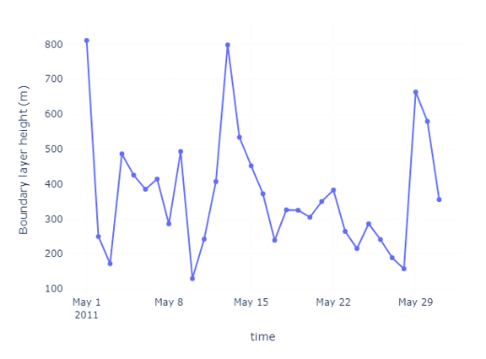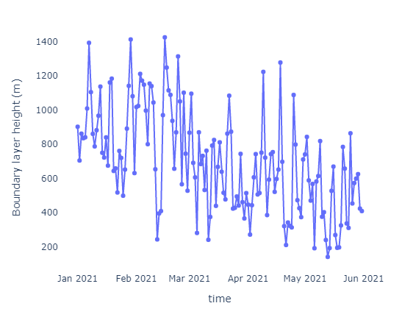
Figure S2. The height of planetary boundary layer during AD occurrence period from 2010 to 2021 over the Toyama area (longitude: 36 < x < 38, latitude: 136 < y < 137)..

Figure S3. The proportion of each PAH BaP_{eq} in different types of AD during long-term observation from 2010 to 2021.

Figure S4. ΣBaP_{eq} and ILCR in AD events and AD frequency in the East Asian winter monsoon period from 2010 to 2021.
Table S1. LOD and LOQ of target PAHs.
(pmol/ml) | LOD | LOQ
FR | 0.346 | 1.187
Pyr | 0.311 | 0.104
BaA | 0.028 | 0.096
Chr | 0.083 | 0.276
BbF | 0.242 | 0.793
BkF | 0.059 | 0.194
BaP | 0.044 | 0.147
BgPe | 0.362 | 1.194
IDP | 1.665 | 5.609
Table S2. TEF of target PAHs.
 | TEF
FR | 0.001
Pyr | 0.001
BaA | 0.1
Chr | 0.01
BbF | 0.1
BkF | 0.1
BaP | 1
BgPe | 0.01
IDP | 0.1

