Table S1. Commercial microfluidic devices used to generate emulsion droplets.
Company | Brand | Material | Characteristics | Applications | References
Dolomite | Telos ® 2 regent  Telos ® 1 reagent 3D flow focusing SC | Glass microfluidic device | -The device consists of 7 parallel junctions that can be combined with others 10.  -Hydrophilic, hydrophobic, and fluorophilic coating options.  -Available at 100 or 50 µm. | Designed for emulsion generation, foam generation, micro-particle synthesis and high throughput experimentation (for example, analysis of cells). | (Dolomite Microfluidics, 2022)
 | Telos ® micromixer Chip |  | -The device consists of 7 independent micromixer channels on the chip (with 5 mixing stages each).  -Hydrophilic and hydrophobic coating options.  -Available at 30 or 50 µm. | Designed to create nano and micro particles and emulsions.
 | µEncapsulator 2 Reagent Droplet Chip |  | -Chip size 11.25mm x 15mm x 2mm.  -Hydrophilic and fluorophilic coating surface options.  -Junction of 100 µm scale. | Designed for rapid generation of double emulsion droplets (an aqueous core, surrounded by an oil shell)
 | µEncapsulator Sample Reservoir Chip |  | -Smooth channel with 100 µL storage volume.  -Easy to clean and clear device.  -Hydrophilic coating surface. | Designed for single emulsion droplet generation.
 | Large Droplet Junction Chip | Glass and quartz device | -Chip offers both a T- and X-junction.  -Simple and easy to use.  -High droplet production (12,000 per second).  -Hydrophilic, hydrophilic and, fluorophilic coating options. | Designed for droplet emulsion generation.
 | Small Droplet Junction Chip |  | -Chip offers a flow focusing junction geometry with 14 x 17 µm cross-section at the junction.  -High droplet production (12,000 per second).  -Hydrophilic, hydrophilic and, fluorophilic coating options. | Designed for generating small droplets in the size range of 5-30 µm, improving control over the targeting and release of active compounds.
 | T-Junction Chip |  | -Extremely smooth channel surface.  - Excellent chemical compatibility.  -Hydrophilic, hydrophilic and, fluorophilic coating options. | Designed for a range of applications, including mixing fluids, microreactions and droplet formation.
 | 6-Junction Droplet Chip | Glass device | -The device consists of 6 separate flow-focusing junctions.  -Excellent chemical compatibility.  -Hydrophilic, hydrophilic and, fluorophilic coating options. | Designed for the parallel generation of 20 µm - 60 µm oil-in-water droplets.
Microfluidic ChipShop | Fluidic 162 | Topas® COC (Cyclic olefin copolymer) or Polycarbonate PC | -One channel device.  -Lid thickness 140 or 170 µm without surface treatment. | Designed for droplet generation on chip. | (microfluidic ChipShop, 2022)
 | Fluidic 537 |  | -The flow-focusing device consists of 4 identical droplet generation units with a 38 µm nozzle size.
 | Fluidic 912 |  | -The flow-focusing device consists of 8 identical droplet generation units with a channel dimension of 80 μm at the droplet formation region.
 | Fluidic 536 |  | -The device consists of double-cross geometry with 37 µm nozzle size and 3 droplet generator units. | Designed for W/W/O double emulsion generation, allowing cell and particle encapsulation.
 | Fluidic 488 |  | -The device consists of a combination of multiple T-junctions.  -Storage module for capturing droplets.  -Double cross nozzle type (74 µm). | Designed for generating single or multiple emulsions and storage.
 | Fluidic 285 |  | -The multi-channel device presents various channels with different nozzle (50; 70; 80; 100 µm).  -The main channel, as well as the entrance channel, vary in diameter, enabling a large set of experiments. | Designed for generating droplets with  different volumes.
 | Fluidic 1196 | Glass microfluidic device | -Several parallel microchannels in one unit.  -Lid thickness of 250 µm -Channel dimensions 20 µm | Designed for droplet generation on chip.

Table S2. Technological approaches and properties of the delivery systems based on food-grade emulsions assembled by microfluidic techniques.
Emulsion type-Delivery system | Aqueous phase | Oil phase | Process conditions | Bioactive | Delivery system characterization | Microfluidic device type | Reference
O/W- Emulsion | Modified lecithin (ML), whey protein isolate (WPI), or Tween 20 (0.05-3 wt%) | Medium chain triacylglycerol oil | Q_{d}= 0.1-10 mL/h  Q_{c}= 100-500 mL/h | Fucoxanthin extract (0-4 wt%) | Size= 30.3 ± 0.2 μm (ML), 32.3 ± 0.1 μm (WPI) and 29.0 ± 0.8 μm (Tween 20)  DI= 0.5  EE= 100%(ML)  90.7% (WPI)  50.4% (Tween 20) | Silicon 24 × 24 mm² microchannels array chip (Model: WMS 11–1; EP. Tech Co., Ltd., Hitachi, Japan) | (Ma et al., 2020a)
 | Tween 20 (1% w/w), sodium salt of colic acid (Na-cholate), decaglycerol monolaurate, polyglyceryl-5-laurate (Sunsoft A-12E), or bovine serum albumin (BSA) (1% w/w) |  | J_{d}= 10-300 L/m.h | Quercetin (0.1-0.6 mg/mL) | Size= 28-29 μm  DI < 0.21  EE= 80 % (4 ºC) and 70 % (25 ºC) | Silicon 24 × 24 mm² microchannels array chip (Model WMS 1-2; EP. Tech Co., Ltd., Hitachi, Japan) | (Khalid et al., 2016a)
 | Decaglycerol monolaurate (ML-750) or Tween 20 (1% w/w) |  | Q_{d}= 1-14 mL/h | β-sitosterol (0.5-4.0% w/w) and γ-oryzanol (0.5-4.0% w/w) | Size= 26-28 μm  DI < 0.20  EE over 80 % | Silicon 24 × 24 mm² microchannels array chip (Model: WMS 11–1; EP. Tech Co., Ltd., Hitachi, Japan) | (Khalid, Kobayashi, et al., 2017a)
 | Sodium dodecyl sulfate (SDS), decaglycerol monolaurate (ML-750), decaglycerol monooleate (MO-7S), sodium casinate (Na-Cs), and modified lecithin (ML) (1% w/w) |  | Q_{d}= 0.25-5 mL/h | AstaReal® (AR, astaxanthin purity 20%), Zanthin® (ZA, astaxanthin purity 10%), and Astaxanthin >97% (Sigma- Aldrich) (1-5% w/w) | Size= 35-37 μm  DI < 0.25  EE over 98 % |  | (Khalid, Shu, et al., 2017a)
O/W-Microgel | Sodium alginate (1 wt%), gelatin (5 wt%), and EDTA-Ca (2 wt%) | Tert-butyl hydroquinone (TBHQ) | Q_{d}= 1-2 mL/h  Q_{c}= 10-20 mL/h | Vitamin A (weight ratio 4:1 vitamin A/TBHQ) | Size= 246 µm  DI= 0.96%  EE= not specified  CR= 75% over 2h | Photosensitive resin microfluidic device made using microscale 3D printing equipment  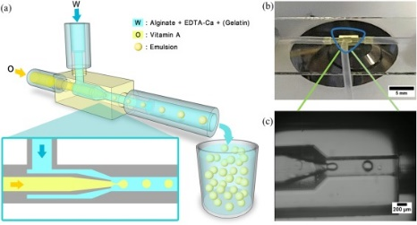 | (J. Zhang et al., 2022)
 | Poly (vinyl alcohol) (PVA) (0.25% w/v) | PLGA 7525A dissolved in dichloromethane (DCM) | - | Finasteride  (28 mg, monthly doses) | Size around 30 µm  DI= 23-28%  EE= not specified  CR= an initial burst, a moderate release, and then a plateau. | IVL-PPF Microsphere® microfluidic device  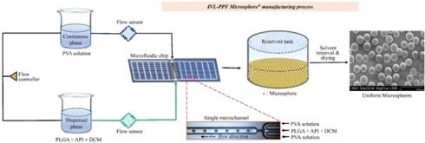 | (J. H. Kim et al., 2019a)
 |  | PLGA 5050A (PURASORB® PDLG 5002A), PLGA 7525A (PURASORB® PDLG 7502A), and PLA02A (PURASORB® PDL 02A) dissolved in dichloromethane (DCM) | P_{d}= 1,100 mbar  P_{c}= 2,200 mbar |  | Size= 40 μm (PLGA 7502A or 5002A) and around 30 µm (PLGA/PLA02A)  DI= 0.28 and 0.16  EE > 96.5% |  | (J. H. Kim et al., 2021a)
O/W-Nanoparticle | D1: acetone or methanol  D2: deionized water | 3M fluorinatedTM Fluid (FC-40) | Q_{c}= 10 to 250 µL/min.  Q_{d}= fixed at 50 µL/min. | Itraconazole (ITZ) nanoparticles (1 mg/mL) | Size= the volume was calculated and range from 1 to 6 µL.  EE= encapsulation was confirmed by the increase of particle size. | 316 stainless steel metal T-junction devices  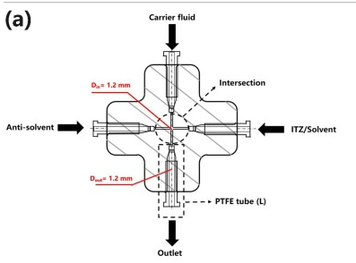 | (S. Kim et al., 2020)
 | Poly (vinyl alcohol) (PVA; 1% w/v) solution | PLGA (13.4 mg/mL) in acetonitrile (ACN) | Total flow rate: 2-12 mL/min  Flow rate ratio= 2:1 to 10:1, aqueous:oilphases | Rutin (10 mg/mL) | Size= 123.4 nm  DI= 0.16 ± 0.005  EE= 34 ± 2% | NanoAssemblr® Benchtop Device  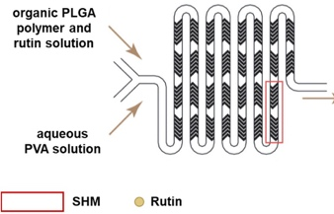 | (T. H. H. Vu et al., 2019)
 | Water | Tween 20 dissolved in ethyl acetate | P_{c}= 4.20 bar  P_{d}= 3.81 bar  For the smallest particle size | Fenofibrate (0.5 %wt) | Size < 1 µm  DI= not specified | Glass microfluidic device  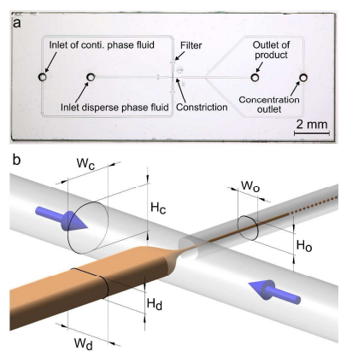 | (Lorenz et al., 2018)
O/W/O-  Core-shell microcapsule | Middle phase: an aqueous solution containing CaCl₂ (100 × 10⁻³ M), disodium-EDTA (100 × 10⁻³ M) and sodium alginate (2.0%; pH 7.0) | Outer phase: soybean oil, acetic acid (5% w/v) and PGPR (5.0% w/v)  Inner phase: soybean  oil, benzyl benzoate (1:1), and PGPR (2.0% w/v) | Q_{i}= 2.2 µL/h.  Q_{m}= 5.0 µL/h.  Q_{o}= 68.1 µL/h | Thyme essential oil and lavender essential oil (33.33% v/v) | Size= 182-342 µm  DI= 2.4-2.8%  EE= not specified | Glass microfluidic device  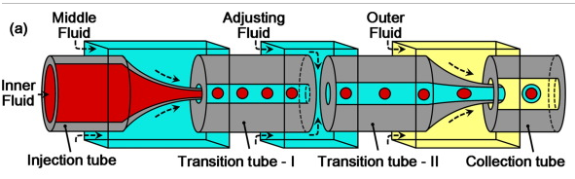 | (Mou et al., 2020)
W/O/W- Giant liposome | Outer phase: poly (vinyl alcohol) (PVA; 10 % w/v)  Inner phase: PVA (1% w/v) and dextran (9% w/v) | Middle phase: soybean lecithin (0.5% w/v) in the following organic solvent mixtures (1:1.8 v/v): chloroform/hexane; ethyl acetate/hexane or ethyl acetate/pentane. | Q_{i}= 1000 μl/h  Q_{m}= 1000 μl/h  Q_{o}= 3,000-12,000 μl/h. | β-carotene  (0.125% w/v) | Size= 100-180 µm  DI= 3-6 %  EE= not specified | Glass microfluidic device  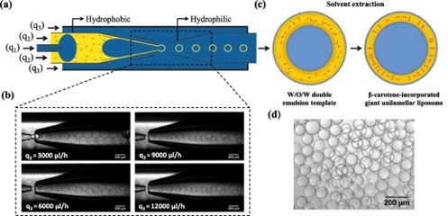 | (Michelon et al., 2019a)
W/O-Microgel | Pectin solution (0.5 and 1% w/w) | Acetic acid and CaCO₃ in rapeseed oil | Q_{d}= 1 mL/h  Q_{c}= 9 mL/h | Silver and gold nanoparticles (5.5 nm; 1.5 mg/mL) | The microgel was able to encapsulate nanoparticles | Polycarbonate (PC) microfluidic device  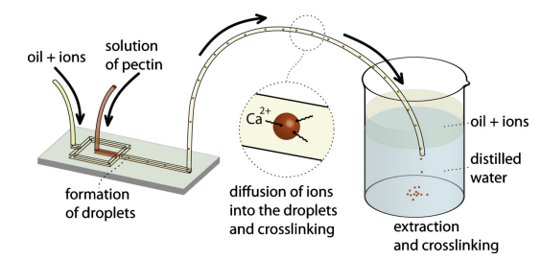 | (Ogończyk et al., 2011)
 | Gellan gum (0.10–0.30% w/w) and Jabuticaba extract (diluted in 0.025 M potassium chloride pH 1 and 0.4 M sodium acetate pH 4.5) | PGPR (4% w/w) and calcium acetate (1% w/w) added to the soybean oil | Q_{d}= 2-30 mL/h  Q_{c}= 150-250 mL/h | Jabuticaba extract (10-30% v/v) | Size= 185-342 µm  DI= 0.016 and 0.086 | Glass microfluidic device  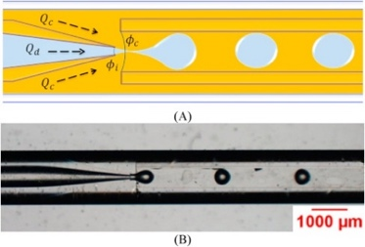 | (Santos et al., 2020a)
 | 1: Dextran or protein aqueous solutions  2: Alginate solution (2% wt%) containing CaCO₃ (200 mM).  poly(ethyleneimine) (PEI; 0.3 wt%) or chitosan (1% v/v in acetic acid) coating | 3: Mineral oil with Span 80 (3 wt%), used as oil phase A  4: Mineral oil with Span 80 and acetic acid (0.2% v/v) used as oil phase B | Q₁= 15 μL/min  Q₂= 0.5 μL/min  Q₃= 10 μL/min  Q₄= 14 μL/min | Ovalbumin | Size around 100 μm  DI= not specified  EE= 88% (PEI coating) and 80% (chitosan coating) | Polydimethylsiloxane (PDMS) microfluidic device (four inlets and one outlet)  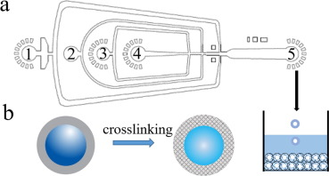 | (L. Yu et al., 2019b)
 | Alginate (2% w/v) and recombinant proteins in water  Collection bath: chitosan (0.5%) and CaCl₂ (0.1%) | Span 80 in mineral oil | Q_{d}= 10 μl/h  Q_{c}= 50 μl/h | eGFP+AvrA nanoparticles (2% w/v) | Size= 339 ± 52 µm  DI= 0.352 ± 0.153  EE= not specified  CR= 70 % of the encapsulated was released after 240 min | Polydimethylsiloxane (PDMS) microfluidic device | (Ling et al., 2019a)
 | Pectin (1 wt%)  Sheath flow: CaCl₂ solution (1 wt%) | Mineral oil solution containing quercetin nanoparticles and retinyl palmitate, and Tween 80 (1 wt%) | Q_{d}= 0.5 μL/min  Q_{c}= 4.0 μL/min Q_{sheath}= 30 μL/min | Quercetin nanoparticles (0.02 wt%) and retinyl palmitate (0.2 wt%) | Size around 67.3-93.1 μm  DI= not specified  EE= not specified, encapsulation confirmed by fluorescence | Polydimethylsiloxane (PDMS) microfluidic device | (Noh et al., 2018a)
W/O/W- Emulsion | Inner phase: phosphate buffer solution (100 mmol/L) containing betanin and D-glucose (1% w/w)  Outer phase: Tween 20 in water | Middle phase: soybean oil and tetraglycerin monolaurate condensed ricinoleic acid ester (CR-310) | J_{d}= 5-100 L/m.h | E162, (mixture of beetroot extract and maltodextrin; 0.4% w/w betanin, TCI/ABCr), betanin, and spray dried beetroot juice) (0.1-1.0% w/w) | Size < 50 μm  DI < 0.26 ± 0.01 | Silicon 24 × 24 mm² microchannels array chip (Model: WMS 11–1; EP. Tech Co., Ltd., Hitachi, Japan)  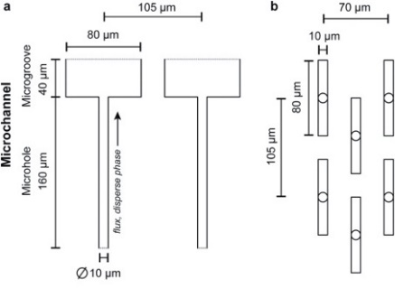 | (Pagano et al., 2018a)
W/O/W- Solid lipid microparticle | Outer phase: water and polyvinyl alcohol (PVA; 10% (w/v)  Inner phase: Ascorbic acid solution with or without CaCl₂, and chitosan. | Middle phase: palm fat oil | Q_{i}= 3,000 and 1,000 µL/h.  Q_{m}= 2,500 and 3,000 µL/h.  Q_{o}= 14,000 and 12,000 µL/h | Ascorbic acid (3-20% w/w) | Size= 195- 342 µm  DI= 73-95 %  EE= 73-95 %  CR decreased around 50% after 30 days | Glass microfluidic device  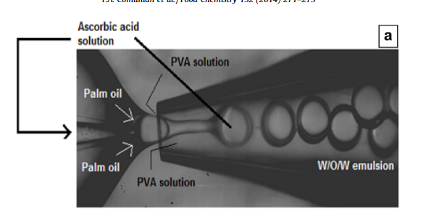 | (Comunian et al., 2014)
W/O/W- Microcapsule | Outer phase: aqueous solution and PVA  Inner phase: aqueous mesoporous silica nanoparticles (MSN) + Rhodamine B (RB) solution | Middle phase: PLGA oil | Q_{i}= 1 mL/h.  Q_{m}= 2 mL/h.  Q_{o}= 4 mL/h | Mesopouros silica nanoparticles (MSN; 40% w/v) + Rhodamine B (RB; 10-500 mg/L) | Size= 119 nm (MSN) and 56 µm (PLGA-MSN)  DI= 4.91%  EE around 88% for PLGA-MSN and 95% for PLGA  CR around 96% after 120 days for PLGA-MSN and  97% after 120 days for PLGA | Polymethyl methacrylate (PMMA) microfluidic device  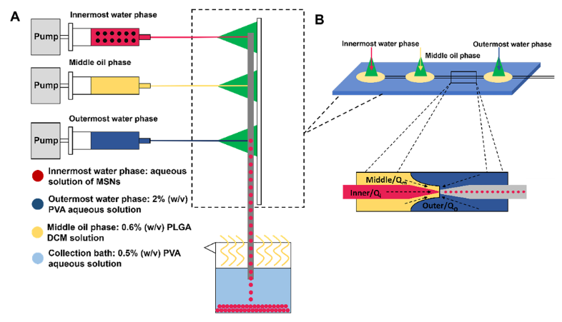 | (Zhou et al., 2021)
 | Outer phase:  Poly (vinyl alcohol) (PVA) aqueous solution (2 wt%)  Inner phase: Poly (vinyl alcohol) (PVA) aqueous solution | Middle phase: PLGA (0.6 wt%) in dichloromethane) | Q_{i}= 1000 μL/min Q_{m}= 2000 μL/min  Q_{o}= 4000 μL/h | 2-[[(4-phenoxyphenyl)sulfonyl]methyl]-thiirane (SB-3CT; 0.5 mg/mL) | Size= 35-65 µm  DI= 3%  EE= 99% | Glass microfluidic device  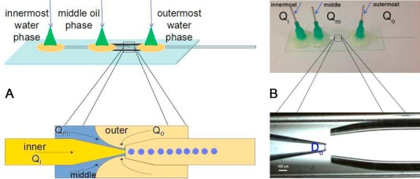 | (H. Chen et al., 2018a)
 | Middle phase: poly (N-isopropyl acry-  lamide) (PNIPAM) | Inner phase: soybean  oil solution added with camptothecin (0.4 mg/mL)  Outer phase: soybean oil and PGPR | Q_{o}= 1600-2400 µL/min  Q_{m}= 130-210 µL/min  Q_{i}= 20-100 µL/min | Doxorubicin hydrochloride and camptothecin (2 mg/mL) | Size= 600-1000 µm  DI= not specified  EE= not specified  CR= burst process | Glass microfluidic device | (Z. Chen et al., 2022)
*Q_{c}: continuous phase flow rate; Q_{d}: disperse phase flow rate; Q_{i}: inner phase flow rate; Q_{m}: middle phase flow rate; Q_{o}: outer phase flow rate; J_{d}: disperse phase flux; P_{d}: disperse phase pressure; P_{c}: continuous phase pressure; Tween 20: polyoxyethylene (20) sorbitan monolaurate; EDTA-Ca: ethylenediaminetetraacetic acid calcium disodium salt hydrate; PGPR: polirricinoleato de poliglicerol; CaCl₂: calcium chloride; CaCO₃: calcium carbonate; PLGA: poly-lactic-co-glycolic acid; DI: dispersity index; EE: encapsulation efficiency; CR: compound release.

Table S3. Trends in droplet-based microfluidics approaches for fabricating delivery systems based on emulsions.
Emulsion type | Continuous phase | Disperse phase | Surfactant | Microfluidic device type | Process conditions | Microfluidic device design | Reference
O/W emulsion | Aqueous surfactant solution | Palm oil | Span 20 | Combination of ultrasound and silicon/epoxy microchannel | Q_{d} and Q_{c}= 4 mL/min | 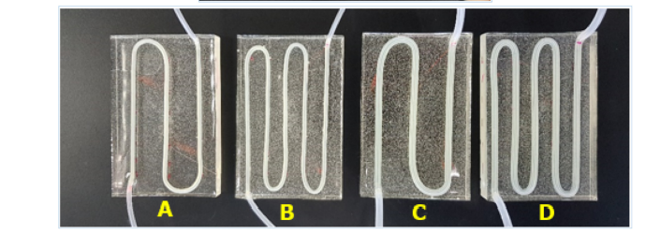 | (Manickam et al., 2020)
 | Xanthan gum or poloxamer in water | Sunflower oil | Tween 80 or Precirol™ | Microsystem at High Throughput (MHT) | Q_{d}= 20.8-95.2 mL/min Q_{c}= 500 mL/min. | 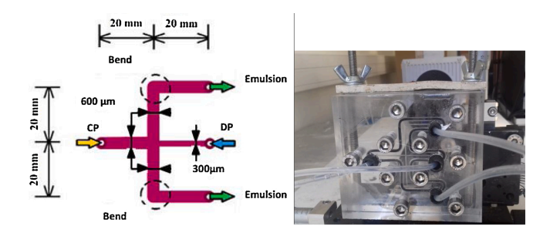 | (Nehme et al., 2021)
 | Argan by-products extract | Soybean oil | Tween 80 | Silicon | Q_{d}= 2 mL/h | 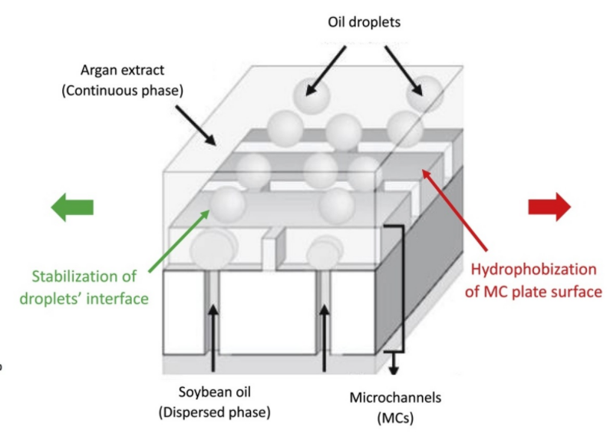 | (Taarji et al., 2020)
 | Mineral oil and glutaraldehyde (5 %wt) | Chitosan (2 %wt) in hydrochloric acid (1 %wt) | Span 80 (3 %wt) | PDMS microfluidic device | Q_{d} and Q_{c} = 100 to 500 µL/h | 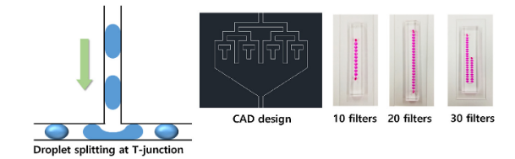  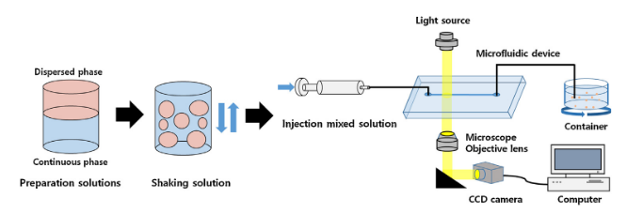 | (C. M. Kim et al., 2020)
 | Silicon oil and surfactant | Deionized water | Span 80 (1% w/v) | Photosensitive resin Gr |  | 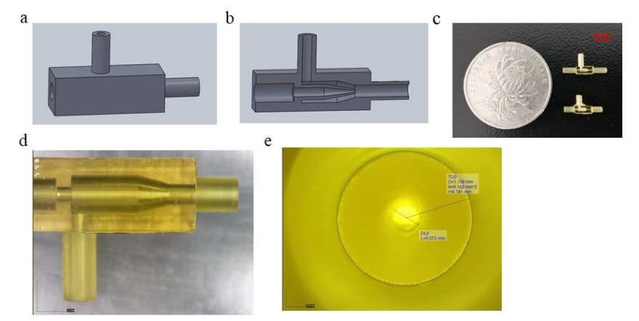 | (J. Zhang, Xu, et al., 2021)
 | Water and PEG 2000 | Sunflower oil | Tween 20 | Glass microfluidic device | Q_{d} and Q_{c}= 20 to 280 µL/min | - | (Jurinjak Tušek et al., 2022)
W/O emulsion | Sunflower oil and surfactant | Whey protein isolated (WPI) | PGPR | Glass microfluidic device | Pressure ranged from 0-200 mbar for both phases | 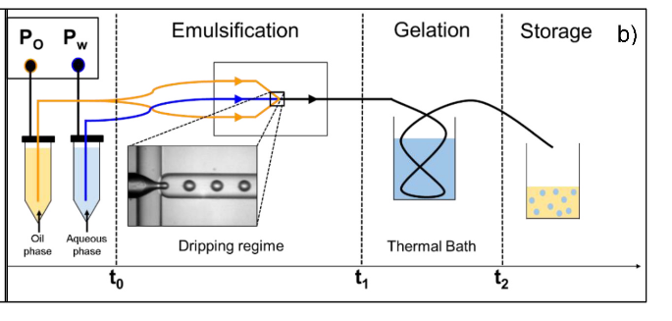 | (Lacroix et al., 2022)
 | Fluorocarbon oil (HFE 7500) and surfactant | PPGDA:Dextran  (20% w/w) Dextran and PPGDA:PPGA (1:3 in 300 µL of ethanol) | Fluorosurfactant 008 (2% w/w) | PDMS microfluidic device | Q_{d}= 60 µL/h for PPGDA and 30 µL/h for dextran | 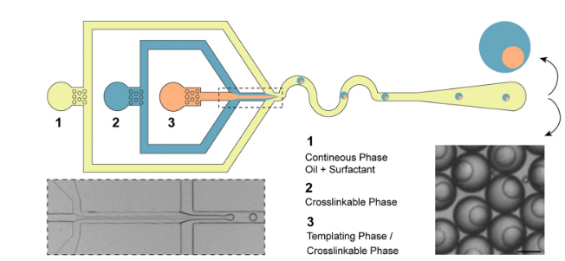 | (Keller et al., 2021)
 | Deionized water and surfactant | Mixture of mineral oil and heptane (50:50). | PVA (2% w/w). | Photosensitive resin Gr | Q_{d} and Q_{c}= 100 to 500 µL/h |  | (J. Zhang, Xu, et al., 2021)
W/O/W emulsion | Outer phase: glycerol (5% w/v) | Inner phase: glycerol (50% w/v) in water  Middle phase: middle chain triglyceride (MCT) | PGPR in MCT | Glass microfluidic device | Q_{i}= 1-5 mL/h  Q_{m}= 4-14 mL/h  Q_{o}= 50-400 mL/h | 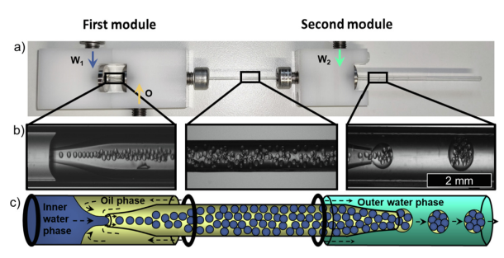 | (Leister et al., 2022)
 | Outer phase: glycerol (25% w/w) in distilled water | Inner phase: Na-alginate (1.5 %wt)  Middle phase: silicon oil | Span 80 (0.25% w/w) in middle phase.  PVA (5% w/w) in outer phase | PDMS microfluidic device | Q_{i} = 50 µL/h.  Q_{m}= 500 µL/h  Q_{o}=: 20000 - 100000 µL/h |  | (Sattari et al., 2021)
 | Outer phase: aqueous surfactant solution | Middle phase: phenylmethyl silicone oil and silicone resin RSN-0749  Inner phase: glycerol, PVA, and water | PVA (5 wt%) in outer and inner phases. | Glass microfluidic device | Q_{i}= 150 mL/h  Q_{m}= 150-1750 mL/h  Q_{o}= 1 mL/h | 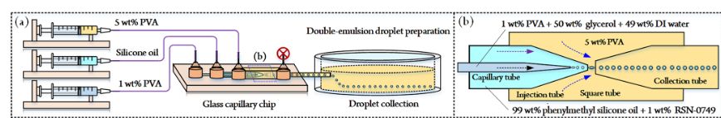 | (K. Zhang et al., 2022)
 | Outer phase: glycerol (40 wt%) and surfactant | Inner phase: glycerol (5 %wt) and surfactant  Middle phase: XIA-METERÒ RSN-0749 resin in Dow Corning ® 200 fluid (2 wt%) | Hydrophilic: PVA  Lipophilic: XIAMETER® RSN-074 | Glass microfluidic device |  | 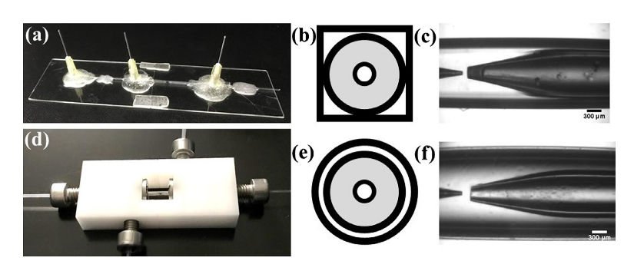 | (Bandulasena et al., 2019)
O/W/O emulsion | Outer phase 1 and 2: oil solution containing PGPR (4% w/v) | Inner phase: poly(ethylene glycol) diacrylate (PEGDA; 50 %wt), 2-Hydroxy-methylpropiophenone (HMPP; 5 %wt), and surfactant | Pluronic ® F 127 | Glass microfluidic device | Q_{i}= 100-900 µL/h  Q_{o1}= 300 and 200 µL/h  Q_{o2}= 500-800 µL/h | 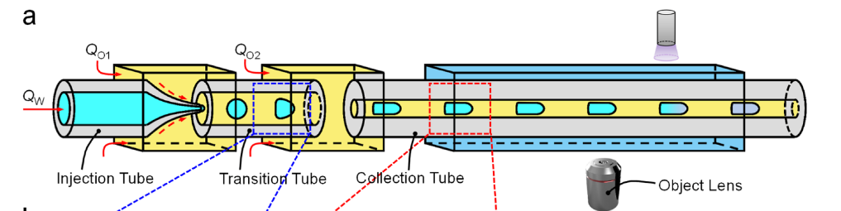 | (Cai et al., 2019)
 | Outer phase: dimethicone | Inner phase: silicone oil.  Middle phase: surfactant | PVA (2 % w/w) in the middle phase | Photosensitive resin Gr and HIT | Q_{i}= Q_{m}= 2 mL/h  Q_{c}= 5 mL/h | 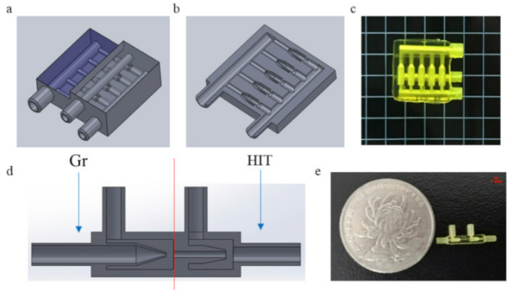 | (J. Zhang, Xu, et al., 2021)
 | Outer phase: sunflower oil and glacial acetic acid (0.1% w/w) | O/W emulsion prepared by ultrasound: Na-alginate (1% (w/w)) and CaCO₃ (0.1825 g/g of Na-alginate), cellulose nanocrystal and sunflower oil | PGPR (4 wt%) | Glass microfluidic device | Q_{c}= 3000 - 15000 µL/h.  Q_{d}= 600-3000 µL/h | 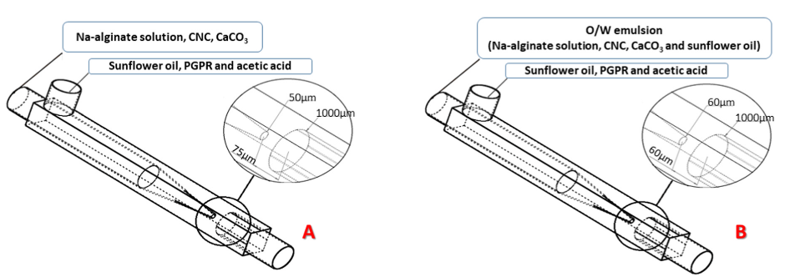 | (Dias Meirelles et al., 2022)
 | Outer phase: silicone oil | Inner phase: silicone oil.  Middle phase: glycerol (25% (w/w)) | Span 80 (0.25% w/w) in the inner phase.  PVA (10 % w/w) and in the middle phase.  Span 80 (2.5% w/w) in the outer phase | PDMS microfluidic device | Q_{i}= 50 µL/h.  Q_{m}= 500 µL/h  Q_{o}= 20,000 - 100,000 µL/h | 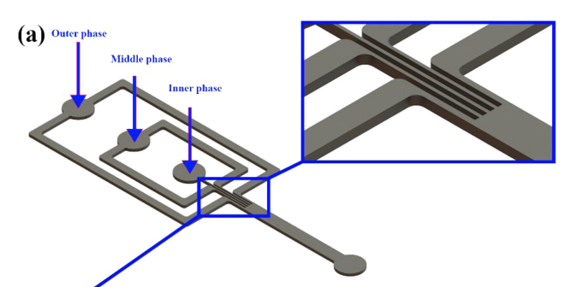 | (Sattari et al., 2021)
 | Outer phase: orange oil | Inner phase: middle chain triglyceride (MCT).  Middle phase: PVA (1% w/v) in water | PVA in water and PGPR in MCT | Glass microfluidic device | Q_{o}=50-400 mL/h  Q_{m}= 4-14 mL/h  Q_{i}=1-5 mL/h |  | (Leister et al., 2022)
* PVA: polyvinyl alcohol; PGPR: polyglycerol polyricinoleate; Span 20: sorbitan monooleate; PDMS: polydimethylsiloxane.

