Supplementary Table 1. List of internal standards used with their specifications

 | Mass [m/z] | Formula [M] | Species | Polarity | N(CE) | Fragments
Aflatoxin B1 | 313.07066 | C₁₇H₁₂O₆ | + H | Positive | 50 | 285.07578  270.05227
Aflatoxin B2 | 315.08631 | C₁₇H₁₄O₆ | + H | Positive | 40 | 287.0914  259.76015
Aflatoxin G1 | 329.06558 | C₁₇H₁₂O₇ | + H | Positive | 50 | 243.06527  283.06014
Aflatoxin G2 | 331.08123 | C₁₇H₁₄O₇ | + H | Positive | 50 | 313.07044  285.0757
Aflatoxin B1-¹³C17 | 330.12770 | [13]C₁₇H₁₂O₆ | + H | Positive | 50 | 301.12866  285.10166
Aflatoxin B2-¹³C17 | 332.14335 | [13]C₁₇H₁₄O₆ | + H | Positive | 50 | 303.14429  273.10633
Aflatoxin G1-¹³C17 | 346.12261 | [13]C₁₇H₁₂O₇ | + H | Positive | 50 | 257.11147  299.11293
Aflatoxin G2-¹³C17 | 348.13826 | [13]C₁₇H₁₄O₇ | + H | Positive | 50 | 330.12726  301.12883
Ochratoxin A | 404.08954 | C₂₀H₁₈CINO₆ | + H | Positive | 30 | 257.02083  239.01029
Ochratoxin A-¹³C20 | 424.15664 | [13]C₂₀H₁₈ClNO₆ | + H | Positive | 30 | 250.04697  268.05869

Supplementary Table 2. Average Ochratoxin A content of table olive cultivars belonging to the four shipping groups (µg/kg), ± SD (standard deviation), n = 4 (Means followed by the same letter do not differ signif-icantly at p ≤ 0.05 according to Tukey’s test.).

Cultivars | Mean
Bella di Cerignola | 2.52±1.33^{b}
Conservolea Nera | 1.94±0.61^{b}
GR2177 | NaN
Hojiblanca Nera | 2.60±1.12^{b}
Itrana Bianca | 2.89±0.41^{b}
Nocellara Etnea | 3.47±1.64ª
Nocellara del Belice | 2.12±0.72^{b}

Supplementary Table 3. Average Ochratoxin A content in processing methods of table olives belonging to the four ship-ping groups (µg/kg), ± SD (standard deviation), n = 4 (Means followed by the same letter do not differ significantly at p ≤ 0.05 according to Tukey’s test.).

Methods | Mean
Pitted | 2.10±0.58^{b}
Castelvetrano | 2.12±0.72^{b}
Californiano I° drying | 1.94±0.61^{b}
Californiano pitted | 3.10±1.31^{ab}
Natural | 3.30±1.42ª
Sivigliano | 2.52±1.33^{b}

Supplementary Table 4. Average Ochratoxin A content using the two kits (Veratox® and Agraquant®) on the four shipping groups (µg/kg), ± SD (standard deviation), n = 4 (Means followed by the same letter do not differ significantly at p ≤ 0.05 according to Tukey’s test.).

Kit | Mean
Veratox® | 2.32±0.81^{b}
Agraquant® | 2.91±1.56ª

Supplementary Table 5. Average Aflatoxins content of table olive cultivars belonging to the four shipping groups (µg/kg), ± SD (standard deviation), n = 4 (Means followed by the same letter do not differ significantly at p ≤ 0.05 according to Tukey’s test.).

Cultivars | Mean
Bella di Cerignola | 3.01±0.95^{ab}
Conservolea Nera | 3.09±0.29^{ab}
GR2177 | NaN
Hojiblanca Nera | 3.61±0.54ª
Itrana Bianca | 3.77±0.38ª
Nocellara Etnea | 2.77±0.57^{b}
Nocellara del Belice | 3.02±0.61^{ab}

Supplementary Table 6. Average Aflatoxins content in processing methods of table olives belonging to the four shipping groups (µg/kg), ± SD (standard deviation), n = 4 (Means followed by the same letter do not differ significantly at p ≤ 0.05 according to Tukey’s test.).

Methods | Mean
Pitted | NaN
Castelvetrano | 3.02±0.61^{b}
Californiano I° drying | 3.09±0.29^{b}
Californiano pitted | 3.61±0.54ª
Natural | 2.99±0.68^{b}
Sivigliano | 3.01±0.95^{b}

Supplementary Table 7. Average Aflatoxins content using the two kits (Veratox® and Agraquant®) on the four shipping groups (µg/kg), ± SD (standard deviation), n = 4 (Means followed by the same letter do not differ significantly at p ≤ 0.05 according to Tukey’s test.).

Kit | Mean
Veratox® | 3.20±1.42ª
Agraquant® | 3.07±0.59ª

Supplementary Figure 1. Aflatoxins concentration in Bella di Cerignola cultivar for both years.

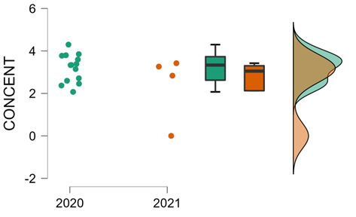

Supplementary Figure 2. Aflatoxins concentration in Nocellara del Belice cultivar for both years.

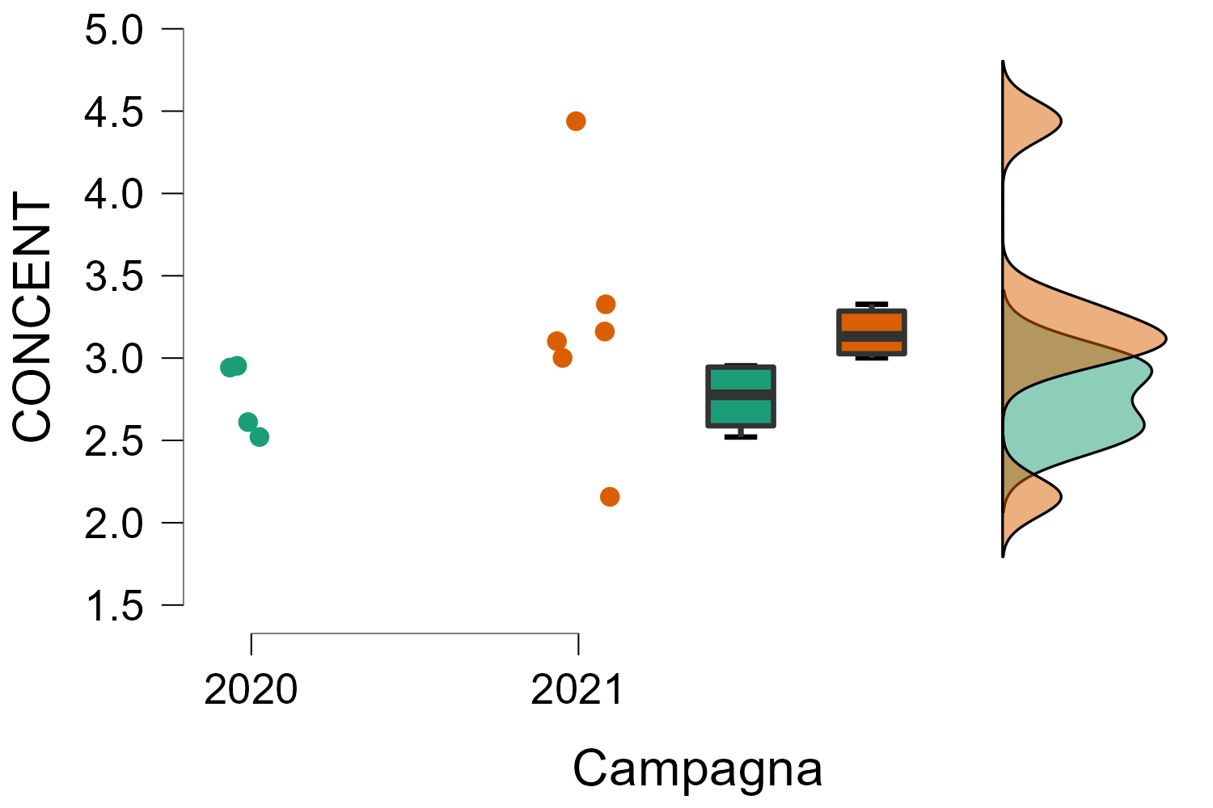

Supplementary Figure 3. Ochratoxin A concentration in Bella di Cerignola cultivar for both years.
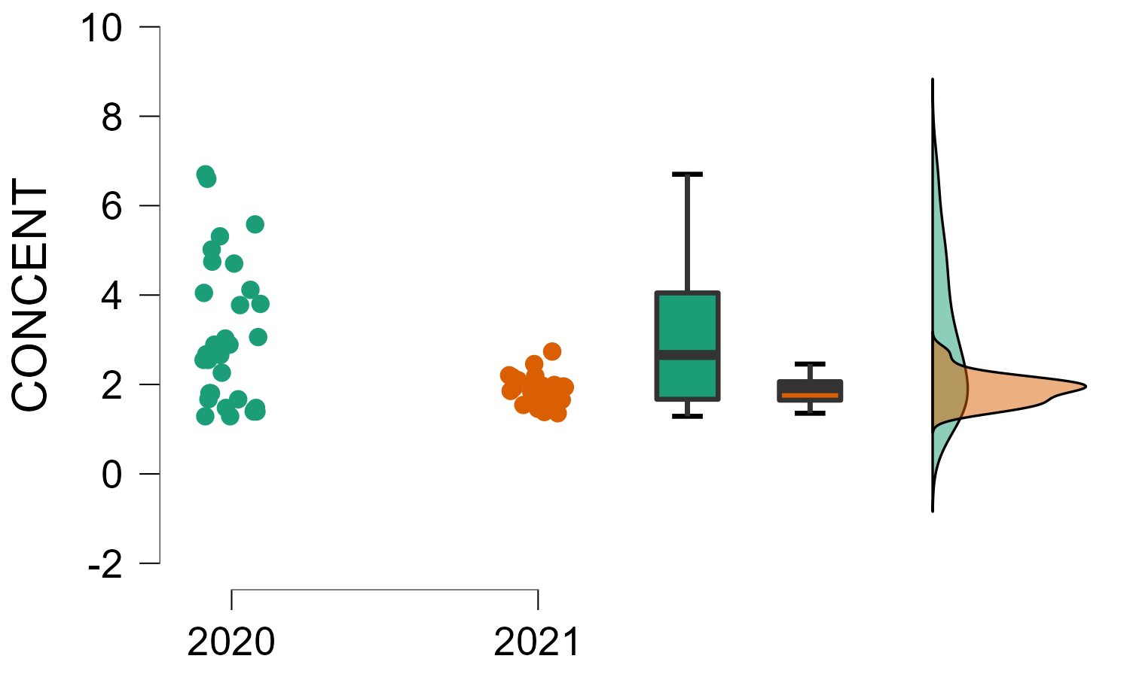

Supplementary Figure 4. Ochratoxin A concentration in Nocellara del Belice cultivar for both years.

