Supplementary Tables
Table S1: Quality target product profile (QTPP) postulated for SNEDDS of Bedaquiline
QTPP elements | Target | Justification
Dosage form | SNEDDS | Selection of lipid-based solid self-nano emulsifying system helps in the oral bioavailability enhancement of poorly bioavailable drug, Bedaquiline.
Dosage type | Sustain release | Faster onset of action leading to enhanced therapeutic benefits.
Dosage strength | 5 mg | Unit dose of Bedaquiline incorporated in a single formulation of SNEDDS
Route of administration | Oral | Recommended route for delivery of Bedaquiline
Stability | 6 months of Accelerated and long-term stability studies | To maintain therapeutic potential of the drug during storage period
Container closure system | Airtight glass bottles | To protect against the degradation of the drug and lipids in the presence of atmospheric air.
Alternative methods of administration | Salt, polymorphs, solid dispersions, nano crystals, co-crystals, inclusion complexes | These systems can only improve the dissolution rate (but not the extent) of which may eventually lead only to enhancement in rate of oral adsorption.
Contraindications | None | None
Abbreviations: QTPP, quality target product profile; SNEDDS, self-nano emulsifying drug delivery system

Table S2: Critical quality attributes (CQAs) for SNEDDS of Bedaquiline and their justifications.
CQAs | Target | Is this a CQA | Justification
Physical attributes  colour | Acceptable to patient | No | Color, odor and appearance were not considered as critical, as these are not directly linked to patient efficacy and safety.
Odour and appearance | Acceptable to patient | No
Assay and content uniformity | 100% | No | SNEDDS being the homogenous dispersions containing drug solubilized in the blend of lipidic excipients, these variables were regarded as less critical.
Drug release | 100% | Yes | Drug release rate is important for fast absorption of the drug in blood; hence was regarded as highly critical.
Liquefaction time | Low | yes* | Lower value of liquefaction time is important for faster drug release from the dosage form. Thus, it was considered as critical.
Emulsification time | Low | yes* | Lower values of emulsification time help in ease of formation of nanoemulsion; hence was taken up as highly critical.
Globule size | <100nm | yes* | Smaller droplet size allows easy penetration through GI epithelial lining and paracellular pathways; hence was regarded as highly critical.
Mean dissolution time | Low | yes* | It is an indicator of faster and complete drug release solubilization of drug in the dissolution medium, thus taken up as highly critical.
PDI | Low | yes* | Highly important for achieving the therapeutically effectiveness he hence considered as highly critical.
*CQAs considered as critical
Abbreviations: CQAs, critical quality attributes; SNEDDS, self-nano emulsifying drug delivery system, PDI, polydispersity index

Table S3: Protocol of stability study
Name of Product: BDQ-F-SNEDDS |  |  | Purpose of Study : New Formulation
Batch Size : 100 ml |  |  | Batch No. : BDSND22
Sr. No. | Storage Condition | Storage  Period | Testing Frequency (Monthly) | Tests
1. | 40 ± 2 ºC & 75 ± 5 % | 6 Months | 0  3  6 | Following test to be performed at all stations of both Accelerated and Long Term Studies.  Physical Appearance  Phase Separation  Caking  Size (nm)  PDI %  Entrapment Efficiency
2. | 25 ± 2 ºC & 60 ± 5 % | Upto Shelf Life | 0  3  6  9  12  18  24
Abbreviations: BDQ-F-SNEDDS, Bedaquiline-fumarate-self-nano emulsifying drug delivery system, PDI, polydispersity index

Table S4: Responses to selected factors

Run | Factor 1  A: Oil  (%) | Factor 2  B: S_{mix}  (%) | Factor 3  C: Sonication time (sec) | Response 1  droplet size  (nm) | Response 2 PDI | Response 3  Transmittance  (%)
1 | 30 | 50 | 30 | 125.9 | 0.21 | 93.6
2 | 10 | 50 | 60 | 94.3 | 0.168 | 98.5
3 | 20 | 60 | 60 | 95.2 | 0.237 | 97.8
4 | 20 | 50 | 45 | 89.8 | 0.21 | 96.9
5 | 20 | 60 | 30 | 83.1 | 0.19 | 97.2
6 | 10 | 50 | 30 | 86.7 | 0.176 | 97.8
7 | 10 | 60 | 45 | 78.4 | 0.16 | 98.9
8 | 30 | 60 | 45 | 119.1 | 0.236 | 94.4
9 | 10 | 40 | 45 | 90.25 | 0.11 | 97.3
10 | 20 | 40 | 30 | 97.5 | 0.153 | 95.6
11 | 30 | 40 | 45 | 130.5 | 0.325 | 93.1
12 | 30 | 50 | 60 | 135.7 | 0.449 | 93.9
13 | 20 | 40 | 60 | 105.6 | 0.331 | 96.4
14 | 20 | 50 | 45 | 88.5 | 0.2 | 96.8
Abbreviations: PDI, polydispersity index

Supplementary Figures
Figure S1: Ishikawa fishbone diagram illustrating a cause-and-effect relationship among the formulation and process variables for the formulation of SNEDDS.

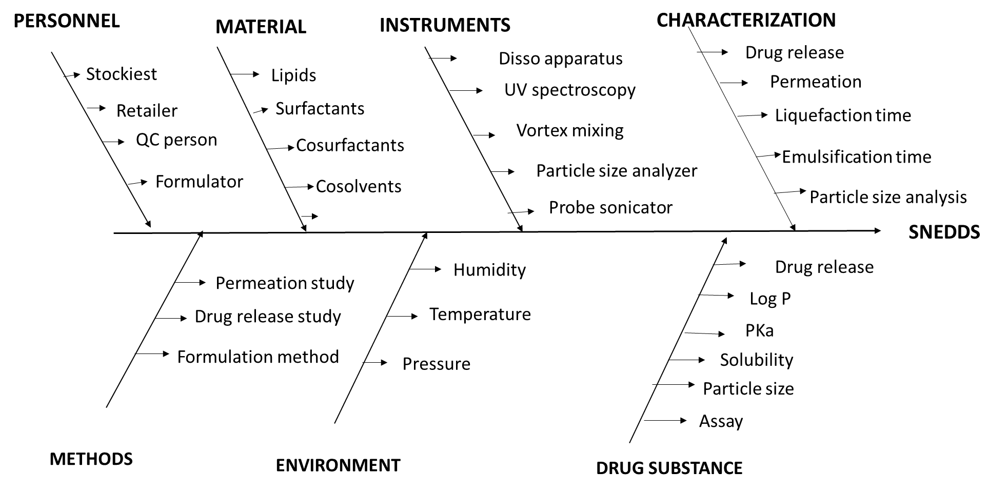

Figure S2: Pseudoternary phase diagram showing different ratios of S_{mix} 1:0, 1:1, 1:2, 2:1, 3:1, 4:1, 5:1
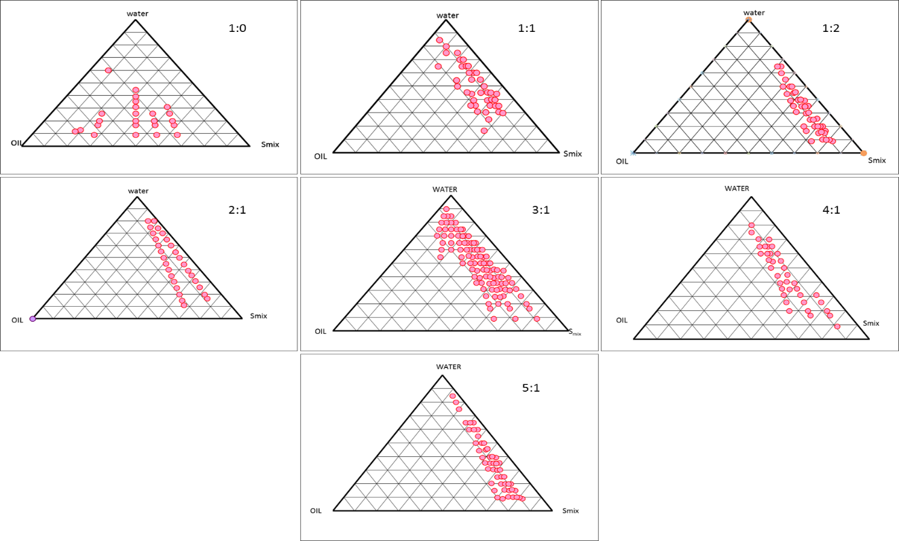

Figure S3: Linear correlation plot between observed and predicted values of droplet size, PDI and Transmittance and their corresponding residual plots.
