NOSE scale:

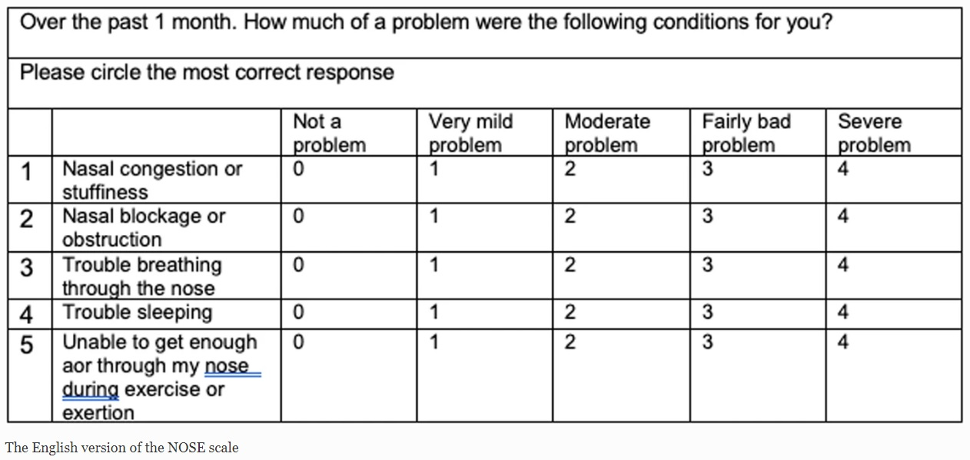

Velocity contours of NSD and normal nasal cavity:

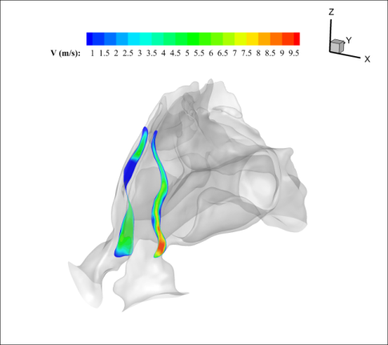
Velocity contours of nasal cavity with NSD (24 mm from nasal tip)

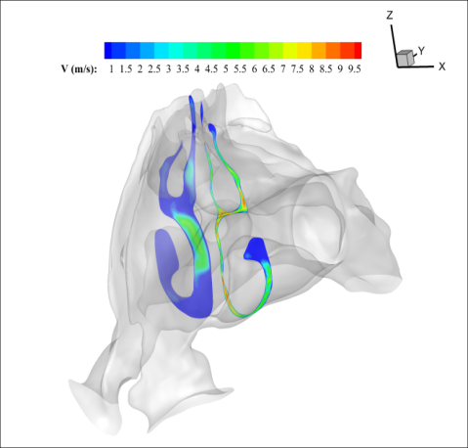
Velocity contours of nasal cavity with NSD (40 mm from nasal tip)

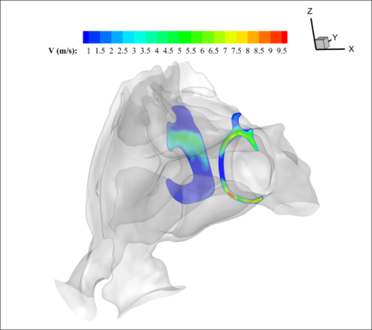
Velocity contours of nasal cavity with NSD (72 mm from nasal tip)
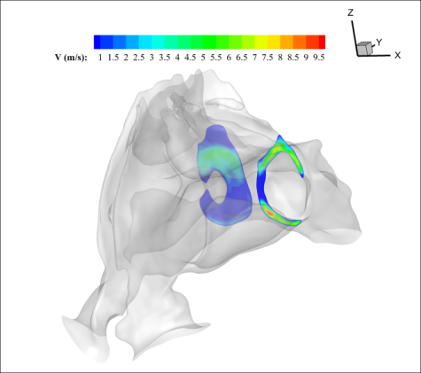
Velocity contours of nasal cavity with NSD (88 mm from nasal tip)
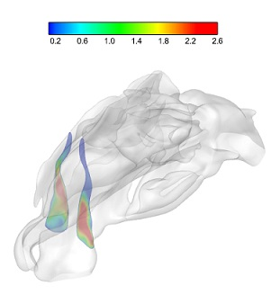
Velocity contours of normal nasal cavity (24 mm from nasal tip)

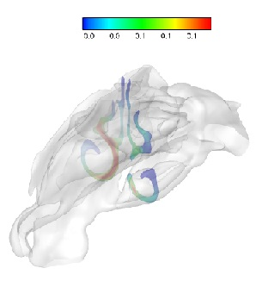
Velocity contours of normal nasal cavity (40 mm from nasal tip)
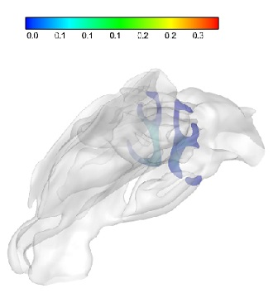
Velocity contours of normal nasal cavity (72 mm from nasal tip)

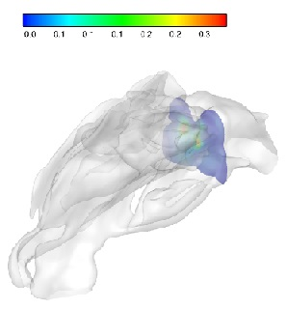
Velocity contours of normal nasal cavity (88 mm from nasal tip)

