Supplementary Material

Novel grafted hydrogel for Iron and ammonia removal from ground water, synthesis and computational chemistry study
H. M. Abd El-Salam ¹, Ali M El Shafey ¹, and Mahmoud K. Abdel-Latif ^{2,3 *}
1 Department of Chemistry, Faculty of Science, Polymer Research Laboratory, Beni-Suef University, 62514 Beni-Suef City, Egypt,
2 Chemistry Department, Collage of Science, United Arab Emirates University, Al-Ain, UAE
3 Chemistry Department, Faculty of Science, Beni-Suef University, Beni-Suef City, Egypt

* Corresponding author. E-mail address: mahmoudkorani@uaeu.ac.ae, m_kkhedr@yahoo.com
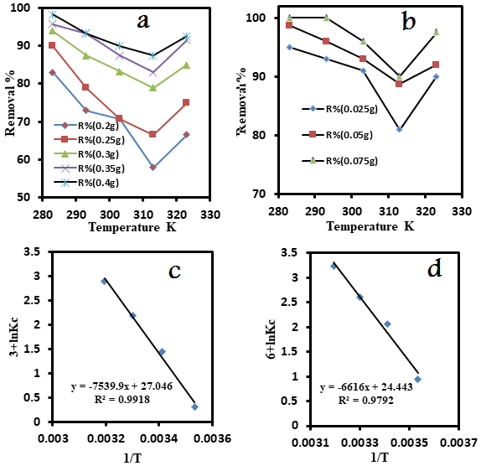
Figure S1: Effect Temperature on the removal iron(A) and ammonia(b) efficiency at different dose of grafted hydrogel. Van’t Hoff plot for the adsorption of iron (c) and ammonia (d) on grafted hydrogel
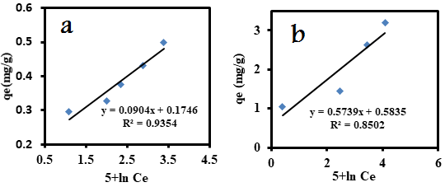
Figure S2: Temkin isotherm for iron (a) and ammonia (b) removal by grafted hydrogel
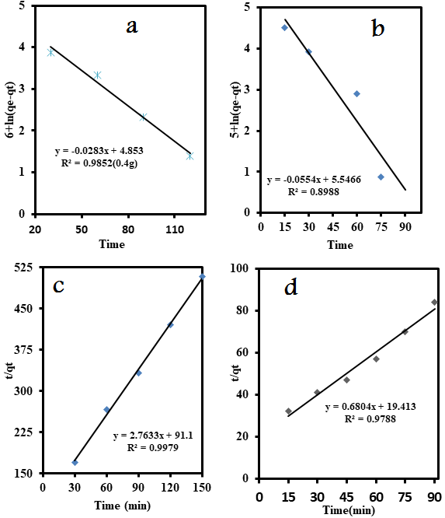
Figure S3: Pseudo-first-order kinetic model of iron (a) and ammonia (b) removal. Pseudo-second-order kinetic model of iron (c) and ammonia (d) removal.

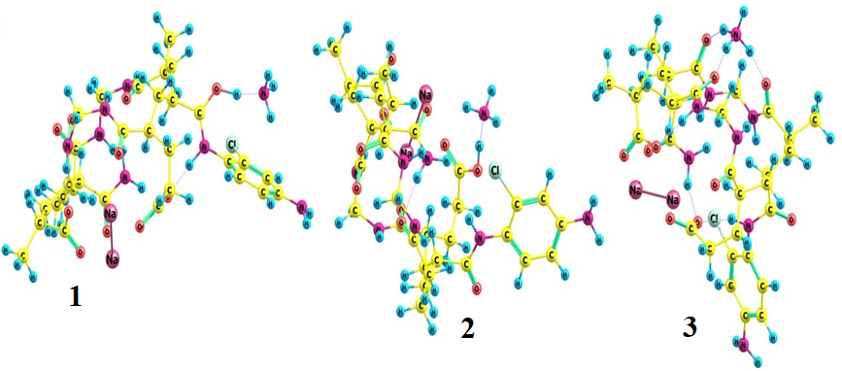

Figure S4: The optimized structure of complexed grafted hydrogel different positions with NH₄⁺ ion at B3LYP/6-311G(d,p) level of theory

Table S1: IR bands and their assignments for hydrogel and grafted hydrogel.

Wave number cm⁻¹ | Wave number cm⁻¹ | Assignments | Ref.
Hydrogel | Grafted hydrogel
612^{vw} | 608^{m} | Stretching vibration of substituted benzene ring | a*
777^{vw} | 783^{s}
1115^{w} | 1110^{w} | C-O and C-N stretching | b*
1176^{w} | 1180^{w} |  | c*
1334^{w} | 1330^{w} | CH₂ bending | d*
1449^{m} | 1447^{m}
- | 1590^{w} | C=O, C=C and/or adsorbed H₂O molecules and –COONa | e*
1656^{s} | 1657^{s}
- | 2069^{m} | Overtone and combination bands
2376^{w} | 2382^{w}
2516w | - | Aliphatic CH | f*
2859^{w} | -
2926^{m} | 2931^{s}
3422^{b} | 3410^{b} | Stretching vibration of OH and/or NH₂ free or bonded | g*
w=weak, b=broad, s=strong, m=medium

a*: (Abd El-Mageed, Abd El-Salam, Abdel- Latif, & Mustafa, 2018)
b*: (Monteiro & Neves, 2014)
c*: (Paiva, 2007)
d*: (Silverstein, Bassler, & Morill, 1974)
e*: (Reddy & Lee, 2007)
f*: (Asabe & Bashar, 2016)
g*: (Rojas & Carlos 2019)

Table S2: TGA data of the fabricated samples (hydrogel and grafted hydrogel).
TGA parameters for polymeric samples |  |  |  | Comments
Hydrogel |  | grafted hydrogel
Midpiont ⁰C | Approx. Wt. loss % | Midpiont ⁰C | Approx. Wt. loss %
73 | 4 | 95 | 2 | Moisture losing
140 | 12 | 116 | 8 | Bonded water loss
233 | 21 | 220 | 13
335 | 38 | 367 | 17 | Series of fragmentation of the polymer backbone depend on the bond strength between atoms
371 | 50 | - | -
403 | 52 | - | -
422 | 63 | 441 | 55
466 | 72 | 460 | 60
703 | 90 | 725 | 60 | Complete degradation with carbonic residue is about 10% for hydrogel but for graft the residue is about 40%.
- |  | 821 | 60
- |  | 918 | 60
- |  | 952 | 60

Table S3: Thermodynamic parameters
G (kJ mol⁻¹)∆ |  | Thermodynamic parameters
Removal of iron | Removal of ammonia
-6332.12 | -1076.26 | 283 | Temperature K
-3795.64 | -1051.82 | 293
-2042.85 | -1021.42 | 303
-280.085 | -912.508 | 313
-62.687 | -55.005 | ∆H (kJ mol⁻¹)
-244.9 | -203.219 | S (J mol⁻¹ K ⁻¹)∆

Table S4: Kinetic models parameters data.
Parameter value |  |  | Parameter | Model
Iron removal | Ammonia removal
0.0283 |  | 0.0554 | k₁(min⁻¹) | Pseudo-first order
128 |  | 254.6 | q_{e} (mg g⁻¹)
0.98 |  | 0.8988 | R²
7.71 |  | 0.023 | k₂(min⁻¹) | Pseudo-second order
0.295 |  | 1.06 | q_{e}(exp) (mg g⁻¹)
0.36 |  | 1.469 | qe(cal) (mg/g)
0.9979 |  | 0.9788 | R²

