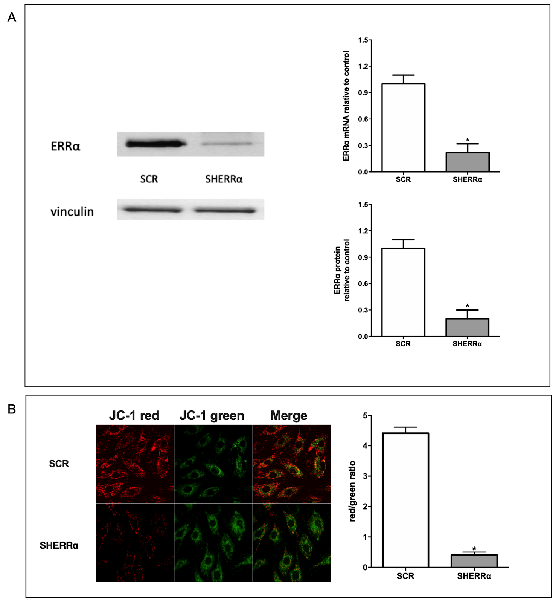
Figure S1. ERRα silencing reduces mitochondrial proton gradient in wild-type H9c2 cardiomyocytes. (A) Left panel, representative Western blots of ERRα protein in in wild-type H9c2 (untransfected for LANCL overexpression) silenced for ERRα, compared with control cells, transfected with the scrambled sequences (SCR); upper right panel, ERRα mRNA levels in SHERRα cells relative to SCR; lower right panel, densitometric quantitation of the ERRα protein in SHERRα cells relative to SCR. Values are normalized against vinculin, as housekeeping protein. **p<0.01 relative to SCR control cells by unpaired t-test. Data shown are the mean ± SD of 3 experiments per group, with each value calculated in triplicate. (B) SHERRα cells were loaded with the ∆Ψ-sensitive ratiometric fluorescent dye JC-1, a higher ΔΨ resulting in a higher red/green fluorescence ratio. Left panel, representative confocal microscopy images; right panel, red/green fluorescence ratio calculated in at least 3 microscopic fields (scale bar: 20µm) for each experiment. **p<0.01 relative to SCR cells by unpaired t-test.

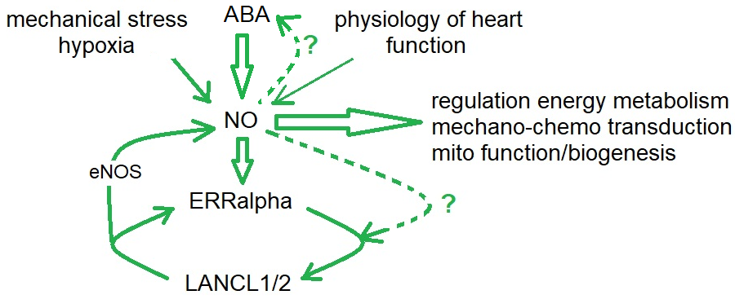
Figure S2. What triggers ERRα and LANCL1/2 activation in the “stressed” heart? Nitric oxide (NO), locally produced in the heart not only by cardiomyocytes but also by endothelial cells and erythrocytes, plays a central role in allowing adaptation of cardiomyocyte metabolism, contraction and electrical conduction to changing physiological conditions [54-56]. Here we observed that LANCL1/2 and ERRα are linked in a feed-forward mechanism of reciprocal transcriptional activation (Figure 5A). In addition, both ERRα [57] and LANCL1/2 [5] activate NO-generating eNOS. Here, we also show that NO is required for LANCL1/2-induced stimulation of ERRα transcription in H9c2 cells (Figure 5A). Finally, ABA release is stimulated by hypoxia in H9c2 and ABA in turn stimulates NO production and LANCL1/2-expression [5]. Does NO activate ABA release from H9c2 (dotted line)? Is NO necessary for ERRa-mediated LANCL1/2 transcriptional activation (dotted line)? These questions are still awaiting an answer. In any case, NO and ABA, via LANCL1/2 and ERRα mediate all transcriptional and functional responses of H9c2 described in this study.
Table S1. Primer sequences used to amplify rat target genes.
Rat genes | Accession N. | Forward Primer 5’-3’ | Reverse Primer 5’-3’
Hprt1 | NM_012583 | TTGGTCAAGCAGTACAGCCC | TGGCCTGTATCCAACACTTCG
Lancl1 | NM_053723 | TCTTGCTCCTCATCCTGCTCATC | CACTGTACTCGCCGAAGGTCTC
Lancl2 | NM_001014187 | GGTGCCACGGTGCTCCAG | CCTCGCTGCCAAATCACATCAC
Slc2a1 | NM_138827 | GACCCTGCACCTCATTGGT | CTCAGATAGGACATCCAGGGC
Slc2a4 | NM_012751 | CCAGCCTACCGCCACCATAG | TTCCAGCAGCAGCAGAGC
Pfk1 | NM_031715 | AGTTGGTATCTTCACGGGCG | CATAGACACGCTCTCCCACG
PK | M24359 | CCAAGAGAACGAGCTACCCC | TGGAGCCCCACTTAAAGCAG
Gapdh | AF106860 | ATGACTCTACCCACGGCAAG | CTGGAAGATGGTGATGGGTT
Pdha1 | NM_001004072 | GATGGAGCTAAAGGCGGATCA | TCCGTAGGGTTTATGCCAGC
Ucp3 | NM_013167 | CCCCCTACACTGTATGCTGA | TTCCAGGATCCCAGACGCA
Mt-nd1 | KJ530565 | CCACGCTTCCGTTACGATCA | GTATGGTGGTACTCCCGCTG
ANT1 | D12770 | TGGATGATTGCGCAGAGTGT | AATATCAGCCCCTTTCCGGC
Cpt1b | NM_013200 | TGTCTACCTCCGAAGCAGGA | TGAACGGCATTGCCTAGACG
Acads | NM_022512 | GAGAAGGAGTTGGTCCCCATT | CCGAGCTCACCCATCTTCTTA
Esrra | NM_001008511 | CCCTGACAGTCCAAAGGGTT | CATCCTCCTCCTCCTTGTGC
KCNK2 | AF385402 | CAGGTGGGTCGGACATTGAA | CCCGTAGCCAGTCTCCAATC
Cacna1c | NM_012517 | CTGCCCTATGTGGCCCTTTT | TCTGTGGTGTCATTCAGGGC
Scn1b | NM_001271045 | CTGCTGGCTCTCGTGGTG | CCATACACTGCCTCGGTCTC
Ccnd1 | NM_171992 | CTACCGCACAACGCACTTTC | CAGGCTTGACTCCAGAAGGG
Ccnd2 | NM_022267 | CCAAGATCACCCACACCGAT | TTGTGCTGCTCTTGACGGAA
Ccnd3 | NM_012766 | AACCACGCCCCTGACTATTG | CACTTGAGCTTCCCCAGGAC
Ccne1 | NM_001100821 | GACAAGACTGTGAAAAGCCAGG | GATGAAAGAGCAGGGGTCCA
Ccna2 | NM_053702 | CTCTTTACCCGGAGCCAGAAA | ACATTCACTGGCTTTTCGTCTT
Cdk2 | NM_199501 | GGCTGCATCTTTGCCGAAAT | CTGGCCAAACCACCTCATCT
cdk4 | L11007 | GTACAAAGCCCGAGATCCCC | ACCTCACGAACTGTGCTGAC
E2f4 | NM_001271345 | TTGAGCCCATCAAGGCAGAC | CGGAGCTCATGCACTCTCTT
Actc1 | NM_019183 | GAGCTGTCTTCCCGTCCATC | TTGCTCTGGGCTTCATCACC
Tubb2a | NM_001109119 | ACTTGCAGCTGGAGAGGATCA | CACTAGGATGGCCCGAGGTA
Ctnnb1 | NM_053357 | TACGAGCACATCAGGACACC | TGGAGAGCTCCAGTACACCC
Myh7 | NM_017240 | CAGCAGTTGGATGAGCGACT | GCTCATCCTCAATCCTGGCAT
Gja1 | NM_012567 | TTACAACAAGCAAGCCAGCG | GGGAGTTGGAGATGGTGCTT
Prkaa2 | NM_019142 | AGAAGCAGAAGCACGACGG | GAAGGTGCCGACGCCC
Ppargc1a | NM_031347 | GCACACATCGCAATTCTCCC | CTCTGCGGTATTCGTCCCTC
Sirt1 | NM_001372090 | CAGTGTCATGGTTCCTTTGC | CACCGAGGAACTACCTGAT
Nampt | NM_177928 | TCGGTTCTGGTGGAGGTTTGCTAC | TCCCTGCTGGCGTCCTATGTAAAG
Nos3 | NM_021838 | AGGCCTTGGTATTGGTGGTG | TAGGGGCCCGACATTTCCAT
Fgf21 | NM_130752 | CACACCGCAGTCCAGAAAGT | CCTAGAGGCTTTGACACCCA
Table S2. Primary and secondary antibodies used for Western blot.
Primary Antibody | Host | Concentrations | Manufacturer
Anti-LANCL1 | Rabbit | 1:250 | Novus Biologicals
Anti-LANCL2 | Mouse | 1:1000 | Reference [58]
Anti-ERRα | Mouse | 1:200 | Santa Cruz Biotechnology Inc., California
Anti-vinculin | Rabbit | 1:1000 | Cell Signaling Technology, Danvers, MA
Secondary Antibody | Concentrations |  | Manufacturer
Anti-Mouse | 1:2000 |  | Santa Cruz Biotechnology Inc., California
Anti-Rabbit | 1:1000 |  | Santa Cruz Biotechnology Inc., California

