Supplementary Materials
First-Principles Investigation of Size Effects on Cohesive Energies of Transition-Metal Nanoparticles
¹Department of Nano and Chemical Engineering, University of California San Diego, 9500
Gilman Drive, Mail Code 0448, La Jolla, California 92093-0448, United States
²Data Science Institute, Vanderbilt University, 2201 West End Ave, Nashville, Tennessee, 37325-0001, United States
Email: kesong@ucsd.edu, Phone: 858-534-2514
Table 1. List of Parameters 'a' and 'b' in the Natural Logarithmic Function for Fitting Cohesive Energies of Nanoparticles. .
Element | a | b
Sc | 0.72504841 | 2.20934348
Ti | 0.89810472 | 12.01789744
V | 1.16951657 | 1.02238005
Cr | 0.79397321 | 0.48902491
Mn | 0.61779602 | 1.1861684
Fe | 0.80001186 | 3.91109861
Co | 0.824159 | 4.70718674
Ni | 0.72964512 | 4.99065518
Cu | 0.55160499 | 4.20072647
Zn | 0.1913661 | 0.55464114
Y | 0.75614744 | 5.3667668
Zr | 1.00990119 | 4.09499696
Nb | 1.04150976 | 6.20878157
Mo | 1.35036784 | 0.96117769
Tc | 1.11531218 | 3.74701285
Ru | 1.01494177 | 4.02485467
Rh | 0.83450127 | 5.01848205
Pd | 0.58276816 | 3.03765054
Ag | 0.42541707 | 3.13586064
Cd | 0.11033387 | 0.67963352
La | 0.71446756 | 6.1480644
Hf | 1.21114911 | 6.83491705
Ta | 1.18925133 | 6.83612842
W | 1.17388636 | 5.396755
Re | 1.37633963 | 2.12208248
Os | 1.30260075 | 3.99292611
Ir | 1.02817762 | 7.76355096
Pt | 0.76148922 | 9.64927626
Au | 0.48851975 | 4.77290778
Hg | 0.02775863 | 1.30970181

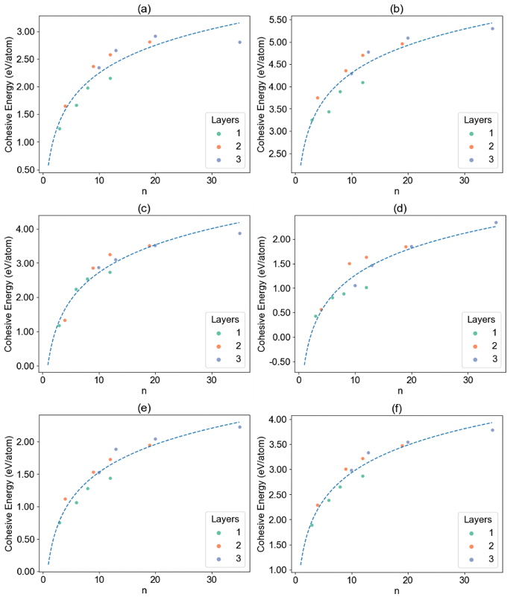
Figure 1. Calculated cohesive energy per atom as a function of the nanoparticle size (n) for transition-metal nanoparticles (X_{n}) in period 4 (a) X = Sc, (b) X = Ti, (c) X = V, (d) X = Cr, (e) X.= Mn, (f) X = Fe.
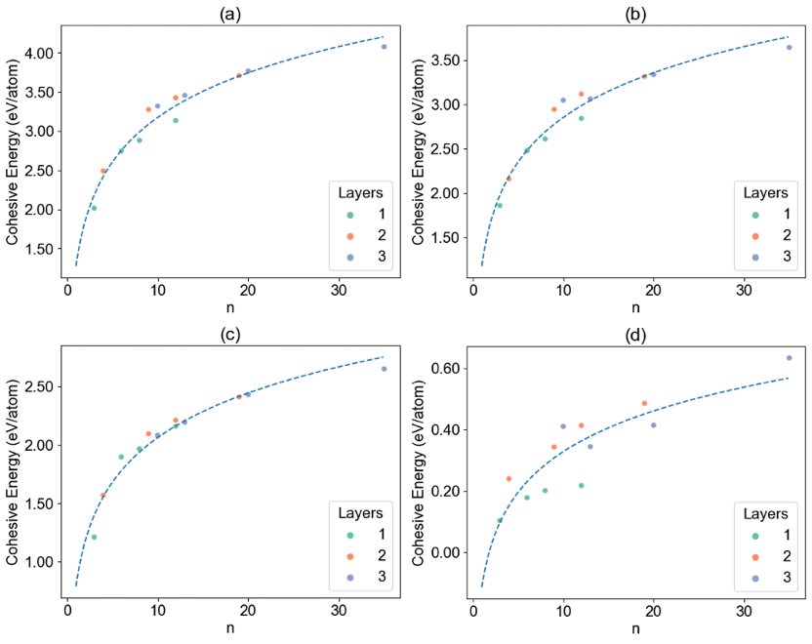
Figure 2. Calculated cohesive energy per atom as a function of the nanoparticle size (n) for transition-metal nanoparticles (X_{n}) in period 4 (a) X = Co, (b) X = Ni, (c) X = Cu, (d) X = Zn.
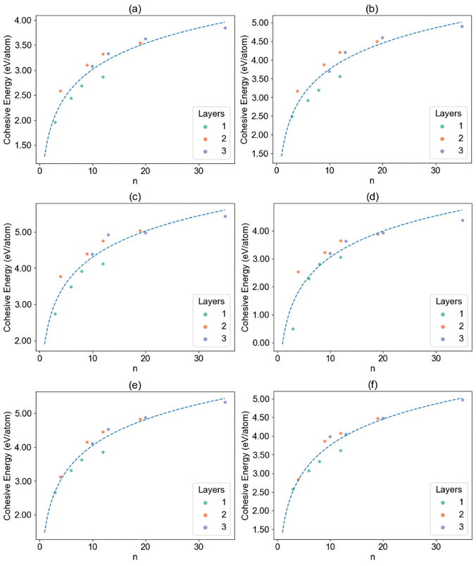
Figure 3. Calculated cohesive energy per atom as a function of the nanoparticle size (n) for transition-metal nanoparticles (X_{n}) in period 5 (a) X = Y, (b) X = Zr, (c) X = Nb, (d) X = Mo, (e).X = Tc, (f) X = Ru.
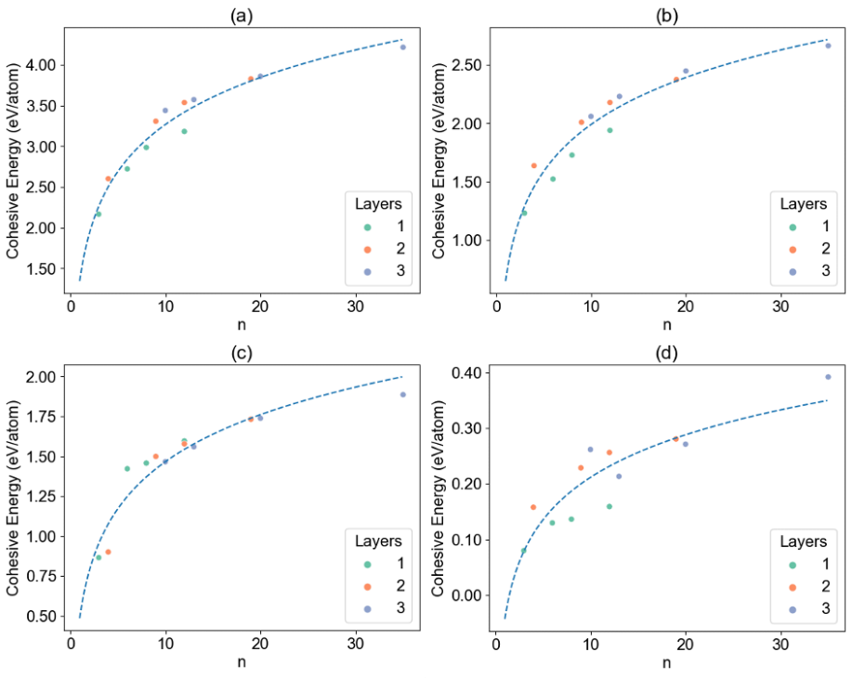
Figure 4. Calculated cohesive energy per atom as a function of the nanoparticle size (n) for transition-metal nanoparticles (X_{n}) in period 5 (a) X = Rh, (b) X = Pd, (c) X = Ag, (d) X = Cd.
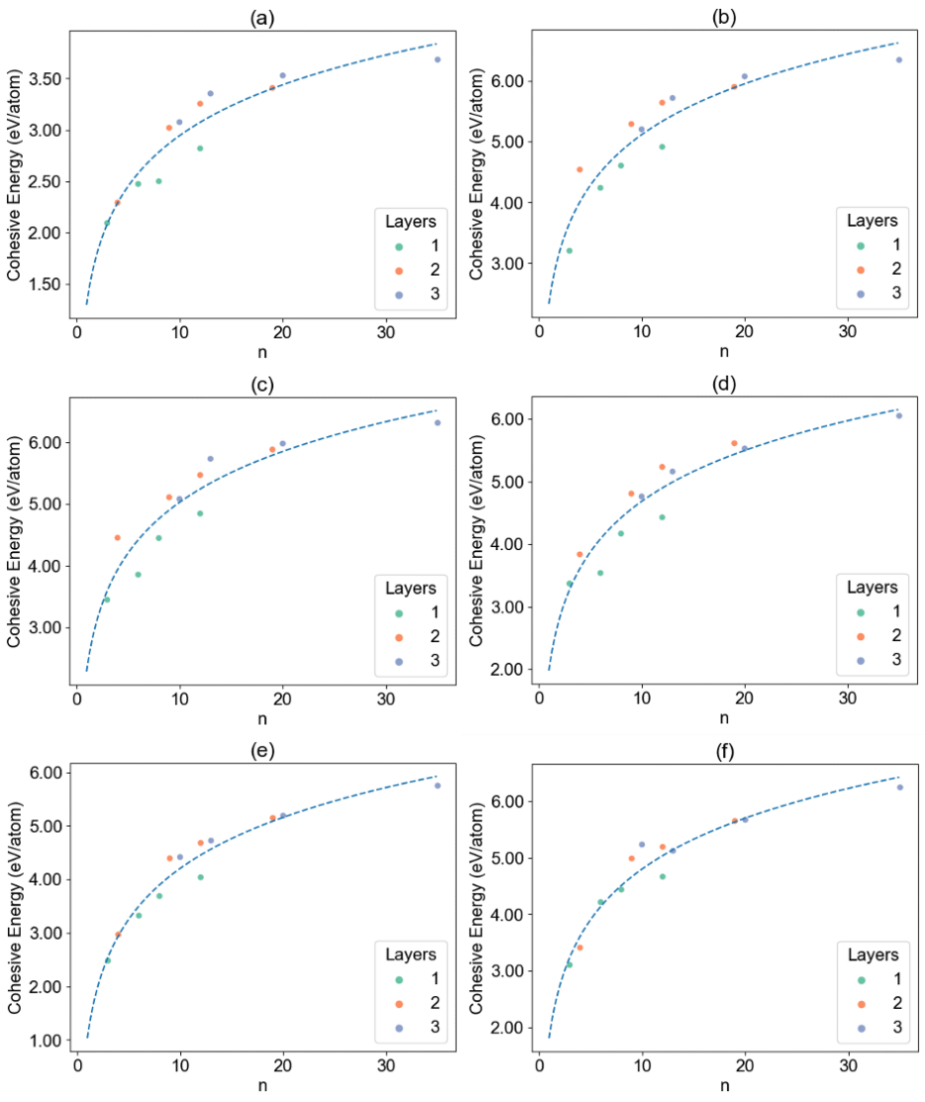
Figure 5. Calculated cohesive energy per atom as a function of the nanoparticle size (n) for transition-metal nanoparticles (X_{n}) in period 6 (a) X = La, (b) X = Hf, (c) X = Ta, (d) X = W, (e) X = Re, (f) X = Os.
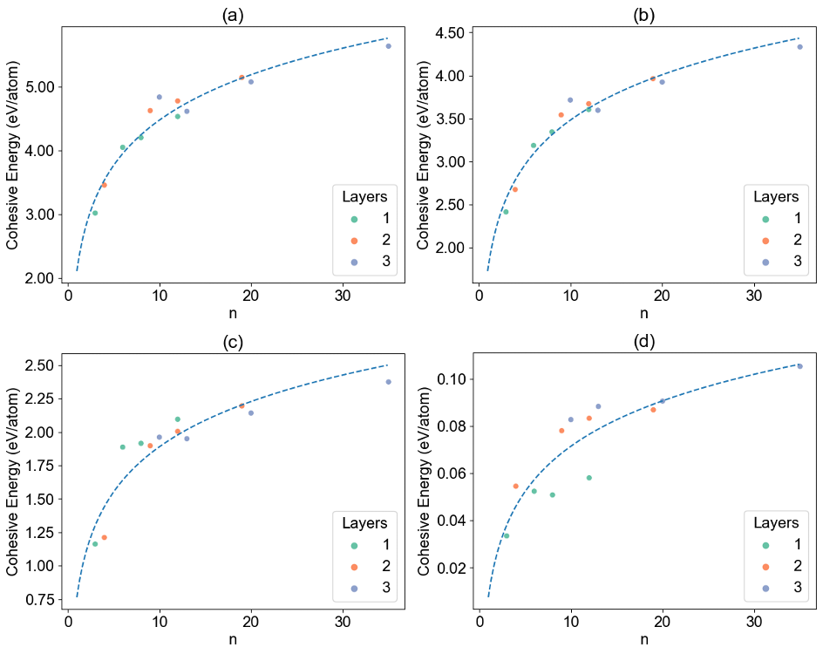
Figure 6. Calculated cohesive energy per atom as a function of the nanoparticle size (n) for transition-metal nanoparticles (X_{n}) in period 6 (a) X = Ir, (b) X = Pt, (c) X = Au, (d) X = Hg.
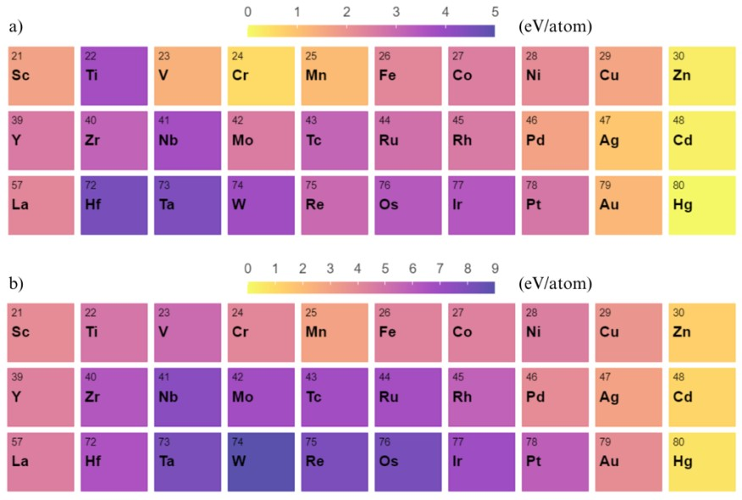
Figure 7. Heat map illustrating (a) the calculated cohesive energy (eV/atom) for transition-metal nanoparticles X₄ and (b) the experimental values of the transition-metal bulk structures.

