Supporting Information

Multipronged Approach to Profiling Metabolites in Beta Vulgaris Dried Pulp Extract Using Chromatography, NMR, and other Spectroscopy Methods
Joshua Fiadorwu¹, Kiran Subedi², Daniel Todd³, and Mufeed M. Basti^{1*}

Affiliation
¹ Department of Applied Science and Technology, College of Science and Technology, North Carolina Agricultural and Technical State University, Greensboro, NC, USA.
^{1*}Department of Chemistry, North Carolina Agricultural and Technical State University, Greensboro, NC, USA.
²Analytical Services Laboratory, College of Agriculture and Environmental Sciences (CAES), North Carolina Agricultural and Technical State University, Greensboro, NC, USA.
³ Triad Mass Spectrometry Facility, University of North Carolina at Greensboro, NC, USA.

Correspondence
Mufeed M. Basti
Professor
NC A&T State University
Department of Chemistry
Science Building
Greensboro, NC 27455
Ph. (336)285-2229
basti@ncat.edu

Contents
Figure S1. COSY spectrum showing the amino acid Leucine (D₂O-salt, 400 MHz).

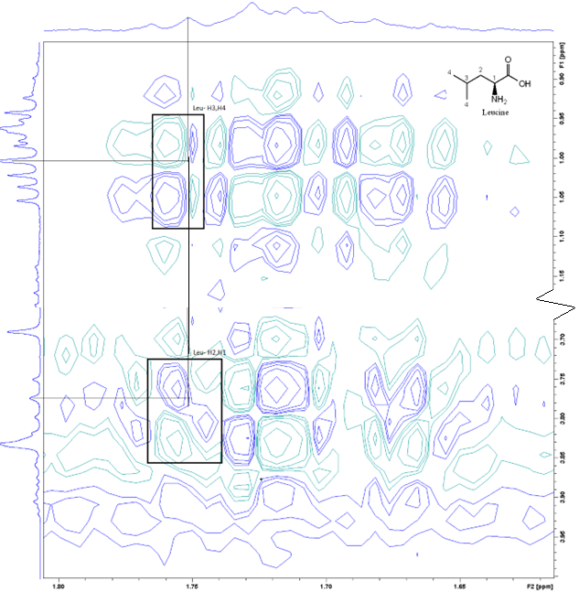
Figure S1. COSY spectrum showing the amino acid Leucine.

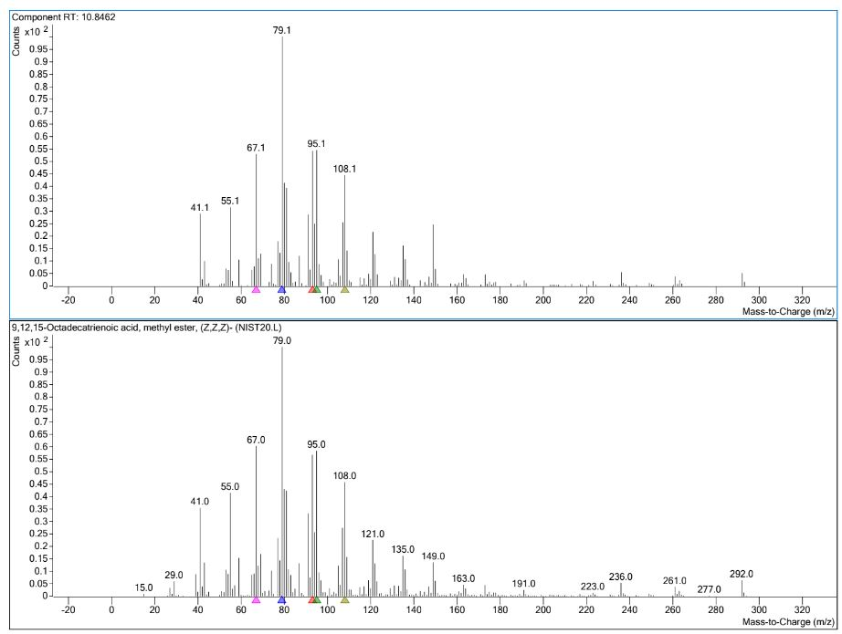
Figure S2. MS spectra of 9,12,15-Octadecatrienoic acid, methyl ester, (Z,Z,Z) (RT = 10.846 min.) experiment spectrum overlaid with the reference library spectrum.

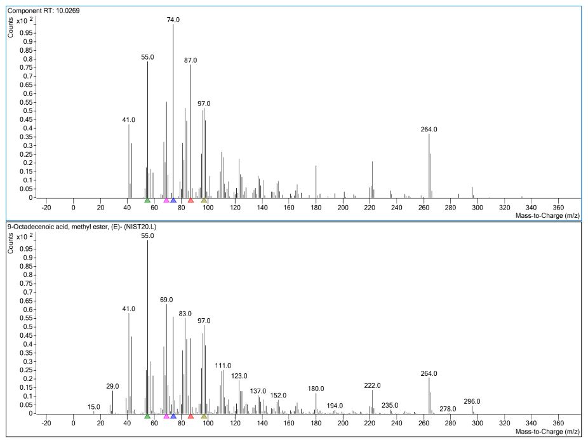
Figure S3. MS spectra of 9-Octadecenoic acid, methyl ester, (E) (RT = 10.027 min.) experiment spectrum overlaid with the reference library spectrum.

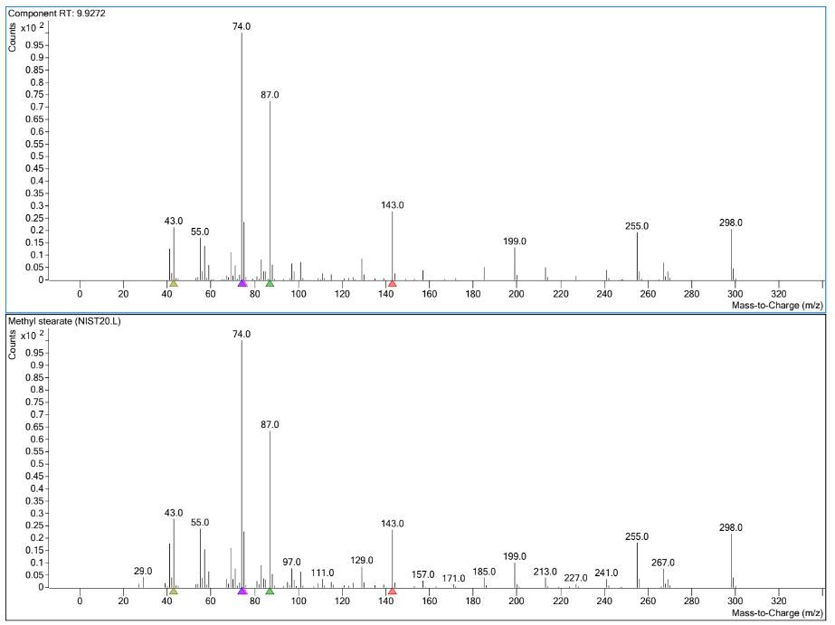
Figure S4. MS spectra of methyl stearate (RT = 9.927 min.) experiment spectrum overlaid with the reference library spectrum.

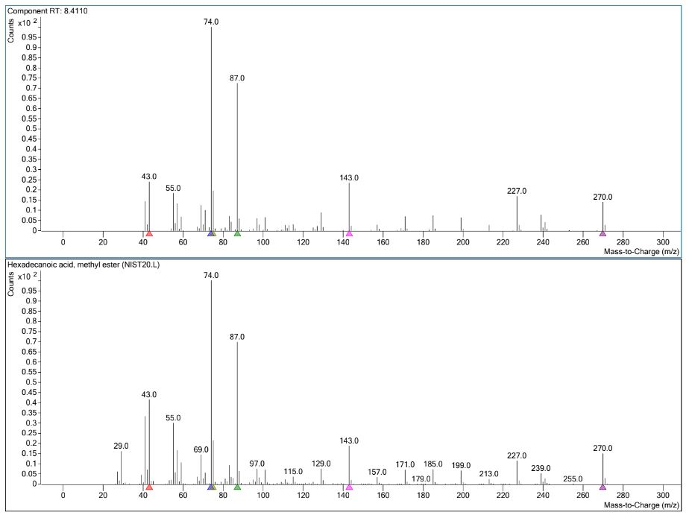
Figure S5. MS spectra of hexadecanoic acid, methyl ester (RT = 8.411 min.) experiment spectrum overlaid with the reference library spectrum.

Figure S6. Proton-decoupled ³¹P NMR spectra of polar extract (A) in D₂O and non-polar extract (B) in CDCl₃ on a 400 MHz spectrometer, ns = 10,000 at 25°C temperature, and 20 Hz line-broadening. Chemical shift is based on the 3¹P peak of 85% phosphoric acid, which is set at 0 PPM.
Figure S6 shows the proton-decoupled ³¹P spectra of the polar extract in D₂O (A) and non-polar extract in CDCl₃ (B). The chemical shift of ³¹P peaks in both media falls between 0 and 6.5 PPM. The peaks were then assigned to orthophosphate monoester (polar phase), and to orthophosphate diester (non-polar phase)[1]. It is interesting to note that no ³¹P signals were observed in the middle layer that we obtain during extraction: The middle layer contains molecules that are not soluble in H₂O/methanol or CHCl₃. This suggests that phosphorus compounds (mono- and di-ester orthophosphate) split during the extraction between the polar and non-polar phases according to their polarity and the polarity of the phase.

References
[1] B. J. Cade-Menun, “Improved peak identification in 31P-NMR spectra of environmental samples with a standardized method and peak library,” Geoderma, vol. 257–258, pp. 102–114, 2015.

