Supplementary material

AREBO Forward Kinematics

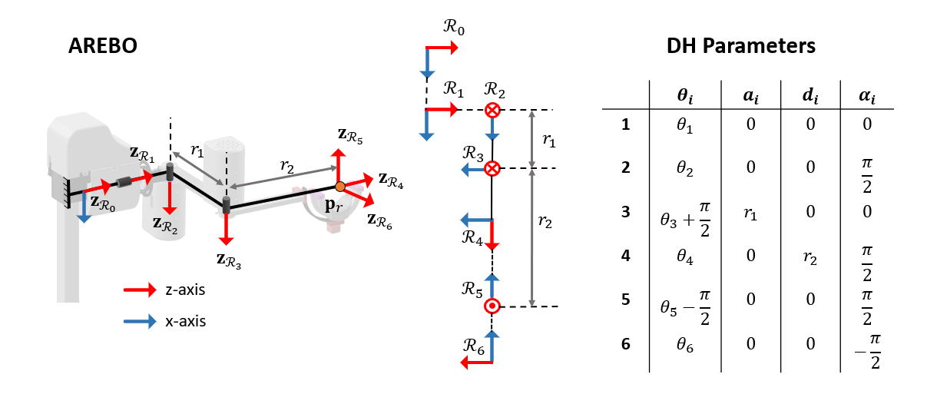
Figure S1, AREBO’s 6 DOF kinematic chain with its DH parameters. The three proximal DOF $(R_{1}, R_{2}, R_{3})$ are actuated and control the 3D position of the robot’s endpoint attached to the arm and the three distal unactuated DOF $(R_{4}, R_{5}, R_{6})$ help the robot to self-align to the orientation of the arm; these three DOF form a spherical joint about the robot’s endpoint $p_{r}$.

Forward kinematics computes the robot’s endpoint position and orientation given the joint angles and DH parameters.
The homogenous transformation matrices between subsequent reference frames are given by:
$$T_{R_{1}}^{R_{0}}=\left[\begin{matrix}c_{1} & {-s}_{1} & 0 & 0 \\ s_{1} & c_{1} & 0 & 0 \\ 0 & 0 & 1 & 0 \\ 0 & 0 & 0 & 1\end{matrix}\right], T_{R_{2}}^{R_{1}}=\left[\begin{matrix}c_{2} & {-s}_{2} & 0 & 0 \\ 0 & 0 & 1 & 0 \\ {-s}_{2} & {-c}_{2} & 0 & 0 \\ 0 & 0 & 0 & 1\end{matrix}\right] , T_{R_{3}}^{R_{2}}=\left[\begin{matrix}{-s}_{3} & {-c}_{3} & 0 & r_{1} \\ c_{3} & {-s}_{3} & 0 & 0 \\ 0 & 0 & 1 & 0 \\ 0 & 0 & 0 & 1\end{matrix}\right]$$

$$T_{R_{4}}^{R_{3}}=\left[\begin{matrix}c_{4} & {-s}_{2} & 0 & 0 \\ 0 & 0 & -1 & -r_{2} \\ s_{4} & c_{4} & 0 & 0 \\ 0 & 0 & 0 & 1\end{matrix}\right], T_{R_{5}}^{R_{4}}=\left[\begin{matrix}s_{5} & c_{5} & 0 & 0 \\ 0 & 0 & -1 & 0 \\ {-c}_{5} & s_{5} & 0 & 0 \\ 0 & 0 & 0 & 1\end{matrix}\right], T_{R_{6}}^{R_{5}}=\left[\begin{matrix}c_{6} & {-s}_{6} & 0 & 0 \\ 0 & 0 & 1 & 0 \\ {-s}_{5} & {-c}_{6} & 0 & 0 \\ 0 & 0 & 0 & 1\end{matrix}\right]$$

The position and orientation of the endpoint is given by:
$$T_{R_{6}}^{R_{0}}=T_{R_{1}}^{R_{0}}∙T_{R_{2}}^{R_{1}}∙T_{R_{3}}^{R_{2}}∙T_{R_{4}}^{R_{3}}∙T_{R_{5}}^{R_{4}}∙T_{R_{6}}^{R_{5}}$$
Since $θ_{6}$ is not measured, it is assumed to be zero,
$$T_{R_{6}}^{R_{0}}=\left[\begin{matrix}R_{R_{6}}^{R_{0}} & p_{r}^{R_{0}} \\ 0 & 1\end{matrix}\right]$$
where,

$$R_{R_{6}}^{R_{0}}=\left[\begin{matrix}-s_{1}s_{4}s_{5}-c_{1}\left(c_{23}c_{5}+c_{4}s_{23}s_{5}\right) & -c_{4}s_{1}+c_{1}s_{23}s_{4} & -c_{5}\left(c_{1}c_{4}s_{23}+s_{1}s_{4}\right)+c_{1}c_{23}s_{5} \\ -c_{23}c_{5}s_{1}+\left(-c_{4}s_{1}s_{23}+c_{1}s_{4}\right)s_{5} & c_{1}c_{4}+s_{1}s_{23}s_{4} & -c_{4}c_{5}s_{1}s_{23}+c_{1}c_{5}s_{4}+c_{23}s_{1}s_{5} \\ c_{5}s_{23}-c_{23}c_{4}s_{5} & c_{23}s_{4} & -c_{23}c_{4}c_{5}-s_{23}s_{5}\end{matrix}\right]$$

$$p_{r}^{R_{0}}=\left[\begin{matrix}c_{1}(r_{1}c_{1}+r_{2}c_{23}) \\ s_{1}(r_{1}c_{1}+r_{2}c_{23}) \\ -r_{1}s_{1}-r_{2}s_{23}\end{matrix}\right]$$
where,
$s_{i_{1}i_{2}⋯i_{n}}=\sin\left(θ_{i_{1}}+θ_{i_{2}}+…+θ_{i_{n}}\right)$ and $c_{i_{1}i_{2}⋯i_{n}}=\cos\left(θ_{i_{1}}+θ_{i_{2}}+…+θ_{i_{n}}\right)$

AREBO Inverse Kinematics
Inverse kinematics is used to find the robot’s joint angles given the position and orientation of the endpoint.
The position of the end point of the robot is given by:

$$p_{r}^{R_{0}}=\left[\begin{matrix}p_{r,x} \\ p_{r,y} \\ p_{r,z}\end{matrix}\right]=\left[\begin{matrix}\cos{θ_{1}}(r_{1}\cos{θ_{2}}+r_{2}\cos{{(θ}_{2}+θ_{3}}) \\ \sin{θ_{1}}(r_{1}\cos{θ_{2}}+r_{2}\cos{{(θ}_{2}+θ_{3}}) \\ -r_{1}\sin{θ_{2}}-r_{2}\sin{(θ_{2}+θ_{3})}\end{matrix}\right]$$
Squaring and adding the terms,

$${p_{r,x}}^{2}+{p_{r,y}}^{2}+{p_{r,z}}^{2}={r_{1}}^{2}+{r_{2}}^{2}+2r_{1}r_{2}\cos{θ_{3}}$$
Rewriting,
$$2r_{1}r_{2}\cos{θ_{3}}+\left({r_{1}}^{2}+{r_{2}}^{2}\right)-({p_{r,x}}^{2}+{p_{r,x}}^{2}+{p_{r,x}}^{2})=0$$
$$θ_{3}=-\cos^{-1}{\frac{({p_{r,x}}^{2}+{p_{r,y}}^{2}+{p_{r,z}}^{2})-\left({r_{1}}^{2}+{r_{2}}^{2}\right)}{2r_{1}r_{2}}}$$

The z-coordinate of the robot’s endpoint is given by:
$$p_{r,z}=-r_{1}\sin{θ_{2}}-r_{2}(\sin{θ_{2}\cos{θ_{3}}+\sin{θ_{3}\cos{θ_{2}}})}$$
$$\left(r_{2}\sin{θ_{3}}\right)\cos{θ_{2}}+\left(r_{2}\cos{θ_{3}}\right)\sin{θ_{2}}+p_{r,z}+r_{1}\sin{θ_{2}}=0$$
Since $θ_{3}$ is known, the above trigonometric equation is solved by the procedure explained in section 1.3 to find $θ_{2}$.

Let, the orientation of the endpoint be:
$$R_{R_{6}}^{R_{0}}=\left[\begin{matrix}r_{11} & r_{12} & r_{13} \\ r_{21} & r_{22} & r_{23} \\ r_{31} & r_{32} & r_{33}\end{matrix}\right]$$

$θ_{4}$ is calculated by solving the following trigonometric equation:
$$(\cos{θ_{1}})\cos{θ_{4}}+(\sin{θ_{1}}\sin\left(θ_{2}+θ_{3}\right))\sin{θ_{4}}-r_{22}=0$$
Finally, $θ_{5}$ is obtained by solving the equation:
$$(\sin\left(θ_{2}+θ_{3}\right))\cos{θ_{5}}- (cos{{(θ}_{2}+θ_{3}})\cos{θ_{4}})\sin{θ_{4}}-r_{31}= 0$$
The above equations are of the form $a\cos{β}+b\sin{β}+c=0$ and are solved by procedure explained in section 1.3.

Solving equation of the form a$\cos{β}+b\sin{β}+c=0$

$$a\cos{β}+b\sin{β}+c=0$$
Substituting,
$$\cos{β}=\frac{1-{\left(\tan{\frac{β}{2}}\right)}^{2}}{1+{\left(\tan{\frac{β}{2}}\right)}^{2}}=\frac{1-t^{2}}{1+t^{2}}$$
$$\sin{β}=\frac{2\tan{\frac{β}{2}}}{1+{\left(\tan{\frac{β}{2}}\right)}^{2}}=\frac{2t}{1+t^{2}}$$
And rewriting,

$$a\frac{1-t^{2}}{1+t^{2}}+b\frac{2t}{1+t^{2}}+c=0$$

$$(c-a)t^{2}+2bt+(c+a)=0$$
Solving for $β$,
$$t=\tan{\frac{β}{2}}=\frac{-b±\sqrt{a^{2}+b^{2}-c^{2}}}{(c-a)}$$
$$β=2\tan\left(\frac{-b±\sqrt{a^{2}+b^{2}-c^{2}}}{(c-a)}\right)$$

Arm Forward Kinematics
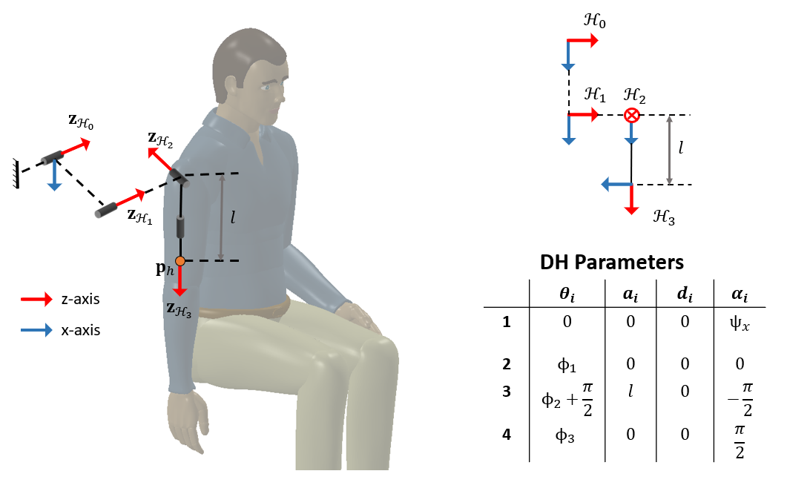
Figure S2, Details of the three-DOF kinematic chain of the shoulder joint. The endpoint of the arm is at $H_{3}$ at a distance $l$ from its origin $H_{0}$. The movements at the shoulder joint associated with the generalized coordinates of the arm are: $ϕ_{1}$ – flexion extension, $ϕ_{2}$ – abduction-adduction, $ϕ_{3}$ – internal external rotation

The homogenous transformation matrices between the reference frames are given by:
$$T_{H_{0}}^{R_{0}}=\left[\begin{matrix}1 & 0 & 0 & x_{H_{0}} \\ 0 & c_{ψ_{x}} & {-s}_{ψ_{x}} & y_{H_{0}} \\ 0 & s_{ψ_{x}} & c_{ψ_{x}} & z_{H_{0}} \\ 0 & 0 & 0 & 1\end{matrix}\right], T_{H_{2}}^{H_{1}}=\left[\begin{matrix}c_{1} & {-s}_{1} & 0 & 0 \\ s_{1} & c_{1} & 0 & 0 \\ 0 & 0 & 1 & 0 \\ 0 & 0 & 0 & 1\end{matrix}\right],$$
$$T_{H_{3}}^{H_{2}}=\left[\begin{matrix}-s_{2} & {-c}_{2} & 0 & 0 \\ 0 & 0 & 1 & 0 \\ -c_{2} & -s_{2} & 0 & 0 \\ 0 & 0 & 0 & 1\end{matrix}\right],{ T}_{H_{3}}^{H_{2}}=\left[\begin{matrix}c_{3} & {-s}_{3} & 0 & 0 \\ 0 & 0 & -1 & l \\ s_{3} & c_{3} & 0 & 0 \\ 0 & 0 & 0 & 1\end{matrix}\right]$$
The position and orientation of the end point is found by:

$$T_{H_{3}}^{R_{0}}=T_{H_{0}}^{R_{0}}∙T_{H_{2}}^{H_{1}}∙T_{H_{3}}^{H_{2}}∙{ T}_{H_{3}}^{H_{2}}$$

As AREBO only supports two DOF movements of the arm, $ϕ_{3}=0,$
$$T_{H_{3}}^{R_{0}}= \left[\begin{matrix}R_{H_{3}}^{R_{0}} & p_{h}^{R_{0}} \\ 0 & 1\end{matrix}\right]$$

$$R_{H_{3}}^{R_{0}}=\left[\begin{matrix}{-c}_{1}s_{2} & {-s}_{2} & c_{1}c_{2} \\ {-c}_{ψ_{x}}s_{2}s_{1}+c_{2}s_{ψ_{x}} & c_{1}c_{ψ_{x}} & c_{2}c_{ψ_{x}}s_{1}+s_{2}s_{ψ_{x}} \\ {-c}_{1}c_{ψ_{x}}-s_{2}s_{1}s_{ψ_{x}} & c_{1}s_{ψ_{x}} & {-c}_{ψ_{x}}s_{2}+c_{2}s_{1}s_{ψ_{x}}\end{matrix}\right]$$

$$p_{h}^{R_{0}}=\left[\begin{matrix}x_{H_{0}}+lc_{1}c_{2} \\ y_{H_{0}}+lc_{ψ_{x}}c_{2}s_{1}+ls_{2}s_{ψ_{x}} \\ z_{H_{0}}-lc_{ψ_{x}}s_{2}+lc_{2}s_{1}s_{ψ_{x}}\end{matrix}\right]$$
where,
$s_{i_{1}i_{2}⋯i_{n}}=\sin\left(ϕ_{i_{1}}+ϕ_{i_{2}}+…+ϕ_{i_{n}}\right)$ and $c_{i_{1}i_{2}⋯i_{n}}=\cos\left(ϕ_{i_{1}}+ϕ_{i_{2}}+…+ϕ_{i_{n}}\right)$

Arm Inverse Kinematics
Let the orientation of the arm with respect to the robot’s base reference frame $R_{0}$ be:
$$R_{H_{3}}^{R_{0}}=\left[\begin{matrix}h_{11} & h_{12} & h_{13} \\ h_{21} & h_{22} & h_{23} \\ h_{31} & h_{32} & h_{33}\end{matrix}\right]$$

$$ϕ_{1}=\cos^{-1}\left(\frac{h_{22}}{\cos{ψ_{x}}}\right)$$

$$ϕ_{2}=- \sin^{-1}{h_{12}}$$

Optimization
The first step in the design of the robot is the calculation of the link lengths. The link lengths were optimized with two objectives:
- Maximize the workspace of the arm ($W^{a}$) that is reachable by AREBO.
- Maximize the manipulability along the plane orthogonal to the arm.
The objective function $O(r_{1},r_{2})$ written as a combination of these two objectives is defined as:
$$O\left(r_{1},r_{2}\right)=\frac{1}{2}\left(O_{w}\left(r_{1},r_{2}\right)+O_{M}(r_{1},r_{2})\right)$$
where $O_{w}\left(r_{1},r_{2}\right)$ and $O_{M}(r_{1},r_{2})$ are the workspace and manipulability components of the objective function.

Workspace of the Arm
The workspace of the arm is decided by the position of the human joint $H_{0}$ with respect to the robot’s base reference frame $R_{0}$, the distance of AREBO attachment from the human joint $l$ and the trunk rotation $ψ_{x}$ and the range of the joint angles $ϕ_{1}, ϕ_{2}$. The entire workspace is divided into discrete numbers of points based on the parameter combinations given in Table S1.

Table S1. Parameter values and range for the coarse and fine search used in the optimization of the robot link lengths. CS – coarse search, FS – fine search, $l$ – distance between human joint and AREBO’s attachment point, $o_{H_{0}}^{R_{0}}={\left[\begin{matrix}o_{x} & o_{y} & o_{z}\end{matrix}\right]}^{T}$ is the origin of the human joint and $ψ_{x}$ is the rotation of the human about $x_{H_{0}}$ axis.
Parameter |  | Values (cm) | No of values
$$r_{1}$$ | CS | {20, 22, ...,50} | 16
 | FS | {33.1, 33.2, …, 34.9} | 19
$$r_{2}$$ | CS | {20, 22, ...,50} | 16
 | FS | {37.1, 37.2, …, 38.9} | 19
$$l$$ |  | {15, 17.5, 20} | 3
$$o_{x} , o_{y}$$ |  | {-10, 0, 10} | 3
$$o_{z}$$ |  | {20, 30, 40} | 3
$ψ_{x}$(deg) |  | {-30, 0, 30} | 3

Workspace component $O_{w}\left(r_{1},r_{2}\right)$
Each point in the workspace of the arm is checked for its reachability with AREBO. A point is considered reachable if the AREBO’s joint angles $θ$ yielded from its inverse kinematics are real and the angles are within the range:
$$-135°≤θ_{1}≤0°$$
$$-45°≤θ_{2}≤45°$$
$$-135°≤θ_{3}≤-45°$$
$$-45°≤θ_{4}≤45°$$
$$-45°≤θ_{5}≤45°$$
These constraints are applied to avoid regions closer to the singular configuration in AREBO. If the point is reachable, the reachability ($η_{i}(r_{1},r_{2},θ)$) is denoted as 1, else it is 0. The workspace component $O_{w}\left(r_{1},r_{2}\right)$ for a given $r_{1},r_{2}$ is the average reachability in all points of the arm’s workspace.
$$O_{w}\left(r_{1},r_{2}\right)=\frac{\sum_{i=1}^{N}{η_{i}}(r_{1},r_{2},θ)}{N}$$
$N∈N$ is the total number of points in $W^{a}.$

Manipulability component $O_{w}\left(r_{1},r_{2}\right)$
Manipulability is defined as the ability of the robot to apply forces in different directions at a given joint space coordinate. In the case of AREBO, for safety reasons, it is required to apply forces only orthogonal to the arm (in the $x_{R_{3}} y_{R_{3}}$ plane).
The relationship between the forces applied by the robot orthogonal to the arm ($f_{xy}$), along the axis of the arm ($f_{z}$) and the actuator torques $τ^{a}$ is given by:
$$f_{xy}=P_{xy}∙{J(θ)}^{-T}∙τ^{a}$$
$$f_{z}=P_{z}∙{J(θ)}^{-T}∙τ^{a}$$
where $J(θ)$ is the Jacobian matrix of the robot as a function of the generalized coordinates $θ$.
$P_{xy}, P_{z}$ are the projection matrices to project the forces at the endpoint orthogonal to the arm and along the axis of the arm respectively.
Assuming the orientation of the endpoint is given by,
$$R_{R_{6}}^{R_{0}}=\left[\begin{matrix}x_{R_{6}} & y_{R_{6}} & z_{R_{6}}\end{matrix}\right]$$
The projection matrices can be calculated by the following relations:
$$P_{xy}= x_{R_{6}}{x_{R_{6}}}^{T}+ y_{R_{6}}{y_{R_{6}}}^{T}$$
$$P_{z}= z_{R_{6}}{z_{R_{6}}}^{T}$$
The ratio of the ability to apply forces orthogonal to the arm and the ability to apply forces along the axis of the arm is given by,
$$γ_{i}\left(r_{1},r_{2},θ\right)=\frac{{\left\|P_{z}∙{J(θ)}^{-T}\right\|}_{2}}{{\left\|P_{xy}∙{J(θ)}^{-T}\right\|}_{2}}$$
The manipulability index $M_{i}\left(r_{1},r_{2},θ\right)$ at a point in the $W^{a}$ is 1 if $γ_{i}\left(r_{1},r_{2},θ\right)≥1$ else it is 0.
The manipulability component $O_{w}\left(r_{1},r_{2}\right)$ for a given $r_{1},r_{2}$ is the average of $M_{i}\left(r_{1},r_{2},θ\right)$ across all points in the arm’s workspace is,
$$O_{M}\left(r_{1},r_{2}\right)=\frac{\sum_{i=1}^{N}{M_{i}}(r_{1},r_{2},θ)}{N}$$
$N∈N$ is the total number of points in $W^{a}.$

Algorithm 1: Estimation of orientation
Algorithm 1: Estimation of orientation of human base frame with respect to the robot.
Let the record of the robot’s endpoint position during the flexion-extension movements be ${\left[\begin{matrix}p_{r,x}\left[n\right] & p_{r,y}\left[n\right] & p_{r,z}\left[n\right]\end{matrix}\right]}^{T}, 0≤n<N,$where $n∈Z$ is the time index and $1<N∈Z$ is the length of recorded data. The endpoint kinematics is computed from the joint angles of the robot.
Let the equation for the plane containing the flexion-extension movement be, $ax+by+c=z.$ The robot’s endpoint must satisfy this equation, which can be expressed as the following:
$$\left[\begin{matrix}p_{r,x}\left[0\right] & p_{r,y}\left[0\right] & 1 \\ p_{r,x}\left[1\right] & p_{r,y}\left[1\right] & 1 \\ ⋮ & ⋮ & ⋮ \\ p_{r,x}\left[N-1\right] & p_{r,y}\left[N-1\right] & 1\end{matrix}\right]\left[\begin{matrix}a \\ b \\ c\end{matrix}\right]=\left[\begin{matrix}p_{r,z}\left[0\right] \\ p_{r,z}\left[1\right] \\ ⋮ \\ p_{r,z}\left[N-1\right]\end{matrix}\right]$$
$$X∙p=z$$
The algorithm for estimating the orientation parameter $ψ_{x}$ is given below.
- Estimate the parameters of the plane using the Moore-Penrose pseudoinverse, $\hat{p}={\left[\begin{matrix}\hat{a} & \hat{b} & \hat{c}\end{matrix}\right]}^{T}=X^{+}∙z$. The normal to the plane is given by $n_{p}={\left[\begin{matrix}a & b & -1\end{matrix}\right]}^{T}$.
- Find the angle between normal to plane and robot z-axis $θ_{s}=±\frac{1}{\sqrt{a^{2}+b^{2}+1}}$.
- Find the vector $n_{s}$ formed by rotating z-axis by angle $θ_{s}$,
$$n_{s}=\left[\begin{matrix}1 & 0 & 0 \\ 0 & \cos{θ_{s}} & -\sin{θ_{s}} \\ 0 & \sin{θ_{s}} & \cos{θ_{s}}\end{matrix}\right]\left[\begin{matrix}0 \\ 0 \\ 1\end{matrix}\right]$$
- If, $n_{p}^{T}n_{s}≈0$ ⇒ $ψ_{x}=θ_{s}$, else $ψ_{x}={-θ}_{s}$.

Algorithm 2: Estimation of the human joint position and limb length
Algorithm 2 Finding initial human joint position $o_{H_{0}}^{R_{0}}$ and distance between the joint to point of robot attachment $(l)$
- Let the robot joint angles recorded while the subject performs small random movements be: $θ\left[n\right], 0≤n<N$, where $n∈Z$ is the time index and $N∈Z, N>1$ is the length of data available. The corresponding endpoint position and orientation are found by forward kinematics of AREBO and are given by $p_{r}^{R_{0}}[n]$ and $R_{R_{6}}^{R_{0}}\left[n\right].$
- Let the position of the human joint at $H_{0}$ be $o_{H_{0}}^{R_{0}}$, then
$$o_{H_{0}}^{R_{0}}=p_{r}^{R_{0}}\left[n\right]-l∙z_{R_{6}}^{R_{0}}[n]$$
- Rewriting,
$$\left[\begin{matrix}I_{3} & z_{R_{6}}^{R_{0}}[n]\end{matrix}\right]\left[\begin{matrix}o_{H_{0}}^{R_{0}} \\ l\end{matrix}\right]=p_{r}^{R_{0}}\left[n\right]$$
- Substituting all the recorded points,
$$\left[\begin{matrix}I_{3} & z_{R_{6}}^{R_{0}}[0] \\ I_{3} & z_{R_{6}}^{R_{0}}[1] \\ ⋮ & ⋮ \\ I_{3} & z_{R_{6}}^{R_{0}}[N-1]\end{matrix}\right]\left[\begin{matrix}o_{H_{0}}^{R_{0}} \\ l\end{matrix}\right]=\left[\begin{matrix}p_{r}^{R_{0}}[0] \\ p_{r}^{R_{0}}[1] \\ ⋮ \\ p_{r}^{R_{0}}[N-1]\end{matrix}\right]$$
$$Av=b ⇒ v= A^{+}b$$
$A^{+}$ is Moore-Penrose inverse calculated as $A^{+}={\left(A^{T}A\right)}^{-1}A^{T}$

AREBO Jacobian matrix
The Jacobian matrix relates the endpoint velocity ${\dot{p}}_{R_{6}}^{R_{0}}∈R^{3}$ in the task space to the angular velocities of the joints of AREBO, $\dot{θ}={[\begin{matrix}{\dot{θ}}_{1} & {\dot{θ}}_{2} & {\dot{θ}}_{3} & {\dot{θ}}_{4} & {\dot{θ}}_{5} & {\dot{θ}}_{6}\end{matrix}]}^{T}∈R^{6}$.
$${\dot{p}}_{R_{6}}^{R_{0}}=\left[\begin{matrix}-s_{1}(r_{1}c_{2}+r_{2}c_{23}) & {-c}_{1}(r_{1}s_{2}+r_{2}s_{23}) & {-r_{2}c}_{1}s_{23} & 0 & 0 & 0 \\ c_{1}(r_{1}c_{2}+r_{2}c_{23}) & s_{1}(r_{1}s_{2}+r_{2}s_{23}) & {r_{2}s}_{1}s_{23} & 0 & 0 & 0 \\ 0 & r_{1}c_{2} & r_{2}c_{23} & 0 & 0 & 0\end{matrix}\right]\left[\begin{matrix}{\dot{θ}}_{1} \\ {\dot{θ}}_{2} \\ {\dot{θ}}_{3} \\ {\dot{θ}}_{4} \\ {\dot{θ}}_{5} \\ {\dot{θ}}_{6}\end{matrix}\right]$$
$${\dot{p}}_{R_{6}}^{R_{0}}=J(θ)∙\dot{θ}$$
where,
$s_{i_{1}i_{2}⋯i_{n}}=\sin\left(θ_{i_{1}}+θ_{i_{2}}+…+θ_{i_{n}}\right)$ and $c_{i_{1}i_{2}⋯i_{n}}=\cos\left(θ_{i_{1}}+θ_{i_{2}}+…+θ_{i_{n}}\right)$

AREBO Gravity compensation
The gravity compensation module of AREBO provides the actuator torques to hold the robot against gravity as a function of the joint angles $θ$. A simple calibration procedure is used to find this relationship by recording the torque sensor values at various combinations of $θ$. The procedure is automated by a PD position controller in the actuators of AREBO. The steps and range for the actuated joint angles are given in
Table S2, The steps and range of each actuated joint angle in the estimate of gravity compensation equations ($τ_{g}$) of AREBO.
Angle | Values (deg) | No. of values
$$θ_{1}$$ | {0, -45, -90, -135, -90, -45, 0, 45, 0} | 9
$$θ_{2}$$ | {-45, 0, 45} | 3
$$θ_{3}$$ | {-45, 0, 45} | 3

Thus, 81 data sets are recorded for fitting with the analytical equation of $τ_{g}$ that is derived from the potential energy of the robot $V$, where the overall potential energy is the sum of the individual potential energy of the individual links, as given below,
$$V= \sum_{i=1}^{5}{w_{i}{\left[\left(\prod_{j=0}^{i-1}{R_{R_{j}}^{R_{j+1}}}\right)x_{i}\right]}_{2,1}} , i∈N, i=1,2,…, 5$$
where,
- $x_{i}$ are the coordinates of the centre of mass of link $i$ in its local reference frame $R_{i}$
- $w_{i}$ is the weight of link $i$,
- ${\left[∙\right]}_{2,1}$ is the element in the second row of column matrix A. This element is the y coordinate of the centre of mass in the global reference frame $R_{0}$ and causes the change in the potential energy of the system.
- $\left(\prod_{j=0}^{i-1}{R_{R_{j}}^{R_{j+1}}}\right)x_{i}$ transforms the location of the centre of mass from frame $R_{i}$ to $R_{0}$.

The torque due to gravity $τ_{g,i}$ at the $i^{th}$ actuated DOF is given by,
$$τ_{g,i}= -\frac{dV}{dθ_{i}} , i∈N, i=1,2,3$$
Examining $τ_{g,i}$, it can be rewritten in the form,
$$τ_{g,i}=a_{1}f_{1}\left(θ\right)+a_{2}f_{2}\left(θ\right)+…+a_{n}f_{n}\left(θ\right)$$
where,
- $a_{x}$ ($a_{x}∈R, x∈N, x=\left\{1,2, …, n\right\}$ )are constants which are the product of the weight of the link and the centre of mass coordinates,
- $f_{x}\left(θ\right)$ are trigonometric functions in joint coordinates $θ$.
The constants $a_{x}$ are treated as unknowns and a linear fit is made in Mathematica with recorded encoder and torque sensor data sets to determine $τ_{g}$. The equations are then exported to Arduino to set the feedforward current to the actuators for gravity compensation.

Gains of AREBO controller
The high-level controller in AREBO sets the interaction force applied by the robot on the user. It uses a PD controller with gains as given below:
1st Joint | $$K_{1,1}=\left\{\begin{aligned}4, τ_{1}^{int}>0 \\ 2, τ_{1}^{int}< 0 \end{aligned}\right., K_{1,2}=2$$
2nd Joint | $$K_{2,1}=3, K_{2,2}=2$$
2nd Joint | $$K_{3,1}=3, K_{3,2}=2$$

Human Limb Model
A simple calibration procedure was employed to estimate the human joint torques due to the weight of the human limb as a function of the human limb angle $ϕ$. This calibration procedure is done after completing the estimation of the human limb length $l$ and the orientation $ψ_{x}$ of the human base frame. For estimating the weight of the upper arm, a flexion-extension movement is imposed on the human shoulder joint while the joint angle and torques of AREBO are recorded. This data is used to estimate the human limb joint angles and the torque required to hold the upper arm against gravity, and the interaction force is measured. The position controller of AREBO is activated to take the arm to various flexion angles ($ϕ_{1}$) and hold for 2 seconds to record the static torque at the joints of AREBO. The torque due to the weight of the arm is recorded as, $τ_{int}={\left[\begin{matrix}τ_{int,1} & τ_{int,2} & τ_{int,3}\end{matrix}\right] }^{T}$is calculated as:
$$τ_{int}=τ_{r}-τ_{g}$$

where,
$τ_{r}$ is the torque read at the torque sensors,
$τ_{g}$ is the torque due to the weight of the links of the robot.
The interaction torque is transformed to the human base reference frame to find the human joint torques $τ_{h}={\left[\begin{matrix}τ_{h,1} & τ_{h,2} & τ_{h,3}\end{matrix}\right]}^{T}$.
$$τ_{h}=R_{R_{0}}^{H_{0}}.τ^{int}$$

Only $τ_{h,1}$ varies with the joint angles as the arm performs flexion extension and $τ_{h,2},τ_{h,3}$ are negligible. Assuming the center of mass of the arm lies along the axis of the arm, a linear fit was made in Mathematica with the equation, $τ_{h,1}=τ_{max}\sin{ϕ_{1}}$ to find the constant $τ_{max}$ and hence the weight torque $τ_{h,1}$ at the shoulder as a function of the flexion angle $ϕ_{1}$.
The gravitational torque to hold the arm as a function of the joint angles $ϕ_{1},$ $ϕ_{2}$ is given by:
$$τ_{h}=\left[\begin{aligned}τ_{max}\sin{ϕ_{1}}\cos{ϕ_{2}} \\ τ_{max}\sin{ϕ_{2}}\cos{ϕ_{1}} \\ 0\end{aligned}\right]$$

SJM joint actuation and sensing
The same Teensy 4.1 microcontroller is used to control both SJM and AREBO. Like AREBO, PWM lines from the microcontroller to the motor controllers are used to vary the torque in the actuators of SJM and four digital lines (channel A, channel B for each encoder) are used to read the encoders. HX711 load cell amplifiers are connected to each torque sensor and two digital lines from the amplifier are used to obtain the torque at the joints of SJM.

Table S3. Specification of actuators and torque sensors used in SJM. Actuators from Maxon International Ltd. and torque sensors from Forsentek Co., Ltd. An Escon 70/10 ec controller is used to control flexion/extension DOF and an Escon 36/3 EC controller is used for abduction/adduction DOF.
 | Motor | Gearbox | Torque Sensor | Encoder
1st Joint | EC Flat 90, Nominal torque – 0.953 Nm, part no. 607950 | GP 52 C, Gear ratio: 53:1, part no. 223090 | FTHC, Range - 40 Nm | MILE, 4096 CPT, part no. 651168
2nd Joint | EC Flat 45, Nominal torque – 0.128Nm, part no. 397172 | GP 42 C, Gear ratio 43:1, part no. 203120 | FTHB, Range - 5 Nm | MILE, 2048 CPT, part no. 462005

Details of SJM controller

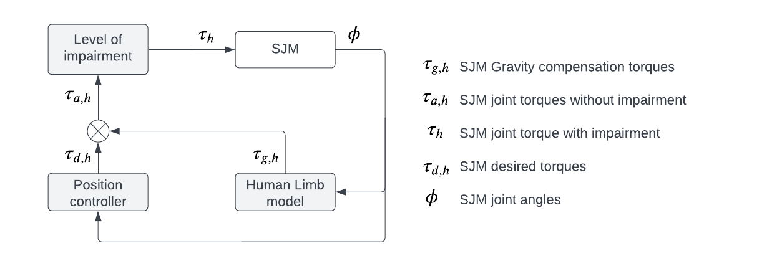
Figure 3, Block diagram of the controller implemented in SJM.

The SJM was designed to be a 2 DOF kinematic and dynamic model of the human arm that can be trained by AREBO. The various blocks in the controllers implemented in SJM are:
- Low-level current control loop – The Maxon motor controllers (Escon 70/10 ec) implement the current control at the lowest level based on the PWM signals sent by the Teensy 4.1 microcontroller.
- Human limb model – The module computes the SJM joint torques to hold it against gravity at various joint space coordinates of SJM.
- High-level position control loop – The position controller moves SJM to the desired joint space coordinates depending on the control mode that is tested (zero torque or adaptive weight support mode).
- Level of impairment – This block simulates the weakness in the arm by multiplying the desired torque from the position controller by a factor $1-ξ$, ($ξ∈R$, $0≤ξ≤1$). $ξ=0$, implies there is no impairment in the arm and $0<ξ≤1$ denotes the presence of arm impairments.

Effects of shoulder abduction joint angle on the estimation of the orientation of the human base frame.
In practical scenarios, it is not possible to perform a pure flexion-extension movement for the calibration procedure to find $ψ_{x}$. To study the effects of these real-life movements on the accuracy of the human joint angles estimated by AREBO, randomly varying abduction movement, $(ϕ_{2})$ was imposed in SJM while it performs the flexion-extension movement ($ϕ_{1}$). Three scenarios were considered in the experiment: 1) $ϕ_{2}$ is almost zero denoting pure flexion movements ($ϕ_{2}≅0$), 2) $ϕ_{2}$varying between $±5°$ ($-5°≤ϕ_{2}≤5°$), 3) $ϕ_{2}$varying between $±10° (-10°≤ϕ_{2}≤10°)$, as shown in Figure 1A. The $ψ_{x}$ estimated in the three cases is then used to individually estimate the joint angles for the same randomly varying polysine movement performed by SJM. During this random movement, $ϕ_{1}$ varied between 0 to 90 degrees and $ϕ_{2}$ varied between -30 and +30 degrees. The encoder values of SJM are considered as ground truth to calculate the error in AREBO’s estimates of the joint angles.

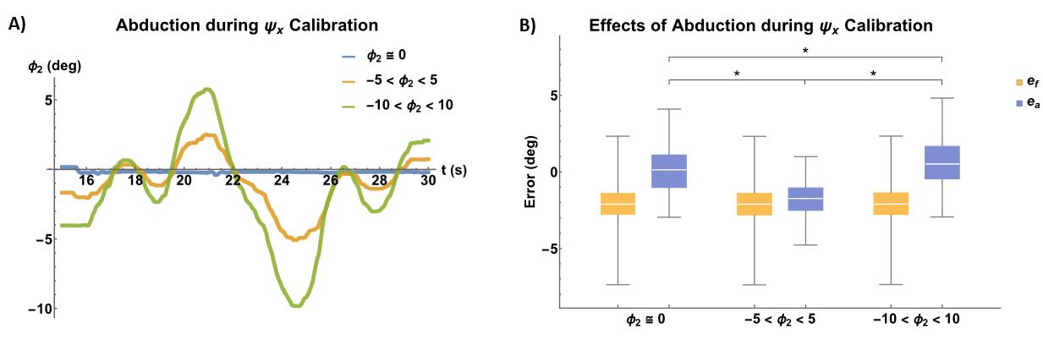
Figure S1. A) Randomly varying Abduction during the calibration procedure to find $ψ_{x}$. The blue curve is the has near zero $ϕ_{2}$ representing pure flexion extension movement. The yellow and green curves depict the randomly varying $ϕ_{2}$ between $±5°$ and $±10°$ respectively. B) Errors in the joint angle estimated by AREBO due to the change in $ϕ_{2}$ during $ψ_{x}$ calibration. $e_{f}$ – error in flexion, $e_{a}$- error in abduction, * - significant difference between the groups (p < 0.05 in one way ANOVA).

Results of the angle estimates in the three cases show that the flexion angle is independent of the value of $ψ_{x}$ estimated and there was no significant difference between the groups (p>0.05 in one-way ANOVA). The errors in abduction were significantly different (p<0.05 in one-way ANOVA). The absolute median errors were high in the case of flexion ($2.10°$) as compared to the error in abduction ($1.73°$).

