Effect of reduced nitrogen fertilization (according to the EC's "Field to Table" strategy) on the chemical and biological traits of soils under maize crops**
Agnieszka Wolińska¹, Artur Banach^{1*}, Anna Kruczyńska¹, Anna Sochaczewska¹, Weronika Goraj¹, Jacek Podlewski², Andrzej Słomczewski², and Agnieszka Kuźniar¹
¹ Department of Biology and Biotechnology of Microorganisms, The John Paul II Catholic University of Lublin, Konstantynów 1 I Str., 20-708 Lublin, Poland
² CGFP Sp. z o.o., Wojnowo 5, 86-014 Sicienko, Poland
* Corresponding author e-mail: artur.banach@kul.pl
** Scientific work supported by the state budget (Poland) under the program of the Ministry of Education and Science named "Science for the Society" project number NdS/531260/2021/2021, the amount of funding 100%, the total value of the project 625 910.50 PLN
SUPPLEMENTARY MATERIALS
Table S1. The correlation analysis between studied parameters with r-value given with their significance (* - p < 0.05, ** - p < 0.01).

 | pH | WHC | Ca | Mg | K | TC | N-NO₃ | N-NH₄ | Olsen P | EDC | TS | AR | C_{KH}
PPW | .591  ** | --
Ca | .725  ** | .662  ** | --
Mg | .63  6** | .703  ** | .804  ** | --
K | .583*  * | .616  ** | .614  ** | .774  ** | --
TC | .313  ** | .430  ** | .312  ** | .433  ** | .328  ** | --
N-NO₃ | -.596  ** | -.621  ** | -.534  ** | -.532  ** | -.477  ** | -.328  ** | --
N-NH₄ | .644  ** | .639  ** | .561  ** | .575  ** | .542  ** | .512  ** | -.644  ** | --
Olsen P | .434  ** | .615  ** | .416  ** | .506  ** | .55  4** | .374  ** | -.659  ** | .734  ** | --
EDC | .760  ** | .749  ** | .791  ** | .820  ** | .764  ** | .451  ** | -.686  ** | .735  ** | .694  ** | --
TS | .472  ** | .453  ** | .404  ** | .474  ** | .375  ** | .453  ** | -.364  ** | .406  ** | .300  ** | .556  ** | --
AR | .598  ** | .624  ** | .628  ** | .659  ** | .561  ** | .372  ** | -.574  ** | .583  ** | .593  ** | .744  ** | .407  ** | --
C_{KH} | -.530  ** | -.353  ** | -.493  ** | -.482  ** | -.540  ** | -.009 | .379  ** | -.405  ** | -.374  ** | -.502  ** | -.191  ** | -.334  ** | --
E4/6 | -.307  ** | -.266  ** | -.318  ** | -.202  ** | -.171  ** | -.106 | .234  ** | -.137  * | -.184  ** | -.287  ** | -.131  * | -.237  ** | .085

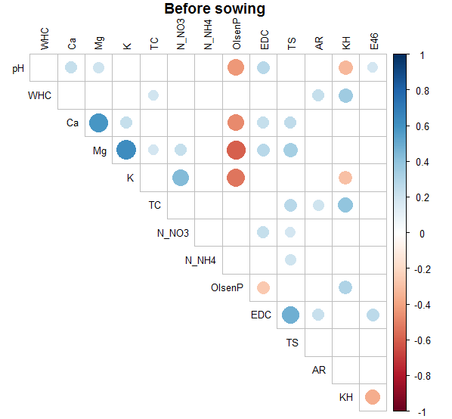
Figure S1. Correlogram between studied parameters for data collected before sowing maize.

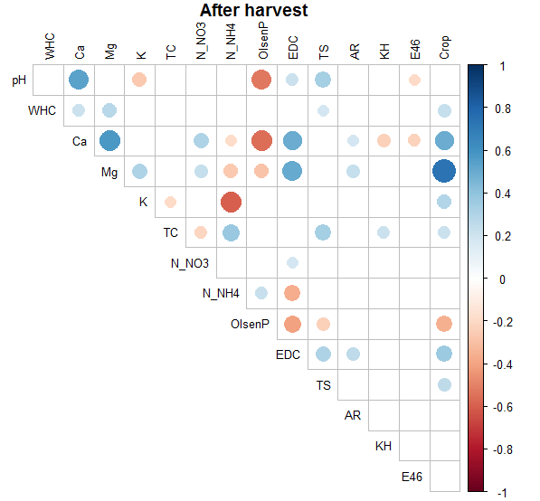
Figure S2. Correlogram between studied parameters for data collected after harvesting maize.

