Supplementary Information:
Fabrication of PEG-PLGA Microparticles with tunable sizes for drug delivery application.
Paul Nana Kwame Sagoe¹, Eduardo Jose Machado², Yohely Maria Espiritusanto^{1, *}, Amelia Gilbert³, Thalma Orado¹, Qiu Wang⁴, Era Jain^{1#}

Parameter | Formulation | Mean Size (µm ± sd) | %CV
Reference | Reference | 6.8 ± 0.1 | 1.5
Stir Rate | 300 rpm | 23 ± 1.9 | 8.3
 | 600 rpm | 11.6 ± 0.6 | 5.2
 | 1500 rpm | 4.9 ± 0.5 | 10.2
Polymer (PEG-PLGA) concentration | 1% w/v | 12.5 ± 0.6 | 4.8
 | 5% w/v | 17.2 ± 1 | 5.8
Surfactant (PVA) concentration | 0.5% w/v | 16.7 ± 0.7 | 4.2
 | 2.5% w/v | 7.5 ± 0.3 | 4
Organic/aqueous phase volume Ratio | 0.01% v/v | 8.8 ± 0.4 | 4.5
 | 0.02% v/v | 10.6 ± 0.6 | 5.7
Organic/aqueous phase flow rate Ratio | 0.01 | 7.6 ± 0.4 | 5.3
 | 0.025 | 6.6 ± 0.3 | 4.5
Organic solvent | 25% w/v ACN/DCM | 4.7 ± 0.8 | 17

S1. Effect of stirrer type and stir bar size on microparticles size and distribution.
The microparticle size and distribution were affected by the type of magnetic stirrer, the size of the stir bar, and the diameter of the inner needle of the coaxial needle construct used in the study. We compared the two different stirrer types, two different stir bar lengths, and two different diameters of the internal needle of the coaxial needle as discussed in the main text section 3.1. The results from these preliminary studies are represented in Table S1 and Figures S1A and S1B.
Table S1: Effect of stirrer type, stir bar size, and inner needle diameter on microparticle size
Formulation code | Process Parameter | Size (μm) | %CV
REF- FM | RT Basic series magnetic stirrer  Stir bar length: 25.4mm  Inner diameter- 30G | 6.8 ± 0.1 | 1.5
FIMS | Fisherbrand Isotemp™ magnetic stirrer | 9.3 ± 0.4 | 4.3
12.7-SBL | Stir bar length -12.7mm | 9.1 ± 0.1 | 1.1
24G-IND | Coaxial needle inner diameter- 24G | 8.6 ± 0.9 | 10.5
Note: Formulation code: REF FM: Reference formulation; FIMS: Fisherbrand isotemp™ magnetic stirrer, 12.7-SBL: 12.7mm Stir bar length, 24G-IND: 24G inner needle diameter.

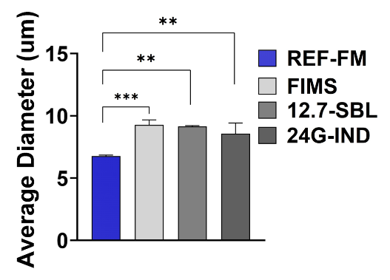
Figure S1.1: Comparison of FIMS, 12.7mm-SBL, and 24G-IND to REF-FM

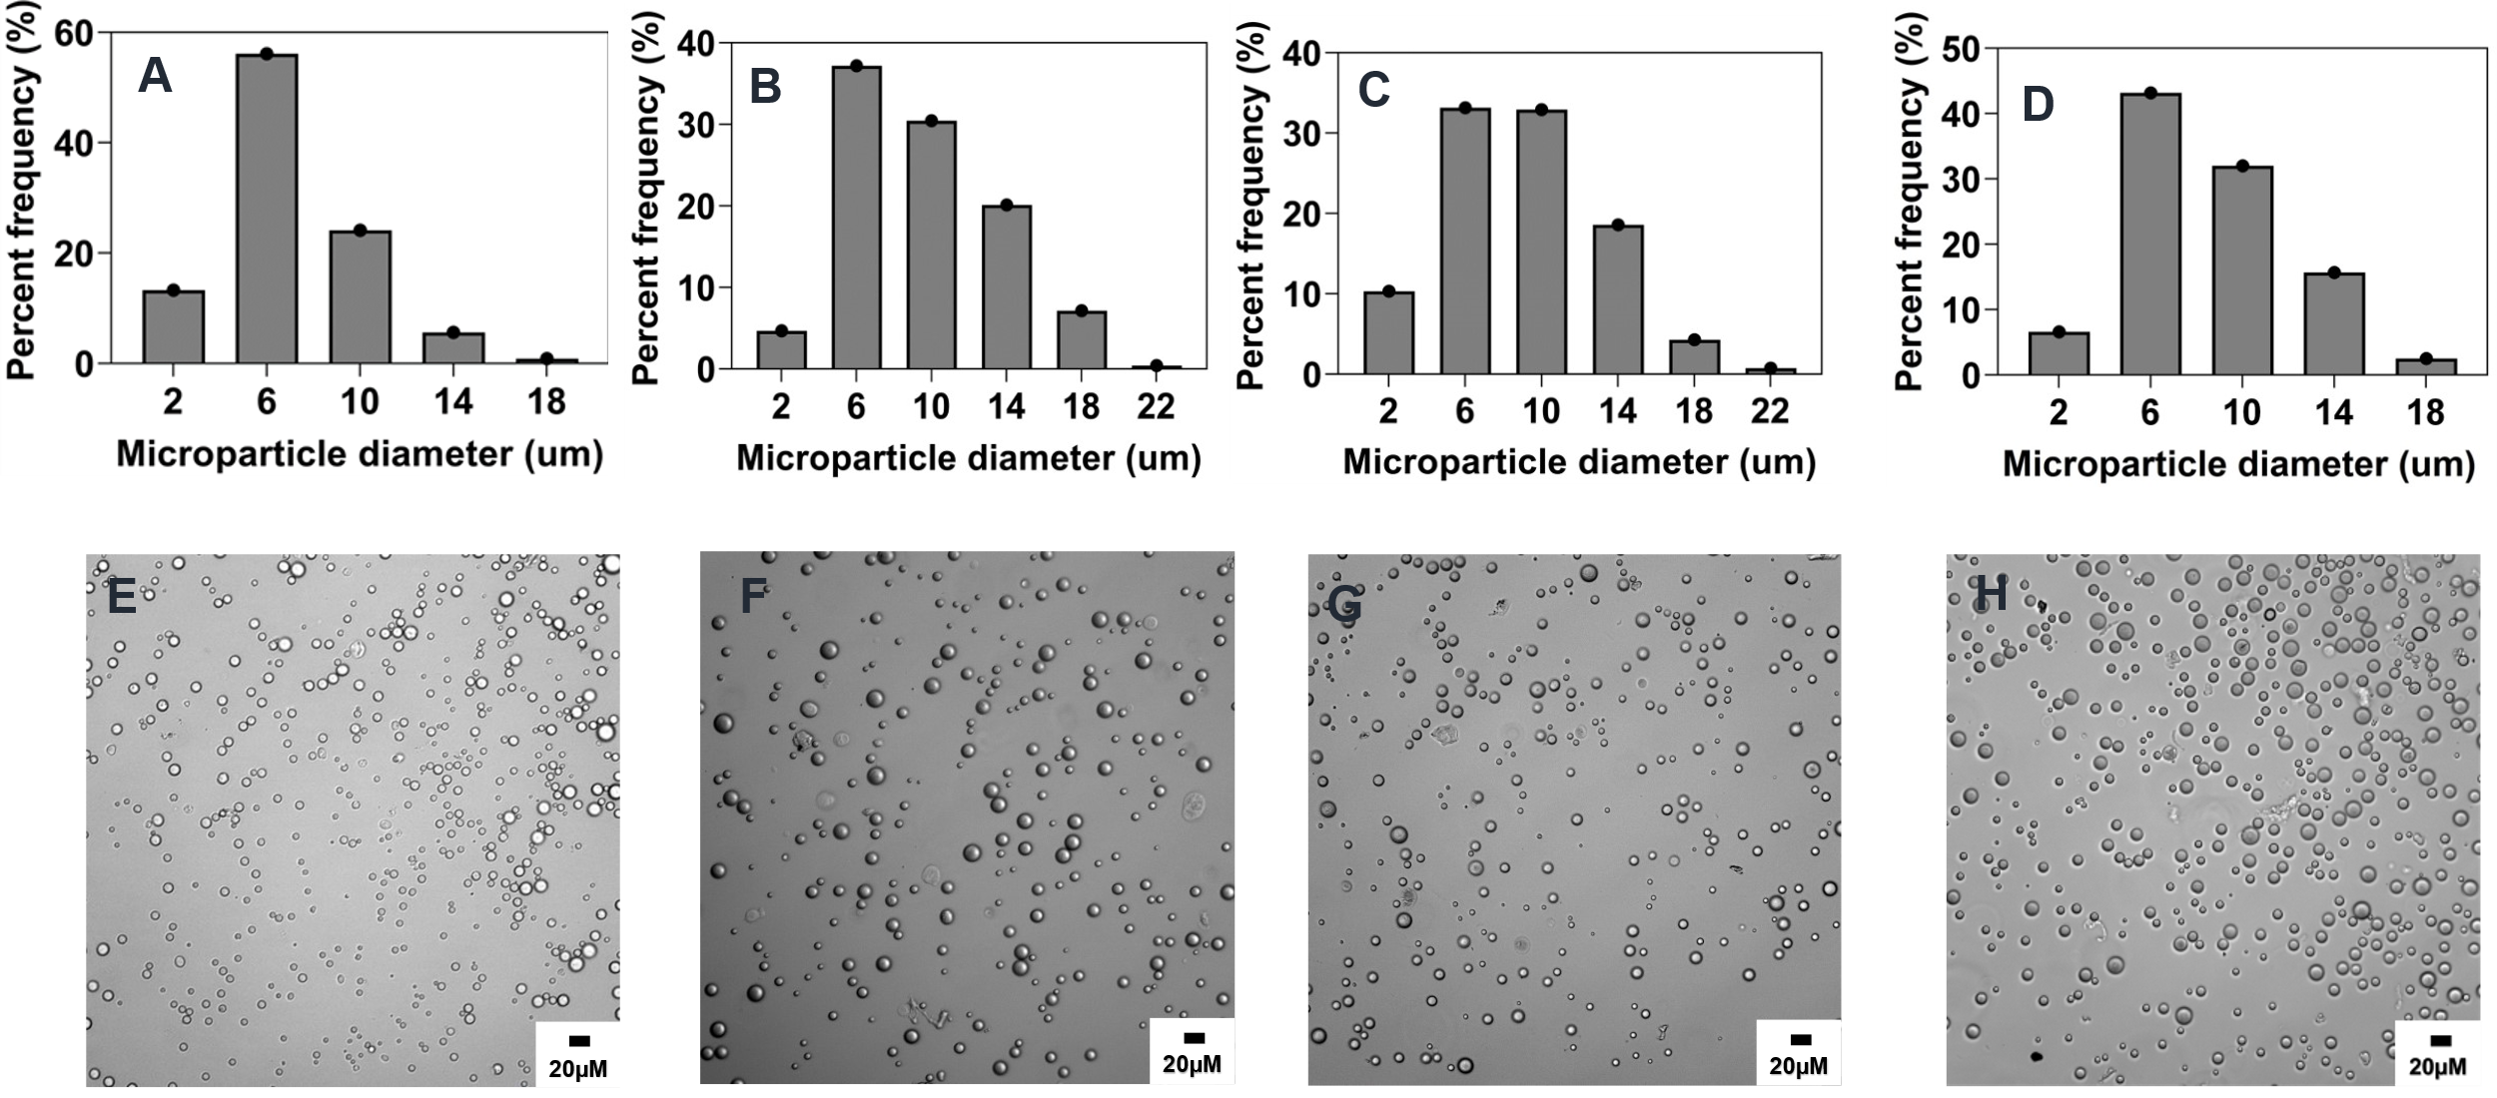
Figure S1.2: Effect of magnetic stirrer type and stir bar length on microparticle size and distributions. Optical micrograph and histogram of particle size distribution: A&E) REF-FM B&F) FIMS, C&G) 12.7mm-SBL and D&H) 24G-IND.
S2. Effect of surfactant concentration on microparticle size and shape
We tested a few additional lower and higher concentrations of the surfactant concentration on the size distribution and microparticle size to test the tunability of the method and application for fabricating microparticles with higher polymer concentrations. For this study, we used 1% polymer concentrations. We observed that at lower concentrations of 0.5% PVA, the particle morphology was spherical, and flat with ruffled edges compared to microparticles formed at intermediate concentrations for PVA of 1 and 5% w/v which had smooth and spherical morphology. However, by increasing the PVA concentration further to 10% w/v we obtained a mixed microparticle morphology with some particles assuming an oval shape. The particles have an average aspect ratio of 1.7 showing a longer major axis (Table S2). Increasing the PVA concentration also led to a decrease in the particle size as particles made at 0.5% PVA had a mean diameter of 114.3 ± 23.1 while the microparticle made using 1% and 5% PVA w/v had a mean size of 43.9 ± 13 and 24.9 ± 9.9 respectively.
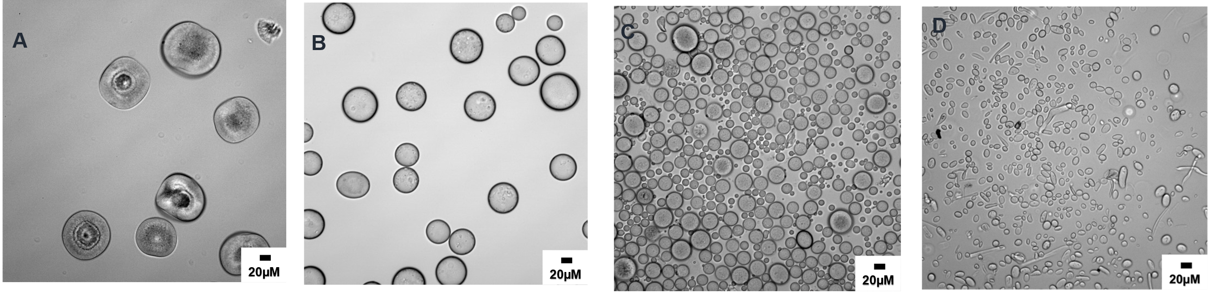
Figure S2: Optical micrograph showing the morphological differences of microparticles synthesized using 1% w/v PEG-PLGA in DCM, 0.005 v/v O/A PVR, 0.005 O/A PFRR, and 600RPM at varied PVA concentration: A) 0.5%w/v B) 1 %w/v C) 5% w/v, and D) 10% w/v. PVR: Phase volume ratio, PFRR: Phase flow rate ratio, O/A: Organic/Aqueous

Mean Aspect ratio (AR_{M}) | % of oval MPs  (AR >1.1) | % of oval MPs  (AR >1.25) | % of oval MPs  (AR >1.4) | % of oval MPs  (AR >1.6)
1.7 ± 0.4 | 99 | 89 | 75 | 57
Table S2: Aspect ratio of the particles shown Figure S2 D

Note: n = 100 particles, AR_{M} was calculated by averaging the individual AR of 100 particles. Where individual AR was calculated by the ratio of the major axis to the minor axis of each particle analyzed.

S3. Effect of drug encapsulation on microparticle size
The mean particle size of the microparticle was influenced by the type of the model drug or dye encapsulated in the microparticles. We observed no significant change in microparticle size upon encapsulation of the hydrophilic dye rhodamine 6G (Fig. S3) while encapsulation of the coumarin led to a small but significant increase in microparticle size. This may be due to coumarin being more hydrophobic and was encapsulated at much higher efficiency compared to rhodamine thus the significant change in size seen with coumarin.
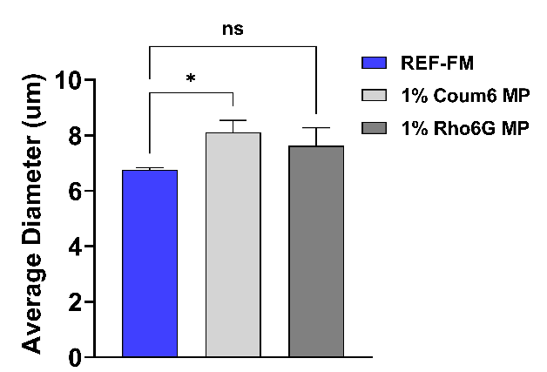
Figure S3: Effect of Rho6G and Coum6 loading on mean microparticle size and distribution.

S4. Effect of varying a combination of different process parameters on microparticle size.
To establish the versatility and tunability of the process we varied a combination of process parameters to obtain a range of microparticle sizes as listed in Table S3. We were to establish that by simultaneously varying the surfactant concentration, PVR, polymer concentration and stir rate we were further ablet o expand the range of microparticle sizes that can be obtained by this method to 50-100 μm.
Table S3: Average particle size of microparticles fabricated by varying a combination process parameter. The various formulation parameters are listed below.
Formulation code | Fabrication parameters | Size (μm) | %CV
A | 2.5%Pol in DCM, 2.5%PVA, 0.005PVR, 0.005PFRR, 300rpm | 50 ± 16.5 | 33
B | 5%Pol in DCM, 2.5%PVA, 0.005PVR, 0.005PFRR, 300rpm | 76.8 ± 20.8 | 27.1
C | 5%Pol in DCM, 1%PVA, 0.005PVR, 0.005PFRR, 600rpm | 102 ± 23.5 | 23
D | 1%Pol in DCM, 0.5%PVA, 0.005PVR, 0.005PFRR, 600rpm | 114.3 ± 23.1 | 20.2
Note: %CV based on single SD from a single run based over 100 microparticles sizes

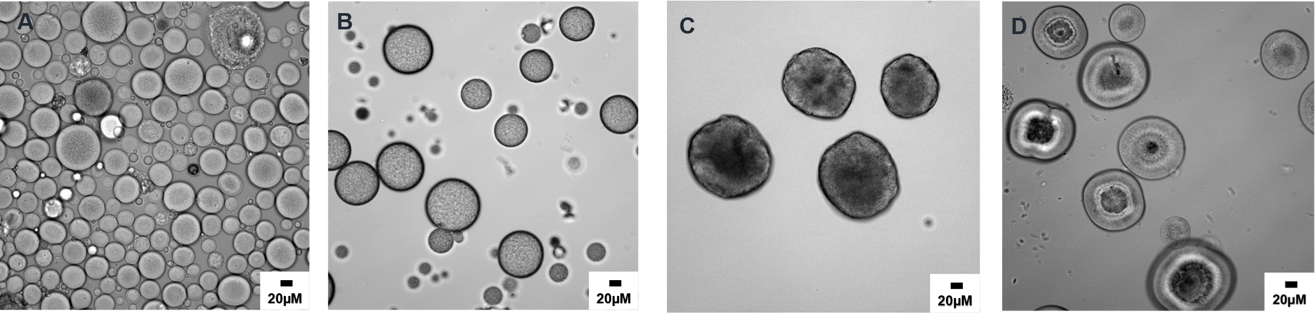
Figure S4 Optical micrograph of different size microparticles synthesized by varying a combination process parameter as indicated for various formulations in Table S3

