Table 6: Structure of GC-MS Analyzed Compounds Obtained from Five Wild Mushrooms
Mushroom Spp. | Structure and Name of the Compounds
auricula-judae | 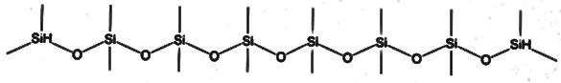  Octasiloxane, 1,1,3,3,5,5,7,7,9,9,11,11,13,13,15,15-hexadecamethyl- | 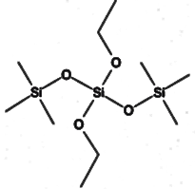  Silicic acid, diethyl bis(trimethylsilyl) ester | 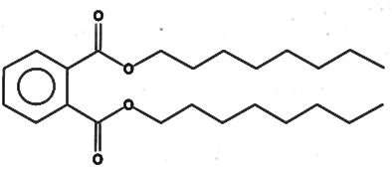  Di-n-octyl phthalate
 | 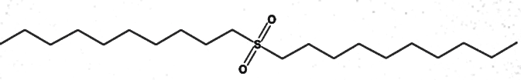  Di-n-decylsulfone | 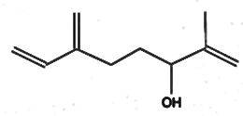  2-Methyl-6-methylene-octa-1,7-dien-3-ol | 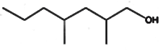  1-Heptanol, 2,4-dimethyl- (R, R)- (+)-
 | 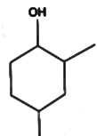  Cyclohexano, 2,4-dimethyl- | 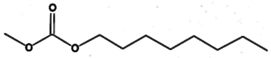  Carbonic acid, methyl octyl ester | 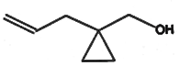  (1-Allylcyclopropyl) methanol
 | 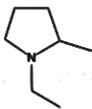  2-Methyl-1-ethylpyrrolidine | 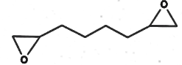  Oxirane, 2,2’-(1,4-dibutanediyl) bis- | 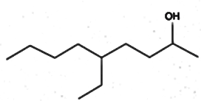  2-Nonanol, 5-ethyl-
 | 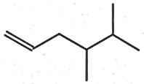  1-Hexene, 4, 5-dimthyl- | 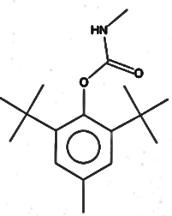  Phenol, 2,6-bis (1,1-dimethylethyl)-4-methyl-, methylcarbamate
M. xanthopus | 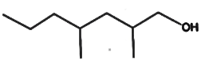  1-Heptanol, 2,4-dimethyl-, (2S, 4R) -(-)- | 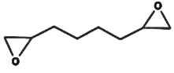  Oxirane, 2,2’-(1,4-butanediyl) bias- | 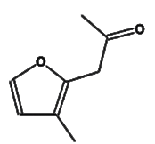  3-Methyl-2-(2-oxopropyl) furan
 | 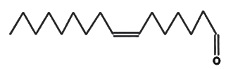  7-Hexadecenal, (Z)- | 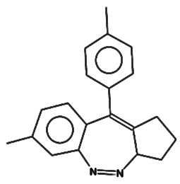  1,2,3,3a-Tetrahydro-7-methyl-10-4-methylphenyl) benzo [c] cyclopenta [f] -1,2-diazepine | 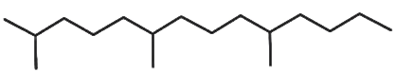  Tetradecane, 2,6,10-trimethyl-
 | Heptacosane | 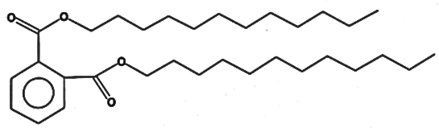  Didodecyl phthalate | 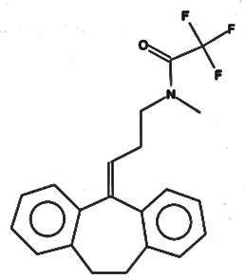  Acetamide, N-[3-(10,11-dihydro-5H-dibenzo [a,d] cyclohepten-5-ylidene)propyl] -2,2,2-triflouro-N-methyl
 | 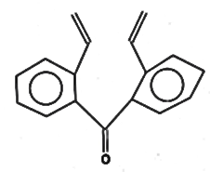  2,2’-Divinylbenzophenone | 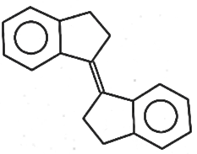  Trans-1, 1’-Bibenzoindanylidene | 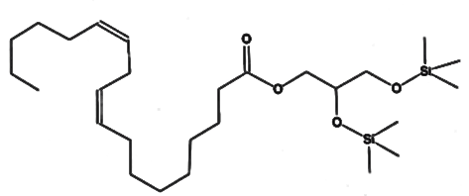  1-Monolinoleoylglycerol trimethylsilyl ether
T. umkowaani | 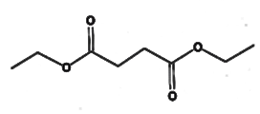  Butanedioic acid diethyl ester | 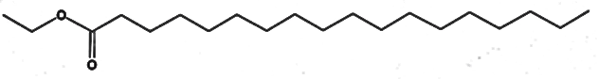  Octadecanoic acid, ethyl ester | 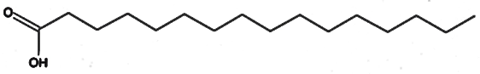  N-Hexadecanoic acid
 | 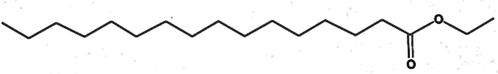  Hexadecanoic acid, ethyl ester | 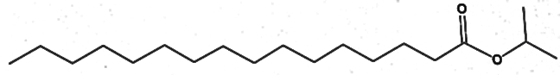  i-Propyl hexadecanoate | 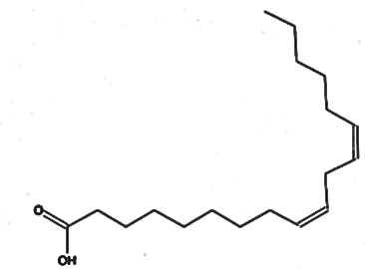  9,12-Octadecadienoic acid (Z, Z)-
 | 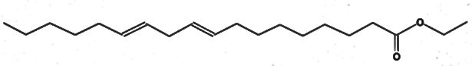  9,12-Octadecadienoic acid, ethyl ester | 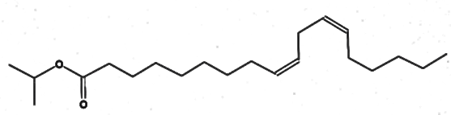  Isopropyl linoleate | 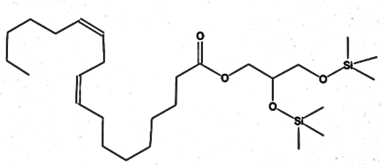  1-Monolinoleoylglycerol trimethylsilyl ether
 | 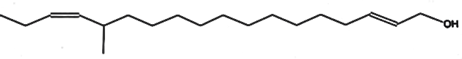  12-Methyl-E, E-2, 13-Octadecadien-1-ol | 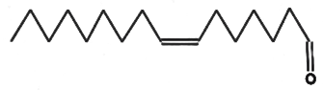  7-Hexadecenal, (Z)- | 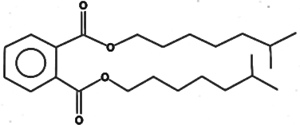  1, 2-Benzenedicarboxylic acid, diisooctyl ester
 | 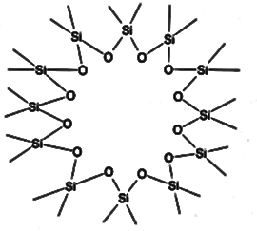  Tetracosamethyl-cyclododecasiloxane | 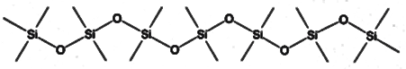  Heptasiloxane hexadecamethyl
T. elegans | 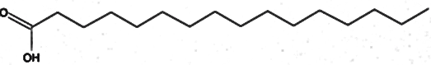  n-Hexadecanoic acid | 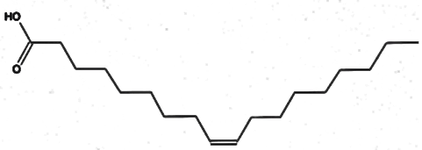  Oleic acid | 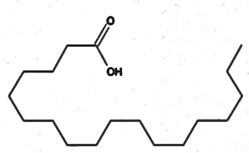  Octadecanoic acid
T. versicolor | 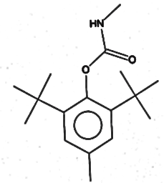  Phenol, 2,6-bis (1,1-dimethyl ethyl)-4- methyl, methylcarbamate | 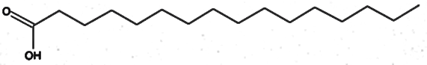  N-Hexadecanoic acid | Nonadecane
 | 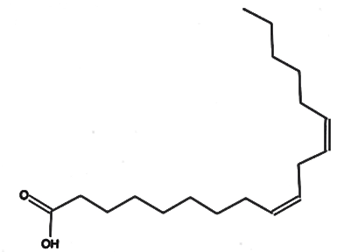  9,12-Octadecadienoic (Z, Z)- | 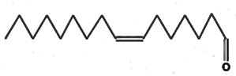  7-Hexadecenal, (Z)- | 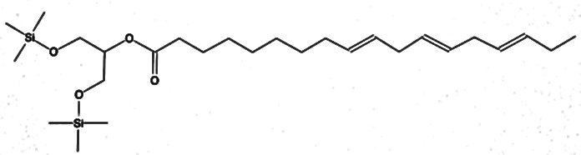  9,12,15-Octadecatrienoic acid, 2-[(trimethylsilyl) oxy]-1-[[(trimethylsilyl) oxy] methyl] ethyl ester (Z, Z, Z)-
 | 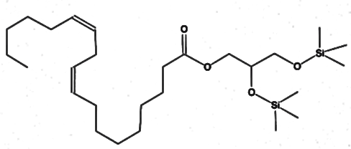  1-Momolinoleoylglycerol trimethylsilyl ether | 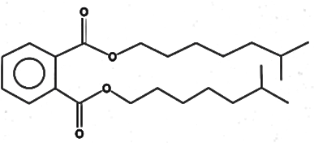  1,2-Benzenedicarboxylic acid, diisooctyl ester

