Supplemental Information: Classifying a highly polymorphic tree species across landscapes using airborne imaging spectroscopy
Seeley, M. M.; Vaughn, N. R.; Shanks, B.; Martin, R. E.; König, M; Asner, G. A.

Figures

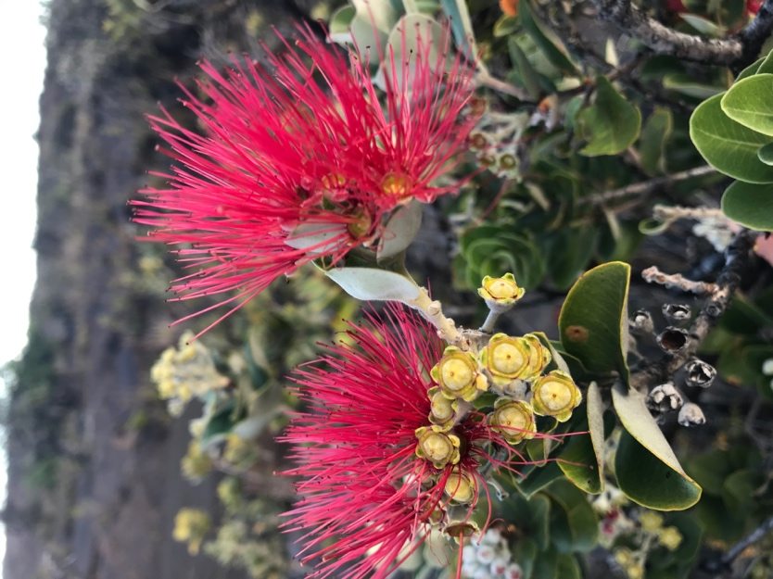
Figure S1: Metrosideros polymorpha ('ohi'a lehua) in bloom.

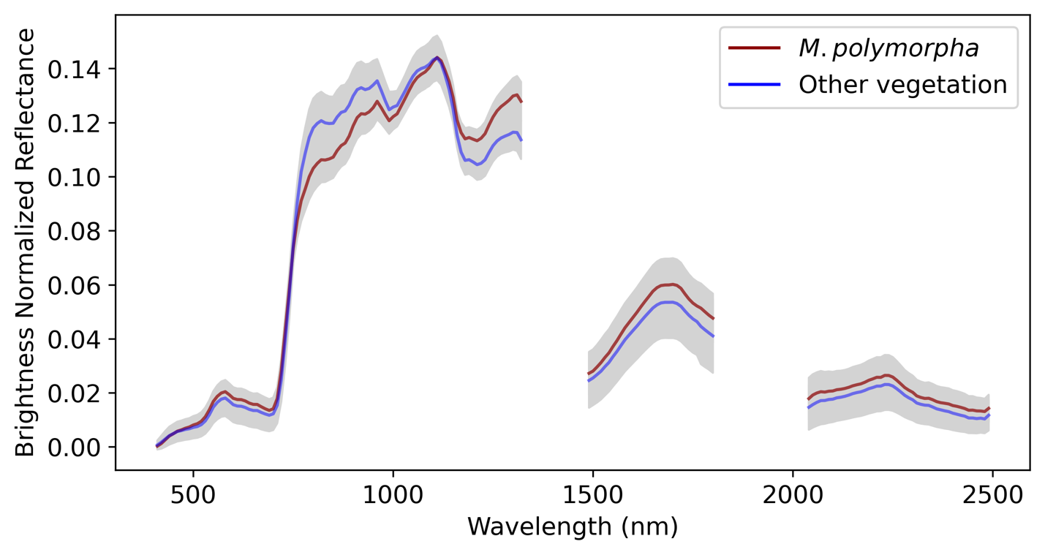

Figure S2: Mean spectra of Metrosideros polymorpha and other vegetation in spectral library.

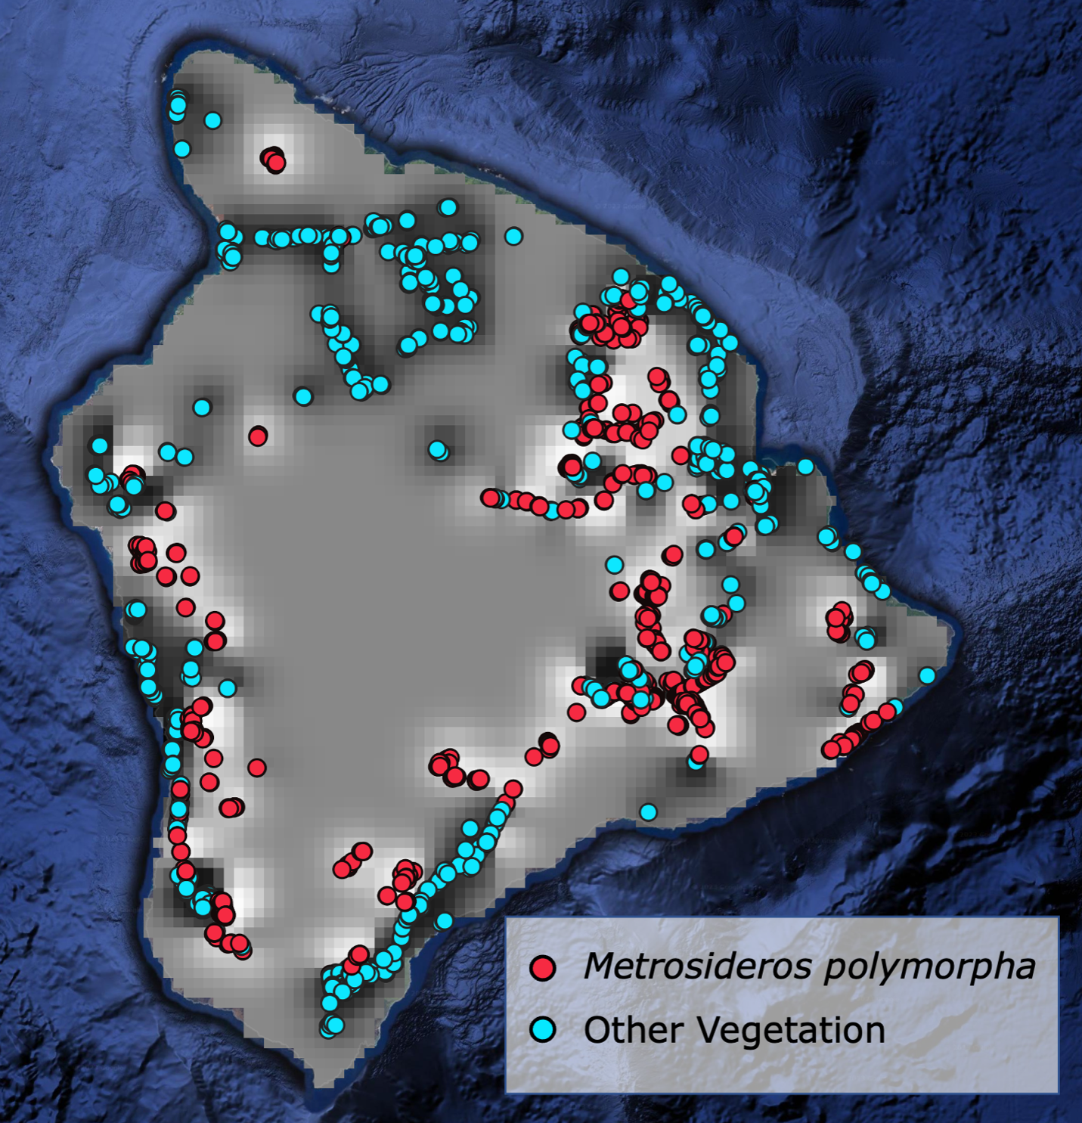
Figure S3: Location of the 5366 crowns collected across Hawai'i Island to train the classification models. Red represents all Metrosideros polymorpha canopies, and blue are all other vegetation types. Heatmap and contour lines are the gaussian process classification where white represents locations not likely to be M. polymorpha, and darker locations represent regions of high M. polymorpha likelihood.
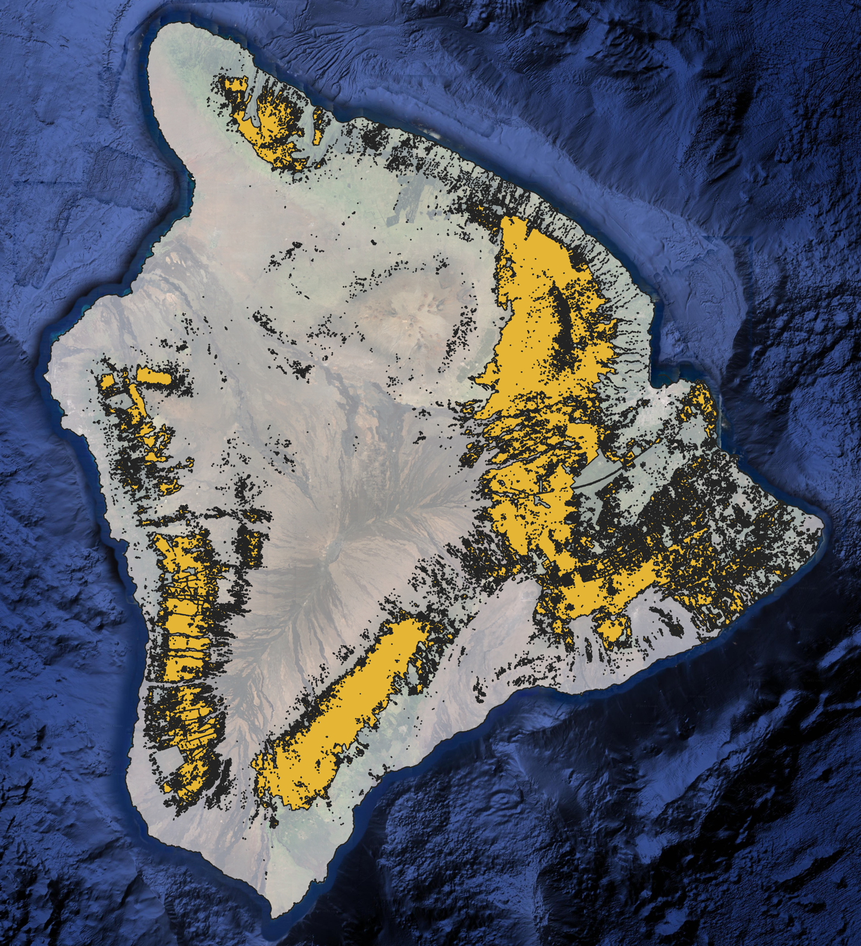
Figure S4: 2001 HI-GAP M. polymorpha extent as estimated using Landsat data

