- Review of Literature
In mountainous areas, there are several types of dynamic winds, diurnal wind, channelling wind and downslope wind (Sharples, 2009; Whiteman, 2000). Diurnal winds are microscale wind and generated by the insolation gap, and often known as thermally driven circulation because these are associated with a location of Sun in a day. Cloud coverage and azimuth are therefore important to measure an insolation. The diurnal wind usually blows from an area with higher pressure and lower temperature to another area with lower pressure and higher temperature (Whiteman, 2000). There are further categories in diurnal winds: along-slope, along-valley, cross-valley and mountain-plain wind systems (Table 1).
Table 1: Four forms of diurnal winds in mountain valleys: along-slope wind system, along-valley wind system, cross-valley wind system and mountain-plain wind system adapted from (Sharples, 2009)
# | Type | Description
A | Along-slope wind system | Around dawn, wind ascends along the slope of valley sidewalls while it descends around dusk.
B | Along-valley wind system | Wind rises along valley axis during the daytime and down during the night.
C | Cross-valley wind system | Wind blows perpendicular to the valley axis.
D | Mountain-plain wind system | It is similar to the along-slope wind system however its scale is larger than the other.

The second type is the wind blow within a valley between mountain ridges. The subtypes are downward transport of momentum, forced channelling and pressure driven wind (Table 2).

Table 2: channelling wind
# | Type | Description
1 | Downward transport of momentum | Deflected slightly toward the lower pressure
2 | Forced channelling | Deflected from geostrophic direction to a valley axis, abrupt wind speed change. This wind usually occurs in a small valley.
3 | Pressure driven channelling | From high to low pressure end in a valley, gradual wind speed change. This wind usually occurs in a large valley.

Terrain-forced flow requires three conditions: unstable or neutral stability, magnitude of wind approaching to terrain, and terrain feature and can be accelerated by Venturi or Bernoulli effect due to terrain structure (Whiteman, 2000).
Downward transport of momentum is caused when a strong upper air and a wind within a valley are vertically mixed, or the upper air is resonated with the sidewall by gravity wave. Consequently, the air aloft is dragged into the valley. This type of dynamic wind favours the valley whose bottom and sidewalls are flat and shallow respectively (Sharples, 2009; Whiteman & Doran, 1993).
Forced channelling wind is often abrupt and occurs when the friction across a valley is greater than the one along the valley (Sharples, 2009). It is preferable during daytime because atmosphere is generally less stable than one at night so that geostrophic wind can influence the ground surface level. In particular, this dynamic wind favours late morning in which nocturnal inversion is dismissed (Whiteman, 2000). This type of wind is prone to occur small, narrow mountain passes or saddles (Kossmann et al., 2001; Sharples, 2009). The wind magnitude is the highest under neutral atmospheric conditions and when the wind aloft enters a valley directly along the valley linear its axis (Sharples, 2009; Smedman et al., 1996; Whiteman, 2000). It is necessary to be cautious about the direction because this wind can suddenly change by 180 degrees when the wind aloft transverses across the valley axis (Sharples, 2009; Whiteman, 2000). The forced channel requires downward transport of momentum and can be strengthened by foehn effect at elevated areas (Whiteman, 2000).
Pressure driven channelling is the winds driven by the geostrophic pressure gradient within the valley when the synoptical atmospheric pressure gradient is greater than the local pressure gradient (Sharples, 2009; Whiteman, 2000; Whiteman & Doran, 1993). Long valley structure is favourable. On the other hand, this channelling wind often takes place in shallow valleys (Sharples, 2009). However, the pressure gradient is highly dependent on the depth of the valley (Whiteman & Doran, 1993). Unlike to forced channelling wind, the pressure driven channelling winds can occur in stable atmosphere and does not require downward transport of momentum (Smedman et al., 1996; Whiteman & Doran, 1993). The magnitude of this wind can be high near the surface, especially over the water in near linear valleys due to the absence of friction (Smedman et al., 1996; Whiteman & Doran, 1993). Similar to forced channelling winds, pressure driven channelling can change direction by 180 degrees when the synoptic wind shift the line perpendicular to the valley axis (Sharples, 2009; Whiteman, 2000).
These dynamic channellings can occur simultaneously and induce lee-slope rotor as well as pyro-cumulonimbus (Sharples, 2009). Fire extinguishment activities need to be conduct with clear instructions for the fire with these dynamic winds due to the nature of winds (Sharples, 2009).
The third dynamic wind is katabatic wind which often takes place with foehn effect. The air can be dried and heated adiabatically by foehn effect and can become downslope wind on the leeside after it surmounts the mountain barrier. This needs to be cautions for prescribed fire even in winter (Sharples, 2009). Dew point temperature is the temperature by which the water component in a given parcel is saturated at constant pressure (American Meteorological Society, 2020). The sudden drop of dew point temperature, which is the temperature by which the water component in a given parcel is saturated at constant pressure (American Meteorological Society, 2020), in an elevated weather station often helps identify the large scale downslope wind caused by the foehn effect (Sharples, 2009; Sharples et al., 2010). The downslope winds often occur in large scale in which the elevation of barriers are greater than 1 km (Kusaka & Fudeyasu, 2017). However, the elevation is not always necessary such height. For example, Waroona Fire 2016 was ignited by lightning hit and propagated down to the west coast of Western Australia. The ignition was about 500 m height and the total damaged area was approximately 700 $km^{2}$ (Peace et al., 2017)
The last dynamic wind is low-level jet. The low-level jet is the narrow airflow above the surface. It blows faster than the ones above and below and can take place from dawn till earlier morning (Sharples, 2009; Whiteman, 2000). There are some triggers. One is the thermal gap between ground surface and air aloft. After dawn, the ground is cooled faster than the above and the air aloft becomes more kinetic than ones in other altitudes. Another is local horizontal pressure gradient due to the different features of landcovers, which varies sensible and latent heat flux. Local pressure gradient can also be influenced by synoptic pressure gradient. The wind magnitude can be altered by terrain. For instance, the narrow gap can accelerate the wind (Sharples, 2009).

- Datasets
Comparison of fire isochrone is described (Table 3).
Table 3: Comparison of isochrones. STD, DEM stand for standard deviation and elevation model respectively. $Δ$ DEM is gap between highest and lowest DEM. Preposition P indicates previous study and C indicates current study in isochrone column.
Isochrone | Estimated ignition time | End | Area ($km^{2}$) | STD DEM (m) | $Δ$ DEM (m) (lowest: highest) | Ruggedness rank by STD DEM
C-1 | 2019/1/25 17:20 | 2019/1/28 15:30 | 24.86 | 64.42 | 336 (141:477) | 4
C-2 | 2019/1/28 15:10 | 2019/1/28 19:30 | 8.52 | 40.24 | 267 (244:511) | 5
P-1 | 2019/1/17 13:28 | 2019/1/22 1:45 | 9.94 | 77.46 | 335 (55:390) | 3
P-2 | 2019/1/16 13:26 | 2019/1/24 21:01 | 6.17 | 137.52 | 571 (167:738) | 2
P-3 | 2019/1/20 16:11:00 | 2019/1/24 21:01 | 9.77 | 151.14 | 619 (146: 765) | 1

- Result
  - Weather plots with cloud coverage (%), temperature (C) and dew point temperature (C)
    - Fire isochrone #1 with Station A

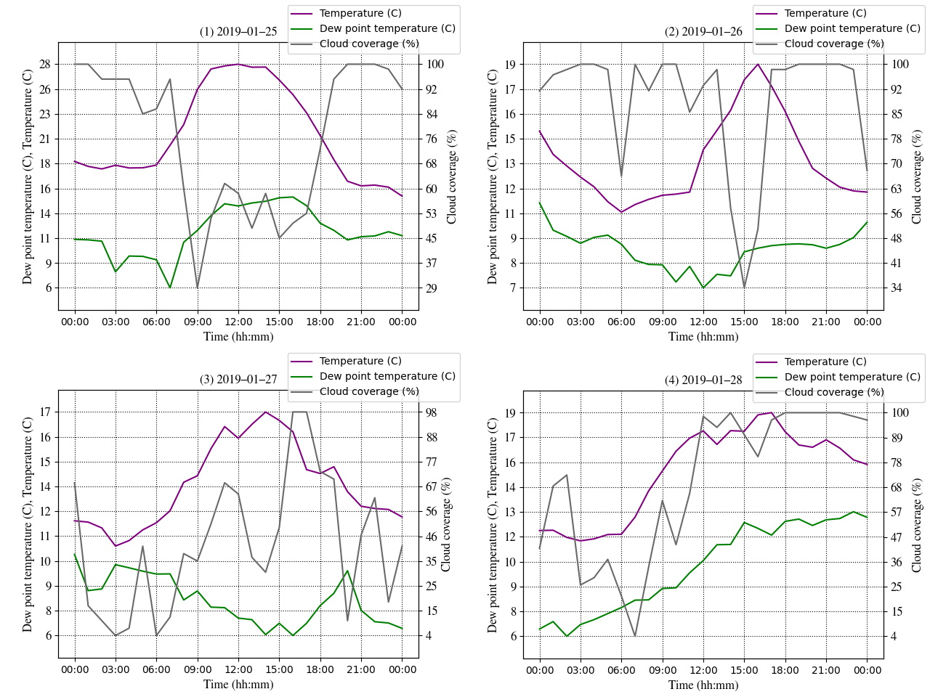
Figure 1: Other weather parameters in isochrone #1 with pseudo weather station A. (1) 25th, (2) 26th, (3) 27th, (4) 28th and (5) 29th in January 2019.

    - Fire isochrone #1 with Station B

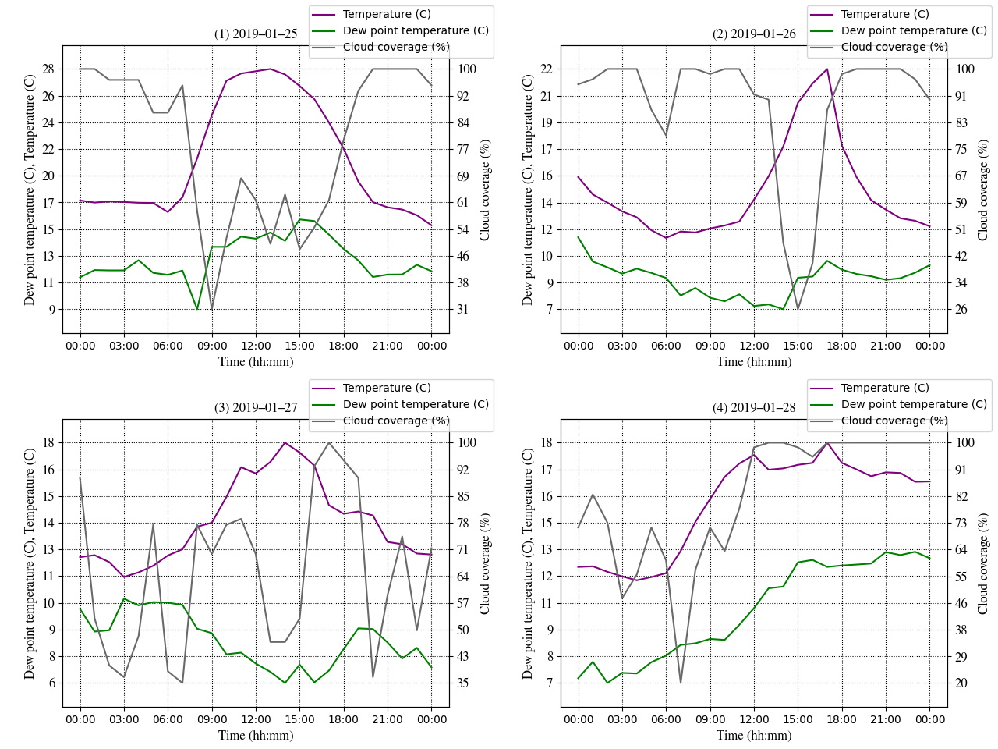
Figure 2: Other weather parameters in isochrone #1 with pseudo weather station B. (1) 25th, (2) 26th, (3) 27th, (4) 28th and (5) 29th in January 2019.

    - Fire isochrone #2 with Station C

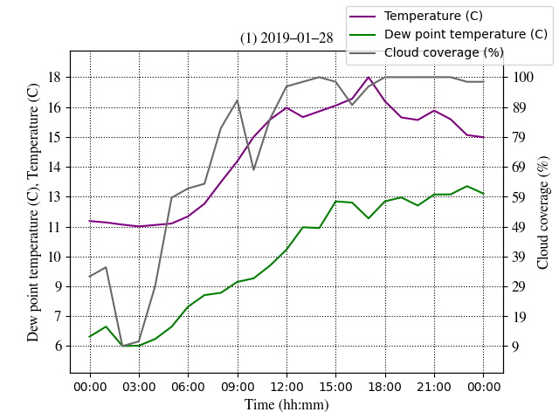
Figure 3: Other weather parameters in isochrone #2 with pseudo weather station C on 28th in January 2019.

    - Fire isochrone #2 with Station D

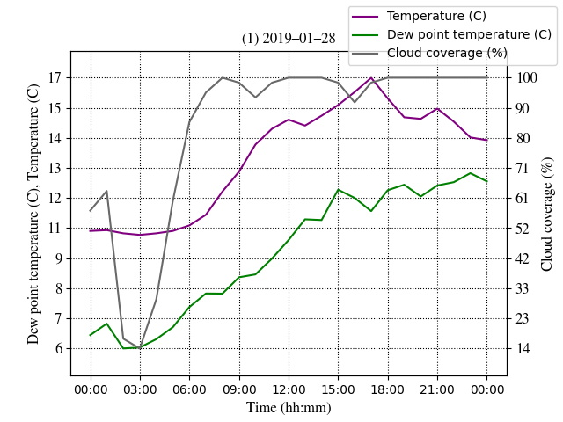
Figure 4: Other weather parameters in isochrone #2 with pseudo weather station D on 28th in January 2019.

  - Downslope angle and fire speed

Table 4: Fire speed ($mh^{-1}$), downslope angle (º), and distance from ignition to the bottom (m) at Station B with BARRA-TA.
 | Delaunay | Diamond | Hexagon | Square | Voronoi | Average | Medium
Fire speed ($mh^{-1}$) | 154.05 | 166.83 | 181.61 | 188.89 | 279.77 | 194.23 | 181.61
Downslope (º) | 19.40 | 16.75 | 17.07 | 19.53 | 18.65 | 18.28 | 18.65
Distance (m) | 738.38 | 883.88 | 866.03 | 750.00 | 773.49 | 802.35 | 773.49

Table 5: Fire speed ($mh^{-1}$), downslope angle (º), and distance from ignition to the bottom (m) in isochrone #1 at Station B with downscaled wind.
 | Delaunay | Diamond | Hexagon | Square | Voronoi | Average | Medium
Fire speed ($mh^{-1}$) | 173.99 | 266.75 | 412.28 | 261.91 | 450.36 | 313.06 | 266.75
Downslope (º) | 19.40 | 14.21 | 11.84 | 19.53 | 18.65 | 16.72 | 18.65
Distance (m) | 738.38 | 1030.78 | 1250.00 | 750.00 | 773.49 | 908.53 | 773.49

  - Fire simulation
    - Fire isochrone #1 with Station A
Table 6: Fraction skills score (FSS), confusion matrix (CM) including threat score¹ and Cohen’s Kappa score in isochrone #1 at Station A with BARRA-TA.
Verification method | Indicator | Delaunay | Diamond | Hexagon | Square | Voronoi | Average | Medium
Duration (days) | – | 2.05 | 1.88 | 1.93 | 1.90 | 1.53 | 1.86 | 1.90
FSS | – | 0.62 | 0.57 | 0.61 | 0.54 | 0.57 | 0.58 | 0.57
 | Useful | 0.50 | 0.50 | 0.50 | 0.50 | 0.50 | 0.50 | 0.50
CM | Accuracy | 1.00 | 1.00 | 1.00 | 1.00 | 1.00 | 1.00 | 1.00
 | Misclassification Rate | 0.00 | 0.00 | 0.00 | 0.00 | 0.00 | 0.00 | 0.00
 | Precision | 0.87 | 0.82 | 0.87 | 0.76 | 0.80 | 0.82 | 0.82
 | Specificity | 1.00 | 1.00 | 1.00 | 1.00 | 1.00 | 1.00 | 1.00
 | Prevalence | 0.01 | 0.01 | 0.01 | 0.01 | 0.01 | 0.01 | 0.01
 | True positive rate | 0.42 | 0.39 | 0.41 | 0.37 | 0.39 | 0.40 | 0.39
 | False positive rate | 0.00 | 0.00 | 0.00 | 0.00 | 0.00 | 0.00 | 0.00
 | Threat score¹ | 0.39 | 0.36 | 0.39 | 0.33 | 0.35 | 0.37 | 0.36
Cohen’s kappa | – | 0.56 | 0.53 | 0.56 | 0.49 | 0.52 | 0.53 | 0.53

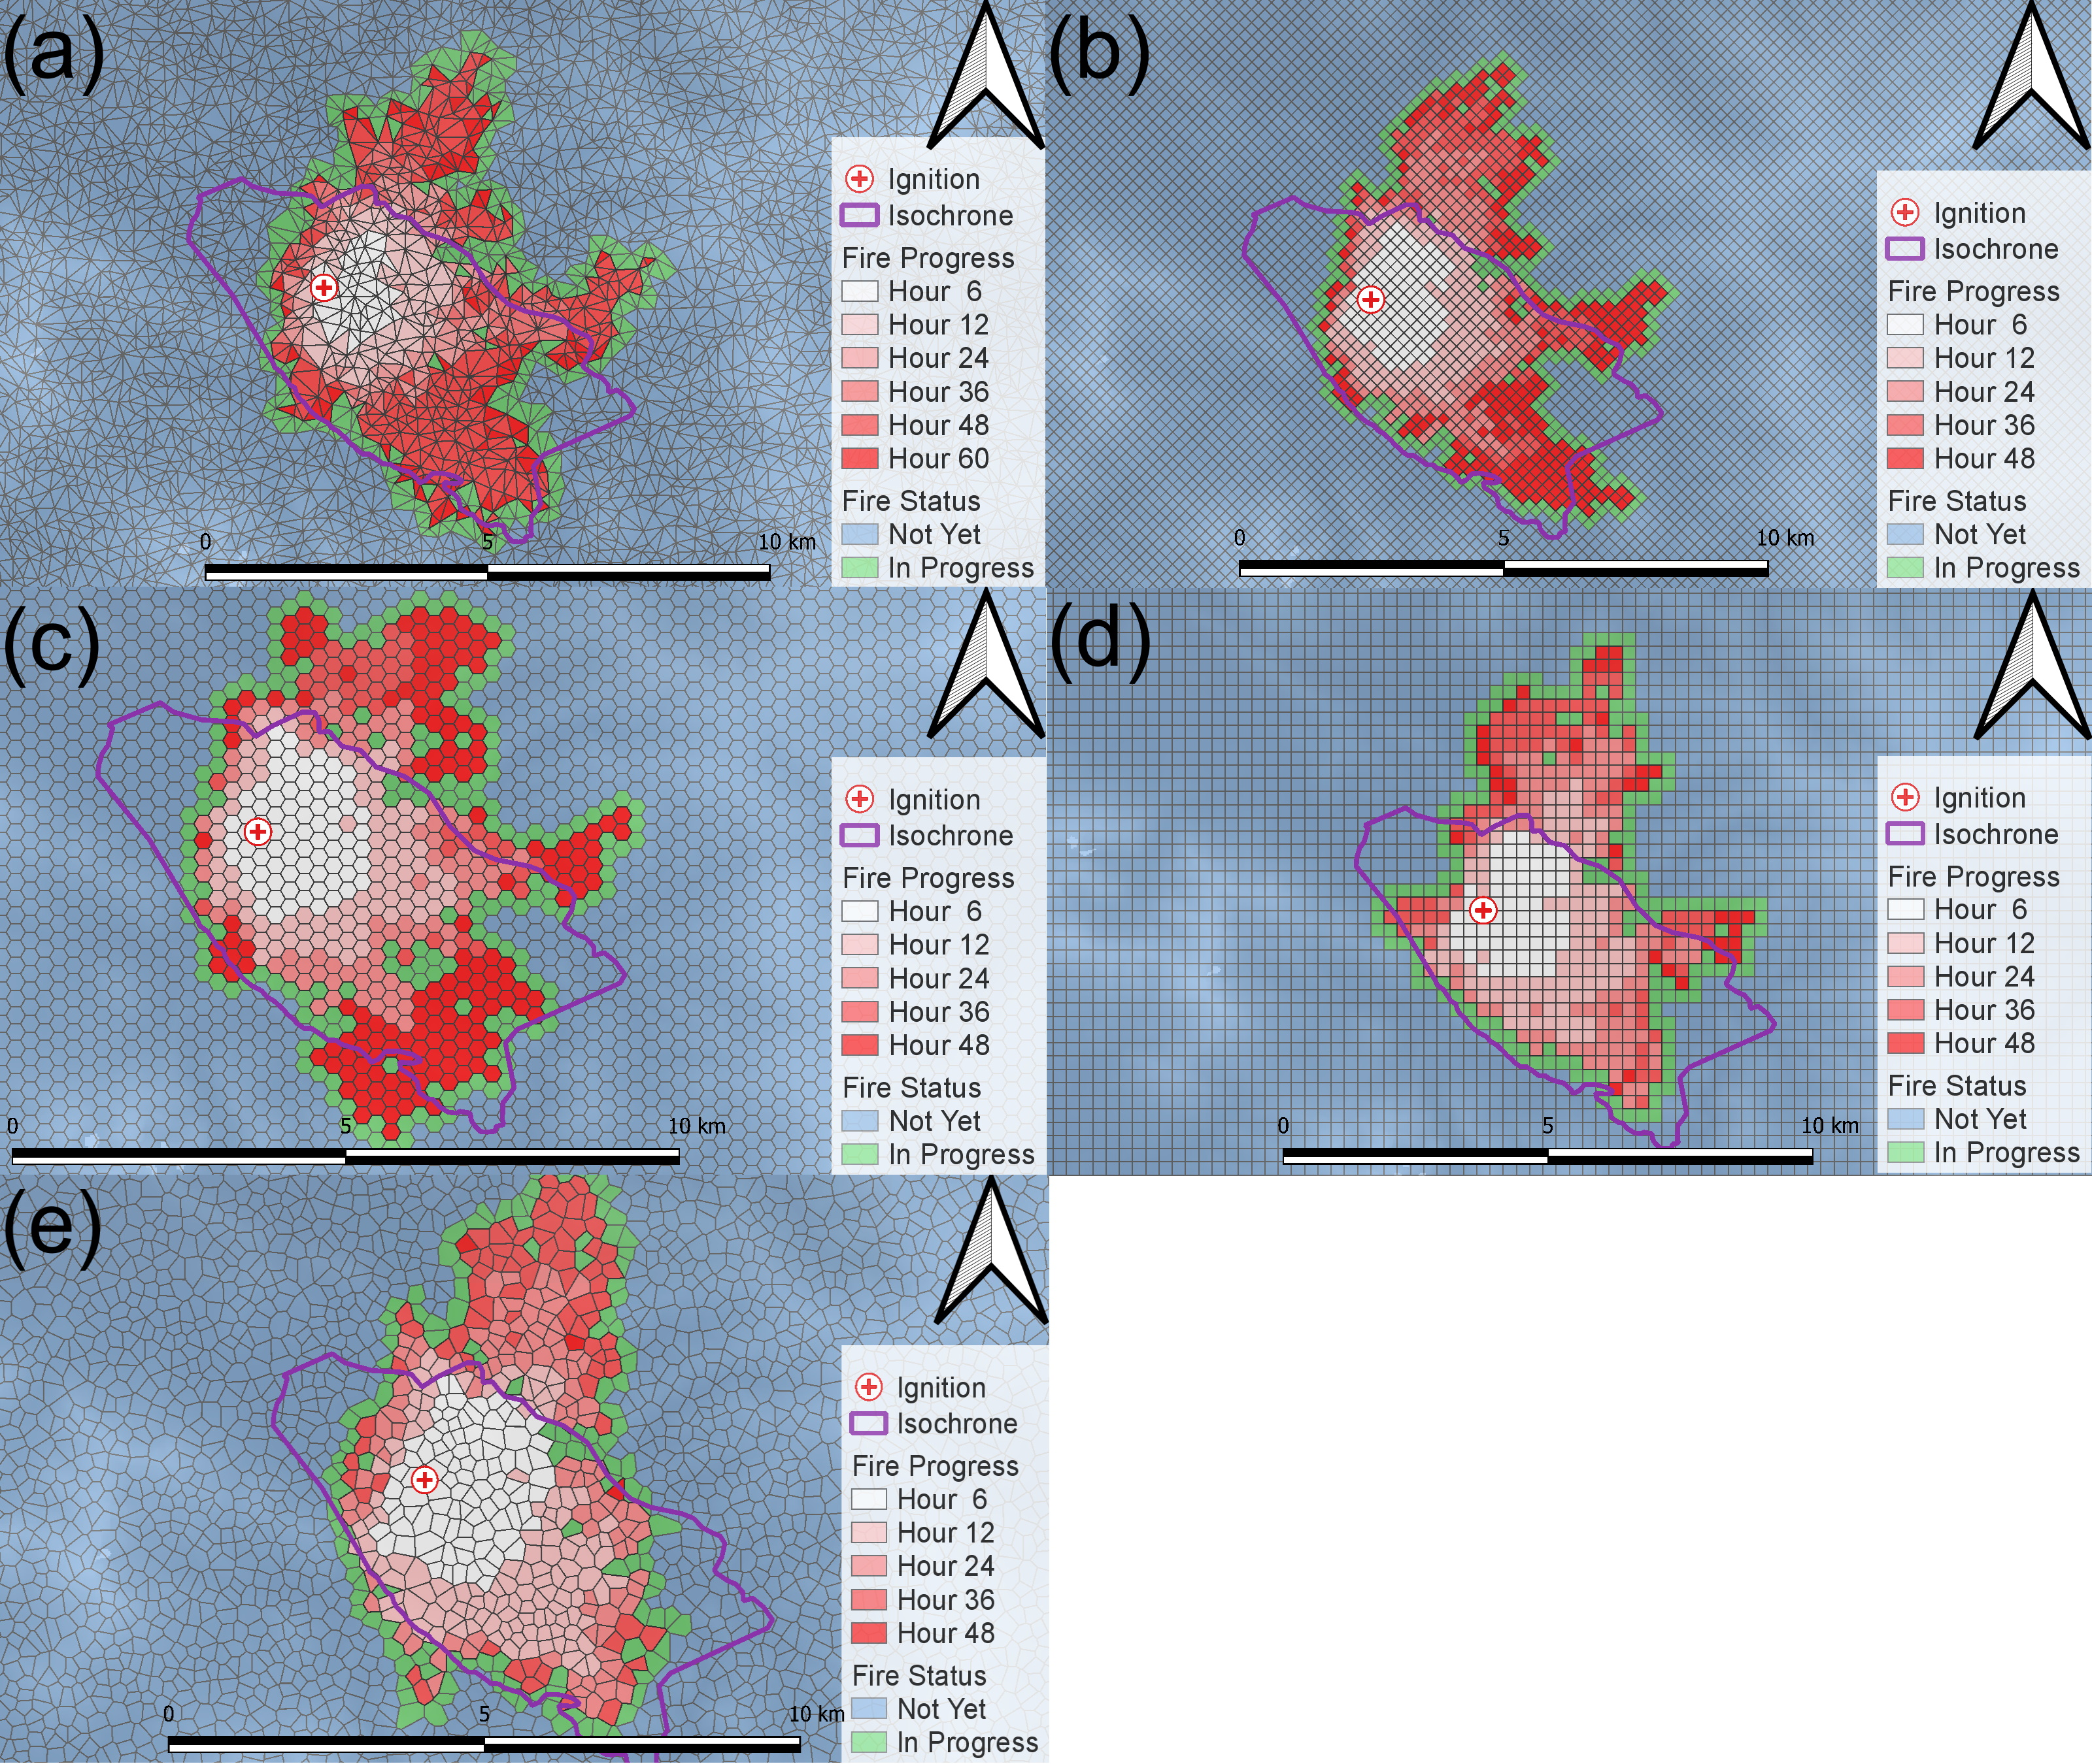
Figure 5: Fire simulation with BARRA-TA wind in isochrone #1 ignited at pseudo station A. (a) Delaunay, (b) diamond (c) hexagon, (d) Square and (e) Voronoi.

Table 7: Fraction skills score (FSS), confusion matrix (CM) including threat score¹ and Cohen’s Kappa score in isochrone #1 at Station A with downscaled wind
Verification method | Indicator | Delaunay | Diamond | Hexagon | Square | Voronoi | Average | Medium
Duration (days) | – | 1.79 | 0.88 | 0.73 | 0.59 | 0.46 | 0.89 | 0.73
FSS | – | 0.67 | 0.66 | 0.68 | 0.67 | 0.69 | 0.67 | 0.67
 | Useful | 0.50 | 0.50 | 0.50 | 0.50 | 0.50 | 0.50 | 0.50
CM | Accuracy | 1.00 | 1.00 | 1.00 | 1.00 | 1.00 | 1.00 | 1.00
 | Misclassification Rate | 0.00 | 0.00 | 0.00 | 0.00 | 0.00 | 0.00 | 0.00
 | Precision | 0.95 | 0.95 | 0.99 | 0.96 | 0.99 | 0.97 | 0.96
 | Specificity | 1.00 | 1.00 | 1.00 | 1.00 | 1.00 | 1.00 | 1.00
 | Prevalence | 0.01 | 0.01 | 0.01 | 0.01 | 0.01 | 0.01 | 0.01
 | True positive rate | 0.45 | 0.46 | 0.47 | 0.46 | 0.48 | 0.46 | 0.46
 | False positive rate | 0.00 | 0.00 | 0.00 | 0.00 | 0.00 | 0.00 | 0.00
 | Threat score¹ | 0.44 | 0.45 | 0.47 | 0.45 | 0.47 | 0.45 | 0.45
Cohen’s kappa | – | 0.61 | 0.62 | 0.64 | 0.62 | 0.64 | 0.63 | 0.62

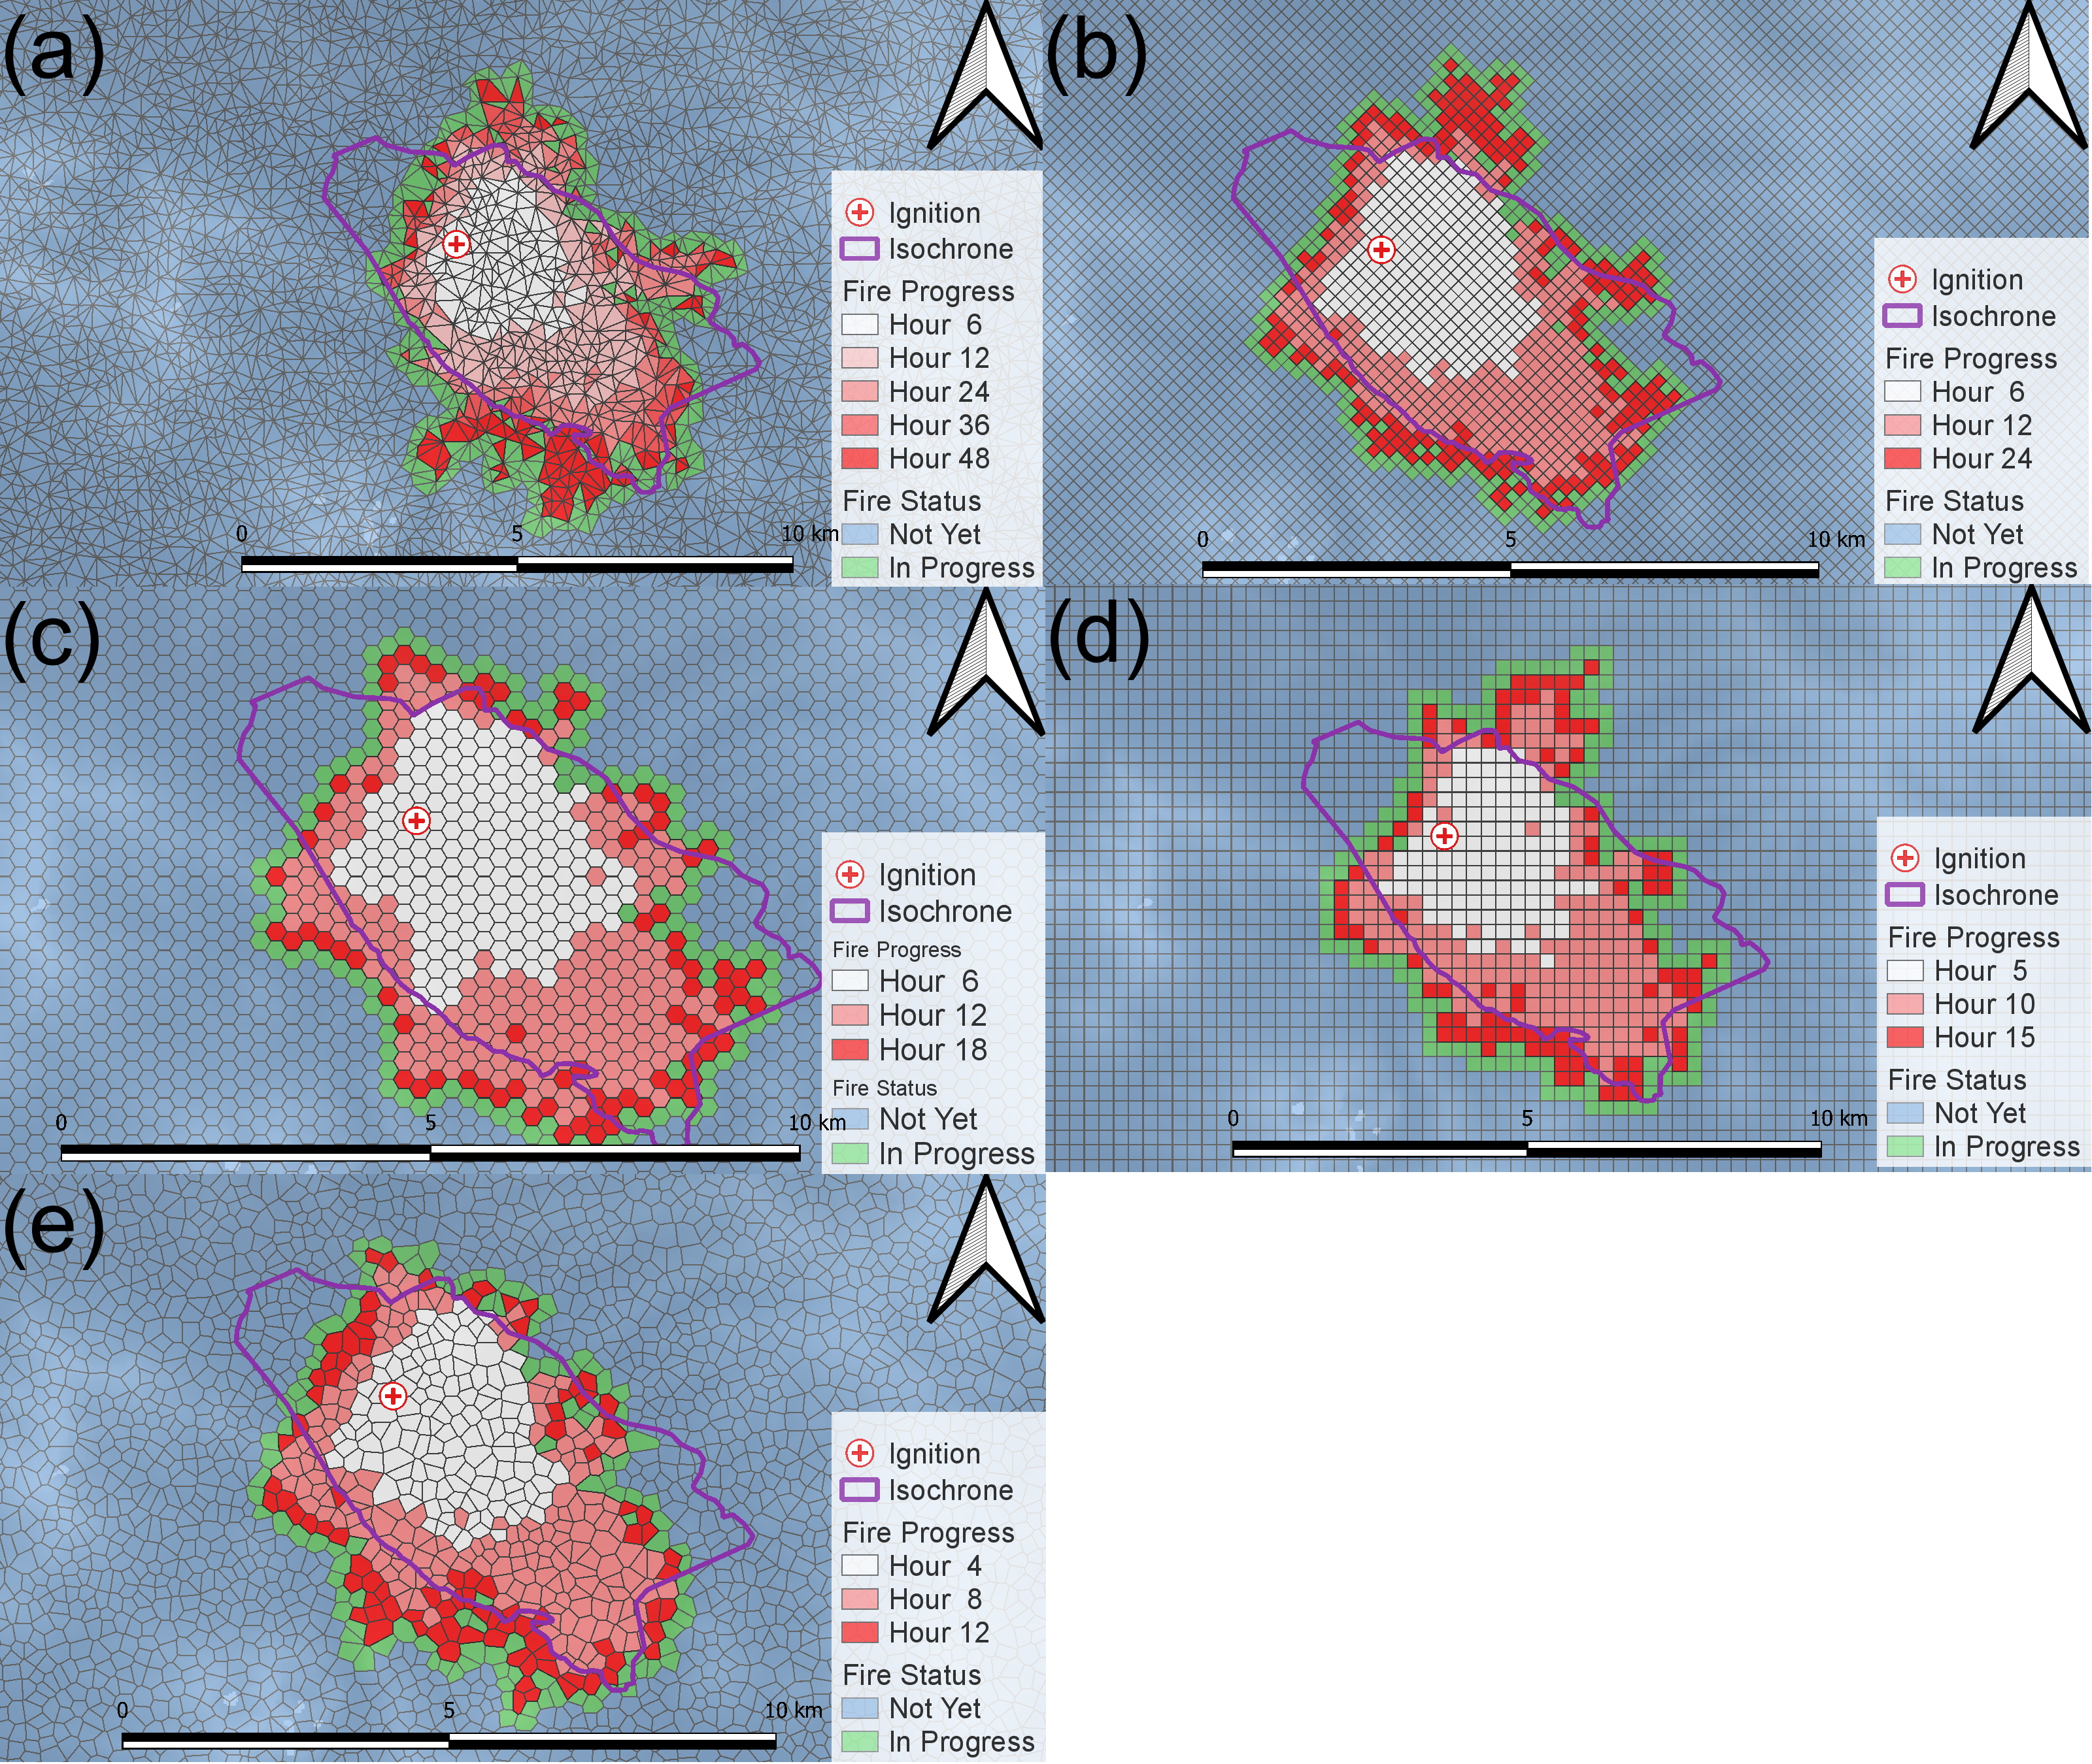
Figure 6: Fire simulation with downscaled wind in isochrone #1 ignited at pseudo station A. (a) Delaunay, (b) diamond (c) hexagon, (d) Square and (e) Voronoi.

    - Fire isochrone #1 with Station B
Table 8: Fraction skills score (FSS), confusion matrix (CM) including threat score¹ and Cohen’s Kappa score in isochrone #1 at Station B with BARRA-TA.
Verification method | Indicator | Delaunay | Diamond | Hexagon | Square | Voronoi | Average | Medium
Duration (days) | – | 2.33 | 2.03 | 2.32 | 2.03 | 1.92 | 2.13 | 2.03
FSS | – | 0.53 | 0.49 | 0.62 | 0.51 | 0.57 | 0.54 | 0.53
 | Useful | 0.50 | 0.50 | 0.50 | 0.50 | 0.50 | 0.50 | 0.50
CM | Accuracy | 1.00 | 0.99 | 1.00 | 0.99 | 1.00 | 1.00 | 1.00
 | Misclassification Rate | 0.00 | 0.01 | 0.00 | 0.01 | 0.00 | 0.00 | 0.00
 | Precision | 0.73 | 0.70 | 0.90 | 0.70 | 0.81 | 0.77 | 0.73
 | Specificity | 1.00 | 1.00 | 1.00 | 1.00 | 1.00 | 1.00 | 1.00
 | Prevalence | 0.01 | 0.01 | 0.01 | 0.01 | 0.01 | 0.01 | 0.01
 | True positive rate | 0.36 | 0.34 | 0.43 | 0.34 | 0.39 | 0.37 | 0.36
 | False positive rate | 0.00 | 0.00 | 0.00 | 0.00 | 0.00 | 0.00 | 0.00
 | Threat score¹ | 0.32 | 0.29 | 0.41 | 0.30 | 0.36 | 0.33 | 0.32
Cohen’s kappa | – | 0.48 | 0.45 | 0.58 | 0.45 | 0.52 | 0.50 | 0.48

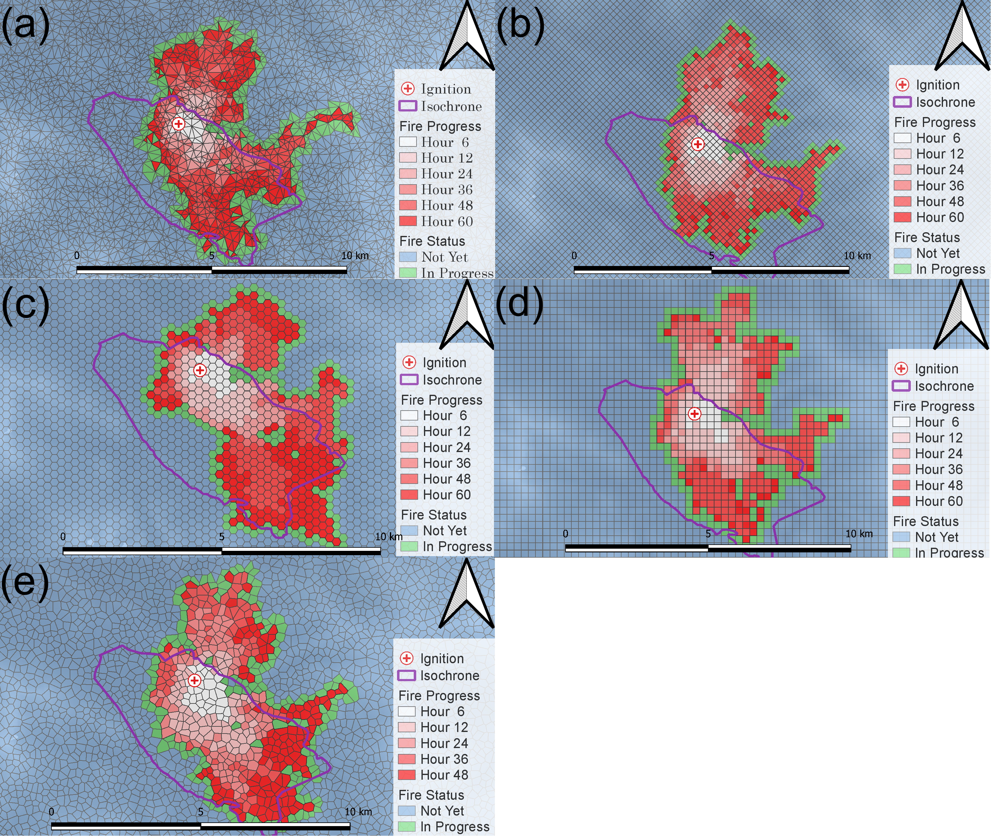
Figure 7: Fire simulation with BARRA-TA wind in isochrone #1 ignited at pseudo station B. (a) Delaunay, (b) diamond (c) hexagon, (d) Square and (e) Voronoi.

Table 9: Fraction skills score (FSS), confusion matrix (CM) including threat score¹ and Cohen’s Kappa score in isochrone #1 at Station B with downscaled wind
Verification method | Indicator | Delaunay | Diamond | Hexagon | Square | Voronoi | Average | Medium
Duration (days) | – | 2.03 | 1.83 | 1.86 | 1.56 | 1.10 | 0.94 | 1.68
FSS | – | 0.63 | 0.57 | 0.65 | 0.58 | 0.64 | 0.61 | 0.63
 | Useful | 0.50 | 0.50 | 0.50 | 0.50 | 0.50 | 0.50 | 0.50
CM | Accuracy | 1.00 | 1.00 | 1.00 | 1.00 | 1.00 | 1.00 | 1.00
 | Misclassification Rate | 0.00 | 0.00 | 0.00 | 0.00 | 0.00 | 0.00 | 0.00
 | Precision | 0.90 | 0.82 | 0.93 | 0.82 | 0.91 | 0.87 | 0.90
 | Specificity | 1.00 | 1.00 | 1.00 | 1.00 | 1.00 | 1.00 | 1.00
 | Prevalence | 0.01 | 0.00 | 0.01 | 0.01 | 0.01 | 0.01 | 0.01
 | True positive rate | 0.44 | 0.87 | 0.44 | 0.39 | 0.44 | 0.52 | 0.44
 | False positive rate | 0.00 | 0.00 | 0.00 | 0.00 | 0.00 | 0.00 | 0.00
 | Threat score¹ | 0.42 | 0.72 | 0.43 | 0.36 | 0.42 | 0.46 | 0.42
Cohen’s kappa | – | 0.59 | 0.53 | 0.60 | 0.53 | 0.59 | 0.57 | 0.59

Figure 8: Fire simulation with downscaled wind in isochrone #1 ignited at pseudo station B. (a) Delaunay, (b) diamond (c) hexagon, (d) Square and (e) Voronoi.

    - Fire isochrone #2 with Station C

Table 10: Fraction skills score (FSS), confusion matrix (CM) including threat score¹ and Cohen’s Kappa score in isochrone #2 at Station C with BARRA-TA
Verification method | Indicator | Delaunay | Diamond | Hexagon | Square | Voronoi | Average | Medium
Duration (days) | – | 0.88 | 0.73 | 0.72 | 0.64 | 0.49 | 0.69 | 0.72
FSS | – | 0.61 | 0.57 | 0.58 | 0.58 | 0.59 | 0.59 | 0.58
 | Useful | 0.50 | 0.50 | 0.50 | 0.50 | 0.50 | 0.50 | 0.50
CM | Accuracy | 1.00 | 1.00 | 1.00 | 1.00 | 1.00 | 1.00 | 1.00
 | Misclassification Rate | 0.00 | 0.00 | 0.00 | 0.00 | 0.00 | 0.00 | 0.00
 | Precision | 0.99 | 0.96 | 0.99 | 0.96 | 0.93 | 0.97 | 0.96
 | Specificity | 1.00 | 1.00 | 1.00 | 1.00 | 1.00 | 1.00 | 1.00
 | Prevalence | 0.00 | 0.00 | 0.00 | 0.00 | 0.00 | 0.00 | 0.00
 | True positive rate | 0.37 | 0.35 | 0.36 | 0.35 | 0.36 | 0.36 | 0.36
 | False positive rate | 0.00 | 0.00 | 0.00 | 0.00 | 0.00 | 0.00 | 0.00
 | Threat score¹ | 0.37 | 0.35 | 0.36 | 0.34 | 0.36 | 0.36 | 0.36
Cohen’s kappa | – | 0.54 | 0.52 | 0.53 | 0.51 | 0.52 | 0.52 | 0.52

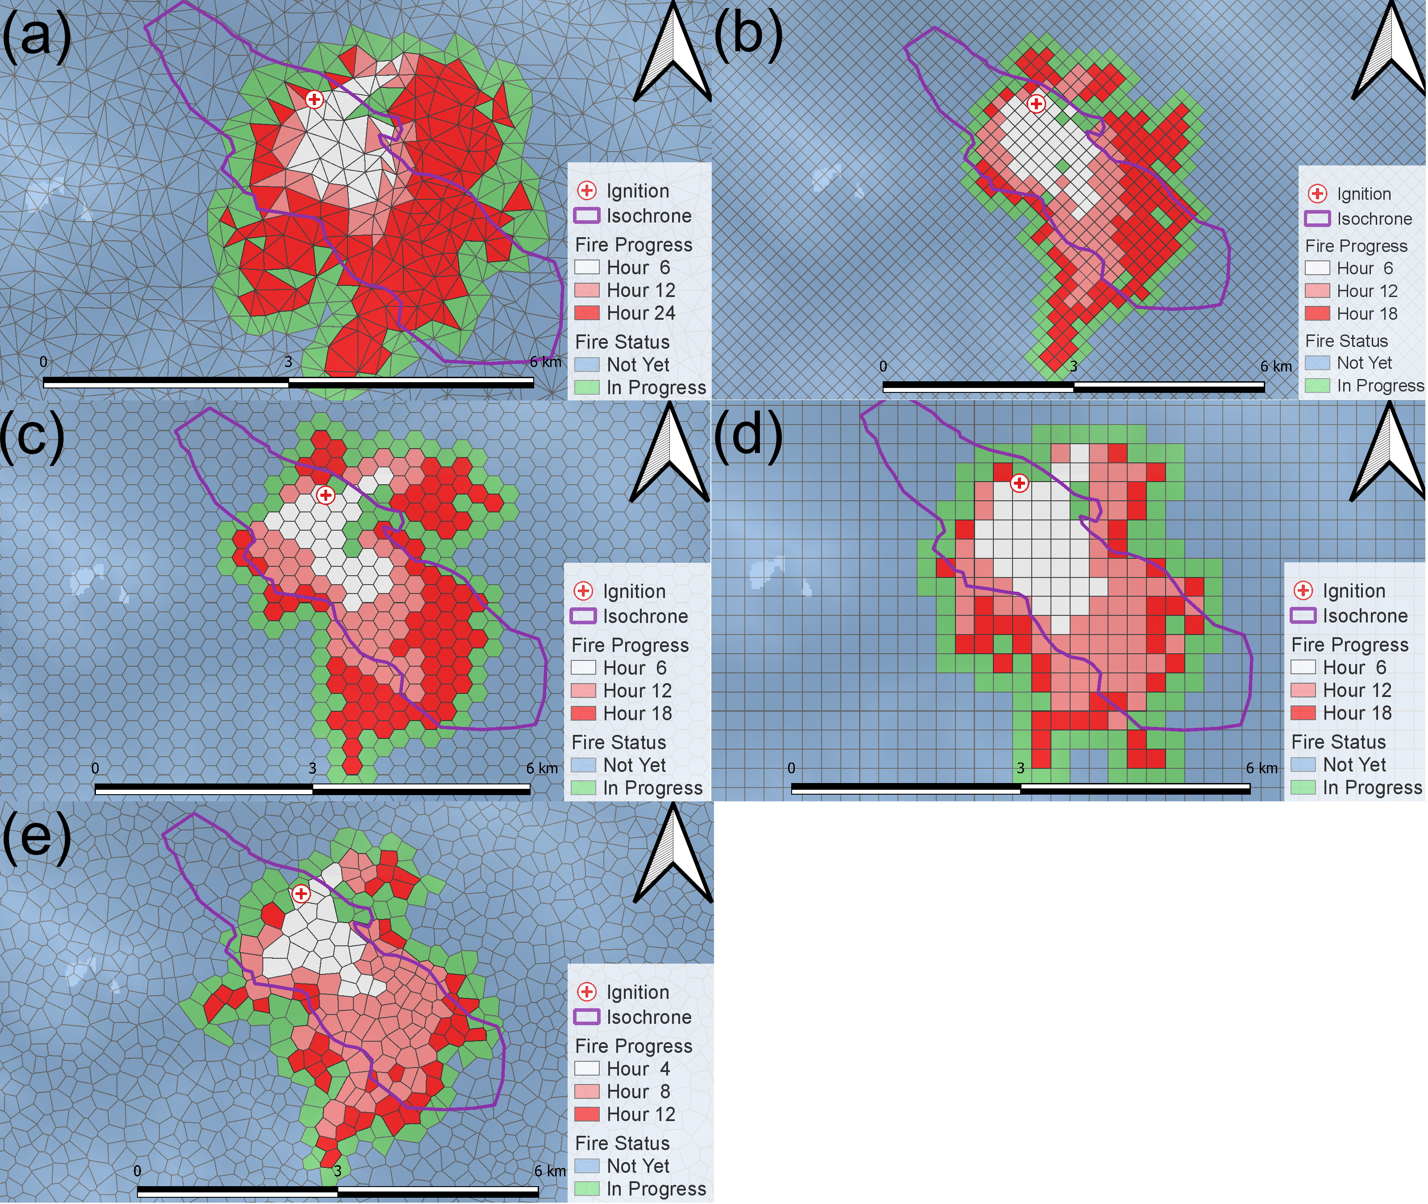
Figure 9: Fire simulation with BARRA-TA wind in isochrone #2 ignited at pseudo station C. (a) Delaunay, (b) diamond (c) hexagon, (d) Square and (e) Voronoi.

Table 11: Fraction skills score (FSS), confusion matrix (CM) including threat score¹ and Cohen’s Kappa score in isochrone #2 at Station C with the downscaled wind
Verification method | Indicator | Delaunay | Diamond | Hexagon | Square | Voronoi | Average | Medium
Duration (days) | – | 1.02 | 0.71 | 0.70 | 0.64 | 0.47 | 0.71 | 0.70
FSS | – | 0.59 | 0.56 | 0.57 | 0.58 | 0.59 | 0.58 | 0.58
 | Useful | 0.50 | 0.50 | 0.50 | 0.50 | 0.50 | 0.50 | 0.50
CM | Accuracy | 1.00 | 1.00 | 1.00 | 1.00 | 1.00 | 1.00 | 1.00
 | Misclassification Rate | 0.00 | 0.00 | 0.00 | 0.00 | 0.00 | 0.00 | 0.00
 | Precision | 0.95 | 0.94 | 0.95 | 0.96 | 0.92 | 0.95 | 0.95
 | Specificity | 1.00 | 1.00 | 1.00 | 1.00 | 1.00 | 1.00 | 1.00
 | Prevalence | 0.00 | 0.00 | 0.00 | 0.00 | 0.00 | 0.00 | 0.00
 | True positive rate | 0.35 | 0.35 | 0.35 | 0.35 | 0.36 | 0.35 | 0.35
 | False positive rate | 0.00 | 0.00 | 0.00 | 0.00 | 0.00 | 0.00 | 0.00
 | Threat score¹ | 0.35 | 0.34 | 0.34 | 0.34 | 0.35 | 0.34 | 0.34
Cohen’s kappa | – | 0.52 | 0.51 | 0.51 | 0.51 | 0.52 | 0.51 | 0.51

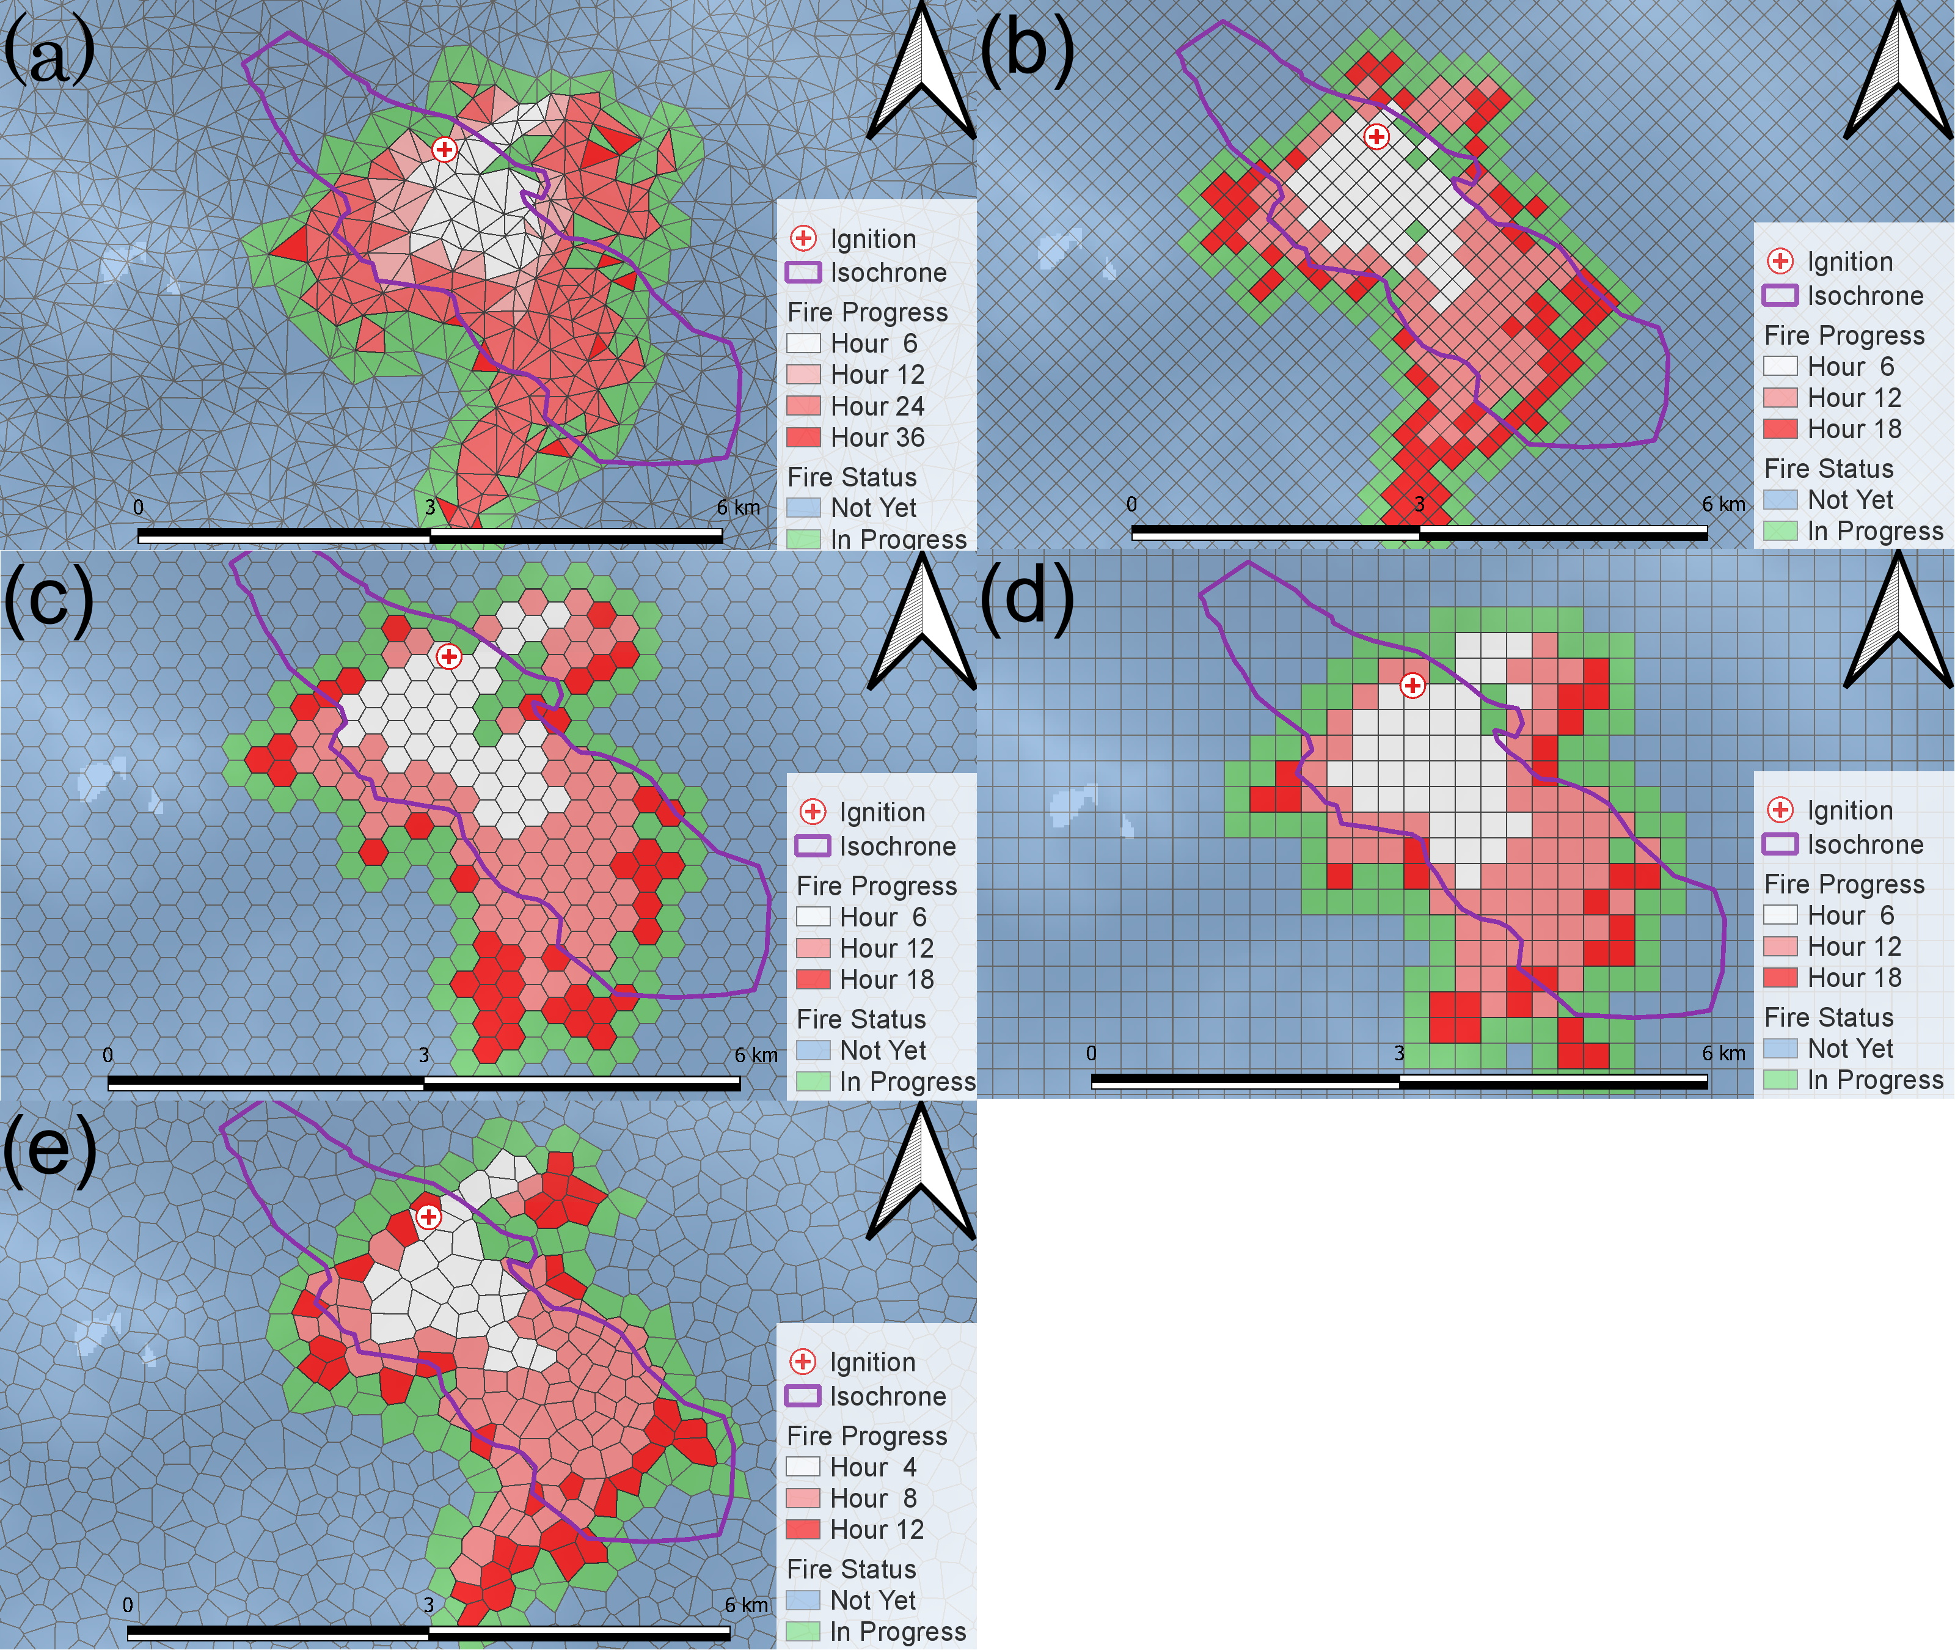
Figure 10: Fire simulation with downscaled wind in isochrone #2 ignited at pseudo station C. (a) Delaunay, (b) diamond (c) hexagon, (d) Square and (e) Voronoi.

    - Fire isochrone #2 with Station D

Table 12: Fraction skills score (FSS), confusion matrix (CM) including threat score¹ and Cohen’s Kappa score in isochrone #2 at Station D with BARRA-TA
Verification method | Indicator | Delaunay | Diamond | Hexagon | Square | Voronoi | Average | Medium
Duration (days) | – | 0.92 | 0.78 | 0.75 | 0.74 | 0.62 | 0.76 | 0.75
FSS | – | 0.39 | 0.46 | 0.39 | 0.47 | 0.46 | 0.43 | 0.46
 | Useful | 0.50 | 0.50 | 0.50 | 0.50 | 0.50 | 0.50 | 0.50
CM | Accuracy | 1.00 | 1.00 | 1.00 | 1.00 | 1.00 | 1.00 | 1.00
 | Misclassification Rate | 0.00 | 0.00 | 0.00 | 0.00 | 0.00 | 0.00 | 0.00
 | Precision | 0.66 | 0.78 | 0.68 | 0.79 | 0.79 | 0.74 | 0.78
 | Specificity | 1.00 | 1.00 | 1.00 | 1.00 | 1.00 | 1.00 | 1.00
 | Prevalence | 0.00 | 0.00 | 0.00 | 0.00 | 0.00 | 0.00 | 0.00
 | True positive rate | 0.24 | 0.29 | 0.25 | 0.29 | 0.28 | 0.27 | 0.28
 | False positive rate | 0.00 | 0.00 | 0.00 | 0.00 | 0.00 | 0.00 | 0.00
 | Threat score¹ | 0.21 | 0.27 | 0.22 | 0.27 | 0.26 | 0.24 | 0.26
Cohen’s kappa | – | 0.35 | 0.42 | 0.36 | 0.42 | 0.41 | 0.39 | 0.41

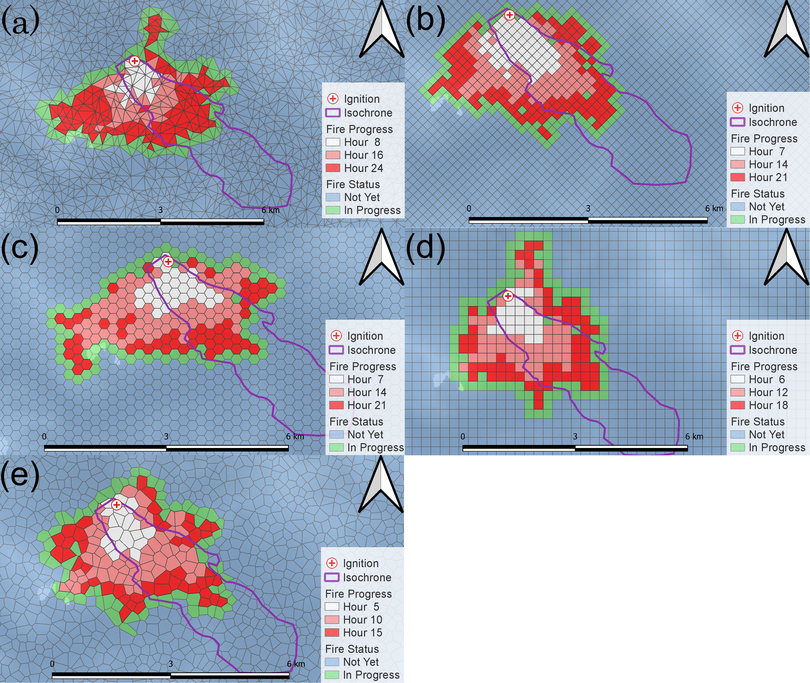
Figure 11: Fire simulation with BARRA-TA wind in isochrone #2 ignited at pseudo station D. (a) Delaunay, (b) diamond (c) hexagon, (d) Square and (e) Voronoi.

Table 13: Fraction skills score (FSS), confusion matrix (CM) including threat score¹ and Cohen’s Kappa score in isochrone #2 at Station D with the downscaled wind
Verification method | Indicator | Delaunay | Diamond | Hexagon | Square | Voronoi | Average | Medium
Duration (days) | – | 0.88 | 0.79 | 0.69 | 0.53 | 0.43 | 0.66 | 0.69
FSS | – | 0.36 | 0.42 | 0.40 | 0.45 | 0.41 | 0.40 | 0.41
 | Useful | 0.50 | 0.50 | 0.50 | 0.50 | 0.50 | 0.50 | 0.50
CM | Accuracy | 1.00 | 1.00 | 1.00 | 1.00 | 1.00 | 1.00 | 1.00
 | Misclassification Rate | 0.00 | 0.00 | 0.00 | 0.00 | 0.00 | 0.00 | 0.00
 | Precision | 0.61 | 0.71 | 0.68 | 0.75 | 0.69 | 0.69 | 0.69
 | Specificity | 1.00 | 1.00 | 1.00 | 1.00 | 1.00 | 1.00 | 1.00
 | Prevalence | 0.00 | 0.00 | 0.00 | 0.00 | 0.00 | 0.00 | 0.00
 | True positive rate | 0.21 | 0.26 | 0.25 | 0.27 | 0.25 | 0.25 | 0.25
 | False positive rate | 0.00 | 0.00 | 0.00 | 0.00 | 0.00 | 0.00 | 0.00
 | Threat score¹ | 0.19 | 0.24 | 0.22 | 0.25 | 0.23 | 0.22 | 0.23
Cohen’s kappa | – | 0.32 | 0.38 | 0.37 | 0.40 | 0.37 | 0.37 | 0.37

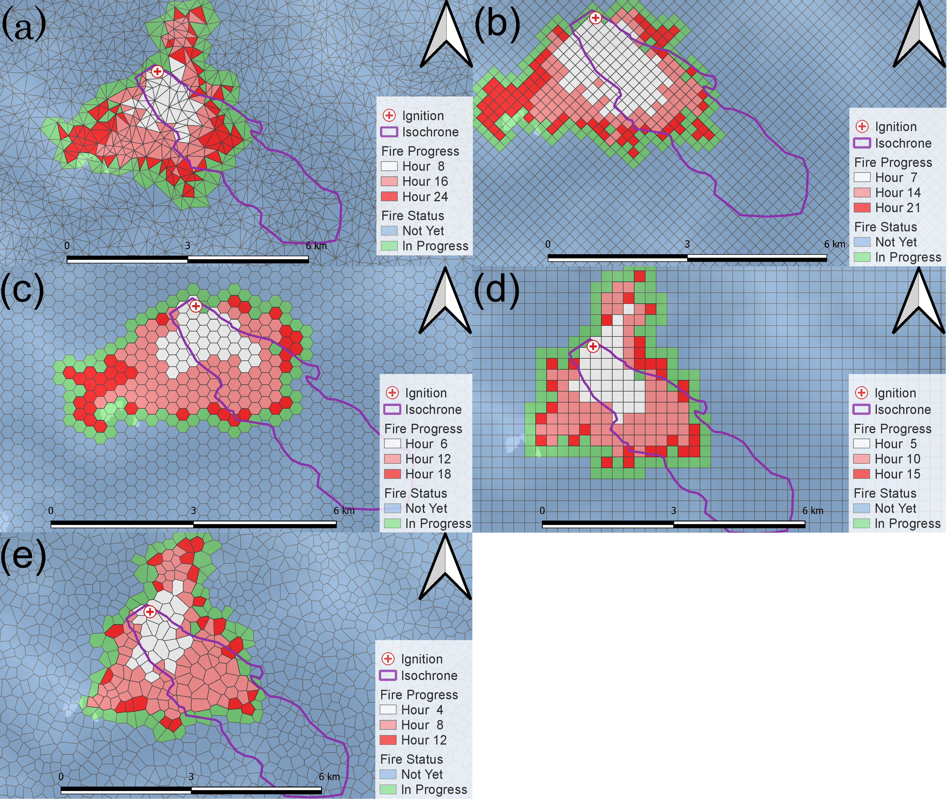
Figure 12: Fire simulation with downscaled wind in isochrone #2 ignited at pseudo station D. (a) Delaunay, (b) diamond (c) hexagon, (d) Square and (e) Voronoi.

- REFERENCES
Kossmann, M., Sturman, A., & Zawar-Reza, P. (2001). Atmospheric influences on bush fire propagation and smoke dispersion over complex terrain. 3–6.
Kusaka, H., & Fudeyasu, H. (2017). Review of downslope windstorms in Japan. Wind and Structures, 24(6), 637–656.
Peace, M., Mccaw, L., Santos, B., Kepert, J. D., Burrows, N., & Fawcett, R. J. (2017). Meteorological drivers of extreme fire behaviour during the Waroona bushfire, Western Australia, January 2016. Journal of Southern Hemisphere Earth Systems Science, 67(2), 79–106.
Sharples, J. J. (2009). An overview of mountain meteorological effects relevant to fire behaviour and bushfire risk. International Journal of Wildland Fire, 18(7), 737–754.
Smedman, A.-S., Bergström, H., & Högström, U. (1996). Measured and modelled local wind field over a frozen lake in a mountainous area. Contributions to Atmospheric Physics 69, 501–516.
Whiteman, C. D. (2000). Mountain meteorology: Fundamentals and applications. Oxford University Press: New York, USA,.
Whiteman, C. D., & Doran, J. C. (1993). The relationship between overlying synoptic-scale flows and winds within a valley. Journal of Applied Meteorology, 32(11), 1669–1682.

