(Supplementary Materials)
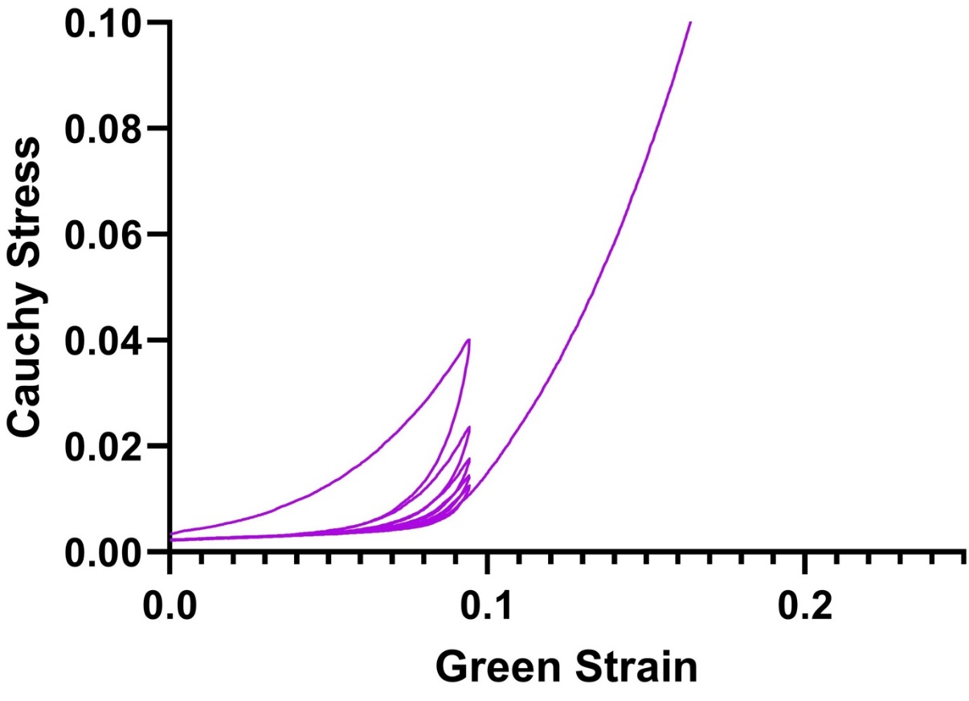
Figure S1. Cauchy stress-Green strain behaviour of a single representative sample from the 27-hour elastase-treated group over five preconditioning cycles to 10% engineering strain before being stretched to failure. Notably, the slope of the curve decreases with each preconditioning cycle giving rise to the flattened appearance of the initial component of the curves seen in this group in Figure 5 (e).
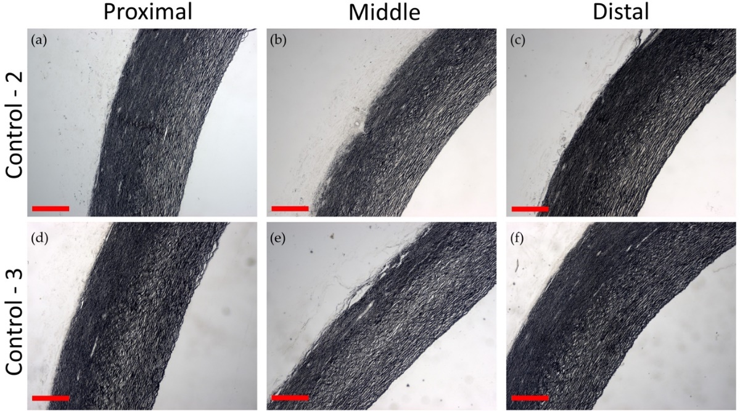
Figure S2. Representative Verhoeff’s elastin stained slices at proximal, middle and distal sites from whole aortae (n=3) treated with control solution (DMEM) for 9 hours. (a-c) and (d-f) demonstrate sections cut from the second and third aortae treated respectively. Slices from the first aorta are shown in Figure 8 (a-c). Scale bars represent 500 μm.
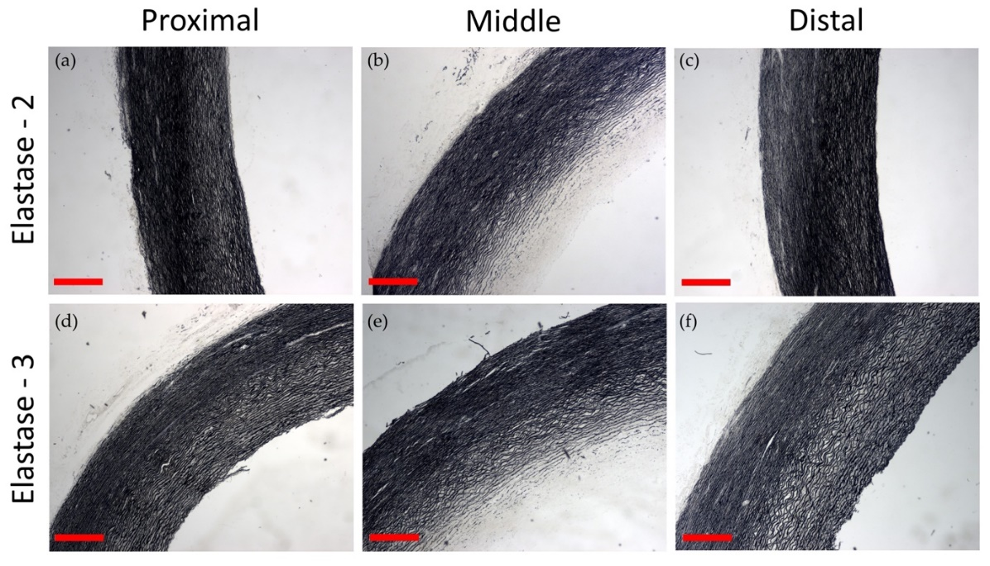
Figure S3. Representative Verhoeff’s elastin stained slices at proximal, middle (treated), and distal sites from whole aortae (n=3) treated with elastase solution for 9 hours. (a-c) and (d-f) demonstrate sections cut from the second and third aortae treated respectively. Slices from the first aorta are shown in Figure 8 (d-e). Scale bars represent 500 μm.

