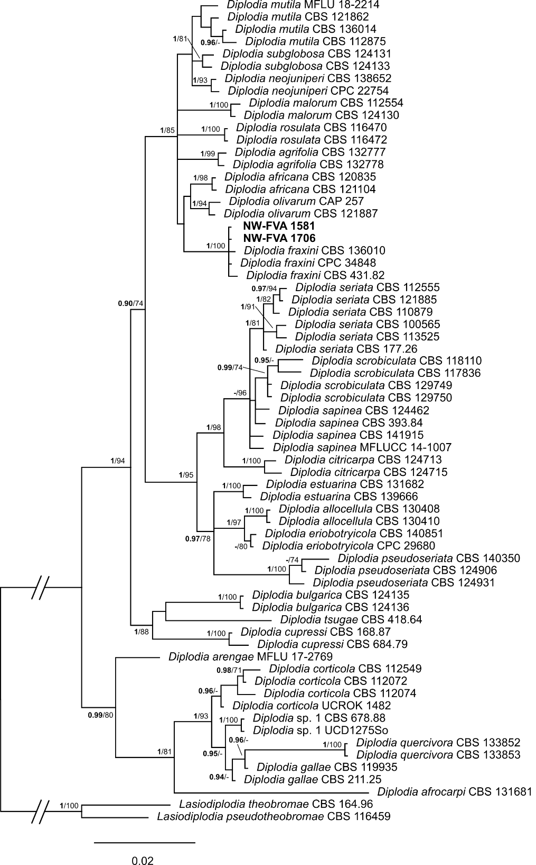
Figure S1: Phylogeny obtained by bayesian inference analysis of the combined ITS, EF1-α, and TUB sequence alignment of Diplodia species. BI posterior probability support values above 90 % (bold) and ML bootstrap support values above 70 % are shown at the nodes. Strains analysed in this study are emphasised in bold. Branches that are crossed by diagonal lines are shortened by 50 %.
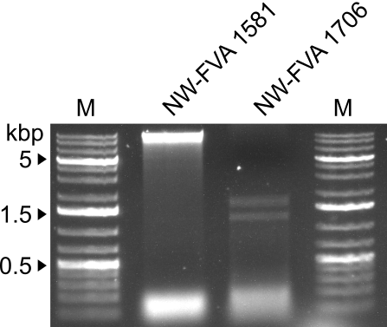
Figure S2: Agarose gel electrophoresis (1 % w/v) of dsRNA extracted from fungal tissue of NW-FVA 1581 and NW-FVA 1706. M, GeneRuler 1 kb plus ladder (Thermo Fisher Scientific). The sizes of the marker are given on the left.

Figure S3: Sequence of DfFV1b with annotated peptides identifies by protein sequencing.

Figure S4: Sequence of DfPV1, segment 2 with annotated peptides identified by protein sequencing.
Appendix B
Table S1: Sequences of oligonucleotides used in this publication.
Number # | Name | Sequence 5‘ – 3‘
1 | Partitivirus-RNA-I-REV | TTCGGGCTTACGCGTGAATCC
2 | Partitivirus-RNA1-II-FW | ATCGGTCTCTTCGATCGG
3 | Partitivirus-RNA2-REV-NEU | AACTTTCCAGGCATCGGC
4 | Partitivirus-RNA2-II-FW | TTCGTTGGAGGGTTAACGCG
5 | Partitivirus-RNA3-I-REV | TCTTAACGCTTCGTCGTACGG
6 | Partitivirus-RNA3-II-FW | TTCCTCGAAGCTCACAACTCGG
7 | Partitivirus-RNA1-I-Detection-FW | TTCGCCTTTGGATCCCACCC
8 | 1581/1706-FV-Det-FW | TTGTGCGTTAAGCACGCCGC
9 | 1581/1706-FV-Det-REV | TTCCTCTCGAGGTGCAAAGCC
10 | 1706-I-REV | ACACTCAGGGACCCCTTATGG
11 | 1706-II-FW | ATGCTTCCGATGTTCCTCCC
12 | 1581-5-rev-neu | GAGTAGTGGGTGATCAGGG
13 | 1581-II-FW | TTCATGCTTCCGATGTCCCTCC

