Rapid Chemical profiling of *Filipendula Ulmaria* using CPC fractionation, 2-D mapping of 13C NMR data and high-resolution LC-MS

**Supplementary File**

**Table1.** Overview of LC/MS Analytical descriptors relevant to the Identification of Secondary metabolites from the Crude Extract of *Filipendula Ulmaria*

|  |  |  |  |  |
| --- | --- | --- | --- | --- |
| **Retention time (min)** | **Observed *m/z*** | **Elemental composition** | **Δppm** | **Tentative identification** |
| 1.6 | 285.0815 | C9H17O10 | -2.5 | *Not assigned* |
| 1.8 | 195.0505 [M-H]- | C6H11O7 | 0.0 | Hexonic acid |
| 1.9 | 191.0555 [M-H]- | C7H11O6 | -0.5 | Quinic acid |
| 2.2 | 341.1089 [M-H]- | C12H21O11 | 1.5 | **Saccharose\*** |
| 4.6 | 331.0664 [M-H]- | C13H15O10 | 0.0 | Mono-*O*-galloyl-hexoside isomer 1 |
| 4.9 | 331.0665 [M-H]- | C13H15O10 | -0.3 | Mono-*O*-galloyl-hexoside isomer 2 |
| 5.1 | 339.1292 | C13H23O10 | 0.3 | *Not assigned* |
| 5.2 | 169.0137 [M-H]- | C7H5O5 | 0.0 | **Gallic acid\*** |
| 5.4 | 483.0783 [M-H]- | C20H19O14 | 1.7 | Di-*O*-galloyl-hexoside isomer 1 |
| 5.8 | 331.0667 [M-H]- | C13H15O10 | 0.6 | Mono-*O*-galloyl-hexoside isomer 3 |
| 6.1 | 483.0775 [M-H]- | C20H19O14 | 0.2 | Di-*O*-galloyl-hexoside isomer 2 |
| 6.3 | 315.0715 [M-H]- | C13H15O9 | -0.3 | Dihydroxybenzoic acid *O*-hexoside |
| 7.7 | 319.0423 [M-H]- | C15H11O8 | -9.7 | Dihydromyricetin |
| 7.8 | 483.0775 [M-H]- | C20H19O14 | 0.0 | Di-*O*-galloyl-hexoside isomer 3 |
| 8.0 | 785.0839 [M-H]- | C34H25O22 | 0.3 | **Tellimagrandin I\*** or isomer |
| 8.2 | 635.0889 [M-H]- | C27H23O18 | 0.8 | Tri-*O*-galloyl-hexoside |
| 8.3 | 451.1010 [M-H]- | C24H19O9 | -4.2 | Coumaroylepigallocatechin |
| 8.4 | 375.0694  191.0556 quinic acid fragment | C18H15O9  C7H11O6 | -5.9  0.0 | *Not assigned* |
| 8.5 | 289.0714  909.0999, 785.0842, 454.0461 | C15H13O6 | 0.7 | Catechin |
| 8.8 | 953.0895 [M-H]-  909.0999 [M-COOH]-  785.0837, 465.0367, 454.0460 | C41H29O27  C40H29O25  C34H25O22 | -0.1  0.0 | Chebulagic acid or isomer |
| 8.9 | 785.0840 [M-H]- | C34H25O22 | 0.4 | **Tellimagrandin I\*** or isomer |
| 9.3 | 319.0431 | C15H11O8 |  | *Not assigned* |
| 9.7 | 339.0718 | C15H15O9 | 0.6 | *Not assigned* |
| 9.8 | 359.0745  337.0925 coumaroylquinic acid  191.0556 quinic acid fragment | C18H15O8  C16H17O8  C7H11O6 |  | *Not assigned* |
| 9.9 | 785.0845 [M-H]-  481.1118, 491.1403, 625.1407 | C34H25O22 | 1.0 | Minor isomer of tellimagrandin I |
| 10.1 | 935.0803 [M-H]-  467.0357 [M-H-3galloyl]- | C41H27O26 | 1.3 | Casuarinin or Casuarictin |
| 10.2 | 1105.1012 [M-H]-  1061.1110 fragment of Rugosin D  936.0874 [M-2H]2-  530.0513 fragment of rugosin A  541.0423 | C48H33O31  C47H33O29 | 0.5  0.2 | Rugosin A  Rugosin D |
| 10.4 | 937.0955 [M-H]-  959.0774, 479.0345, 468.0435 | C41H29O26 | 0.9 | **Tellimagrandin II\*** |
| 10.8 | 935.0800 [M-H]-  787.1003 [M-H-galloyl]-  467.0357 [M-H-3galloyl]-  303.0485 [M-H-4galloyl]- | C41H27O26 | 1.0 | Casuarinin or Casuarictin |
| 10.9 | 687.3029 [M-H]- | xx | xx | *Not assigned* |
| 11.0 | 609.1450 [M-H]- | C27H29O16 | -1.0 | **Rutoside\*** |
| 11.3 | 197.0454 [M-H]- | C9H9O5 | 2.0 | Syringic acid |
| 11.4 | 463.0877 [M-H]- | C21H19O12 | 0.0 | Quercetin *O*-hexoside isomer 1 |
| 11.5 | 463.0876 [M-H]-  301.0348 quercetin fragment | C21H19O12 | -0.2 | Quercetin *O*-hexoside isomer 2 |
| 11.9 | 593.1505 [M-H]-  1087.0900 [2M-H]-  285.0396 kaempferol fragment | C27H29O15 | -0.2 | Kaempferol *O*-hexoside-rhamnoside |
| 11.9 | 433.0771 [M-H]- | C20H17O11 | 0.0 | Quercetin *O*-pentoside |
| 12.1 | 447.0930 [M-H]- | C21H19O11 | 0.0 | Quercetin *O*-rhamnoside |
| 12.2 | 477.1034 [M-H]- | C22H21O12 | 0.2 | Methyl-quercetin *O*-hexoside |
| 12.3 | 433.0772 [M-H]-  301.0353 quercetin fragment | C20H17O11 | 0.2 | Quercetin *O*-pentoside |
| 12.4 | 447.0927 [M-H]- | C21H19O11 | 0.0 | Quercetin *O*-rhamnoside |
| 12.5 | 477.1031 [M-H]- | C22H21O12 | -0.4 | Methyl-quercetin *O*-hexoside |
| 12.7 | 463.0882  301.0353 quercetin fragment | C21H19O12 | 1.1 | **Spiraeoside\*** (Quercetin *O*-hexoside isomer 3) |
| 12.8 | 601.0827 [M-H]-  301.0347 quercetin fragment | C27H21O16 | -0.5 | Quercetin *O*-galloyl-pentoside |
| 13.0 | 447.0922 [M-H]-  285.0389 kaempferol fragment | C21H19O11 | -1.1 | **Kaempferol 4’-O-glucoside\*** |
| 13.2 | 519.1136  465.1031 | C24H23O13  C21H21O12 | -0.6  -0.4 | *Not assigned* |
| 13.4 | 615.0984 [M-H]- | C28H23O16 | -0.3 | Quercetin *O*-galloyl-hexoside |
| 13.8 | 585.0880 [M-H]-  301.0350 quercetin fragment | C27H21O15  C15H9O7 | 0.9  0.7 | Quercetin *O*-galloyl-arabinoside |
| 14.2 | 297.0399 [M-H]- | C16H9O6 | -7.1 | *Not assigned* |
| 14.9 | 301.0348 [M-H]- | C15H9O7 | 1.0 | **Quercetin\*** |
| 16.1 | 271.0606 [M-H]- | C15H11O5 | 0.4 | **Naringenin\*** |
| 16.2 | 285.0399 [M-H]- | C15H9O6 | 1.1 | **Kaempferol\*** |
| 16.5 | 329.2329 | C18H33O5 | 0.3 | Tri-HOME (trihydroxyyoctadecenoic acid) |
| 16.9 | 287.222 | C16H31O4 | 1.5 | Dihydroxypalmitic acid |

**Figure 1.** HPTLC profile of the 13 CPC fractions - a) 254 nm; b) 366 nm; c) visible after vanillin/H2SO4 reagent spraying

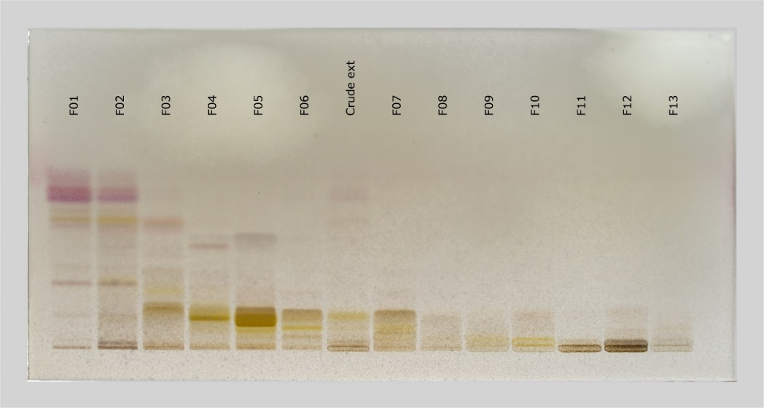

**b**

**c**

**a**

**Figure 2.** Iterative Cluster Analysis using 13C NMR Resonance signals from CPC fractions of the *Filipendula ulmaria* extract, and identification of 28 Secondary Metabolites.



**Figure 3**. LC/MS data of the crude extract of *Filipendula Ulmaria* in negative ion mode



**Figure 4.** Effect of *F. ulmaria* base extract, Fractions F01, F03, F04, F06 and F09 on Epidermal barrier function, Epidermal renewal, Keratinocyte differentiation and Stress response: (A) RT-qPCR on CNFN*; (B) RT-qPCR on EREG*; (C) RT-qPCR on HAS3*; (D) RT-qPCR on KRT10*; (E) RT-qPCR on GPX2* and (F) RT-qPCR on HMOX1*.

* All evaluations were done in duplicates and therefore the P-values could not be calculated