Supplementary material
Banana peel powder biosorbent for removal of hazardous organic pollutants from wastewater
Kelly C. S. Fariasª, Rita C. A. Guimarães ^{b}, Karla R. W. Oliveira^{c}, Carlos E. D. Nazário^{c}, Julio A. P. Ferencz^{a,d} and Heberton Wender^{a*}
ªNano&Photon Research Group, Laboratory of Nanomaterials and Applied Nanotechnology (LNNA), Institute of Physics, Federal University of Mato Grosso do Sul, Campo Grande, Mato Grosso do Sul, 79070-900, Brazil
^{b}Graduate Program in Health and Development in the Midwest Region, Medical School, Federal University of Mato Grosso do Sul, Campo Grande 79070-900, Brazil
^{c}Institute of Chemistry, Federal University of Mato Grosso do Sul, 79070-900, Campo Grande, MS, Brazil
^{d}Faculty of Engineering, Architecture and Urbanism and Geography, Federal University of Mato Grosso do Sul, 79070-900, Campo Grande, MS, Brazil.

*Corresponding authors: heberton.wender@ufms.br

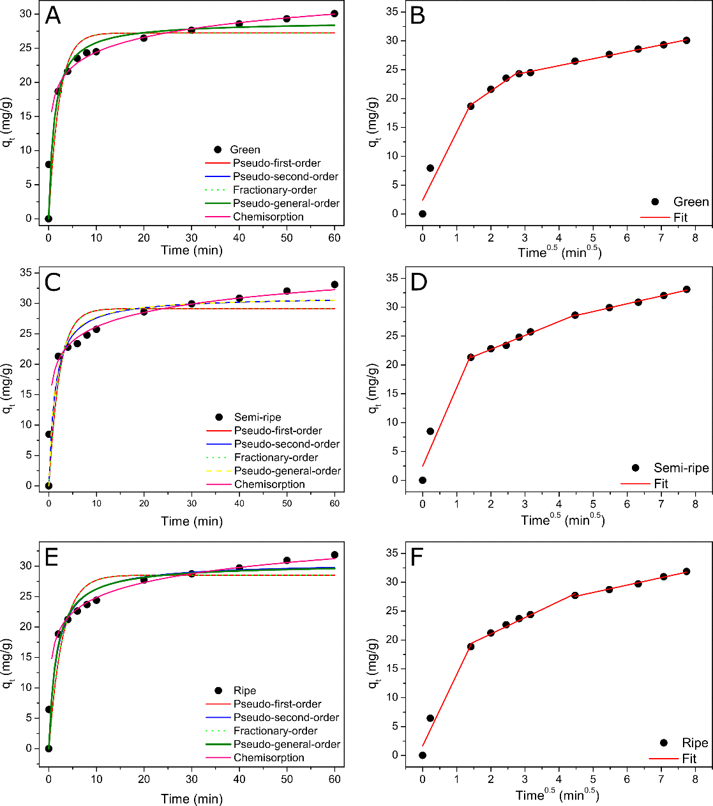
Figure S1. Kinetic models and intraparticle diffusion fits for MB removal using green (A, B), semi-ripe (C, D), and ripe (E, F) BPP. Conditions: 50 mg of BPP (biosorbent) and 50 mL MB dye solution at C₀ = 50 mg L⁻¹.

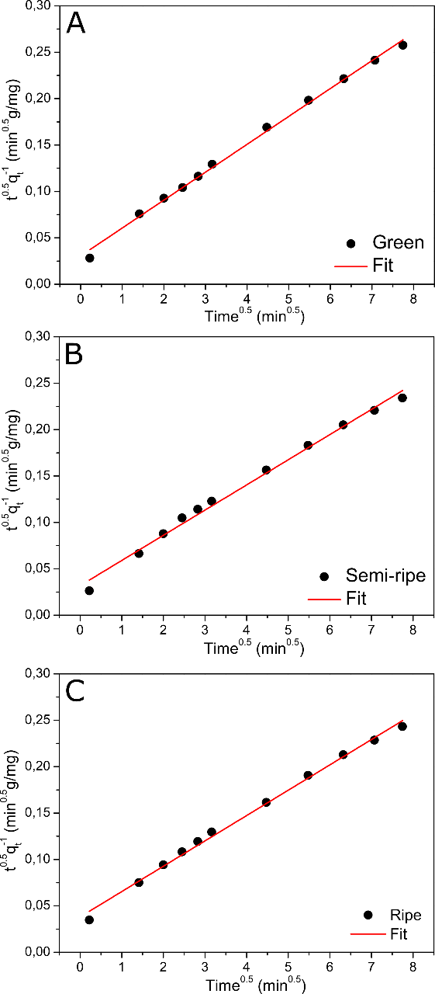
Figure S2. Fitted curves of the diffusion-chemisorption model for green (A), semi-ripe (B), and ripe (C) BPP. Conditions: 50 mg of BPP (biosorbent) and 50 mL MB dye solution at C₀ = 50 mg L⁻¹.

Table S1. Parameters obtained from the diffusion-chemisorption model for MB removal using green, semi-ripe, and ripe banana peel flour as biosorbent.
Parameters | Ripeness stage
 | Green | Semi-ripe | Ripe
Diffusion-chemisorption
$$k_{DC}(mg g^{-1} \min^{-0.5})$$ | 32.76 | 31.40 | 26.25
$$q_{e}(mg g^{-1})$$ | 33.26 | 36.85 | 36.61
$$R_{adj}^{2}$$ | 0.99651 | 0.99158 | 0.99479
Residual sum of squares | 1.92.10⁻⁵ | 3.79.10⁻⁵ | 2.37.10⁻⁵

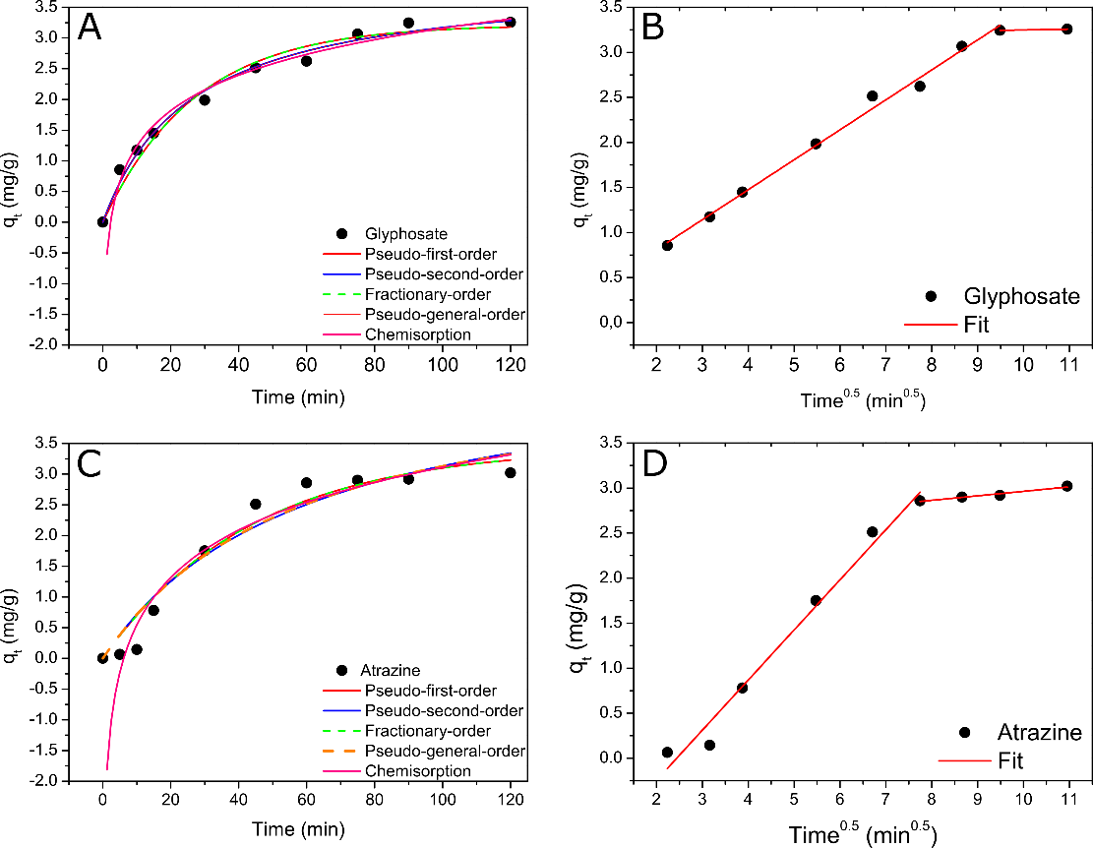
Figure S3. Fitted curves of the different kinetic models studied for semi-ripe BPP using glyphosate (A) and atrazine (C) as a pollutant and the intraparticle diffusion fit for glyphosate (B) and atrazine (D). Conditions: 60 mg of semi-ripe BPP and 10 mL of the pesticide at C₀ = 20 mg L⁻¹.

