Supplementary information
Figure S1. Study population
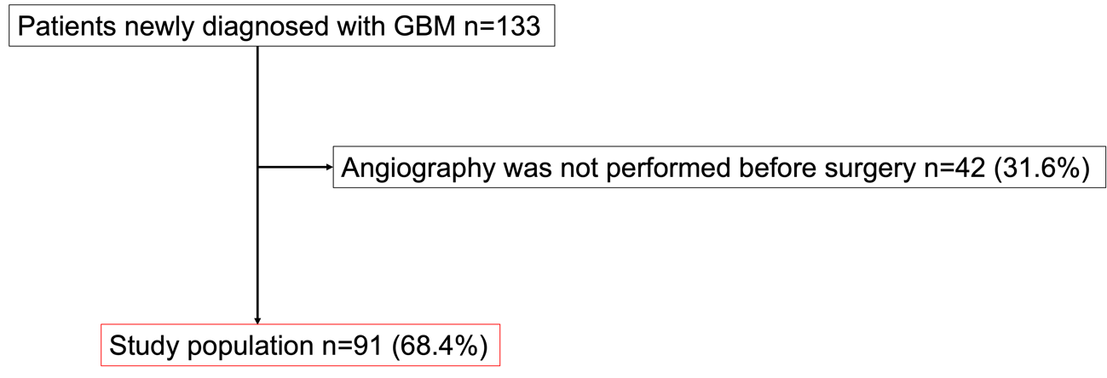

Table S1. Background of groups with and without preoperative angiography
Patient characteristics
 |  | All glioblastoma (n=133) | Preoperative angiography (n=91) | Non-preoperative angiography (n=42) | P
Age in years, median, IQR |  | 64 [52–72] | 64 [52–71] | 67 [52–74] | 0.56
Men, n (%) |  | 80 (60.2) | 61 (67.0) | 19 (45.2) | 0.02
Baseline neurological findings
Modified Rankin Scale, median, IQR |  | 2 [2–4] | 2 [1–4] | 2 [2–4] | 0.75
Karnofsky Performance Status, median, IQR |  | 70 [50–85] | 70 [50–80] | 70 [50–90] | 0.85
The degree of removal
Biopsy, n (%) |  | 23 (17.3) | 10 (11.0) | 13 (31.0) | 0.005
Maximum safe removal, n (%) |  | 110 (82.7) | 81 (89.0) | 29 (69.1)
Maximum safe removal | Partial removal, n (%) | 30 (22.6) | 20 (22.0) | 10 (23.8) | 0.31
 | Total (>90%) removal, n (%) | 80 (60.2) | 61 (67.0) | 19 (45.2)
Adjuvant therapy
Non-adjuvant therapy, n (%) |  | 4 (3.0) | 2 (2.2) | 2 (4.8) | 0.46
Chemotherapy and radiation therapy, n (%) |  | 125 (94.0) | 87 (95.6) | 38 (90.5)
Only radiation therapy, n (%) |  | 2 (1.5) | 1 (1.1) | 1 (2.4)
Only chemotherapy, n (%) |  | 1 (0.8) | 0 (0) | 1 (2.4)
Others, n (%) |  | 1 (0.8) | 1 (1.1) | 0 (0)
Avastin, n (%) |  | 44 (33.1) | 26 (28.6) | 18 (42.9) | 0.10
Molecular features
IDH mutation, n (%) |  | 5 (4.2) | 3 (3.8) | 2 (5.3) | 0.70
MGMT methylation, n (%) |  | 32 (31.4) | 23 (32.4) | 9 (29.0) | 0.74
MIB1 index, median, IQR |  | 0.3 [0.2–0.4] | 0.3 [0.2–0.4] | 0.2 [0.2–0.4] | 0.35
Follow-up duration
Follow-up duration, months median, IQR |  | 17 [9–26] | 17 [9–26] | 14 [9–26] |  | 0.64

Table S2. Effects of the patient group (preoperative angiography vs. non-preoperative angiography) on death and progression
Preoperative angiography vs. non-preoperative angiography | Crude HR (95% CI) | P
Death | 0.82 (0.55–1.22) | 0.33
Progression | 0.77 (0.52–1.13) | 0.18

Table S3. Diagnostic method for IDH mutation and MGMT methylation

 |  | All (n=91) | Non-early venous filling (n=44) | Early venous filling (n=47) | P
IDH mutation | Genetic diagnosis, n (%) | 30 (37.5) | 13 (35.1) | 17 (39.5) | 0.69
 | Pathological diagnosis, n (%) | 50 (62.5) | 24 (64.9) | 26 (60.5)
MGMT methylation | Genetic diagnosis, n (%) | 30 (42.3) | 13 (39.4) | 17 (44.7) | 0.65
 | Pathological diagnosis, n (%) | 41 (57.8) | 20 (60.6) | 21 (55.3)

Table S4. Background for the 20 cases undergone pathological examination
Patient characteristics
 | Non-Early venous filling (n=10) | Early venous filling (n=10) | P
Age in years, median, IQR | 45.5 [39.5–70.5] | 63 [55.5–70] | 0.23
Men, n (%) | 6 (60) | 5 (50) | 0.65
Baseline neurological findings
Modified Rankin Scale, median, IQR | 2 [1–2] | 3 [1–4] | 0.23
Karnofsky Performance Status, median, IQR | 70 [70–90] | 75 [68–83] | 0.46
The degree of removal
Biopsy, n (%) | 0 (0) | 0 (0) | -
Maximum safe removal, n (%) | 10 (100) | 10 (100)
Total (>90%) removal, n (%) | 7 (70) | 6 (60) | 0.64
Molecular features
IDH mutation, n (%) | 2 (28.6) | 0 (0) | 0.07
MGMT methylation, n (%) | 3 (50) | 2 (20) | 0.21
MIB1 index, median, IQR | 0.2 [0.2–0.3] | 0.3 [0.1–0.4] | 0.78

Table S5. “Pink” vessels considered to be vascular mimicry
 | All (n=20) | Non-early venous filling (n=10) | Early venous filling (n=10) | P
Score 2, n (%) | 5 (25) | 0 | 5 (50) | 0.02
Score 1, n (%) | 7 (35) | 3 (30) | 4 (40)
Score 0, n (%) | 6 (30) | 5 (50) | 1 (10)
Not diagnosable, n (%) | 2 (10) | 2 (20) | 0

