Supplementary data for

Controlled Fabrication of Hierarchically Structured MnO₂@NiCo-LDH Nanoarrays for Efficient Electrocatalytic Urea Oxidization

Wenjun Liu ª, Wenbo Xu ª, Guofa Dong ^{b,*}, Ming Fang ^{a,*}

- Shenzhen Key Laboratory of Special Functional Materials, Guangdong Research Centre for Interfacial Engineering of Functional Materials, College of Materials Science and Engineering, Shenzhen University, Shenzhen 518060, China.

- Fujian Key Laboratory of Functional Marine Sensing Materials, College of Materials and Chemical Engineering, Minjiang University, Fuzhou 350108, China

*E-mail: gfdong@mju.edu.cn; m.fang@szu.edu.cn

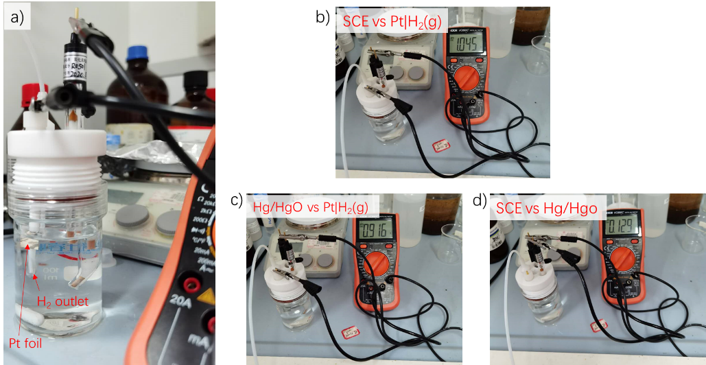
Figure S1. Potential calibration of the SCE and Hg/HgO against a Pt|H₂(g) electrode in 1 M KOH. Note: H₂ gas was bubbled against a fresh polished platinum foil for at least 30 min, and the voltage measurements were conducted immediately after shutting off the gas to avoid any mechanical disturbance by the gas bubbling.

Figure S2. SEM images of MnO₂ nanosheet arrays grown on nickel foam (NF).

Figure S3. SEM image of CoNi-LDH deposited on NF.

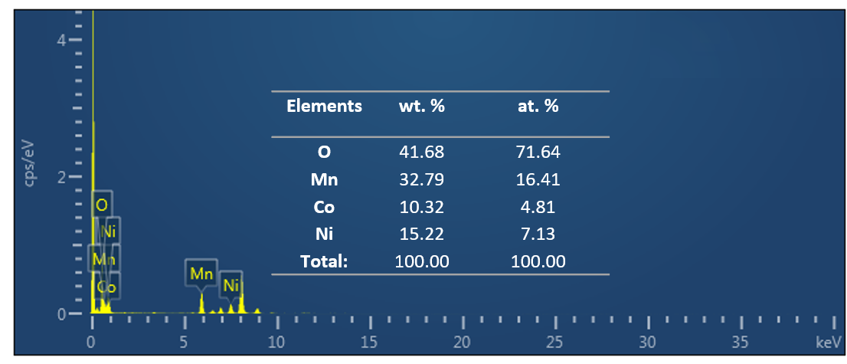
Figure S4. EDS spectrum of the mapping area.

Figure S5. Enlarged view of the UOR LSV curves of different catalysts.

Figure S6. CV curves of a) MnO₂@NiCo-LDH, b) NiCo-LDH/NF, c) MnO₂/NF, and d) NF at different potential scan rates in the non-Faradaic potential range.

Figure S7. LSV curves of UOR determined on various MnO₂@NiCo-LDH samples with different deposition time.
Table S1. Performance comparison of UOR catalysts reported recently.

Catalysts | Electrolyte | j (mA cm⁻²) |  |  | Potential (V) | Reference
CoS₂-MoS₂ | 1.0 M KOH  0.5 M urea |  | 10 | 1.29 |  | Adv. Energy Mater., 2018, 1801775
Ni₃N/NF | 1.0 M KOH  0.5 M urea |  | 100 | 1.42 |  | ACS Appl. Mater. Interfaces, 2019, 11, 13168
Mo-Co-S-Se/CC | 1.0 M KOH  0.5 M urea |  | 10 | 1.40 |  | ACS Sustainable Chem. Eng., 2019, 7, 16577
NiMoO₃S/NF | 1.0 M KOH  0.5 M urea |  | 10 | 1.34 |  | Chem. Commun., 2020, 56, 11038
NiSe₂-NiO 350 | 1.0 M KOH  0.33 M urea |  | 10 | 1.33 |  | Appl. Catal. B Environ., 2020, 276,119165
CoFeCr LDH/NF | 1.0 M KOH  0.33 M urea |  | 10 | 1.31 |  | Appl. Catal. B Environ., 2020, 272,118959.
NiMo_{x}O_{y}/NF | 1.0 M KOH  0.5 M urea |  | 100 | 1.36 |  | Applied Catalysis A, General, 2021 622, 118220
Ni₂Fe(CN)₆ | 1.0 M KOH  0.33 M urea |  | 100 | 1.35 |  | Nature Energy, 2021, 6, 904–912
NiCoGe oxyhydroxide | 1.0 M KOH  0.33 M urea |  | 100 | 1.33 |  | Adv. Funct. Mater., 2023, 33, 2300687
Ni-TPA@NiSe/NF | 1.0 M KOH  0.5 M urea |  | 100 | 1.37 |  | ACS Catal. 2023, 13, 837−847
MnO₂@NiCo-LDH | 1.0 M KOH  0.5 M urea |  | 10  100 | 1.262  1.326 |  | This work

