Table S1. Prediction results of pigments using different pre-processing methods.
Pigments | Pretreatment | Calibration set |  |  | Prediction set |  | RPD
 |  | R_{c}² | RMSE_{c} |  | R_{p}² | RMSE_{p}
Chla | Raw | 0.7632 | 1.97 |  | 0.7976 | 1.53 | 2.22
 | S-G | 0.7645 | 1.97 |  | 0.7781 | 1.55 | 2.12
 | SNV | 0.8002 | 1.83 |  | 0.7171 | 1.75 | 1.88
 | S-G+SNV | 0.7877 | 1.88 |  | 0.8064 | 1.49 | 2.27
Chlb | Raw | 0.7863 | 0.78 |  | 0.7831 | 0.56 | 2.15
 | S-G | 0.7790 | 0.79 |  | 0.8286 | 0.54 | 2.42
 | SNV | 0.8036 | 0.73 |  | 0.8223 | 0.59 | 2.37
 | S-G+SNV | 0.7944 | 0.75 |  | 0.8156 | 0.60 | 2.33
Chll | Raw | 0.7863 | 2.60 |  | 0.7369 | 2.46 | 1.95
 | S-G | 0.7772 | 2.67 |  | 0.7646 | 2.29 | 2.06
 | SNV | 0.7964 | 2.53 |  | 0.7776 | 2.25 | 2.12
 | S-G+SNV | 0.7982 | 2.53 |  | 0.7677 | 2.29 | 2.07
Caro | Raw | 0.6827 | 0.35 |  | 0.6912 | 0.29 | 1.80
 | S-G | 0.6710 | 0.36 |  | 0.6828 | 0.29 | 1.78
 | SNV | 0.6768 | 0.35 |  | 0.7294 | 0.29 | 1.92
 | S-G+SNV | 0.6689 | 0.36 |  | 0.7213 | 0.28 | 1.89
Table S2. Classification of variables screened by the CARS algorithm using the IRIV algorithm.
Pigments | Variable classification | Spectral variables (nm)
Chla | Strong information | 473, 504, 672, 698, 702
 | Weak information | 506, 691, 692, 715, 716, 730, 731, 745, 760, 821, 831
Chlb | Strong information | 439, 497, 667, 689, 691, 702, 703, 715, 716
 | Weak information | 734, 736, 737, 760, 761, 864, 895
Chll | Strong information | 473, 502, 670, 692, 702, 703, 745
 | Weak information | 506, 672, 691, 715, 716, 731, 733, 736, 737, 760, 821, 832
Caro | Strong information | 468, 473, 506, 761, 890
 | Weak information | 510, 671, 691, 694, 699, 700, 715, 716, 730, 731, 733, 821, 823
Table S3. The key wavelengths screened by CARS and CARS-IRIV algorithms for Chla, Chlb, Chll, and Caro.
Pigments | VSMª | NV^{b} | Key spectral variables (nm)
Chla | CARS | 16 | 473, 504, 506, 672, 691, 692, 698, 702, 715, 716, 730, 731, 745, 760, 821, 831
 | CARS-IRIV | 12 | 473, 506, 672, 692, 698, 702, 715, 731, 745, 760, 821, 831
Chlb | CARS | 16 | 439, 497, 667, 689, 691,702, 703, 715, 716, 734, 736, 737, 760, 761, 864, 895
 | CARS-IRIV | 10 | 439, 497, 667, 691, 702, 715, 736, 760, 864, 895
Chll | CARS | 19 | 473, 502, 506, 670, 672, 691, 692, 702, 703, 715, 716, 731, 733, 736, 737, 745, 760, 821, 832
 | CARS-IRIV | 12 | 473, 506, 672, 691, 702, 715, 731, 736, 745, 760, 821, 832
Caro | CARS | 18 | 468, 473, 506, 510, 671, 691, 694, 699, 700, 715, 716, 730, 731, 733, 761,821, 823, 890
 | CARS-IRIV | 11 | 473, 506, 510, 671, 691, 699, 715, 730, 761, 821, 890
ªVSM: variables selection methods; ^{b}NV: number of variables.

Table S4. Fertilizer (mg/L), EC, and pH with different nitrogen concentrations.
Fertilizer | N20 | N40 | N60 | N80 | N100 | N120 | N140 | N160 | N180 | N200
Calcium nitrate | 0 | 307.48 | 605.68 | 913.15 | 1216 | 1216 | 1216 | 1216 | 1216 | 1216
Calcium fertilizer | 491.57 | 367.27 | 246.72 | 122.43 | 0 | 0 | 0 | 0 | 0 | 0
Urea | 0 | 0 | 0 | 0 | 0 | 131.67 | 262.34 | 395.01 | 526.68 | 658.35
Calcium ammonium nitrate | 42.1 | 42.1 | 42.1 | 42.1 | 42.1 | 42.1 | 42.1 | 42.1 | 42.1 | 42.1
Potassium nitrate | 395 | 395 | 395 | 395 | 395 | 395 | 395 | 395 | 395 | 395
Potassium phosphate monobasic | 208 | 208 | 208 | 208 | 208 | 208 | 208 | 208 | 208 | 208
Potassium sulphate | 393 | 393 | 393 | 393 | 393 | 393 | 393 | 393 | 393 | 393
Magnesium sulphate | 466 | 466 | 466 | 466 | 466 | 466 | 466 | 466 | 466 | 466
Nitrogen concentration | 59.64 | 121.14 | 181.7 | 242.27 | 302.84 | 363.41 | 423.98 | 484.54 | 545.54 | 605.68
EC | 2.49 | 2.42 | 2.40 | 2.30 | 2.29 | 2.33 | 2.43 | 2.50 | 2.53 | 2.56
pH | 6.88 | 6.84 | 6.80 | 6.95 | 6.99 | 7.05 | 7.00 | 6.95 | 6.96 | 6.98

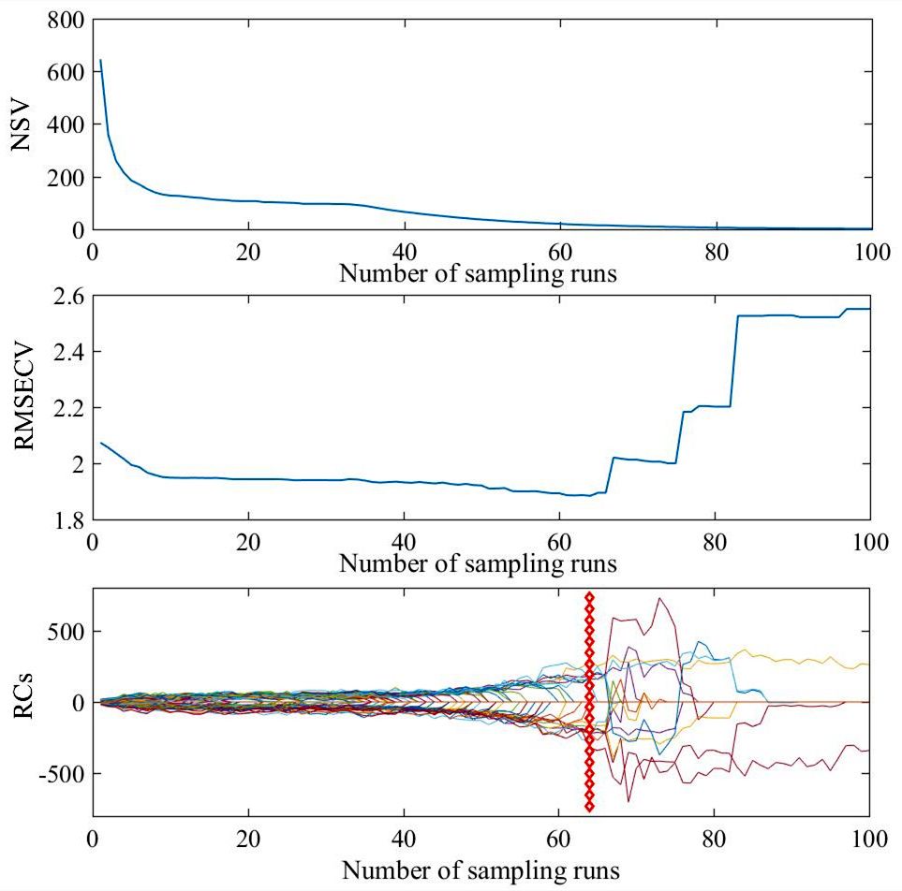
Figure S1. The changes in sample variables (NSV), RMSEcv, and regression coefficient paths (RCs) in a subset of CARS arithmetic for Chla.
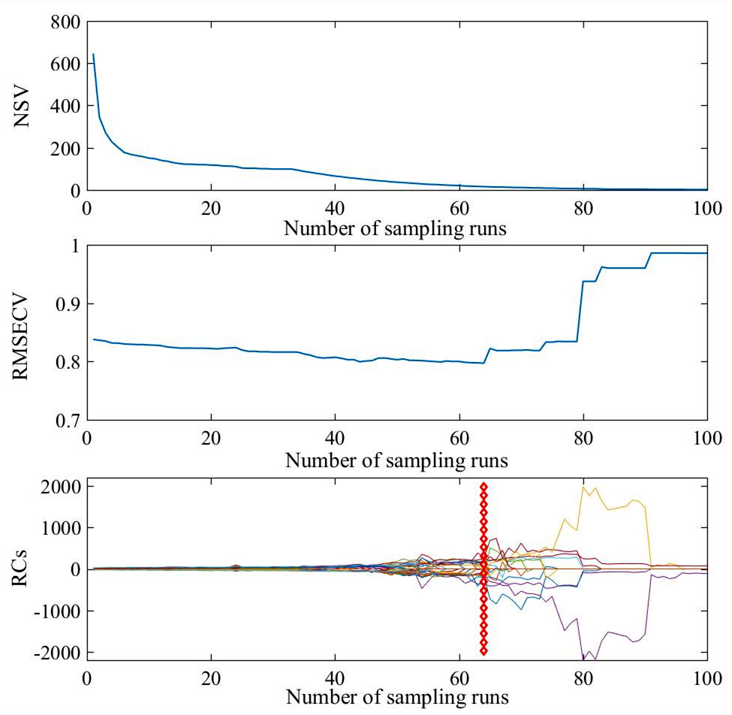
Figure S2. The changes in sample variables (NSV), RMSEcv, and regression coefficient paths (RCs) in a subset of CARS arithmetic for Chlb.
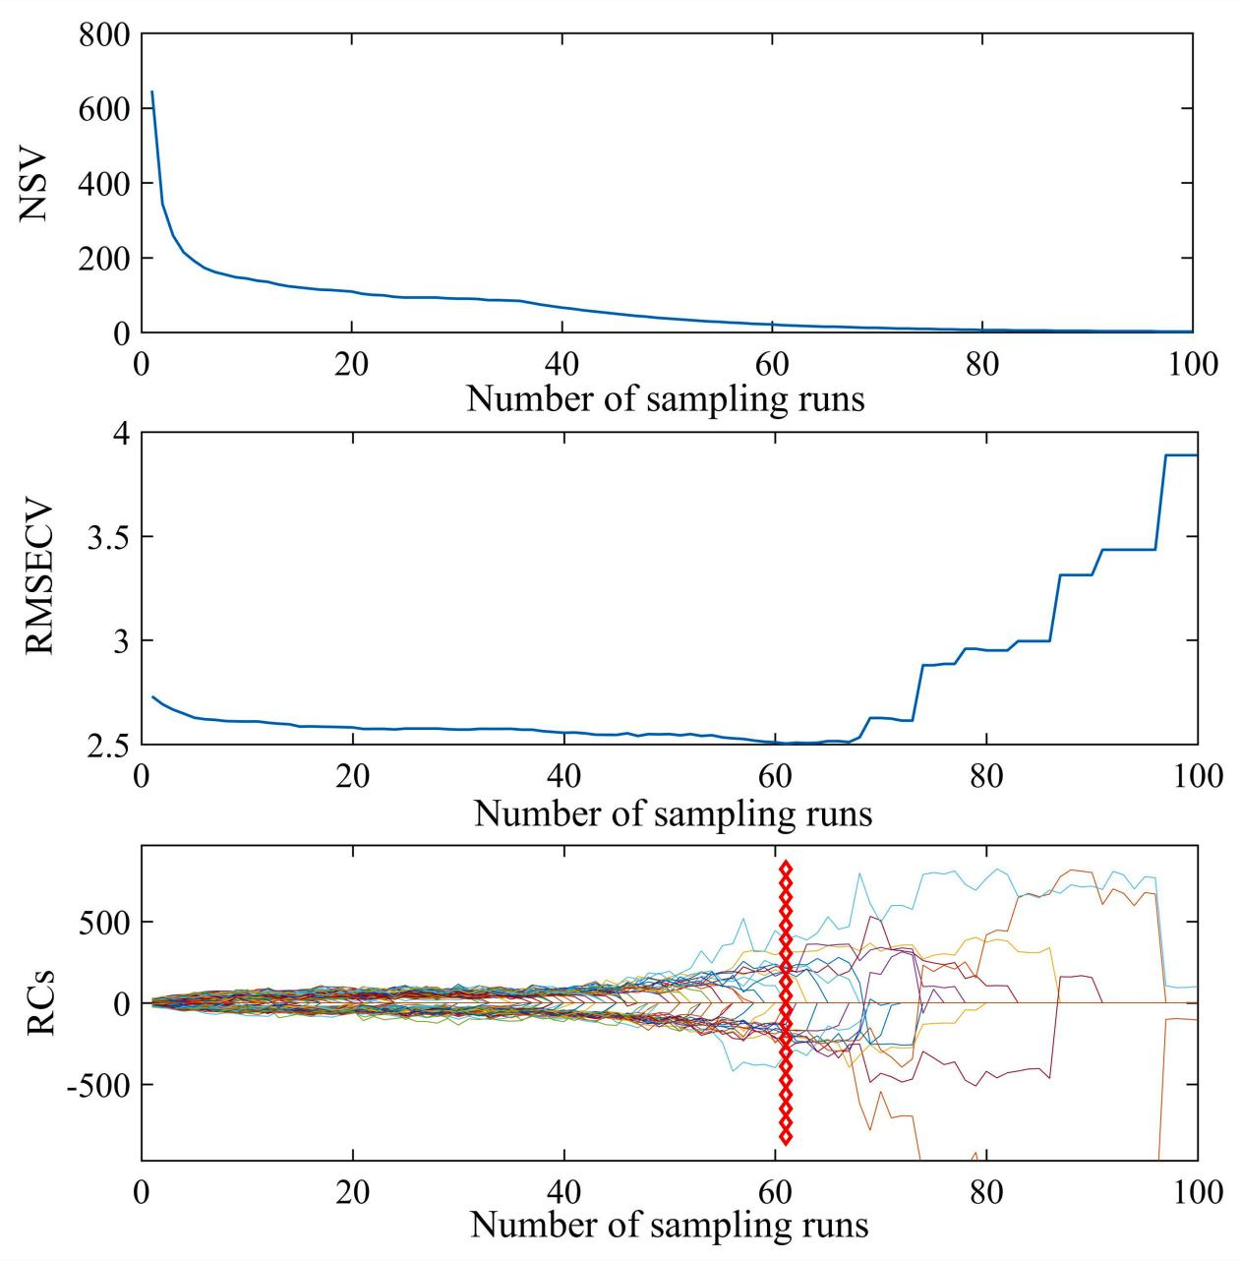
Figure S3. The changes in sample variables (NSV), RMSEcv, and regression coefficient paths (RCs) in a subset of CARS arithmetic for Chll.
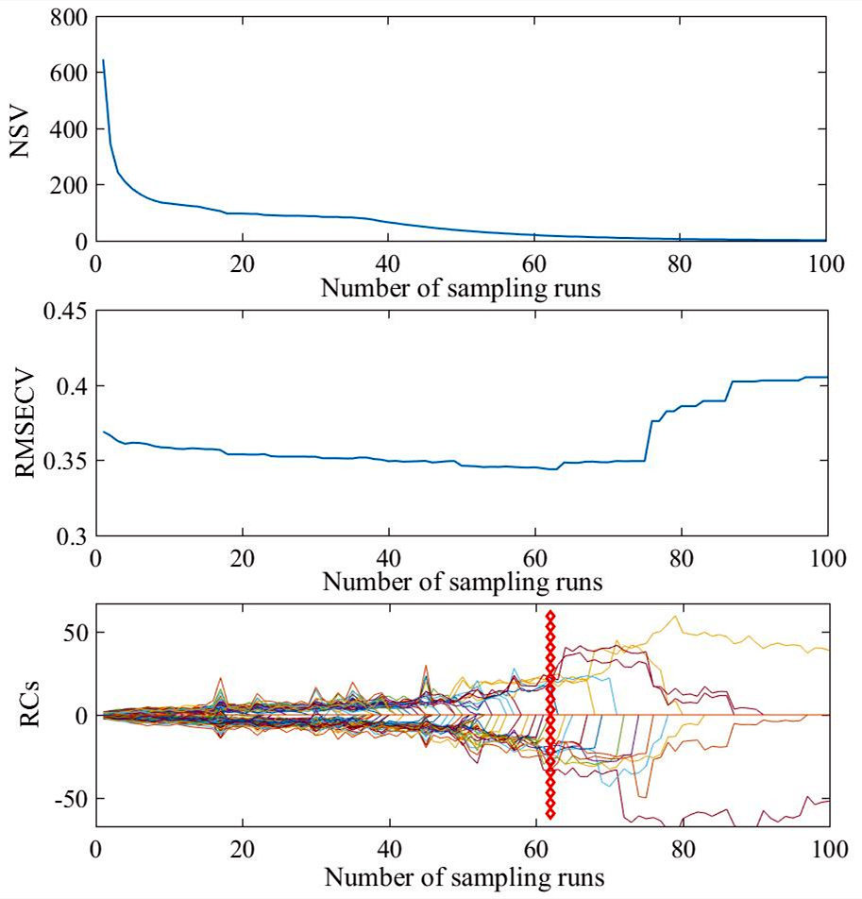
Figure S4. The changes in sample variables (NSV), RMSEcv, and regression coefficient paths (RCs) in a subset of CARS arithmetic for Caro.

