Supplementary Materials

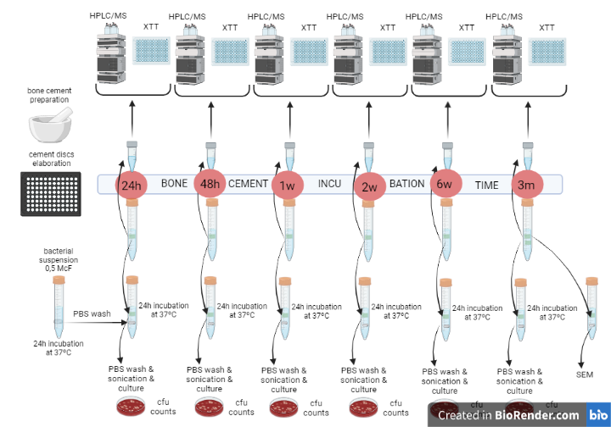
Figure S1: Laboratory procedure

