Supplementary materials
Localized permeability of blood brain barrier for antibody-conjugates in the cuprizone model of
demyelination
Tatiana Abakumova, Anastasia Kuzkina, Philipp Koshkin, Daria Pozdeeva, Maxim Abakumov , Pavel Melnikov, Klavdia Ionova, Ilia Gubskii, Olga Gurina, Natalia Nukolova, Vladimir Chekhonin
Table S1. Specific primers for qPCR used in the study
 | Forward primer | Reverse primer
MBP | GACTCACACACGAGAACTACC | GAAGAAATGGACTACTGGGTTT
PLP | ACCTGTTTATTGCTGCGTTTGTG | TTAAGGACGGCGAAGTTGTAAGT
HPRT | CGAGGAGTCCTGTTGATGTTG | GATAAGCGACAATCTACCAGAGG

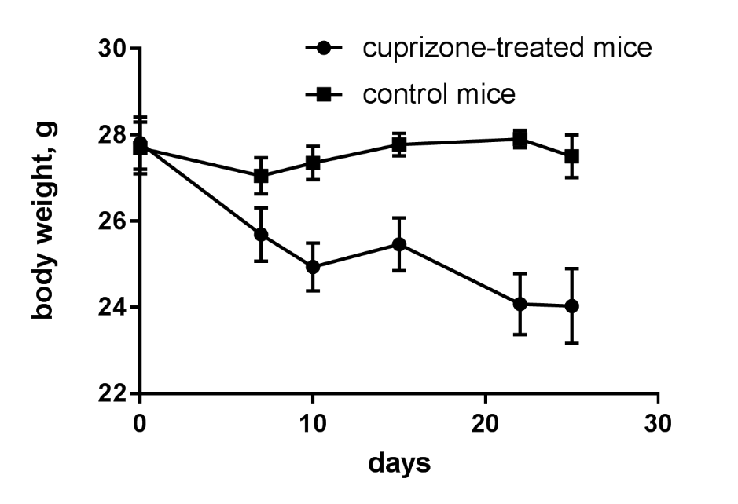
Figure S1. Plot of the weight loss during cuprizone diet
Figure S2. Non-specific IgG were used as control for demyelinated (A) and remyelinated (B) brain in immunohistochemical analysis of cuprizone-treated mice and non-treated healthy control mice (C)

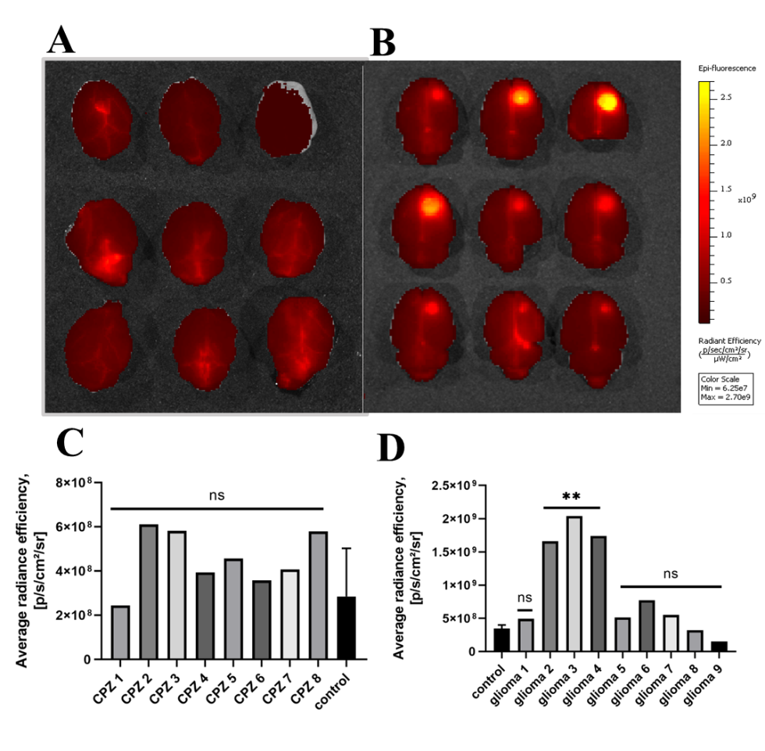
Figure S3. Evans blue accumulation in cuprizone-intoxicated mice (A,C) and C6 glioma (B, D) model using IVIS Spectrum CT. **-p-value<0.005, ns-non-significant (in comparison with control)
Figure S4. Quantification analysis of area of GFAP+ cells at immunofluorescent tissue staining of control (healthy) and cuprizone-treated mice at demyelination (4 week) and remyelination stage. **p-value < 0.01
Figure S5. Accumulation of non-specific IgG -Alexa Fluor™ 488 conjugates in the corpus callosum of healthy (A) and cuprizone-treated mice (B).

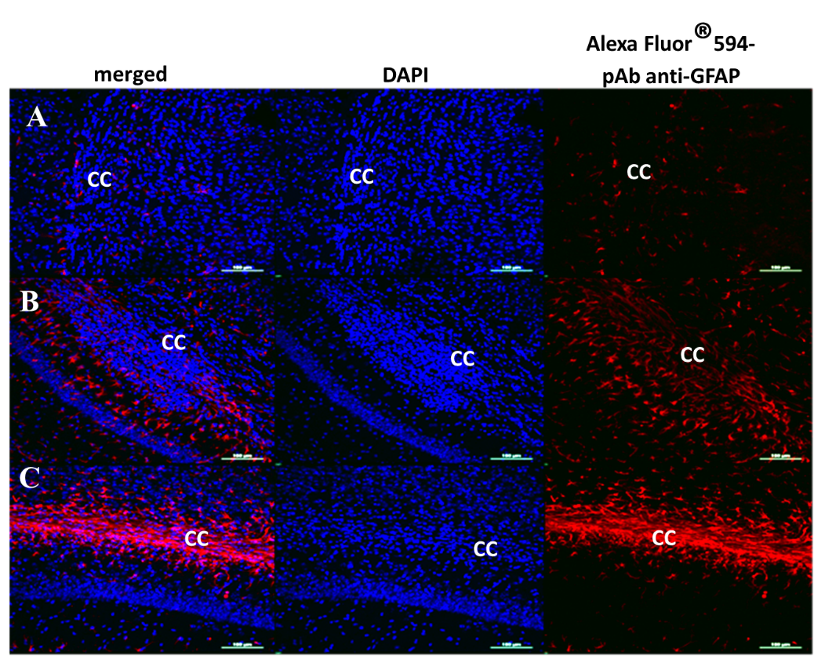
Figure S6. Immunofluorescence staining with pAb anti-GFAP of the corpus callosum (CC) of the healthy (A) and cuprizone-treated mice on the 4th week of demyelination (B) and at the remyelination stage (in 2 weeks after cuprizone withdrawal) (C). Scale bar is 500 µm

