Metabolome Mining of Curcuma longa L. Using HPLC-MS/MS and Molecular Networking
Rabin Budhathoki¹, Arjun Prasad Timilsina¹, Bishnu P. Regmi², Khaga Raj Sharma¹, Niraj Aryal^{3,*} and Niranjan Parajuli^{1,*}

¹Biological Chemistry Lab, Central Department of Chemistry, Tribhuvan University, Kirtipur, Kathmandu, 44618, Nepal
²Department of Chemistry, Florida Agricultural and Mechanical University, Tallahassee, FL 32307, USA
³Department of Biology, University of Florida, Gainesville, FL 32611, USA

*Corresponding authors: niraj.aryal@ufl.edu (N.A.); niranjan.parajuli@cdc.tu.edu.np (N.P.), Tel: +977-1-4332034

Rabin Budhathoki: 0009-0001-9116-366X
Arjun Prasad Timilsina: 0000-0003-3131-390X
Bishnu P. Regmi: 0000-0001-7690-9825
Khaga Raj Sharma: 0000-0002-1555-0887
Niraj Aryal: 0000-0001-6145-9657
Niranjan Parajuli: 0000-0002-9233-6489

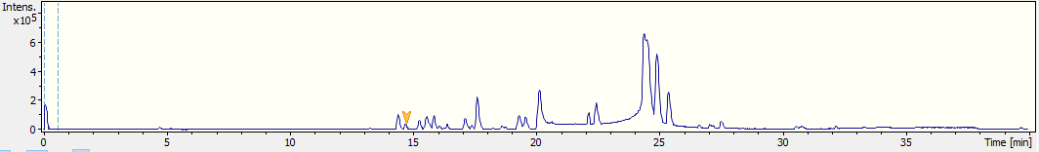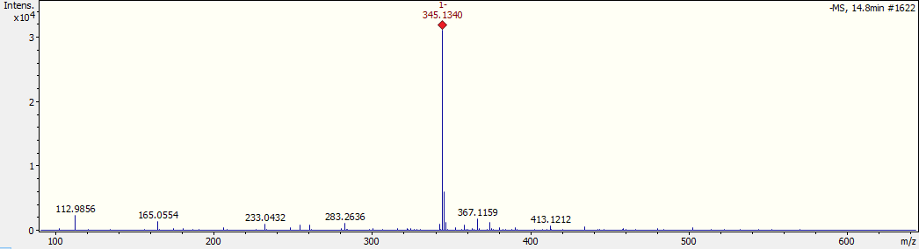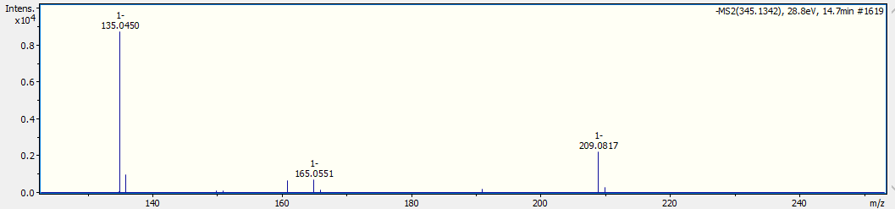Figure S1. MS¹ and MS² spectra of compound 1

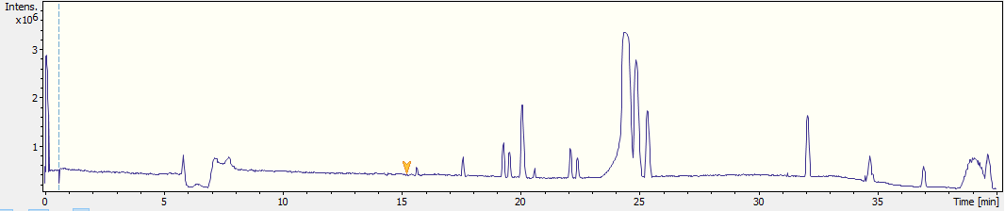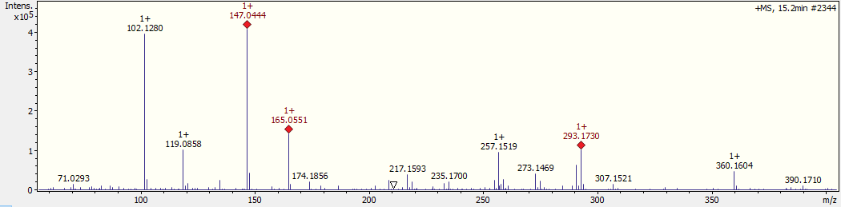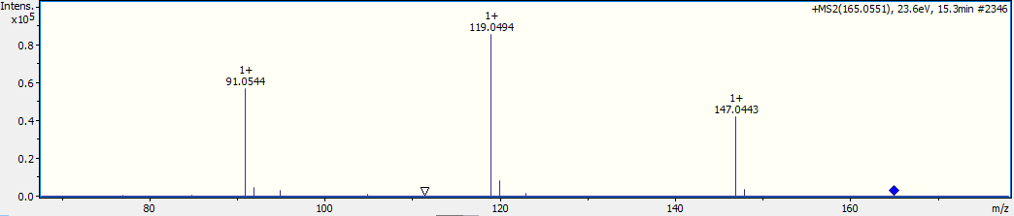 Figure S2. MS¹ and MS² spectra of compound 2

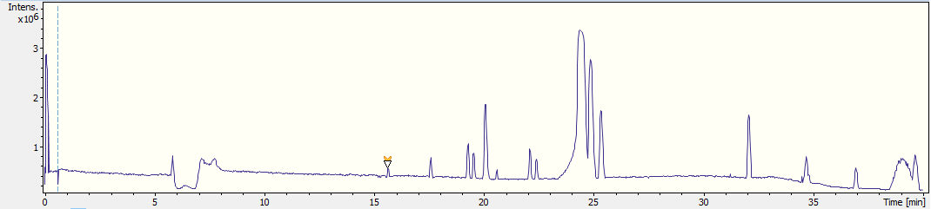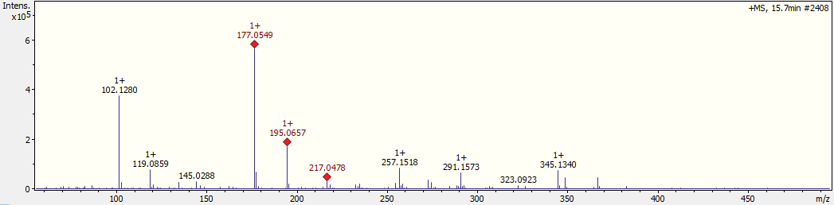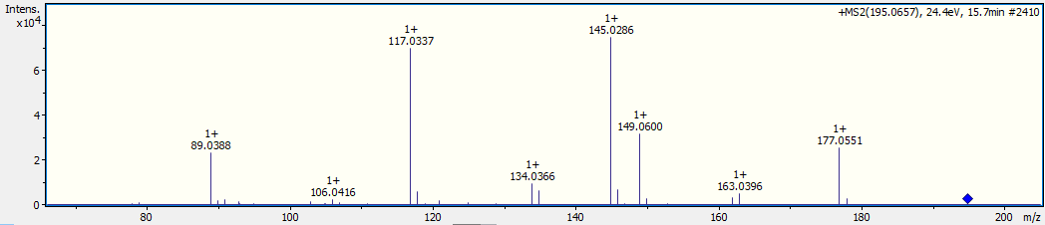
Figure S3. MS¹ and MS² spectra of compound 3
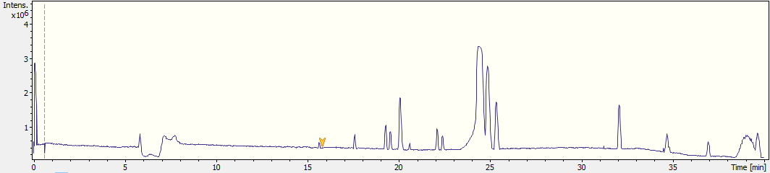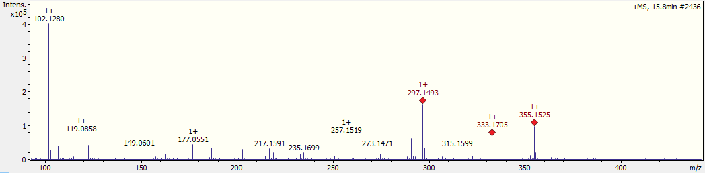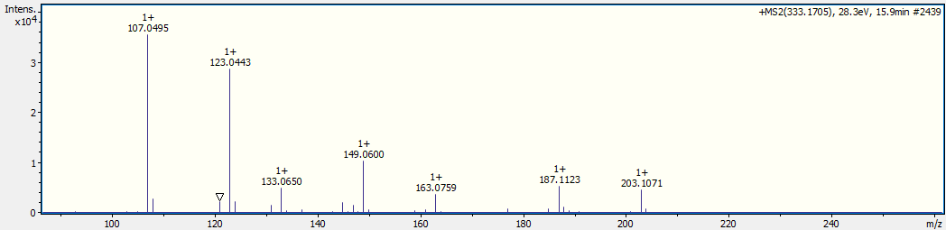
Figure S4. MS¹ and MS² spectra of compound 4
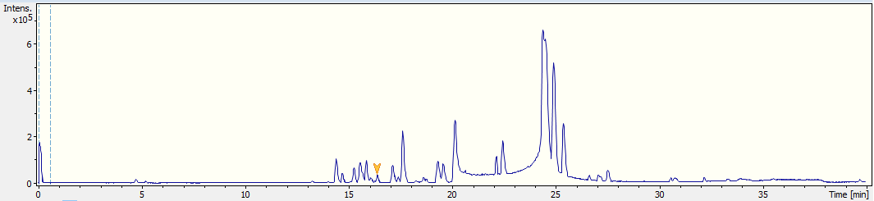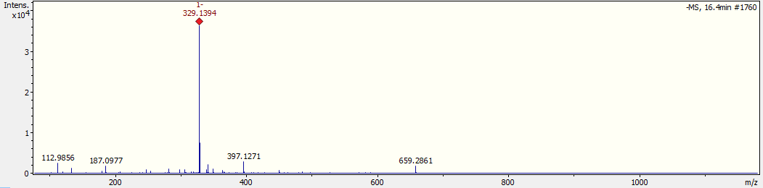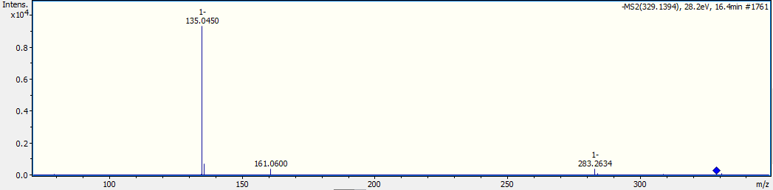
Figure S5. MS¹ and MS² spectra of compound 5
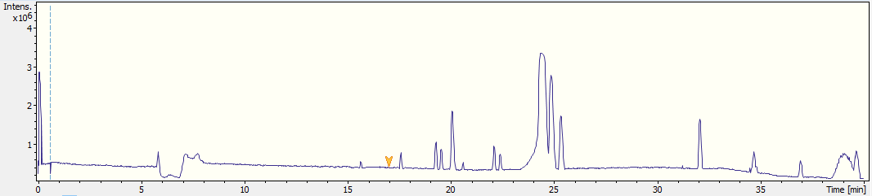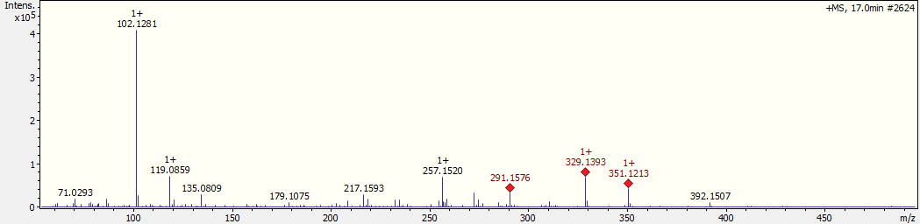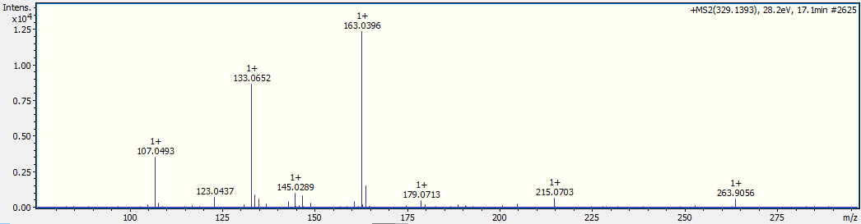
Figure S6. MS¹ and MS² spectra of compound 6
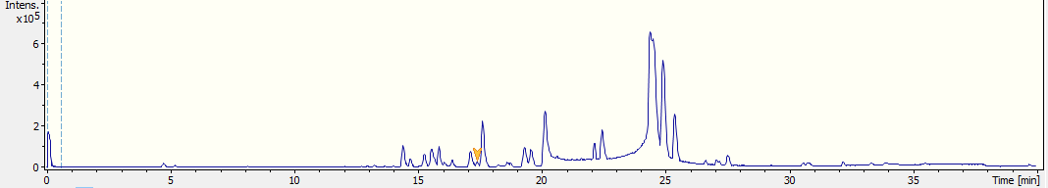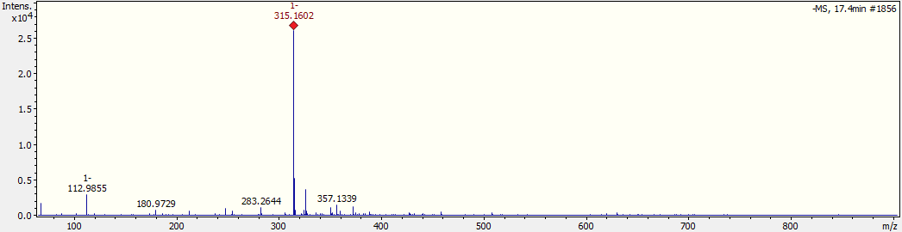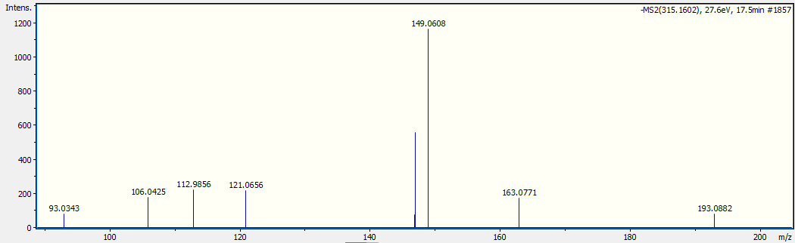
Figure S7. MS¹ and MS² spectra of compound 7
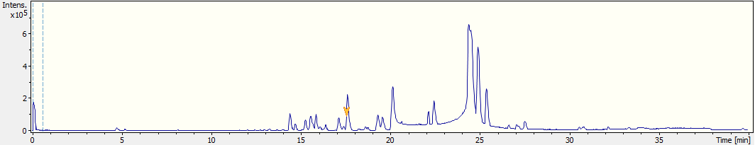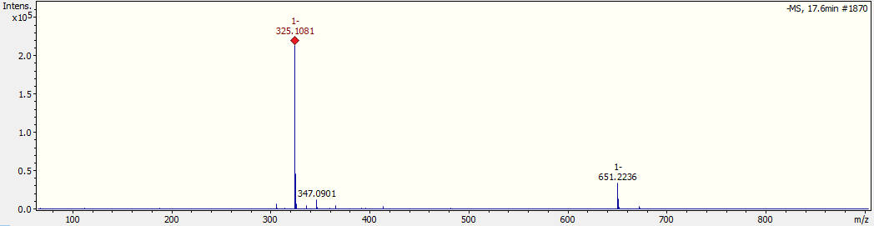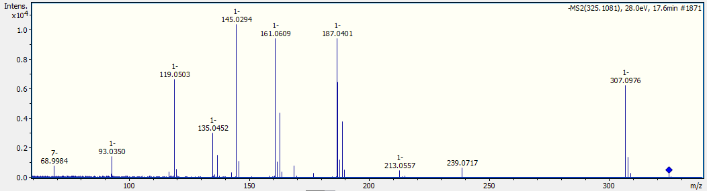
Figure S8. MS¹ and MS² spectra of compound 8
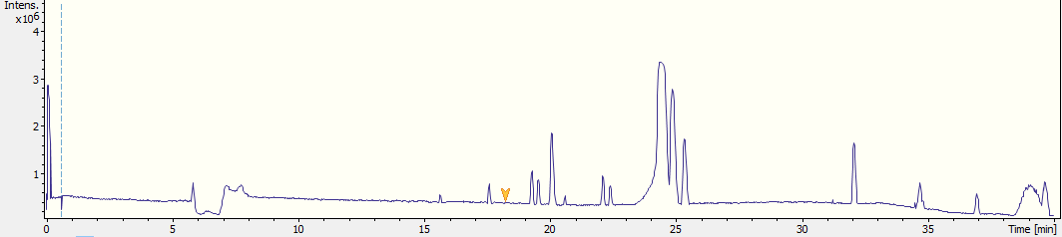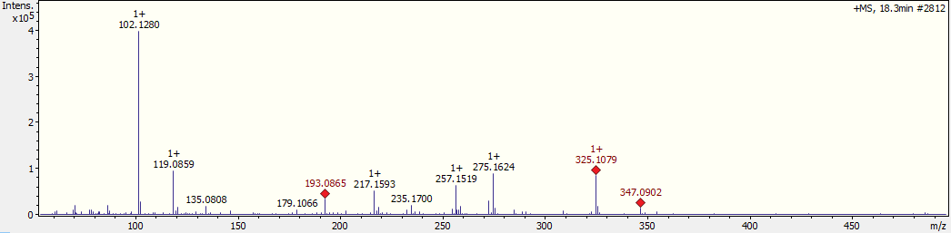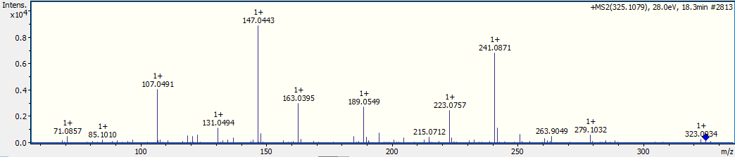
Figure S9. MS¹ and MS² spectra of compound 9
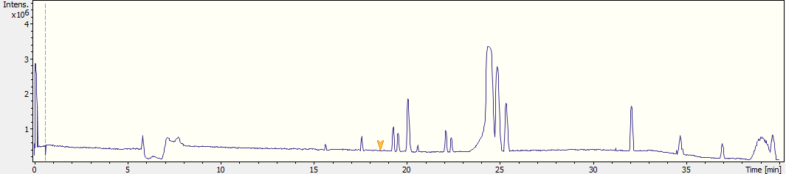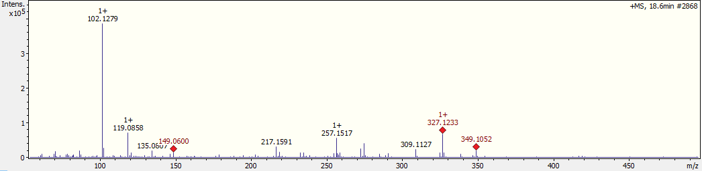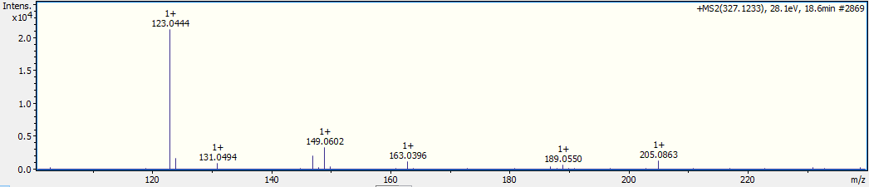
Figure S10. MS¹ and MS² spectra of compound 10
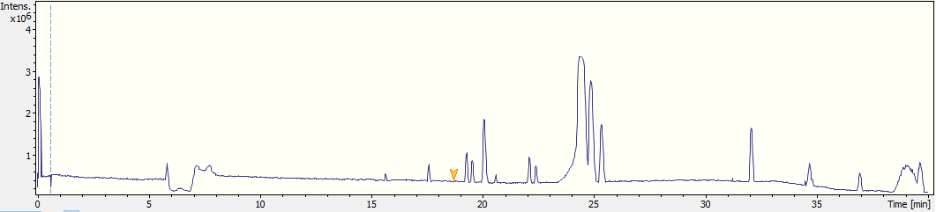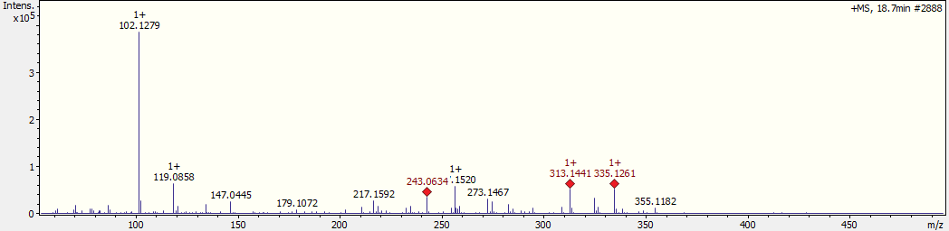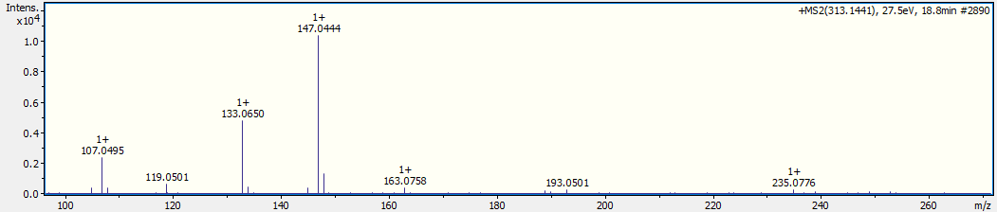
Figure S11. MS¹ and MS² spectra of compound 11
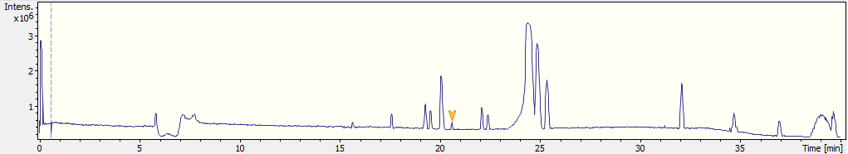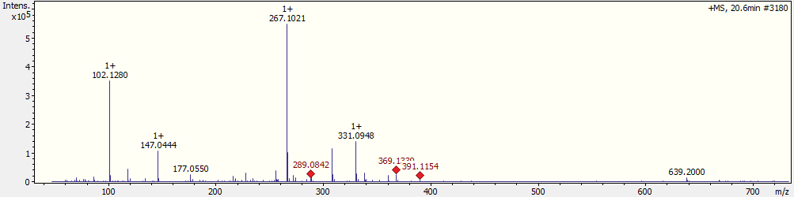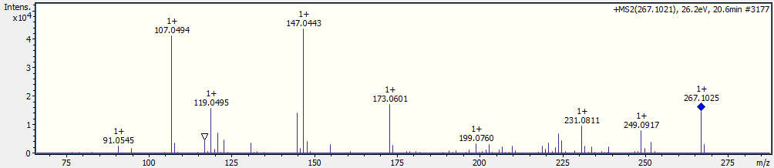
Figure S12. MS¹ and MS² spectra of compound 12

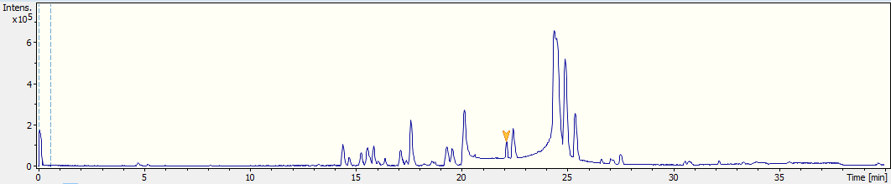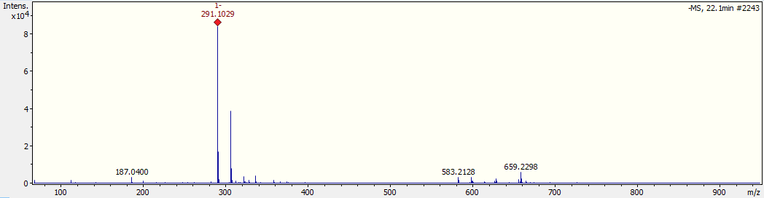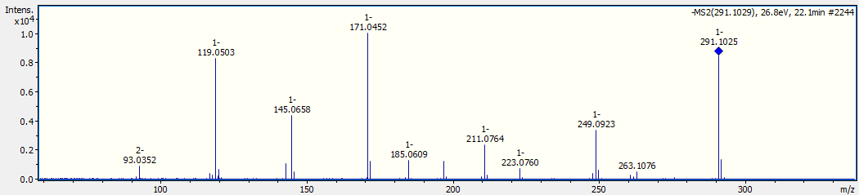
Figure S13. MS¹ and MS² spectra of compound 13
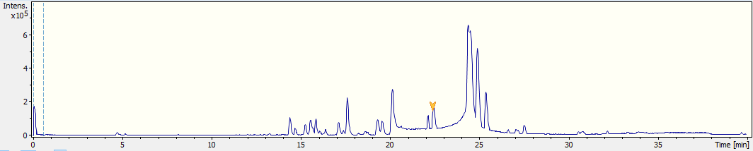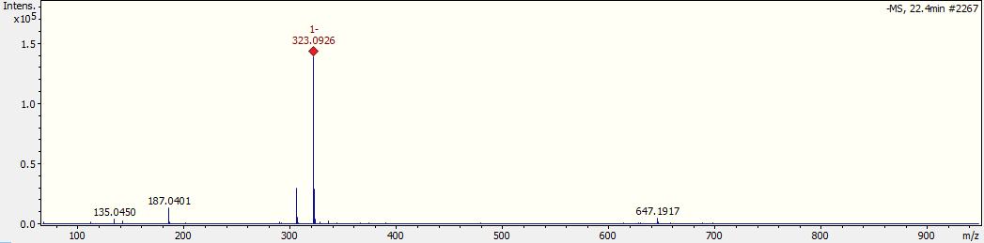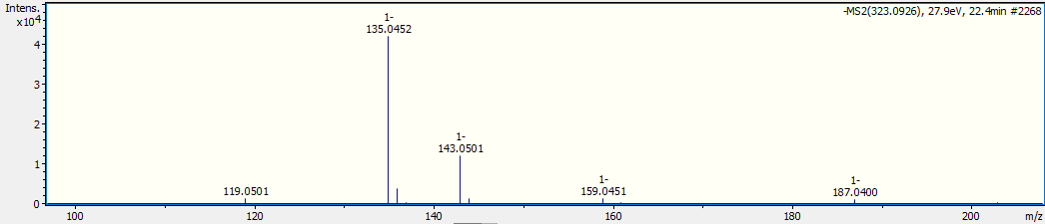
Figure S14. MS¹ and MS² spectra of compound 14
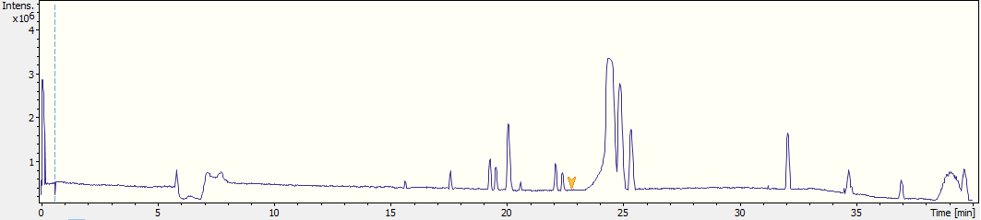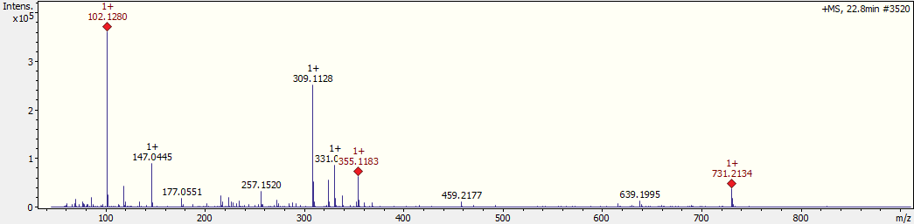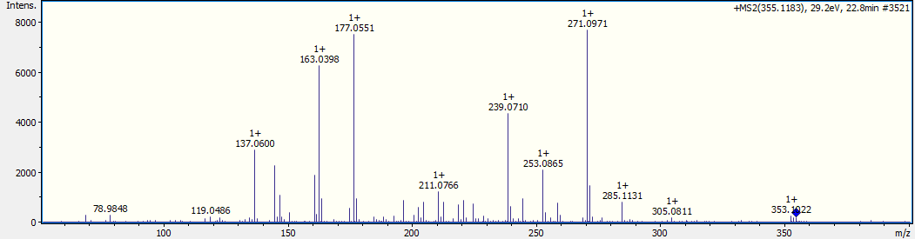
Figure S15. MS¹ and MS² spectra of compound 15
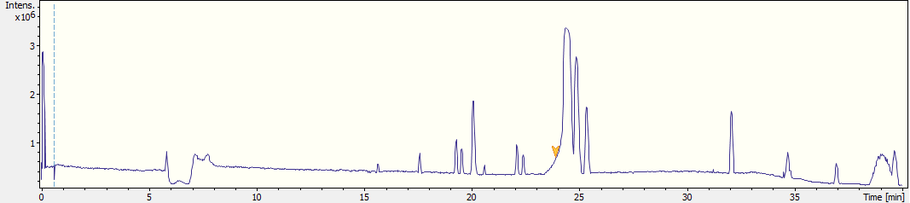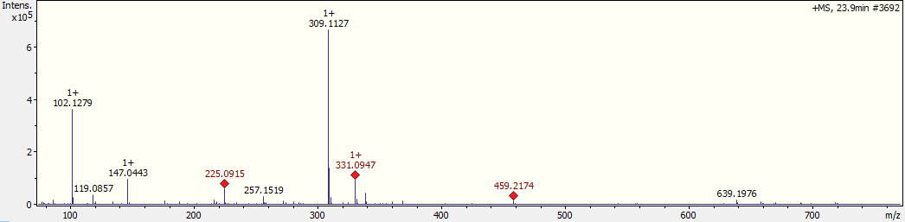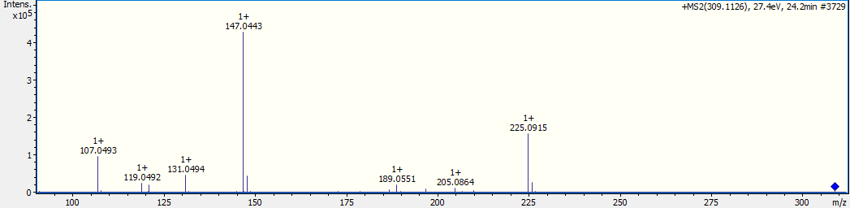
Figure S16. MS¹ and MS² spectra of compound 16
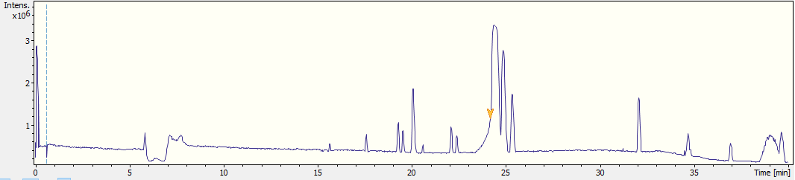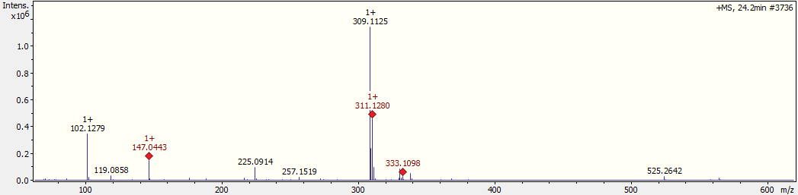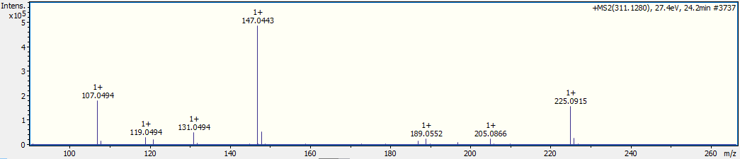
Figure S17. MS¹ and MS² spectra of compound 17
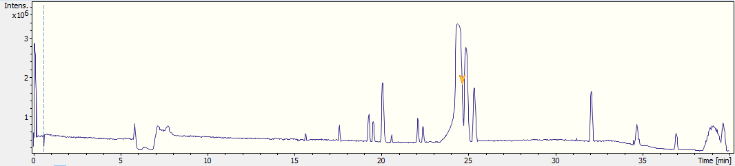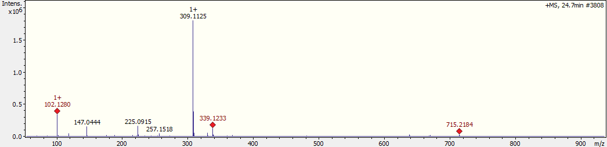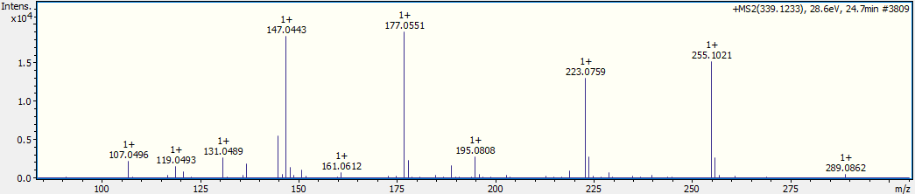
Figure S18. MS¹ and MS² spectra of compound 18
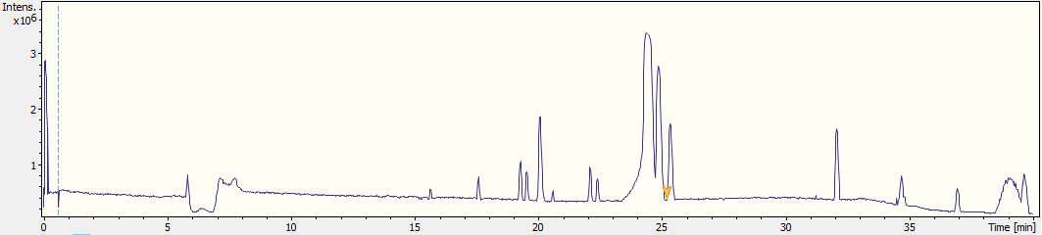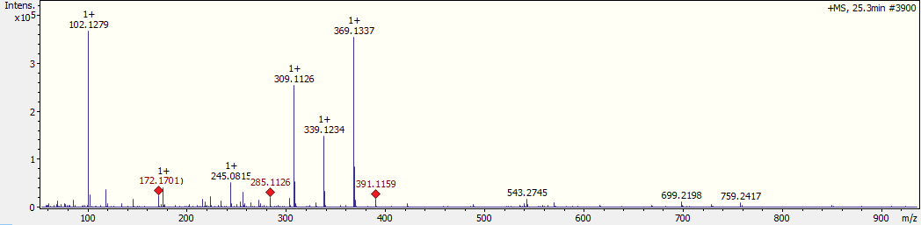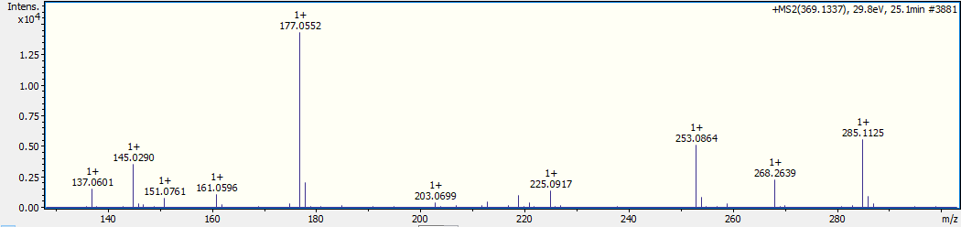
Figure S19. MS¹ and MS² spectra of compound 19
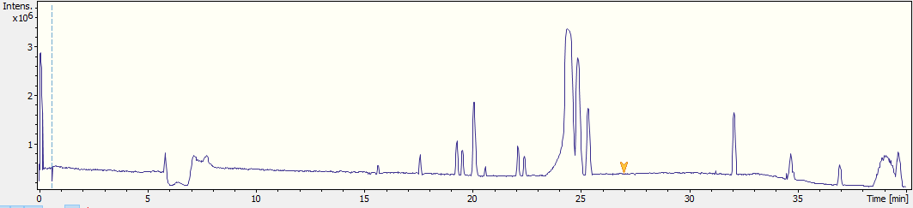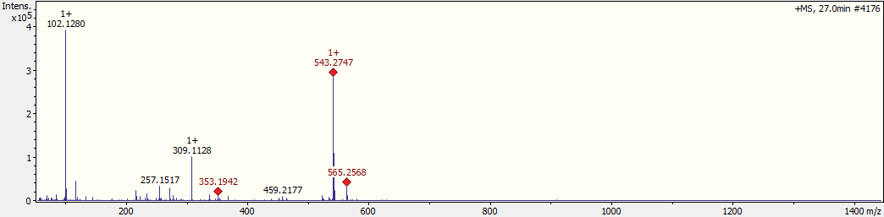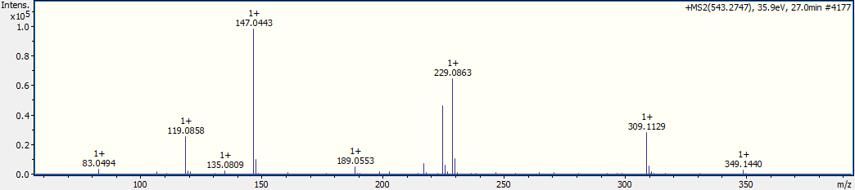
Figure S20. MS¹ and MS² spectra of compound 20
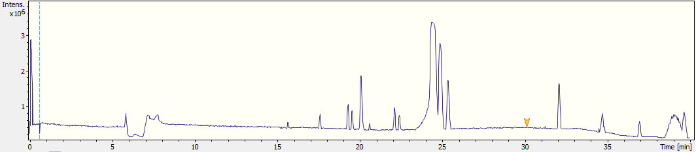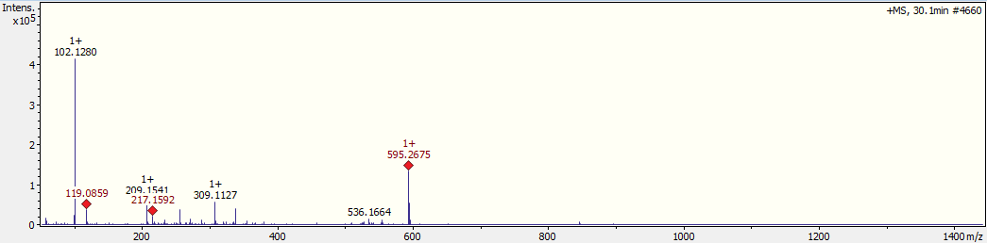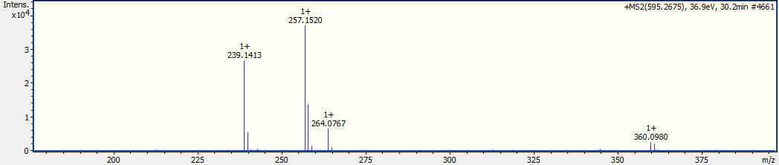
Figure S21. MS¹ and MS² spectra of compound 21
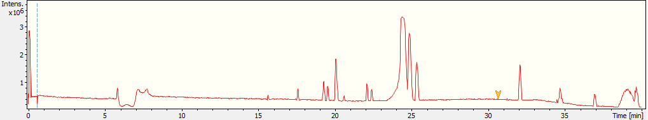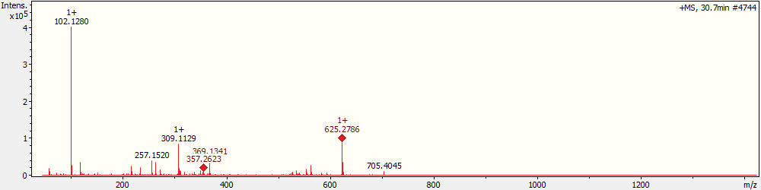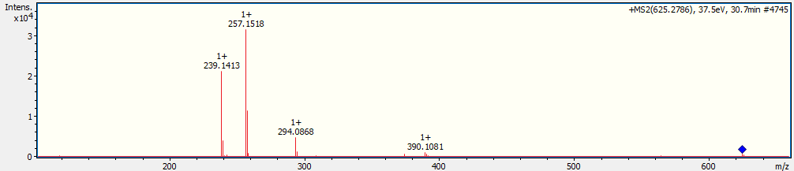
Figure S22. MS¹ and MS² spectra of compound 22

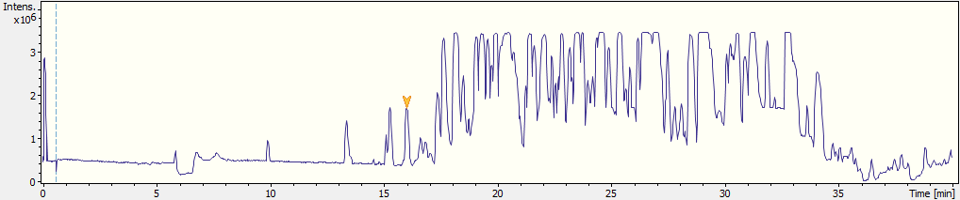
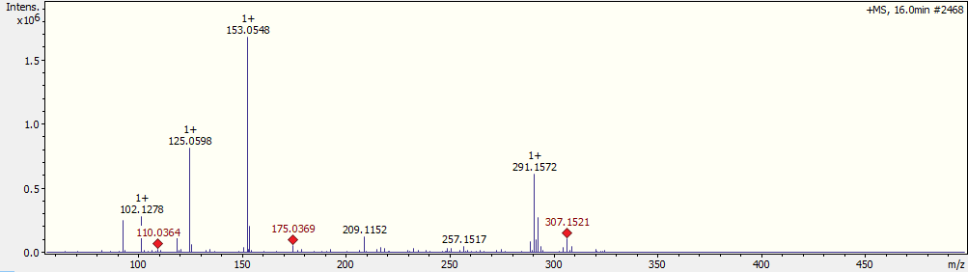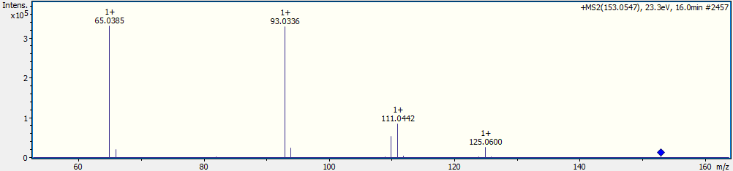
Figure S23. MS¹ and MS² spectra of compound 23
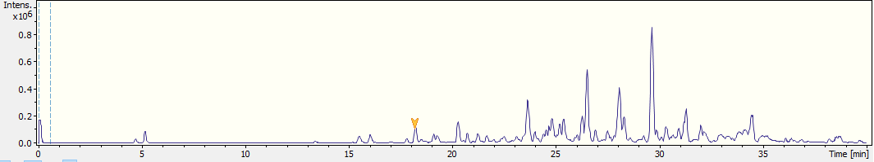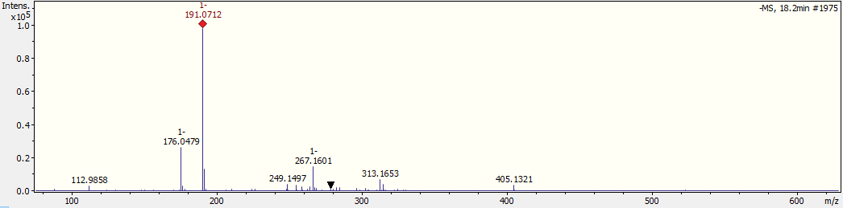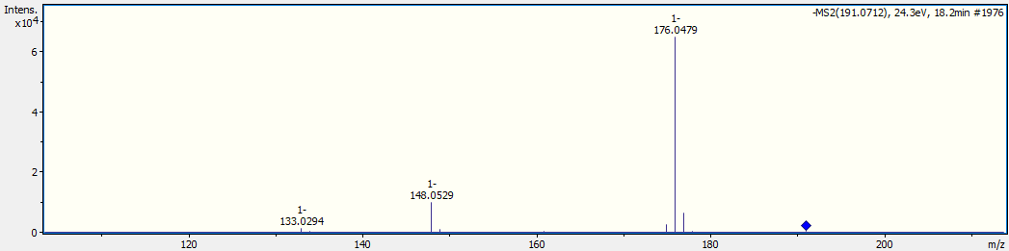
Figure S24. MS¹ and MS² spectra of compound 24
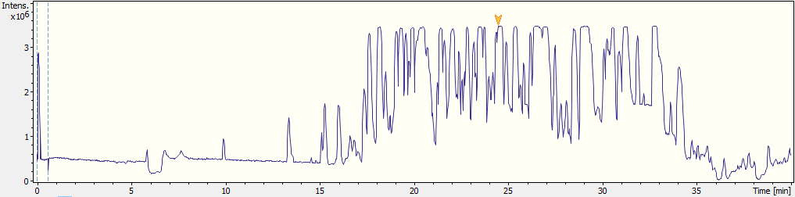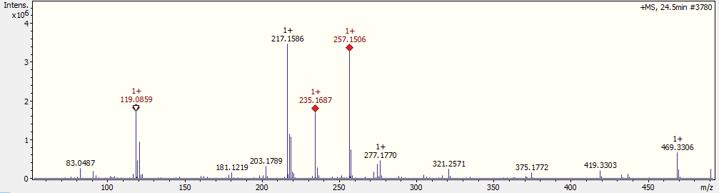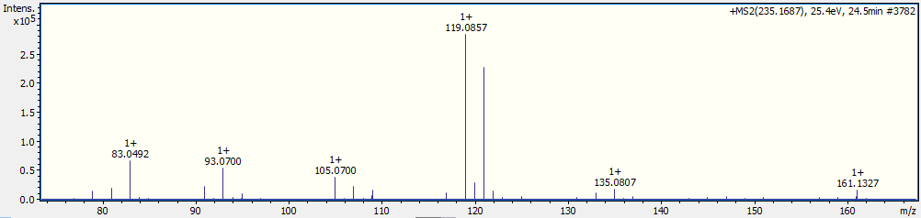
Figure S25. MS¹ and MS² spectra of compound 25
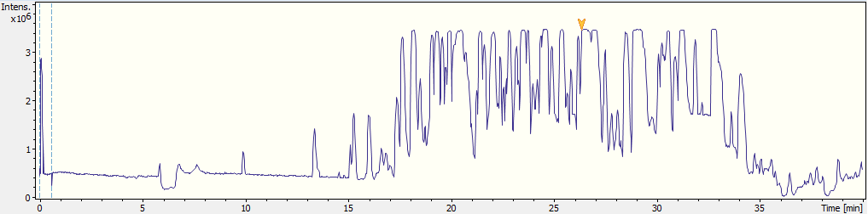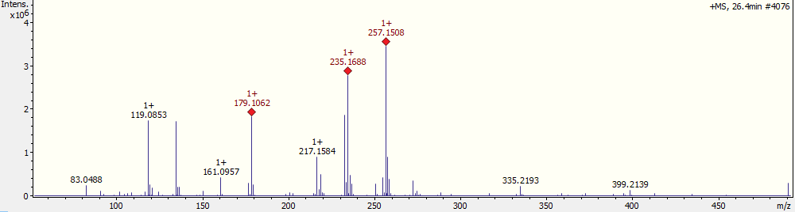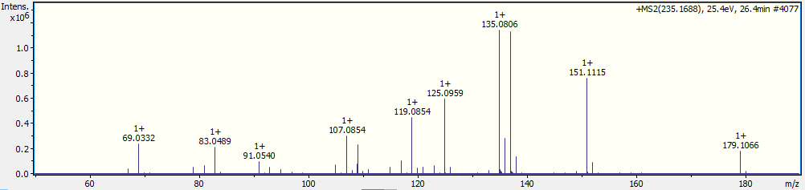
Figure S26. MS¹ and MS² spectra of compound 26
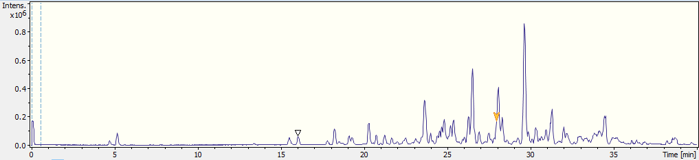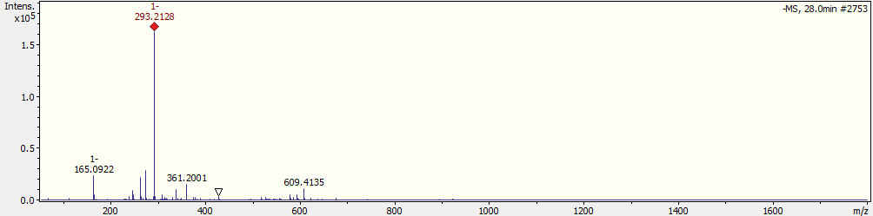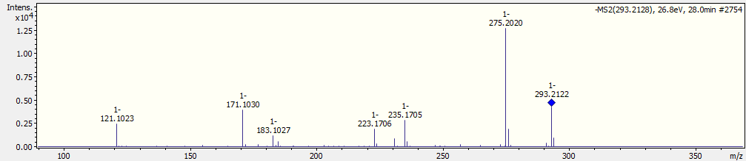
Figure S27. MS¹ and MS² spectra of compound 27
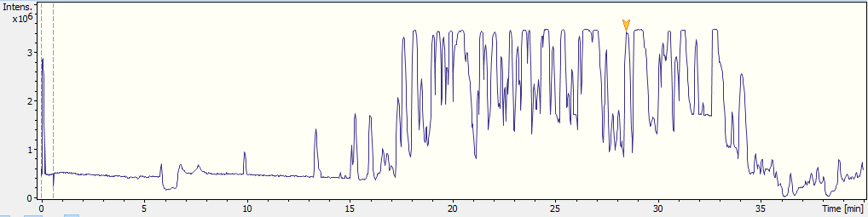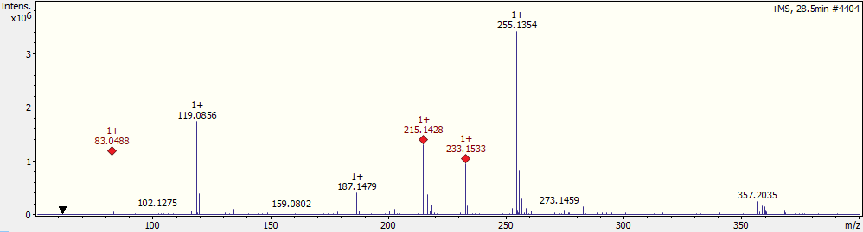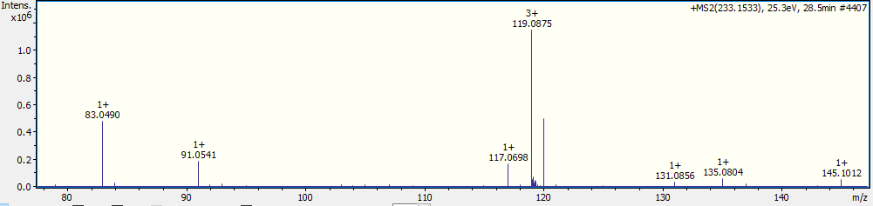
Figure S28. MS¹ and MS² spectra of compound 28
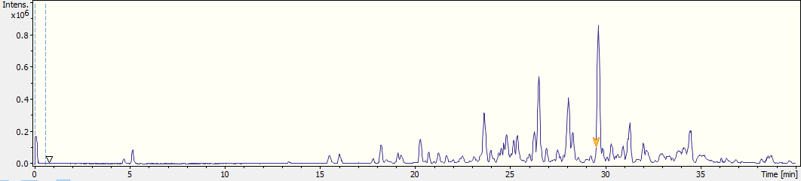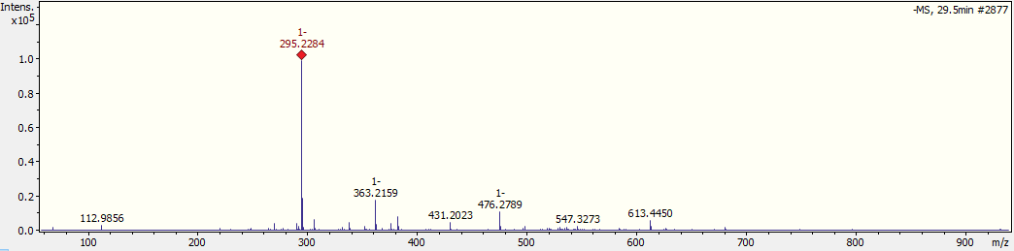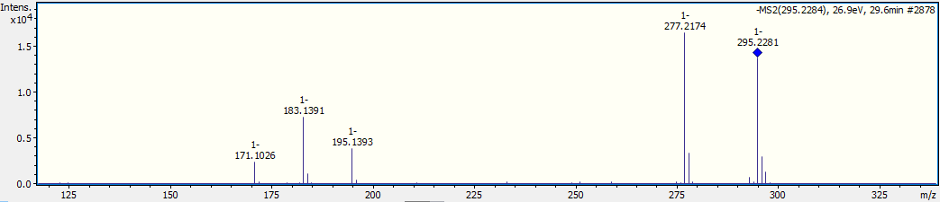
Figure S29. MS¹ and MS² spectra of compound 29
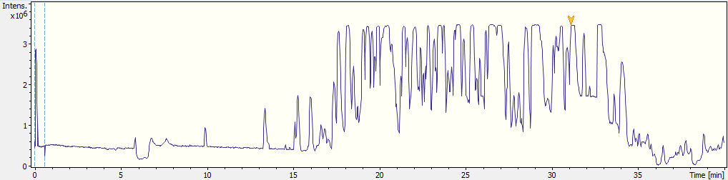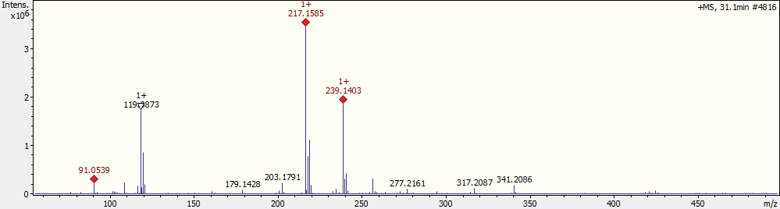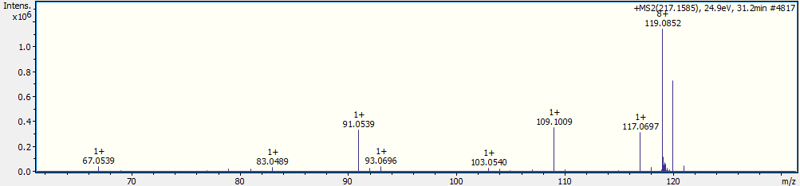
Figure S30. MS¹ and MS² spectra of compound 30

Figure S31. Observed fragmentation pattern of compound 8 in (–)-ESI mode.

Figure S32. Observed fragmentation pattern of compound 16 in (+)-ESI mode.

Figure S33. Observed fragmentation pattern of compound 17 in (+)-ESI mode.
Figure S34. Observed fragmentation pattern of compound 18 in (+)-ESI mode.
Figure S35. Observed fragmentation pattern of compound 19 in (+)-ESI mode.

