Figure S1. Flow chart of the study design

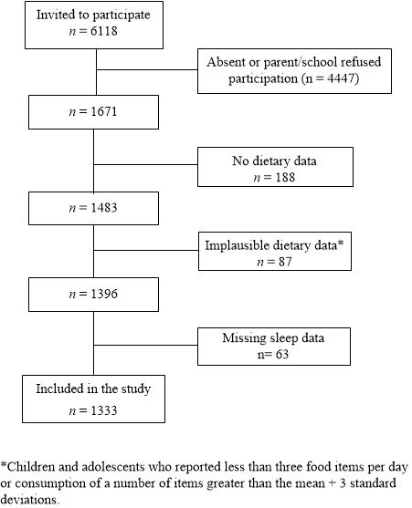

Table S1. Description of sleep variables according to the midpoint of sleep. Florianopolis, Brazil, 2018/2019.
Sleep variables | Early  n=460 | Intermediate  n=434 | Late  n=439
 | median (p25; p75) | median (p25; p75) | median (p25; p75)
Sleep duration (h)
Total | 9.64 (9.08; 10.29) ª | 9.64 (9.11; 10.43) ^{c} | 10.14 (9.29; 11.00) ^{a,c}
Weekday | 9.50 (8.75; 10.00) ª | 9.50 (8.50; 10.50) ^{c} | 10.00 (9.00; 11.00) ^{a,c}
Weekend | 10.00 (9.50; 11.00) | 10.50 (10.00; 11.00) | 10.50 (9.50; 11.00)
Bedtime (local time)
Weekday | 21:30 (21:00; 22:00) ^{a,b} | 22:00 (21:40; 22:35) ^{b,c} | 23:00 (22:00; 23:30) ^{a,c}
Weekend | 22:00 (22:00; 22:30) ^{a,b} | 23:00 (23:00; 23:30) ^{b,c} | 0:00 (23:35; 1:00) ^{a,c}
Wake-up time (local time)
Weekday | 6:40 (6:30; 7:00) ^{a,b} | 7.00 (6:30; 8:30) ^{b,c} | 9:00 (7:00; 10:00) ^{a,c}
Weekend | 8:00 (8:00; 9:00) ^{a,b} | 9:30 (9:00; 10:00) ^{b,c} | 10:30 (10:00; 11:00) ^{a,c}
MSFsc | 3:01 (2:38; 3:17) ^{a,b} | 3.58 (3.44; 4:11) ^{b,c} | 5:05 (4:38; 5:41) ^{a,c}
Bold font and superscripts indicate: Kruskal-Wallis test, a that the first and third tertile are significantly different at 5% level; b that the first and second tertile are significantly different at 5% level; c that the second and third tertiles are significantly different at 5% level.

Table S2. Associations between the midpoint of sleep and mid-afternoon snack, lunch, and dinner. Florianopolis, Brazil, 2018/2019.
 | Lunch |  |  |  | Mid-afternoon snack |  |  |  | Dinner
 | Crude  OR (95% CI) | p | Adjustedª  OR (95% CI) | p | Crude  OR (95% CI) | p | Adjustedª  OR (95% CI) | p | Crude  OR (95% CI) | p | Adjustedª  OR (95% CI) | p
Early | 1.21(0.70;2.09) | 0.451 | 1.18(0.60;2.33) | 0.590 | 0.54(0.25;1.17) | 0.104 | 0.50(0.22;1.15) | 0.093 | 0.91(0.59;1.43) | 0.656 | 0.95(0.54;1.67) | 0.838
Intermediate | 1 | - |  |  | 1 |  |  |  | 1 | -
Late | 2.24(0.56;9.06) | 0.223 | 2.68(0.57;12.67) | 0.184 | 0.57(0.33;1.00) | 0.050 | 0.47(0.20;1.09) | 0.074 | 1.02(0.67;1.56) | 0.912 | 1.25(0.89;1.76) | 0.167
Gender | 0.94(0.43;2.08) | 0.869 | 0.95(0.45;2.04) | 0.890 | 1.74(1.17;2.58) | 0.011 | 1.57(1.00;2.45) | 0.049 | 0.78(0.43;1.41) | 0.368 | 0.84(0.41;1.72) | 0.593
Age | 1.71(0.64;4.52) | 0.245 | 2.00(0.81;4.98) | 0.119 | 0.92(0.51;1.67) | 0.761 | 1.02(0.59;1.78) | 0.931 | 1.36(0.61;3.00) | 0.406 | 1.35(0.64;2.83) | 0.386
Screen use
once | 1.20(0.22;6.60) | 0.810 | 0.96(0.22;4.30) | 0.958 | 1.19(0.72;1.96) | 0.451 | 1.10(0.58;2.10) | 0.746 | 0.91(0.61;1.37) | 0.627 | 0.84(0.48;1.48) | 0.509
twice | 1.02(0.15;6.97) | 0.980 | 1.02(0.13;8.11) | 0.987 | 1.04(0.45;2.43) | 0.911 | 1.02(0.42;2.46) | 0.970 | 0.61(0.29;1.28) | 0.168 | 0.62(0.35;1.11) | 0.098
three times or more | 0.56(0.16;1.93) | 0.319 | 0.43(0.14;1.36) | 0.131 | 1.18(0.69;2.01) | 0.506 | 1.19(0.70;2.04) | 0.469 | 1.45(0.82;2.58) | 0.175 | 1.30(0.69;2.45) | 0.370
Physical activity
3-4 times | 1.17(0.38;3.57) | 0.760 | 1.22(0.38;3.90) | 0.713 | 1.04(0.62;1.73) | 0.880 | 0.96(0.62;1.49) | 0.834 | 1.60(0.94;2.71) | 0.076 | 1.43(0.74;2.76) | 0.247
>=5 times | 6.30(0.60;66.39) | 0.111 | 7.48(0.57;97.85) | 0.110 | 1.74(1.06;2.87) | 0.033 | 1.56(1.10;2.21) | 0.018 | 5.35(1.35;21.26) | 0.022 | 4.78(1.25;18.20) | 0.027
Type of school | 2.44(1.22;4.89) | 0.018 | 2.18(0.77;6.17) | 0.123 | 1.23(0.95;1.59) | 0.107 | 1.33(0.82;2.16) | 0.213 | 1.61(0.95;2.74) | 0.073 | 1.23(0.57;2.82) | 0.586
Maternal education, years of schooling
9-11 | 2.37(1.03;5.43) | 0.043 | 2.19(1.07;4.50) | 0.036 | 1.85(0.85;4.04) | 0.107 | 1.62(0.88;2.96) | 0.107 | 0.70(0.48;1.01) | 0.054 | 0.66(0.52;0.84) | 0.004
≥12 | 3.50(1.37;8.90) | 0.014 | 2.40(0.52;11.22) | 0.230 | 1.23(0.78;1.92) | 0.329 | 0.86(0.39;1.90) | 0.669 | 1.25(0.79;1.98) | 0.297 | 1.04(0.54;2.01) | 0.901
Day of the food intake report | 0.48(0.09;2.59) | 0.347 | 0.25(0.04;1.43) | 0.106 | 1.98(0.95;4.13) | 0.063 | 2.02(0.99;4.13) | 0.053 | 1.28(0.68;2;38) | 0.399 | 0.92(0.42;2.02) | 0.824
Weight status
Overweight | 0.85(0.41;1.73) | 0.609 | 0.96(0.47;1.97) | 0.907 | 0.44(0.30;0.68) | 0.002 | 0.44(0.28;0.69) | 0.003 | 0.84(0.36;1.91) | 0.635 | 0.87(0.35;2.15) | 0.731
Total sleep duration (h) | 0.85 (0.47;1.57) | 0.572 | 0.86(0.48;1.52) | 0.560 | 1.20(0.95;1.53) | 0.113 | 1.27(1.01;1.59) | 0.039 | 0.84 (0.56;1.26) | 0.361 | 0.88(0.61;1.27) | 0.456
Reference categories: gender (male); age (7-10 years); screen use (never); Physical activity (0-2 times); type of school (public school); maternal education (0-8 years); day of food intake report (weekend); and weight status (non-overweight).
ªAdjusted by gender, age, screen use, physical activity, type of school, weight status, maternal education, day of food intake report, and total sleep duration.

