Effects of Algal Extracellular Polymeric Substances on the Formation of Filamentous Manganese Oxide Particles in the near-Bottom Layer of Lake Biwa
Seiko Furuta ^{1,2}, Hisato Ikegaya ³, Megumu Fujibayashi ⁴, Hideki Hashimoto ⁵, Shiro Suzuki ⁶, Kunihiro Okano ², Satoshi Ichise ¹ and Naoyuki Miyata ^{2,}*
¹ Lake Biwa Environmental Research Institute, Ohtsu 520-0022, Japan; furuta-3@ex.bw.dream.jp (S.F.); ichise_home0115@kxf.biglobe.ne.jp (S.I.)
² Department of Biological Environment, Akita Prefectural University, Akita 010-0195, Japan; k_okano@akita-pu.ac.jp
³ Department of Biology, Kobe University, Kobe 657-0013, Japan; ikegaya16@people.kobe-u.ac.jp
⁴ Faculty of Engineering, Kyushu University, Fukuoka 819-0395, Japan; m.fujibayashi@civil.kyushu-u.ac.jp
⁵ Department of Applied Chemistry, Kogakuin University, Tokyo 192-0015, Japan; hideki-h@cc.kogakuin.ac.jp
⁶ Faculty of Applied Biological Sciences, Gifu University, Gifu 501-1193, Japan; suzuki.shiro.n5s@f.gifu-u.ac.jp
* Correspondence: nmiyata@akita-pu.ac.jp; Tel.: +8118 872 1660

Table S1. Composition of CT medium [27]
 | Concentration (L⁻¹)
Ca(NO₃)₂⋅4H₂O | 15 mg
KNO₃ | 10 mg
MgSO₄⋅7H₂O | 4 mg
Disodium β-glycerophosphate | 5 mg
Thiamin hydrochloride | 1 μg
Cyanocobalamin | 0.01 μg
Biotin | 0.01 μg
TAPS | 10 mg
PIV metal salts soln.* | 0.3 mL
*This solution contained (per liter) 19.6 mg of FeCl₃⋅6H₂O, 3.6 mg of MnCl₂⋅4H₂O, 2.2 mg of ZnCl₂⋅7H₂O, 0.4 mg of CoCl₂⋅6H₂O, 0.25 mg of Na₂MoO₄⋅2H₂O, and 100 mg of Na₂EDTA⋅2H₂O (pH 8.2).

Figure S1. Mn(II) oxidation by Bosea sp. BIWAKO-01 in agar-containing cultures. Mn(II) ions were added at a concentration of 0.1 mM at the time indicated by the arrow. Data from triplicate cultures are represented as means ± SD.

Figure S2. TEM image of filamentous Mn oxide particle collected at a depth of 90 m at the study site of Lake Biwa. The high magnification image shows that the filaments consist of sheet-type structure. Bar: 500 nm. Inset, SAED pattern obtained for the sheet-type structure with d values of 0.253 and 0.148 nm.

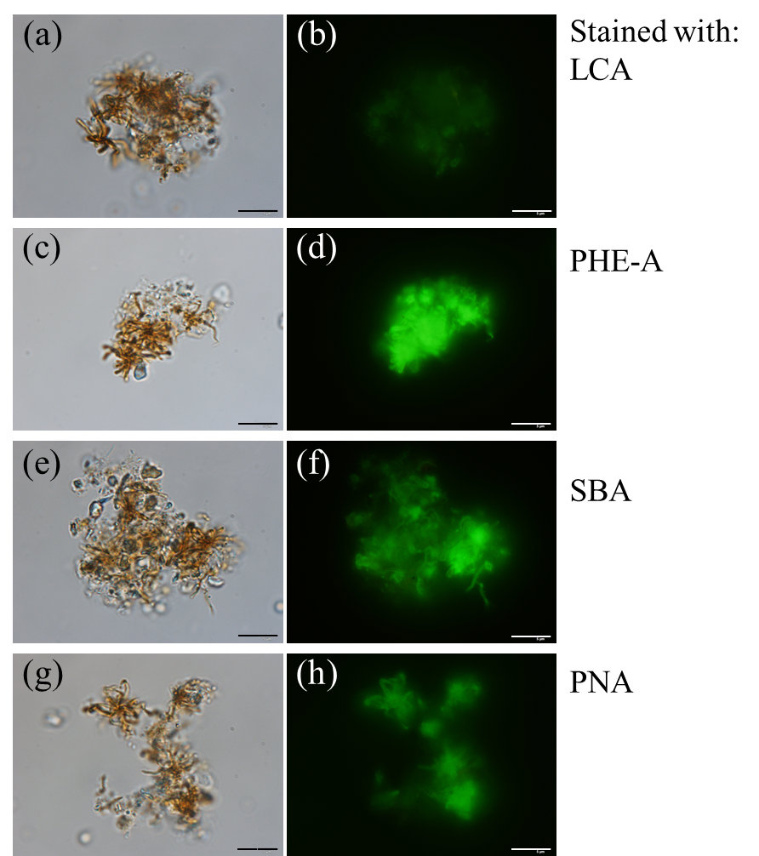

Figure S3. Differential interference contrast and epifluorescence images of aggregates collected at a depth of 90 m at the study site of Lake Biwa. The aggregates were stained with fluorescein-conjugated LCA (a, b), PHA-E (c, d), SBA (e, f), and PNA (g, h). Bar: 10 μm.

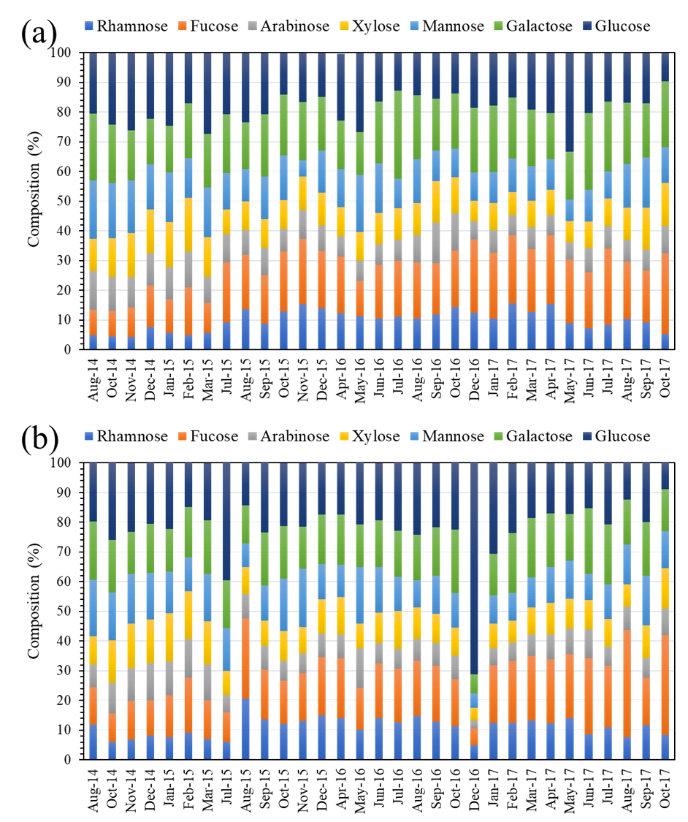

Figure S4. Neutral monosaccharides detected in the total polysaccharides collected from the lake waters at 0.5 m (a) and 90 m (b) during 2014−2017.

