Supplementary Material: Compound Drought-Heat Weather Extremes Induce a More Severe Summer Fire Season in the Three Gorges Reservoir Area, Subtropical China
(Figures S1, S2, S3, S4 are based on the analysis of Copernicus ERA5 satellite images)
Figure S1. Precipitation between July 1st and August 31st (period 2001-2022).
Figure S2. Maximum temperature between July 1st and August 31st (period 2001-2022).
Figure S3. Relative humidity between July 1st and August 31st (period 2001-2022).
Figure S4. Vapor pressure deficit (VPD) between July 1st and August 31st (period 2001-2022).
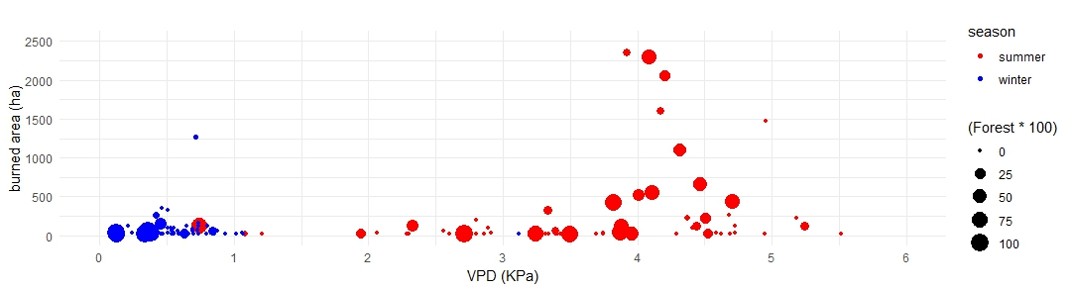
Figure S5. Winter fires tend to occur on lower forest cover (smaller circles in blue), whereas summer CDHE fires are occurring on landscapes (bigger circles in red). Burned area and VPD, controlled for each season (i.e. summer and winter). The radius of circles represents the forest cover (%).
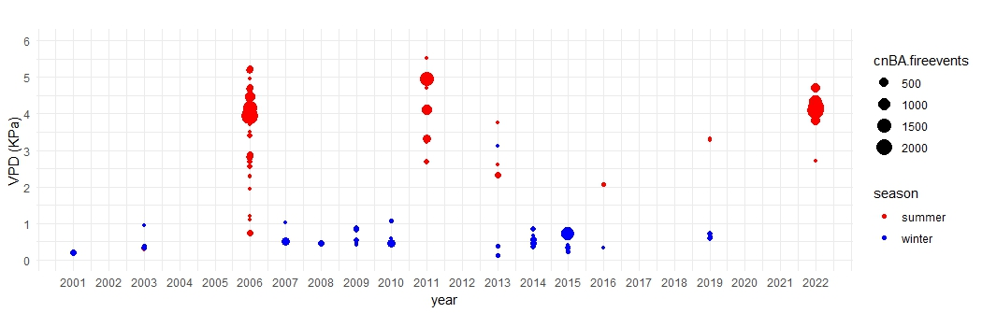
Figure S6. Alternating fire seasons between the historical mild winter and the newly emerging virulent summer season, with higher VPD and burned area records. Scatter plot between VPD and year (of each individual fire), controlling for summer/winter season and burned area (individual fires’ point size).

