Figure S1. Biometry of Posidonia EG: length (L), width (W) and height (H).
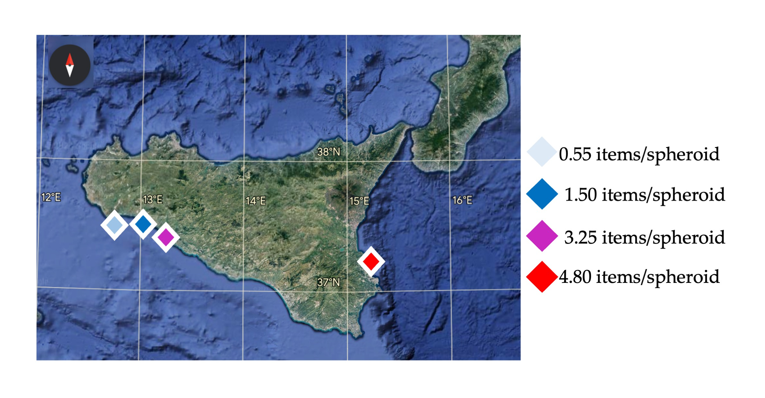
Figure S2. Map of abundance of plastic debris in EGs for each beach.

