Supplementary information
Exogenous CFH Modulates Levels of Pro-Inflammatory Mediators to Prevent Oxidative Damage of Retinal Pigment Epithelial Cells with the At-Risk CFH Y402H Variant
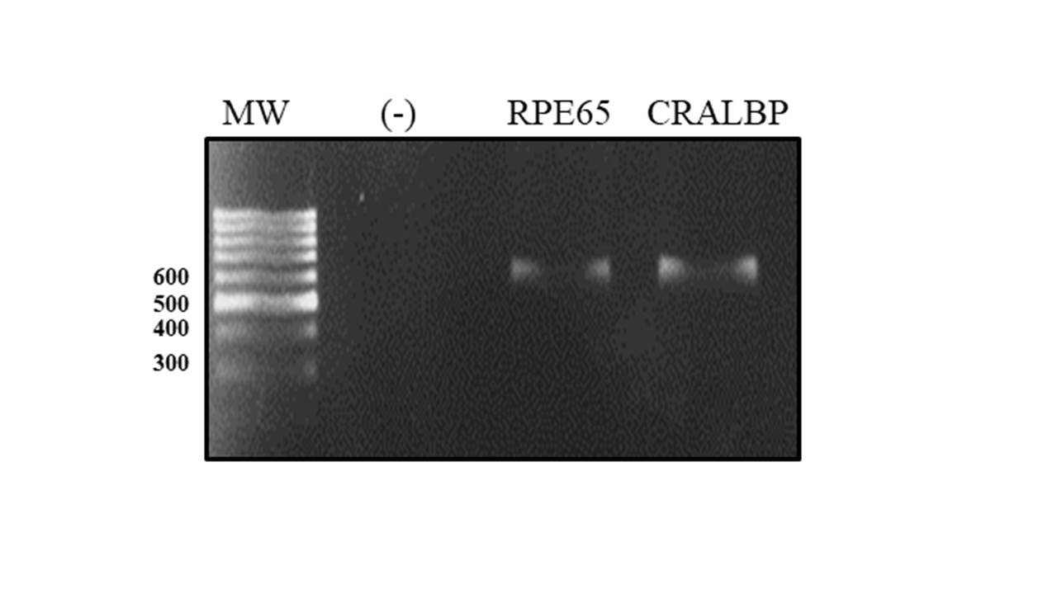
Supplementary Figure 1. Expression of ARPE-19 cell differentiation markers. The total RNA of ARPE-19 was extracted and the expression of RPE65 and CRALBP was determined by RT-PCR. CRALBP expression in peripheral blood monocytes was used as a negative control (-).

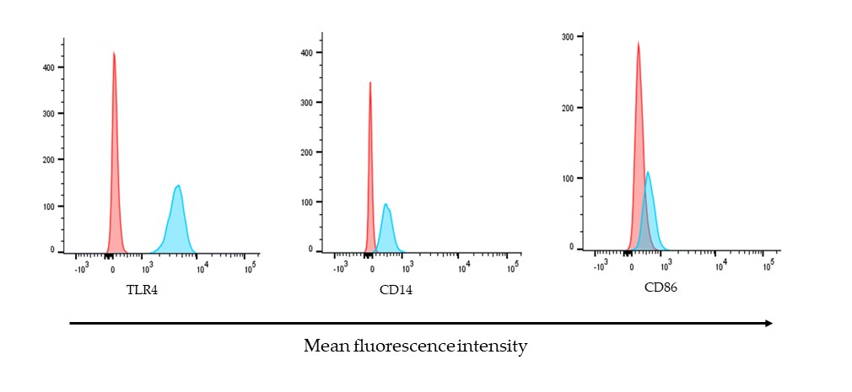
Supplementary Figure 2. Molecules of immunological importance on the surface of ARPE-19 cells. The expression of TLR4, CD14 and CD86 was determined by their detection with specific antibodies coupled to different fluorochromes. Histograms are representative of three independent assays and show the relative fluorescence intensity of ARPE-19 cells without staining (negative control) or stained with APC-conjugated-Anti-TLR4, FITC-conjugated-anti-CD40 or PE-conjugated-CD86 antibodies.

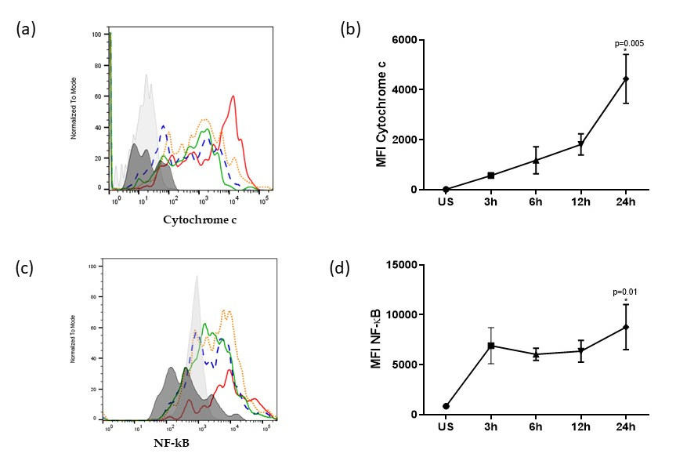
Supplementary Figure 3. Kinetics of cytochrome C release and NF-κB expression in ARPE-19 cells under oxidative stress. ARPE-19 cells were stimulated with 400μM H₂0₂ for 3,6,12, and 24 h or left unstimulated. Intracellular cytochrome C release and NF-κB expression were evaluated. (a) and (c) Representative histograms depicting MFI for cytochrome C and NF- κB respectively. Black: un-stained cells, grey: unstimulated cells, green: stimulated for 3 h, blue: stimulated for 6 h, orange: stimulated for 12 h, red: stimulated for 24h. (b) and (d) Graphic depicts the mean MFI ± SD for three independent assays for cytochrome C and NF- κB, respectively.

