A Semi – Three Dimensional (3D) Bioprinted Neurocardiac System for Tissue Engineering of a Cardiac Autonomic Nervous System (CANS) Model
Ivana Hernandez^{1,2}, Salma P. Ramirez^{1,2}, Wendy V. Salazar¹, Sarahi Mendivil¹, Andrea Guevara¹, Akshay Patel^{1,3}, Zayra N. Dorado^{1,2}, Carla D. Loyola^{1,2}, and Binata Joddar^{1,2,4}
¹Inspired Materials and Stem-Cell Based Tissue Engineering Laboratory (IMSTEL), The University of Texas at El Paso, El Paso, TX, 79968, USA
²Department of Metallurgical, Materials, and Biomedical Engineering, M201 Engineering, The University of Texas at El Paso, 500 W. University Avenue, El Paso, TX, 79968, USA
³Department of Chemical Engineering, University of California, Santa Barbara, CA, 93106, USA
⁴Border Biomedical Research Center, The University of Texas at El Paso, 500 W. University Avenue, El Paso, TX, 79968, USA

Supplementary Materials and Methods
S2.1 Materials
The complete growth medium for the neuro-cardiac structure consisted of the following components: DMEM (Gibco 11966-025, Billings, MT); L-Glutamine (SIGMA cat. No. G7513, St. Louis, MO); Fetal Bovine Serum (FBS) (Approved Source USDA heat inactivated Corning cat. No. 35-011-CV, Corning, NY); Penicillin-Streptomycin Solution (100X) (HyClone cat. No. SV30010, Logan, Utah); Glucose (Acros Organics cat. No. 41095-5000, Geel, BE); Nutrient Mixture F-12 Ham (SIGMA cat. No. N4888, St. Louis, MO); Minimum Essential Medium Eagle (EMEM) (SIGMA cat. No. M2279, St. Louis, MO); Non-Essential Amino Acids (NEAA) (Lonza cat. No. 13-114E, Basel, CH); Neurobasal® medium (Gibco cat. No.21103-049, Billings, MT); B27® Supplement Electro (50X) (ThermoFisher Scientific cat. No A14097-01, Waltham, MA); GlutaMAX Supplement (100X) (Gibco cat. No. 35050-061, Billings, MT) and Trans Retinoic Acid (SIGMA R2625, St. Louis, MO).
For detaching all cells and subculturing, the following items were used: 0.25% Trypsin-EDTA (Gibco cat. No. 25200-056, Billings, MT); centrifuge (ThermoFisher Scientific, Waltham, MA); culture flask T75 (ThermoFisher Scientific, Waltham, MA); Incubator (ThermoFisher Scientific, Waltham, MA) micropipettes (ThermoFisher Scientific, Waltham, MA) (1-10ul, 10-100ul, 100-1000ul); Countess III automated cell counter (ThermoFisher Scientific, Waltham, MA).
For confocal microscopic imaging, the samples required fixing, staining, and labelling with fluorescent dyes or antibodies to highlight specific structures or molecules of interest. For fixing of all cell-gel samples, 4% paraformaldehyde in PBS (PFA) (ThermoScientific cat. No. J19943-K2, Waltham, MA) was used. For cell labelling and confocal microscopic imaging, the PKH67 Green [8, 11] and PKH26 Red [8] Fluorescent Cell Linker Mini Kit were used in accordance with the manufacturer’s instructions (Sigma-Aldrich cat. No. MINI67-1KT – PKH26GL-1KT, St. Louis, MO). For immunofluorescence and imaging, the primary antibodies used for immunostaining included the myogenic determination factor 1 (MyoD1) (Abcam ab16148 Waltham, MA) targeted towards the AC16 cardiomyocytes, and the microtubule-associated protein 2 (MAP-2) (ThermoFisher 131500, Waltham, MA) for the differentiated SH5YSY cells. The secondary antibodies used included the Donkey Anti-Mouse IgG H&L (Alexa Fluor® 647, a bright, far-red–fluorescent dye) (ab150107, 1:800, Abcam, Waltham, MA) to bind to MyoD1. The other secondary antibody included Goat Anti-Mouse IgG H&L (Alexa Fluor® 488, a bright, green-fluorescent dye) preadsorbed (ab150117, 1:200, Abcam, Waltham, MA) to bind to MAP-2. Stained samples were mounted on microscopic glass slides (ThermoFisher, Waltham, MA) using DAPI Fluoromount-G® (Southern Biotech, Birmingham, AL) and dried prior to imaging. To visualize the three-dimensional structure of the samples and cells within using confocal microscopy, a Z-stack of images acquired from optical sections at different focal planes was acquired. These image slices were then reconstructed into a 3D image to generate a maximum intensity image using the software in the confocal fluorescent microscope (ZEISS LSM, Germany).
S2.5 Material Characterization
S2.5.1. Swelling Analysis
The hydration behaviour of acellular bioprinted scaffolds were assessed for a one-week time period. The printed acellular scaffolds were air-dried and the dry weights of each sample was recorded. Each sample was then immersed in 1 mL of 1X PBS at pH 7.4, without calcium and magnesium ions. Weights of the swollen gels were monitored and recorded every 24 h. A swelling ratio was determined for each sample at each time point using previously reported metrics [8]. Briefly, the data collected was used to estimate the swelling ratio, by calculating the difference between the mass in the swollen state and the mass in the dried state (original weight) and normalizing this to the initial dry weight of each sample recorded.
S2.5.2 Attenuated Total Reflectance Fourier Transform Infrared Spectroscopy (ATR-FTIR)
ATR-FTIR was used to study the chemical composition, molecular structure, and functional groups present in the non-crosslinked as well as in the cross-linked samples. Acellular scaffolds were used for ATR-FTIR absorbance studies, and measurements were carried out with the cardiac and neuronal scaffolds using a Nicolet FTIR spectrometer (ThermoFisher Scientific, Waltham, MA) equipped with a diamond ATR crystal. The spectrum of the samples was recorded from 400 to 4000 cm−1 and an average of 32 scans per sample were averaged to reduce spectral noise.
S2.5.3 Scanning Electron Microscopy (SEM)
SEM micrographs were acquired from acellular scaffolds to demonstrate the sequence of the semi 3D printing process, adopted in this study. The cardiac scaffold was studied using SEM followed by imaging of the neuro-cardiac scaffold and visible differences were identified by analysing en-face electron micrographs of lyophilized acellular samples.
3D bioprinted scaffolds were deposited on plastic microscope slides (non-conductive) and freeze-dried or lyophilized before characterization. For freeze-drying, samples were placed in a petri dish in a -80°C freezer overnight and lyophilized (FreeZone Triad, LABCONCO, Kansas City, MO) for 12 hours to preserve their 3D morphology. Prior to SEM imaging the lyophilized samples were sputter-coated with gold/palladium (2–3 min) in a sputter coater (Gatan Model 682 Precision etching coating system, Pleasanton, CA) and visualized using SEM (S-3500, Hitachi, Japan) at 15 kV voltage in a low vacuum setting (VP- 90Pa) at varying magnifications. Three different sample areas were targeted to obtain scaffold morphologies of the semi 3D bioprinted scaffolds. A total of at least n = 5 images per sample were assessed for samples evaluated.
S2.6 Cell Culture and Passaging
AC16 human cardiomyocytes cell line (EMD Millipore cat. No. SCC109, Burlington, MA), derived from an adult human ventricular heart tissue, was used in this study, and cultured based on vendor’s recommendations. To culture these cells, normoglycemic (5mM glucose) DMEM complete growth containing 2mM L-Glutamine, 10% FBS, and 1X Penicillin-Streptomycin Solution was prepared and used.
The neuronal cells used in this study were sourced from the SH-SY5Y neuroblast derived from human neural tissues (SH-SY5Y neuroblastoma cell line ATCC cat. No. CRL-2266, city, state) [15]. Culture medium for these cells contained 1:1 ratio Ham’s F12:EMEM (EBSS), 2mM Glutamine, 1% Non-Essential Amino Acids (NEAA), 15% FBS, and 1% Penicillin/Streptomycin. For making the media, 250 mL of F12 was prepared using 250 mL of EMEM (EBSS), 5 mL of NEAA, 75.75 mL of FBS, 5.80 mL of Glutamine (0.2M), and 5.68 mL of Penicillin/Streptomycin. Cells were grown and passaged for experimental stabilization as per vendor’s recommendations and seeded in T75 flask at a seeding density of 1000 – 10,000 cells/cm². Once the desired cell density was attained and confirmed via cell counting, neuronal differentiation was performed adopting guidance from published studies in literature [16]. The growth medium was replaced with Neurobasal medium containing B27 supplement and GlutaMAX. In addition, 10 μM of all-trans-retinoic acid (ATRA) were added to the T75 culture flask to induce differentiation and neuronal phenotype. Cells were incubated for 3-5 days, refreshing the Neurobasal medium every 48 hours (about 2 days). Morphological changes monitoring the entire differentiation process (approximately 7 days) were performed using an EVOS compound microscope (ThermoFisher Scientific, Waltham, MA).
The thawing process was performed as described herein, the AC16 cell vial was removed from the freezer and incubated in a 37°C water bath until the cells were completely thawed. The outside of the vial was disinfected with 70% ethanol and transferred to the laminar flow hood. The cells were carefully transferred to a sterile 15 mL conical tube using a 2 mL pipette. Using a 10 mL pipette, 9 mL of AC16 growth culture medium was slowly added dropwise to the 15 mL conical tube. The cell suspension was mixed slowly and centrifuged at 300xg for 3 minutes. After centrifugation, the supernatant was discarded, and cells were resuspended in 10-15 mL of AC16 Culture Medium. Then, the cell mixture was transferred to a T75 culture flask, and the cells were incubated at 37°C in a humidified incubator with 5%CO2. The medium was exchanged the next day with 10-15 mL of fresh AC16 Culture Medium. Every two to three days after, the medium was exchanged with fresh medium and the cells were checked under the microscope for confluency daily. Cells were grown and passed for experimental stabilization as per vendor’s recommendations. When the cells reached 80-95% confluency, they were detached from the T75 tissue culture flask using trypsin-EDTA. For passaging the cells, the growth medium was removed from the T75 tissue culture flask and 5 mL of trypsin-EDTA solution was added to the flask with cells and it was incubated at 37°C for 3 minutes. Then, the same volume of AC16 Culture Medium was added to the T75 flask to inactivate the trypsin-EDTA plate and the cells were detached followed by gently rotating of the flask to ensure a homogenous cell suspension. The detached cell suspension was transferred to a 15 mL conical tube and centrifuged at 300xg for 5 minutes to form a cell pellet. The supernatant was discarded and 2mL of AC16 Culture Medium were added to the conical tube. Using a pipette, the cells were resuspended thoroughly, and cells were automatically counted with Countess III to estimate cell density for further experiments.
For thawing and passaging of the neuronal cells, a similar method reported for the cardiac cells was adopted. For further passaging and differentiation, the growth medium in the T75 culture flask was discarded and adherent cells were rinsed with pre-warmed and sterile 1x PBS. 5 mL of trypsin were added to adherent cells and incubated for 2 minutes or until cells visibly detached from culture flask. Trypsin was neutralized by adding 5 mL of EMEM/F12 medium containing 15% FBS. The cell suspension was transferred to a 15 mL conical tube and centrifuged at 1,500 rpm for 5 minutes at room temperature to pellet the cells. The supernatant was discarded, and the pellet was suspended in 2 mL of EMEM/F12 medium containing 15% FBS. The cell suspension was mixed by gently pipetting up and down.
Supplementary Immunostaining Results
Shown in Supplementary Figure 1 are the immunostaining results confirmed via confocal microscopic imaging from 3D Neuro-Cardiac cultures (A-D) showing AC16 cardiomyocytes (MYO D1+Alexa Fluor 647: Red) as shown in (C), and SHSY5Y neurons (MAP-2+Alexa Fluor 488: Green) as shown in (B). All cell nuclei are stained using DAPI (blue) as depicted in (A) and a merged result of both cell types is depicted in (D) and (E).
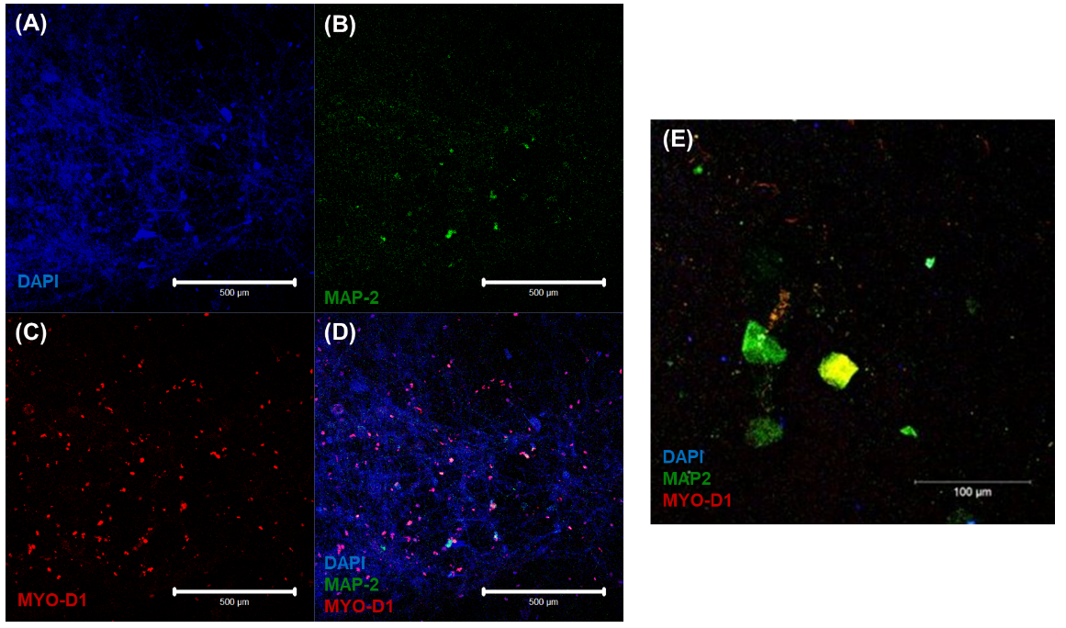
Supplementary Figure 1. Immunostaining results confirmed via confocal microscopic imaging from 3D Neuro-Cardiac cultures (A-D) showing AC16 cardiomyocytes (MYO D1+Alexa Fluor 647: Red) as shown in (C), and SHSY5Y neurons (MAP-2+Alexa Fluor 488: Green) as shown in (B). All cell nuclei are stained using DAPI (blue) as depicted in (A) and a merged result of both cell types is depicted in (D) and (E).

Shown in Supplementary Figure 2 are the immunostaining results from 2D cultures showing SHSY5Y neurons (A) with neurite projections identified with MAP2, and (B) showing clustering of neurons confirming their differentiation. Shown in (C) are cardiomyocytes cultured in 2D controls and identified with their MyoD1 expression.
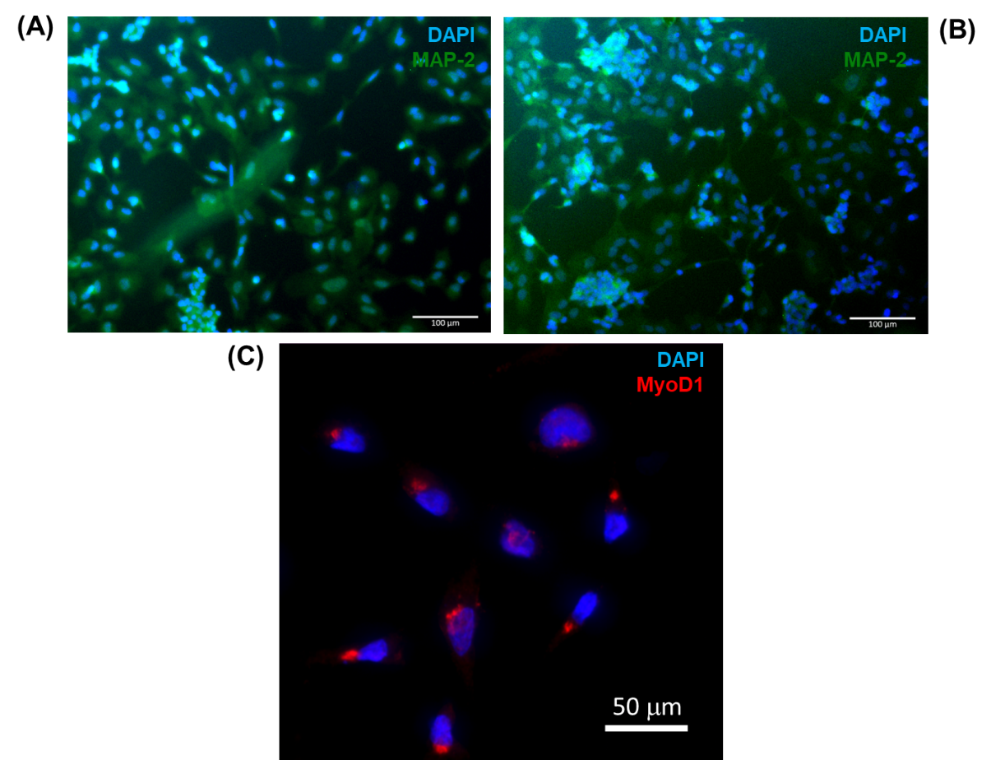
Supplementary Figure 2. Immunostaining results from 2D cultures showing SHSY5Y neurons (A) with neurite projections, and (B) showing clustering of neurons confirming their differentiation. Shown in (C) are cardiomyocytes cultured in 2D controls.

