Supplementary Material
(A)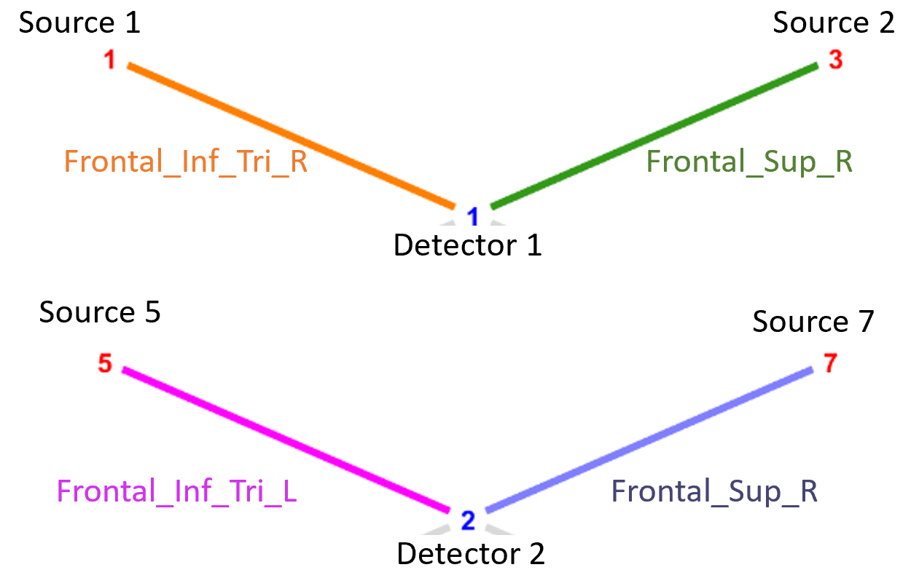
(B)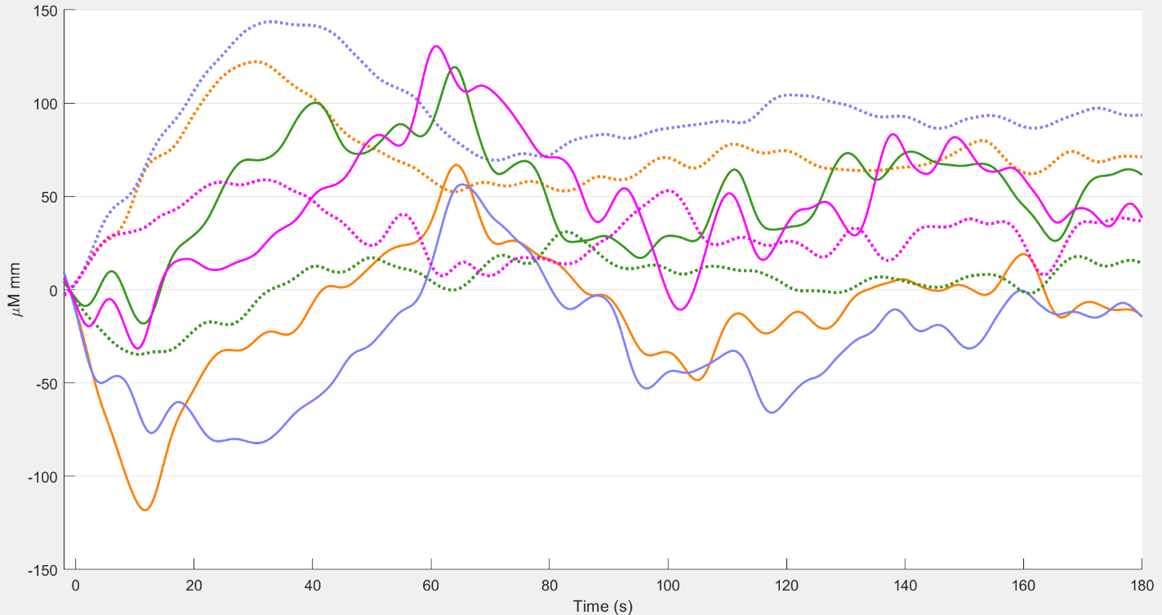
(C)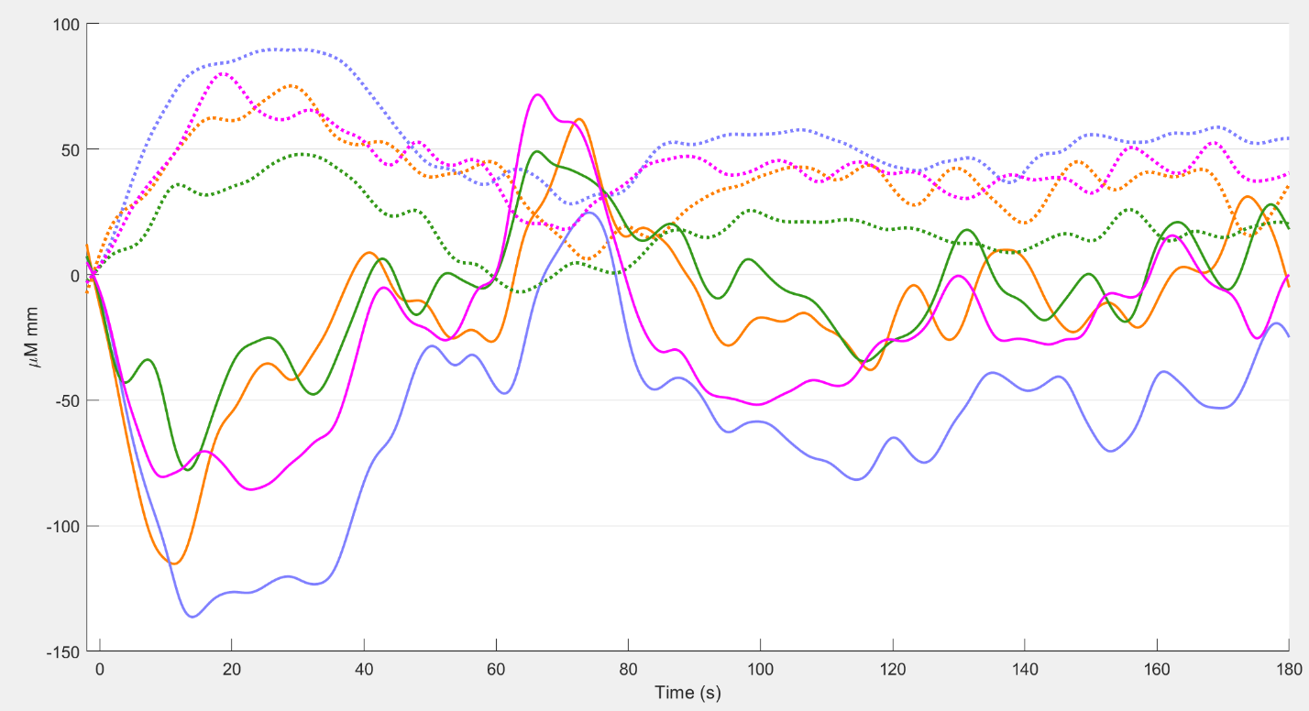
(D)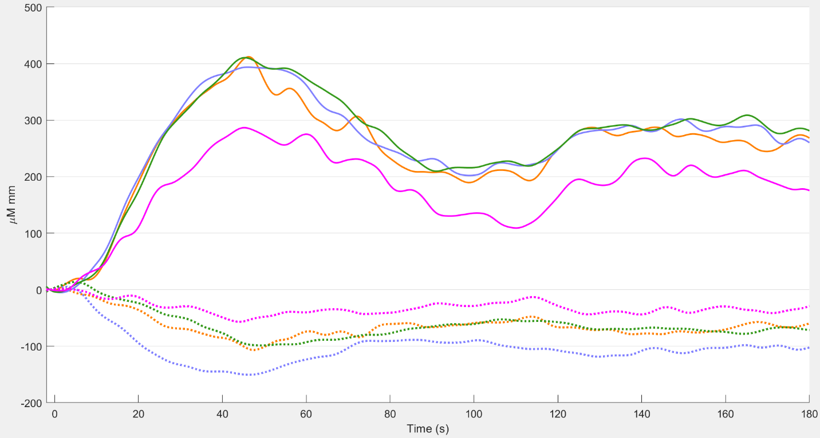
(E)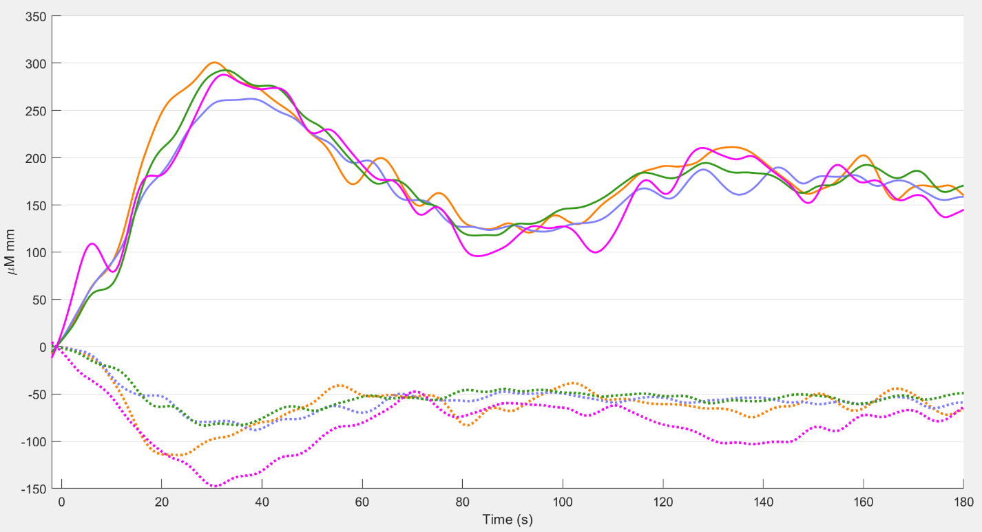
Figure S1. Averaged hemodynamic response function (HRF) of the experimental groups with solid line showing oxyhemoglobin concentration changes and the dotted line showing the deoxyhemoglobin concentration changes. (A) Optode montage with colors denoting different prefrontal brain regions of interest. (B) Sedentary healthy control group HRFs. (C) Active healthy control group HRFs. (D) T2DM intervention group pre-intervention HRFs. (E) T2DM intervention group post-intervention HRFs.

A1
B1
A2
B2
A3
B3
A4
B4 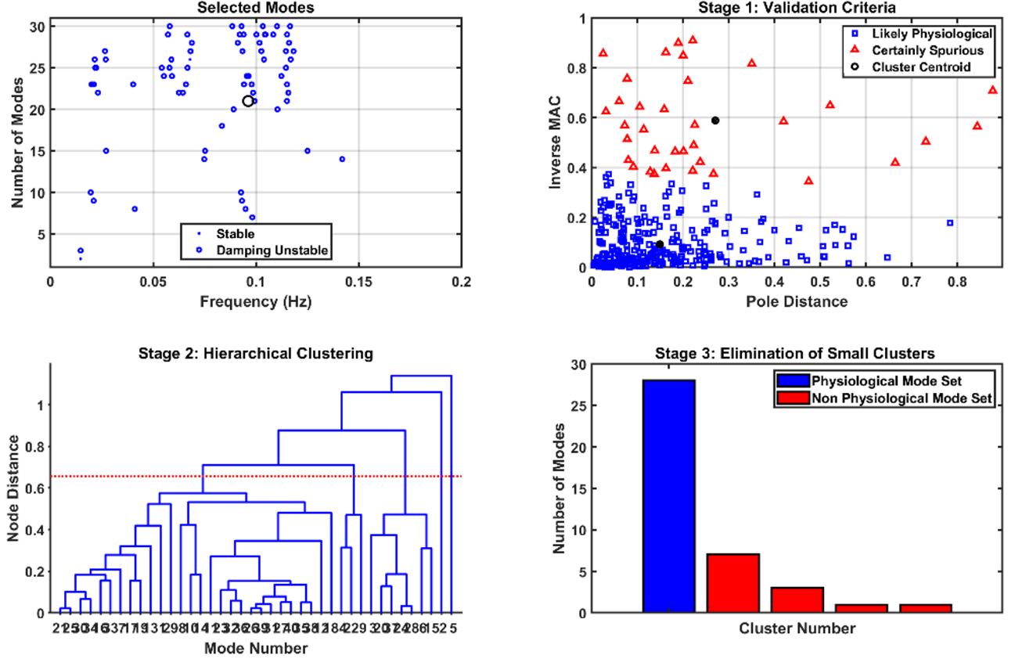
Figure S2. Operational modal analysis (OMA) of near-infrared spectroscopy effects with maximum 30 modes for the power spectrum <0.1Hz in the stabilization diagram shown. Then, a multi-stage clustering for identifying physiological clusters using the Modal Toolkit (https://code.vt.edu/vibes-lab/modal-analysis). A1 and B1 are the stabilization diagram and the multi-stage clustering respectively for the Sedentary healthy control group. A2 and B2 are the stabilization diagram and the multi-stage clustering respectively for the Active healthy control group. A3 and B3 are the stabilization diagram and the multi-stage clustering respectively for the T2DM intervention group pre-intervention. A4 and B4 are the stabilization diagram and the multi-stage clustering respectively for the T2DM intervention group post-intervention.

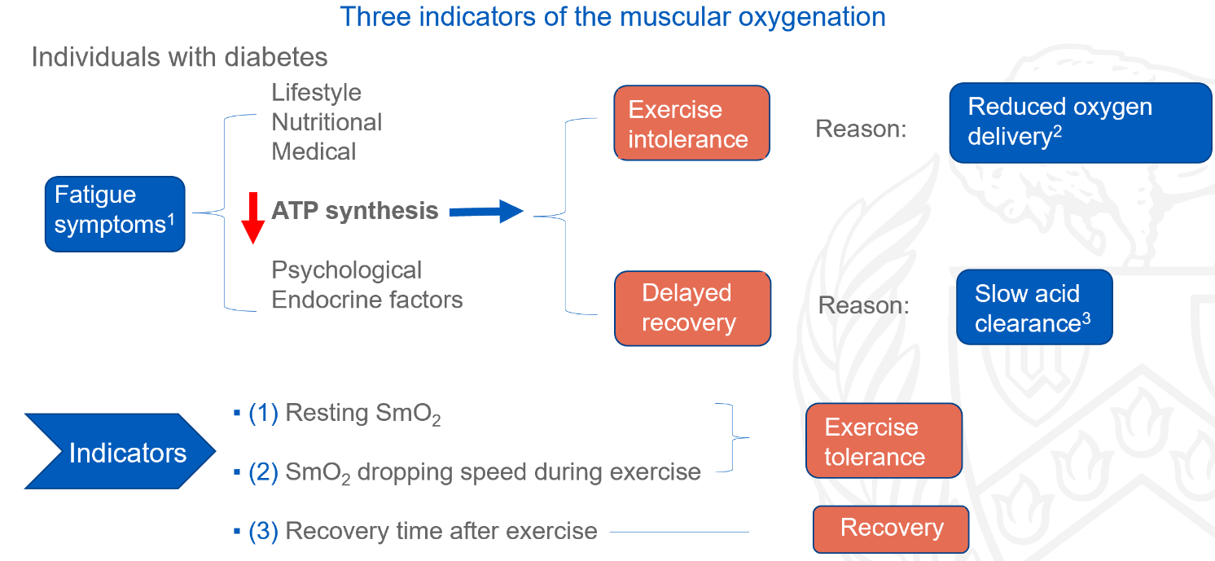
Figure S3. Postulated indicators of the muscle oxygenation response – resting SmO2, SmO2 drip during exercise, SmO2 recovery after exercise.

