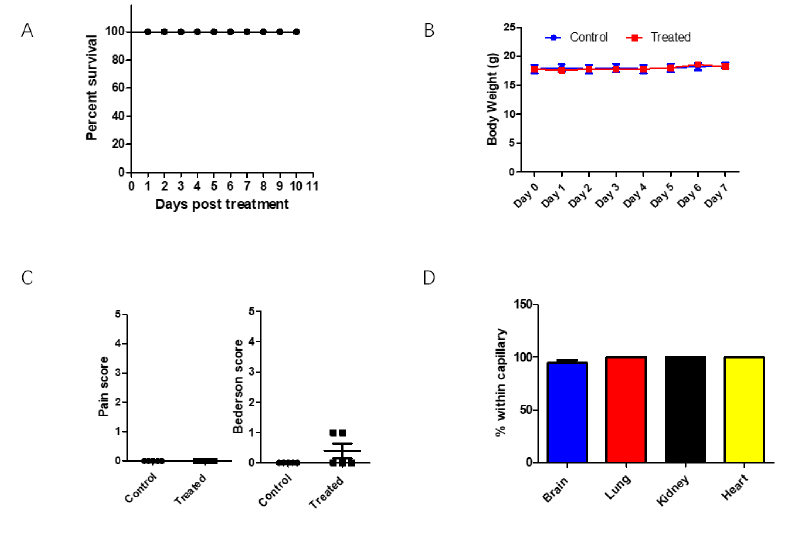

Figure S1 Mouse behavior after microsphere treatment.
(A) The survival of mice after treatment with 5x10⁶ 6 μm microspheres from the tail vein.
(B) The daily body weight change of mice with or without treatment with 5x10⁶ 6 μm microspheres from the tail vein.
(C) The pain score and neurological evaluation Bederson score of mice after treatment with 5x106 6 μm microspheres from the tail vein.
(D) The percentage of microspheres within capillary after 7 days.

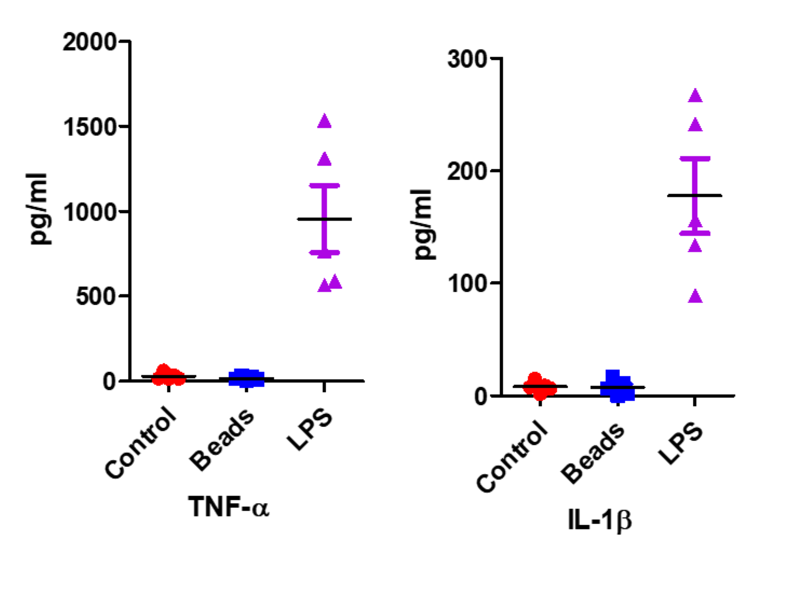
Figure S2 The detection of TNF-α and IL-1β production using ELISA. 10 μg/ml final concentration of LPS was used as control.

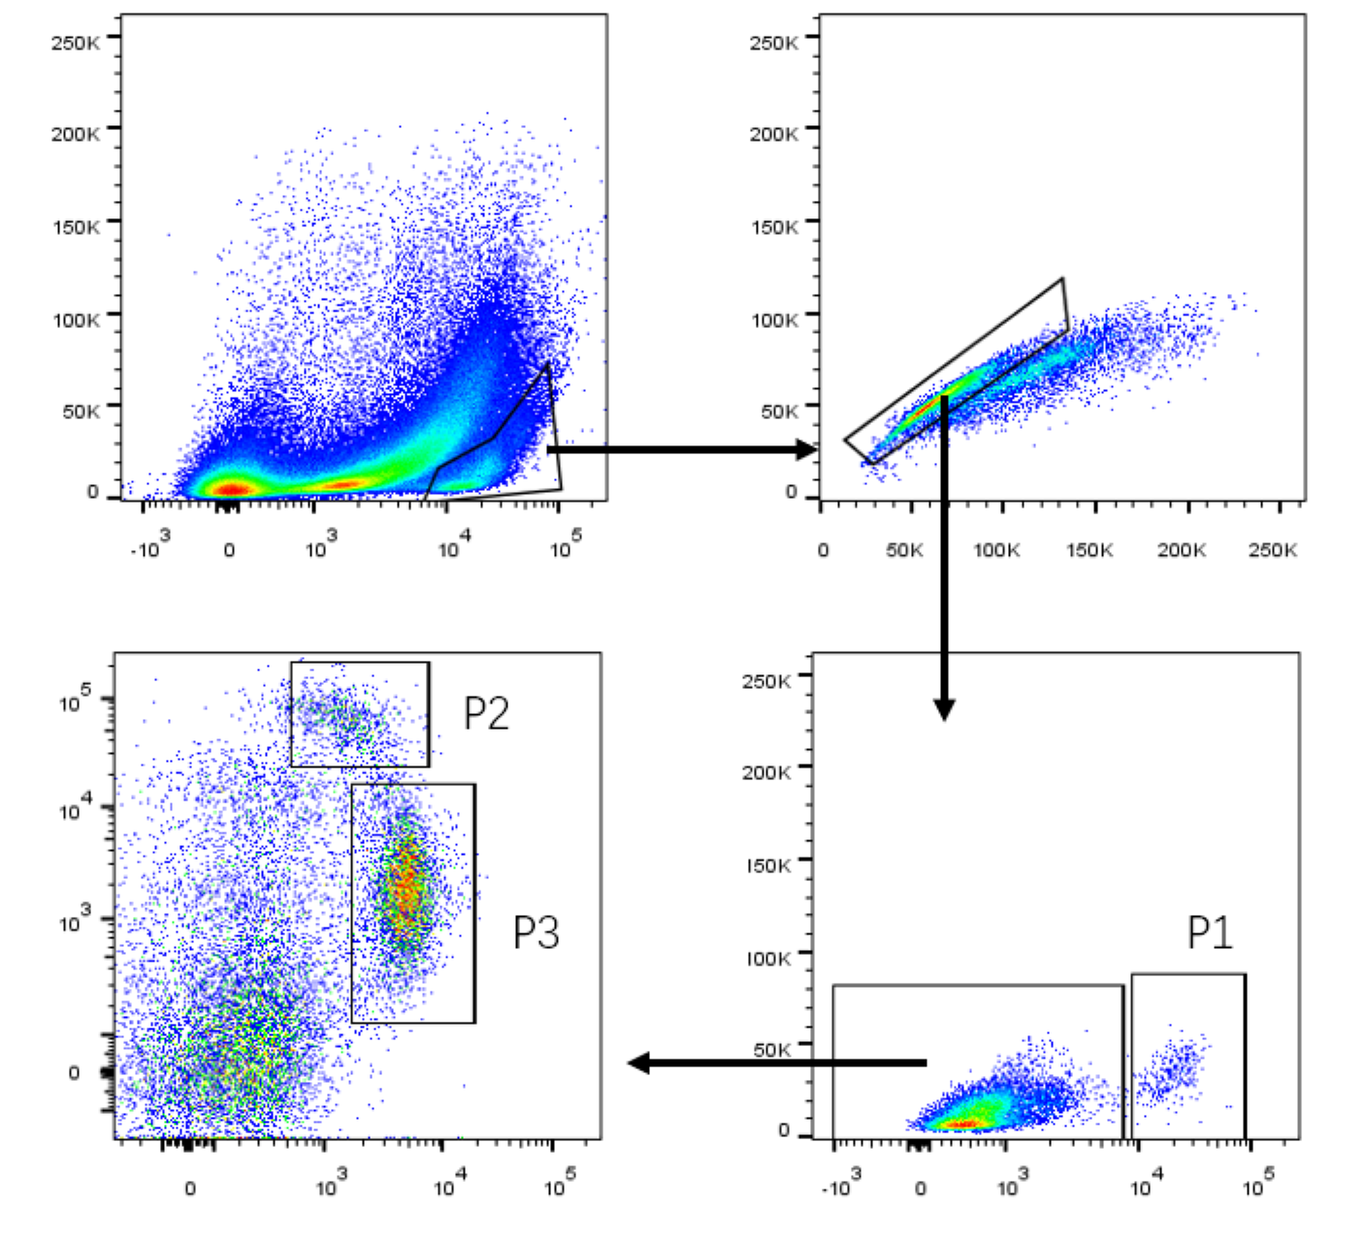

Figure S3 The gating strategy for neutrophil P1, Ly6Chi monocyte P2 and Ly6Clo monocyte P3.
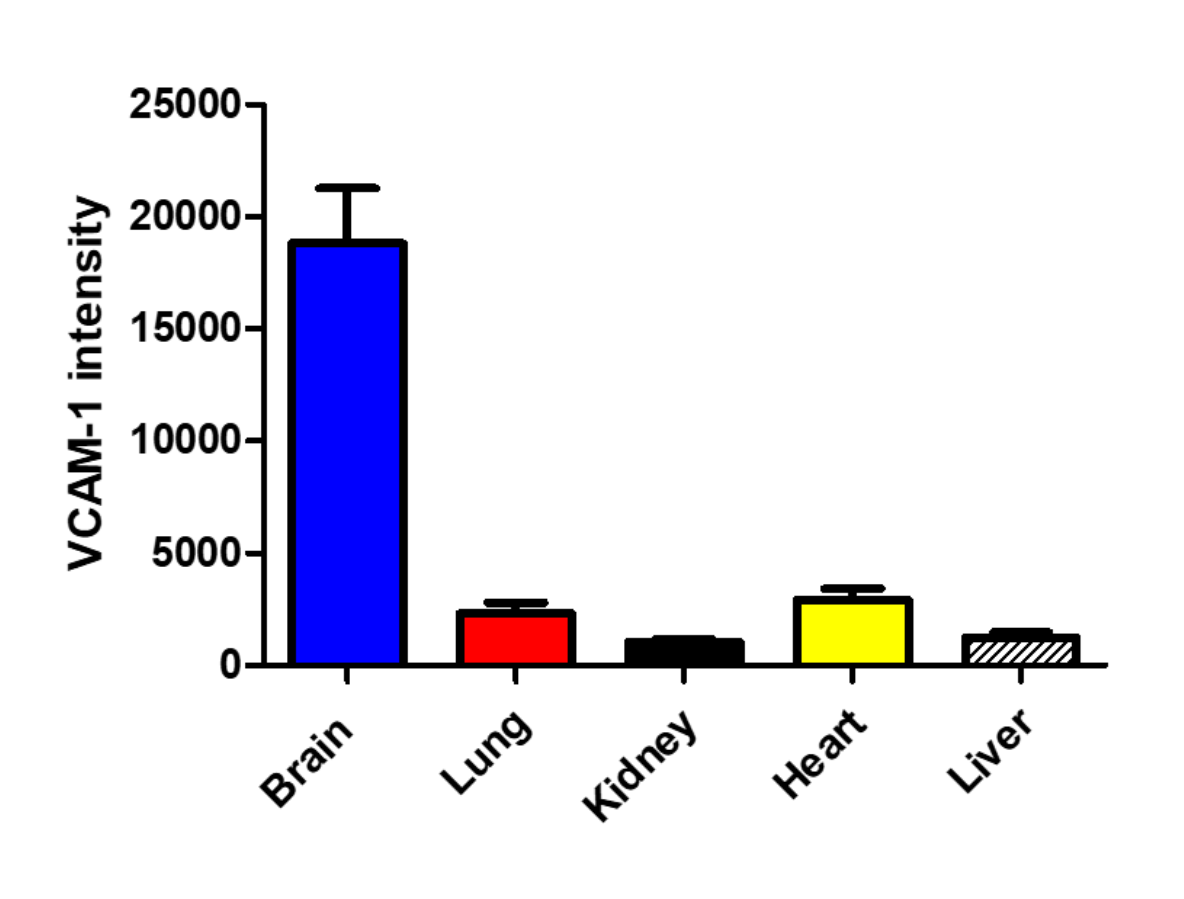

Figure S4 The VCAM-1 intensity on different organs studied by fluorescence microscope.
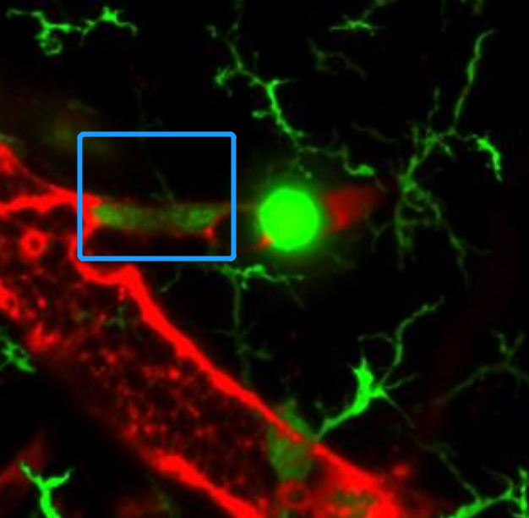

Figure S4 Monocytes were frequently seen approaching the microsphere

