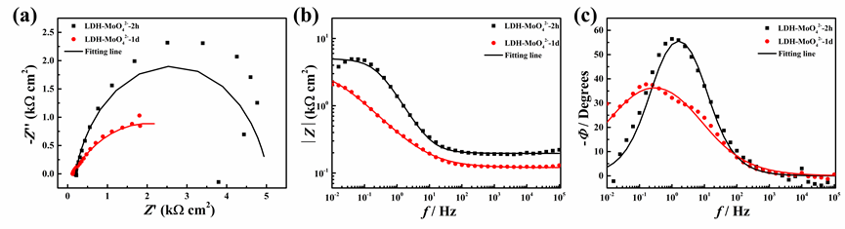
Fig.S1 The EIS results of carbon steel in 0.02 M NaCl solution with 5g/L LDH-MoO₄²⁻.

