Supplementary materials:
Table S1. Antibodies used in IHC and mIF samples.
 |  |  | Antibody | Clone | AntibodyDilution | Vendor | Flourescence
Panel 1 |  |  | Pancytokeratin | AE1/AE3 | 1:100 | Dako, Carpinteria, CA | Opal Polaris 650
 |  |  | CD3 | D7A6E | 1:100 | Cell Signaling Technology, Danvers, MA | Opal Polaris 780
 |  |  | CD8 | C8/144B | 1:25 | Thermo Fisher Scientific, Waltham, MA | Opal Polaris 520
 |  |  | FOXP3 | D2W8E | 1:50 | Cell Signaling Technology, Danvers, MA | Opal Polaris 570
 |  |  | PD-1 | EPR4877-2 | 1:250 | Abcam, Cambridge, MA | Opal Polaris 620
 |  |  | PD-L1 | E1L3N | 1:1500 | Cell Signaling Technology, Danvers, MA | Opal Polaris 690
 |  |  | Ki67 | MIB-1 | 1:100 | Dako, Carpinteria, CA | Opal Polaris 480
 |  |  | CD68 | PG-M1 | 1:50 | Dako | Opal Polaris 540
Panel 2 |  |  | TTF-1 | 8G7G3/1 | 1:200 | Agilent Technologies | Opal Polaris 540
 |  |  | WT-1 | 6F-H2 | 1:40 | Sigma-Aldrich | Opal Polaris 780
 |  |  | CD3 | D7A6E | 1:100 | Agilent Technologies | Opal Polaris 4800
 |  |  | CD8 | C8/144B | 1:25 | Thermo Fisher Scientific, Waltham, MA | Opal Polaris 670
 |  |  | FOXP3 | 206D | 1:50 | BioLegend, San Diego, CA | Opal Polaris 570
 |  |  | PD-1 | EPR4877-2 | 1:100 | Abcam, Cambridge, MA | Opal Polaris 620
 |  |  | PD-L1 | E1L3N | 1:300 | Cell Signaling Technology, Danvers, MA | Opal Poliris 650
 |  |  | Ki67 | MIB-1 | 1:100 | Dako, Carpinteria, CA | Opal Polaris 690
 |  |  | CD68 | PG-M1 | 1:25 | Agilent Technologies | Opal Polaris 520
Panel 3 |  |  | GATA-3 | EPR16651 | 1:200 | Leica; Abcam | Opal Polaris 540
 |  |  | WT-1 | 6F-H2 | 1:40 | Sigma-Aldrich | Opal Polaris 780
 |  |  | CD3 | D7A6E | 1:200 | Agilent Technologies | Opal Polaris 480
 |  |  | CD8 | C8/144B | 1:25 | Thermo Fisher Scientific, Waltham, MA | Opal Polaris 670
 |  |  | FOXP3 | 206D | 1:50 | BioLegend, San Diego, CA | Opal Polaris 570
 |  |  | PD-1 | EPR4877-2 | 1:100 | Abcam, Cambridge, MA | Opal Polaris 620
 |  |  | PD-L1 | E1L3N | 1:250 | Cell Signaling Technology, Danvers, MA | Opal polaris 650
 |  |  | Ki67 | MIB-1 | 1:100 | Dako, Carpinteria, CA | Opal Polaris 690
 |  |  | CD68 | PG-M1 | 1:25 | Agilent Technologies | Opal Polaris 520
CD, cluster of differentiation; FOXP3, forkhead box P3; IHC, immunohistochemistry; mIF, multiplex immunofluorescence; PD-1, programmed cell death protein 1; PD-L1, programmed death-ligand 1;TTF-1, thyroid transcription factor-1; WT-1, Wilms tumor 1.

Table S2. Immunophenotyping by mIF using 3 Opal panels.
Phenotype | Marker expression
Panel 1
Malignant cells | Total PanCK+
PD-L1+ malignant cells | PanCK+PD-L1+
Total T cells | CD3+
Cytotoxic T cells | CD3+CD8+
Antigen-experienced T cells | CD3+PD-1+
Total macrophages | CD68+
PD-L1+ macrophages | CD68+PD-L1+
Regulatory T cells | CD3+ FOXP3+CD8^{neg}
Ki67 expression | Total Ki67+
Panel 2
Malignnat cells | Total TTF-1+
Mesothelial cells | WT-1
PD-L1+ malignant cells | TTF-1+PD-L1+
Total T cells | CD3+
Cytotoxic T cells | CD3+CD8+
Antigen-experienced T cells | CD3+PD-1+
Total macrophages | CD68+
PD-L1+ macrophages | CD68+PD-L1+
Regulatory T cells | CD3+FOXP3+CD8^{neg}
Ki67 expression | TTF-1+Ki67+ and CD3+Ki67+
Panel 3
Malignant cells | Total GATA3+
Mesothelial cells | WT-1
PD-L1+ malignant cells | GATA3+PD-L1+
Total T cells | CD3+
Cytotoxic T cells | CD3+CD8+
Antigen-experienced T cells | CD3+PD-1+
Total macrophages | CD68+
PD-L1+ macrophages | CD68+PD-L1+
Regulatory T cells | CD3+FOXP3+CD8^{neg}
Ki67 expression | GATA+Ki67+ and CD3+Ki67+

CD, cluster of differentiation; FOXP3, forkhead box P3; mIF, multiplex immunofluorescence; PanCK, pancytokeratin; PD-1, programmed cell death protein 1; PD-L1, programmed death-ligand 1; WT-1, Wilms tumor 1.

Table S3. Cellular composition of LADC MPEs in absolute numbers.
 | Samples
Cell Phenotype | S1 | S2 | S3 | S4 | S5
TTF-1+ | 3200 | 7330 | 4372 | 408 | 6435
WT-1+ | 137 | 259 | 24 | 738 | 67
TTF-1+ PD-L1+ | 1 | 0 | 0 | 0 | 2
TTF-1+ Ki67+ | 473 | 980 | 241 | 10 | 950
CD3+ | 5636 | 338 | 3528 | 5941 | 5885
CD3+ CD8+ | 292 | 36 | 949 | 613 | 901
CD3+ PD-1+ | 85 | 6 | 17 | 55 | 96
CD3+ PD-L1+ | 0 | 0 | 0 | 16 | 33
CD3+Ki67+ | 71 | 5 | 17 | 111 | 130
CD3+ CD8+ Ki67+ | 3 | 1 | 13 | 12 | 44
CD3+ PD-1+ PD-L1+ | 0 | 0 | 0 | 0 | 0
CD3+ CD8+ PD-L1+ | 0 | 0 | 0 | 16 | 29
CD3+CD8+ PD-1+ | 5 | 2 | 2 | 5 | 14
CD3+ FOXP3+ CD8^{neg} | 287 | 59 | 88 | 517 | 583
CD68+ | 2607 | 2226 | 7972 | 5750 | 686
CD68+ PD-L1+ | 0 | 0 | 0 | 1 | 1
Total cells | 17,771 | 16,331 | 25,674 | 48532 | 25393

CD, cluster of differentiation; FOXP3, forkhead box P3; LADC, lung adenocarcinoma; MPE, malignant pleural effusion; PD-1, programmed cell death protein 1; PD-L1, programmed death-ligand 1; S,sample; WT-1, Wilms tumor 1.

Table S4. Cellular composition of BC MPEs in absolute numbers.
 | Samples
Cell phenotype | S1 | S2 | S3 | S4 | S5 | S6
GATA3+ | 87 | 169 | 9749 | 3155 | 9106 | 1102
WT-1+ | 480 | 168 | 318 | 2869 | 202 | 1095
GATA3+ PD-L1+ | 0 | 0 | 29 | 11 | 2 | 0
GATA3+ Ki67+ | 20 | 4 | 710 | 153 | 353 | 388
CD3+ | 436 | 3330 | 2274 | 1377 | 170 | 1214
CD3+ CD8+ | 81 | 348 | 306 | 426 | 15 | 48
CD3+ PD-1+ | 7 | 0 | 0 | 128 | 9 | 30
CD3+ PD-L1+ | 0 | 0 | 0 | 31 | 1 | 11
CD3+ Ki67+ | 31 | 75 | 26 | 98 | 2 | 15
CD3+ CD8+ Ki67+ | 4 | 34 | 1 | 51 | 0 | 0
CD3+ PD-1+ PD-L1+ | 0 | 0 | 0 | 6 | 0 | 0
CD3+ CD8+ PD-L1+ | 0 | 0 | 0 | 25 | 1 | 11
CD3+ CD8+ PD-1+ | 1 | 0 | 0 | 61 | 0 | 1
CD3+ FOXP3+CD8^{neg} | 8 | 137 | 156 | 129 | 21 | 17
CD68+ | 2604 | 47 | 2099 | 8979 | 1325 | 809
CD68+PD-L1+ | 2 | 0 | 2 | 23 | 3 | 0
Total cells | 31278 | 8695 | 23849 | 32472 | 12960 | 14086

BC, breast carcinoma ; CD, cluster of differentiation; FOXP3, forkhead box P3; MPE, malignant pleural effusion; PD-1, programmed cell death protein 1; PD-L1, programmed death-ligand 1; S,sample; WT-1, Wilms tumor 1.

Table S5. Phenotype spatial distributions in LADC PTs.
Nearest-neighbor median distances for phenotype pairs (microns)
Samples
From PanCK+ to | S1 | S2 | S3 | S4 | S5
CD3+ | 30.2 | 78.3 | 32.8 | 68.9 | 60.2
CD3+CD8+ | 92.0 | 228.6 | 53.8 | 257.2 | 109.0
CD68+ | 51.3 | 167.5 | 122.2 | 197.6 | 72.5
CD, cluster of differentiation; LADC, lung adenocarcinoma; PanCK, pancytokeratin; PT, primary tumor; S,sample.

Table S6. Phenotype spatial distributions in BC PTs.
Nearest-neighbor median distances for phenotype pairs (microns)
Samples
From PanCK+ to | S1 | S2 | S3 | S4 | S5 | S6
CD3+ | 127.4 | 108.8 | 121.7 | 158.1 | 272.1 | 111.7
CD3+CD8+ | 231.3 | 260.8 | 157.7 | 217.0 | * | 329.2
CD3+PD-1+ | 265.5 | 333.7 | 369.8 | 267.7 | 573.9 | 342.7
CD68+ | 37.6 | 41.3 | 83.6 | 93.9 | 204.4 | 124.0

* No evaluable cells.
BC, breast carcinoma; CD, cluster of differentiation; PanCK, pancytokeratin; PD-1, programmed cell death protein 1; PT, primary tumor; S,sample.

Figure S1. Phenotypes in PTs ,BC MPE panel and LADC MPE panel.

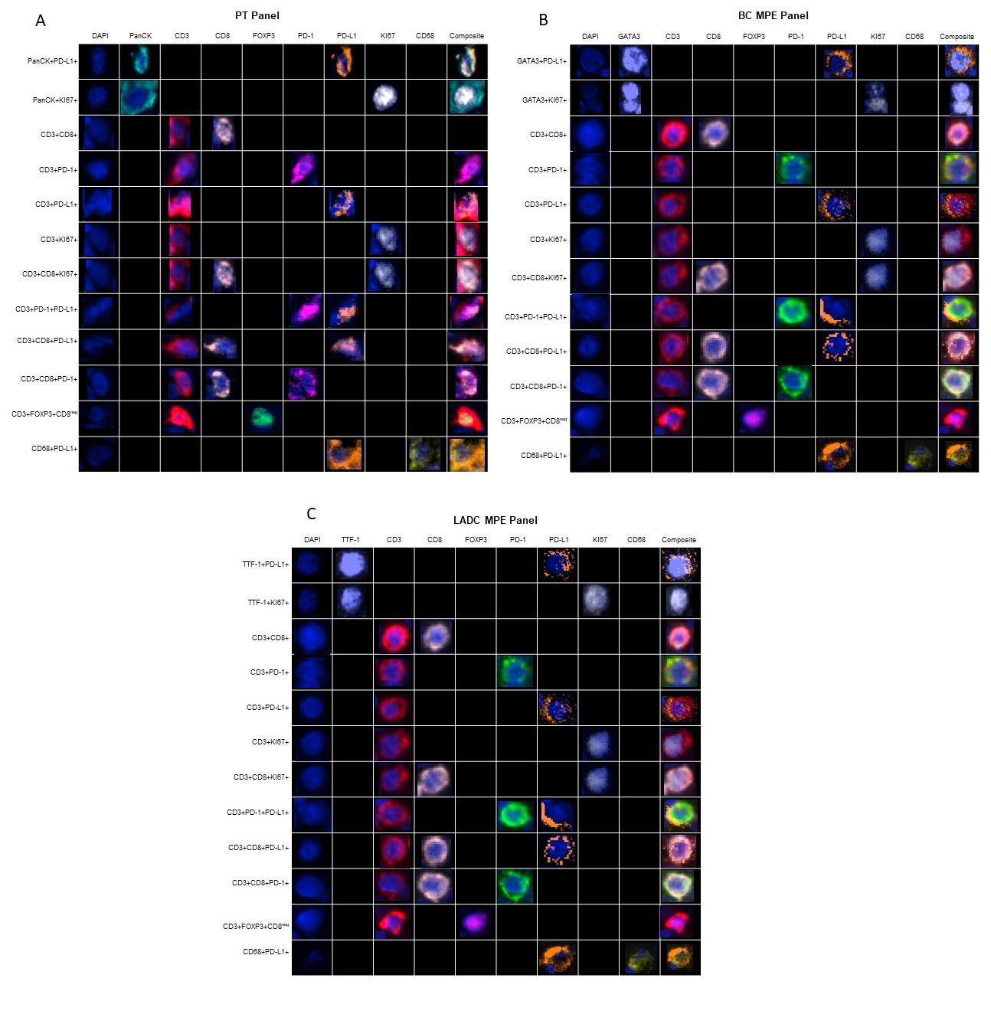
BC, breast carcinoma; CD, cluster of differentiation; FOXP3, forkhead box P3; LADC, lung adenocarcinoma; MPE, malignant pleural effusion; PD-1, programmed cell death protein 1; PD-L1, programmed death-ligand 1; PT, primary tumor; TTF-1, thyroid transcription factor-1.

