Supplementary material

Social Sustainability of Raw Rubber Production: A Supply Chain Analysis under Sri Lankan Scenario
Pasan Dunuwila^{1*}; V.H.L. Rodrigo²; Ichiro Daigo¹; Naohiro Goto³
¹ Research Center for Advanced Science and Technology, The University of Tokyo, 4 Chome-6-1 Komaba, Meguro City, Tokyo 153-0041, Japan.
² CIFOR-ICRAF, Sri Lanka.
³ Faculty of Information Networking for Innovation and Design (INIAD), Toyo University, 1-7-11 Akabanedai, Kita-ku, Tokyo 115-0053, Japan.
*Corresponding author
Pasan Dunuwila,
Research Center for Advanced Science and Technology, The University of Tokyo, 4 Chome-6-1 Komaba, Meguro City, Tokyo 153-0041, Japan
Tel: +8180-3270-7836
E-mail: pasan@mfa.t.u-tokyo.ac.jp

Table S1. Data related to Rubber cultivation (per field latex containing 1 tonne of dry rubber output). GTAP sector: Crops nec/LKA.
Inputs | Economic sector | Amount | Reference to the amount in the previous column | Unit price | Country(s) sourced from (RRISL, the Observatory of Economic Complexity (OEC) (Datawheel, 2023) and Volza databases (Volza, 2020)) | Percentage of importation
Urea | CRP | 79.36 kg | RRISL | 1.35 USD/kg | China | 42%
 |  |  |  |  | Saudi Arabia | 19%
 |  |  |  |  | Indonesia | 12%
 |  |  |  |  | United Arab Emirates | 8%
 |  |  |  |  | Oman | 6%
 |  |  |  |  | Qatar | 6%
 |  |  |  |  | Egypt | 3%
 |  |  |  |  | India | 2%
 |  |  |  |  | Malaysia | 1%
Rock phosphate | CRP | 70.45 kg | RRISL | 0.07 USD/kg | Sri Lanka | 100
MOP | CRP | 77.34 kg | RRISL | 1.35 USD/kg | Belarus | 52%
 |  |  |  |  | Lithuania | 18%
 |  |  |  |  | Russia | 10%
 |  |  |  |  | Jordan | 9%
 |  |  |  |  | Israel | 8%
 |  |  |  |  | Germany | 2%
Dolomite | CRP | 1.33 kg | RRISL | 0.03 USD/kg | Sri Lanka | 100%
KIE | CRP | 0.17 kg | RRISL | 1.35 USD/kg | China | 100%
Diesel (and preparation) | OIL | 34.2 l | (Jawjit et al., 2021) | 1.13 USD/l | United Arab Emirates | 94%
 |  |  |  |  | Egypt | 6%
Sodium sulfite (in case of crepe rubber production) | CRP | 1.59 kg | RRISL | 0.48 USD/kg | China | 100%
Ammonia (in case of concentrated latex) production) | CRP | 6.68 kg | (Birnbach et al., 2020) | 0.35 USD/kg | India | 100%
Insecticides | CRP | 0.34 kg | (Birnbach et al., 2020) | 6.00 USD/kg | India | 100%
Herbicides | CRP | 5.21 kg | (Birnbach et al., 2020) | 4.20 USD/kg | India | 100%
Fungicides | CRP | 1.23 kg | (Birnbach et al., 2020) | 7.92 USD/kg | India | 100%
RRISL: Rubber Research Institute of Sri Lanka; MOP: muriate of potash; KIE: Kieserite; CRP: Chemical, rubber, plastic products; LUM: Wood products; ELY: electricity, OIL: Oil
Table S2. Data related to crepe rubber production (1 tonne of white-crepe rubber). GTAP sector: CRP/LKA.
Inputs | Economic sector | Amount | Reference to the amount in the previous column | Unit price | Country(s) sourced from (RRISL, the Observatory of Economic Complexity (OEC) (Datawheel, 2023) and Volza databases (Volza, 2020)) | Percentage of importation
Diesel for transportation | OIL | 4.06 l | (Dunuwila et al., 2018c, 2018b) | 1.13 USD/l | See previous table | See previous table
Field latex | From rubber cultivation (crops nec) | 3540.28 kg | (Dunuwila et al., 2018c, 2018b) | Transported from own plantations | Sri Lanka | 100%
Sodium bisulfite | CRP | 5.22 kg | (Dunuwila et al., 2018c, 2018b) | 1.18 USD/kg | China | 100%
Formic acid | CRP | 5.11 kg | (Dunuwila et al., 2018c, 2018b) | 1.07 USD/kg | Hong Kong | 25%
 |  |  |  |  | Finland | 20%
 |  |  |  |  | Germany | 12%
 |  |  |  |  | India | 3%
 |  |  |  |  | South Korea | 1%
Bleaching agent | CRP | 1.29 kg | (Dunuwila et al., 2018c, 2018b) | 14.27 USD/kg | India | 100%
Electricity | ELY | 665.30 kwh | (Dunuwila et al., 2018c, 2018b) | 0.08 USD/kg | Sri Lanka | 100%
Firewood | LUM | 569.00 kg | (Dunuwila et al., 2018c, 2018b) | 0 (felled trees are used) | Sri Lanka | 100%
LDPE film | CRP | 2.39 kg | (Dunuwila et al., 2018c, 2018b) | 0.004 USD/kg | Sri Lanka | 100%
Freshwater | WTR | 62354.95 kg | (Dunuwila et al., 2018c, 2018b) | 0 (freely abundant) | Sri Lanka | 100%
RRISL: Rubber Research Institute of Sri Lanka; CRP: Chemical, rubber, plastic products; LUM: Wood products; ELY: electricity, OIL: Oil; WTR: Water; LDPE: Low-density polyethylene
Table S3. Data related to concentrated latex production (per 1 tonne of concentrated latex). GTAP sector: CRP/LKA.
Inputs | Economic sector | Amount | Reference to the amount in the previous column | Unit price | Country(s) sourced from (RRISL, the Observatory of Economic Complexity (OEC) (Datawheel, 2023) and Volza databases (Volza, 2020)) | Percentage of importation
Diesel for transportation | OIL | 11.41 l | (Dunuwila et al., 2020) | 1.13 USD/l | See table 1 | See table 1
Field latex | rubber cultivation (crops nec) | 3648.15 kg | (Dunuwila et al., 2020) | Transported from own plantations | Sri Lanka | 100%
DAHP* | CRP | 15.59 kg | (Dunuwila et al., 2020) | 1.98 USD/kg | India | 100%
TZ * | CRP | 1.75 kg | (Dunuwila et al., 2020) | 2.1 USD/kg | India | 100%
Lauric Soap* (at bulking) | CRP | 2.57 kg | (Dunuwila et al., 2020) | 1.78 USD/kg | India | 68%
 |  |  |  |  | China | 32%
Ammonia * | CRP | 6.26 kg | (Dunuwila et al., 2020) | 0.35 USD/kg | India | 100%
TMTD* | CRP | 0.83 kg | (Dunuwila et al., 2020) | 2.1 USD/kg | India | 100%
Lauric Soap* (at preservation) | CRP | 2.98 kg | (Dunuwila et al., 2020) | 1.78 USD/kg | India | 68%
 |  |  |  |  | China | 32%
Sulfuric acid* | CRP | 20.19 kg | (Dunuwila et al., 2020) | 0.24 USD/kg | India | 100%
Electricity | ELY | 128.71 kwh | (Dunuwila et al., 2020) | 0.08 USD/kwh | Sri Lanka | 100%
Freshwater | WTR | 6981.96 kg | (Dunuwila et al., 2020) | 0 USD/l | Sri Lanka | 100%
RRISL: Rubber Research Institute of Sri Lanka; DAHP: Di Ammonium Hydrogen Phosphate; TZ: mixture of Tetramethylthiuram Disulfide and Zinc oxide; TMTD: Tetramethylthiuram Disulfide; *wet basis; CRP: Chemical, rubber, plastic products; ELY: electricity, OIL: oil; WTR: Water
Table S4. Data related to RSS production (per 1 tonne of RSS). GTAP sector: CRP/LKA.
Inputs | GTAP sector | Amount | Reference to the amount in the previous column | Unit price (USD per kg) | Country(s) sourced from (RRISL, the Observatory of Economic Complexity (OEC) (Datawheel, 2023) and Volza databases (Volza, 2020)) | Percentage of importation
Field latex | rubber cultivation (crops nec) | 2763.86 kg | (Dunuwila et al., 2018a) | N/A | Manhandled from plantations | 100%
Fresh water | WTR | 4489.77 kg | (Dunuwila et al., 2018a) | 0 (freely abundant) | Sri Lanka | 100%
Formic acid* | CRP | 448.96 kg | (Dunuwila et al., 2018a) | 1.07 | Please see Table S2 | Please see Table S2
Firewood | LUM | 766.67 kg | (Dunuwila et al., 2018a) | 0 (felled trees are used) | Sri Lanka | 100%
RRISL: Rubber Research Institute of Sri Lanka; *wet basis; CRP: Chemical, rubber, plastic products; LUM: Wood products; WTR: Water
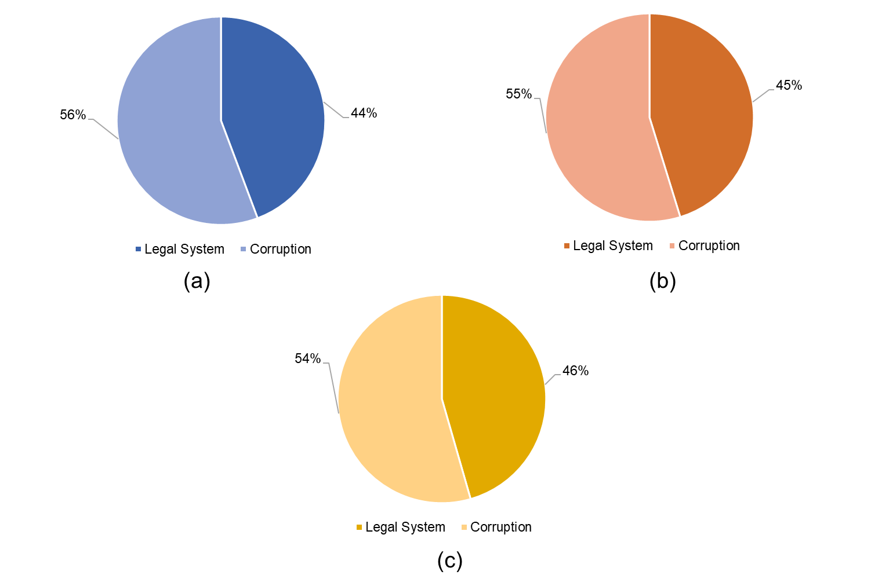
Fig.S1. Contribution of each subcategory to the impact category, Governance. (a: crepe rubber; b: concentrated latex; c: ribbed smoked sheets)

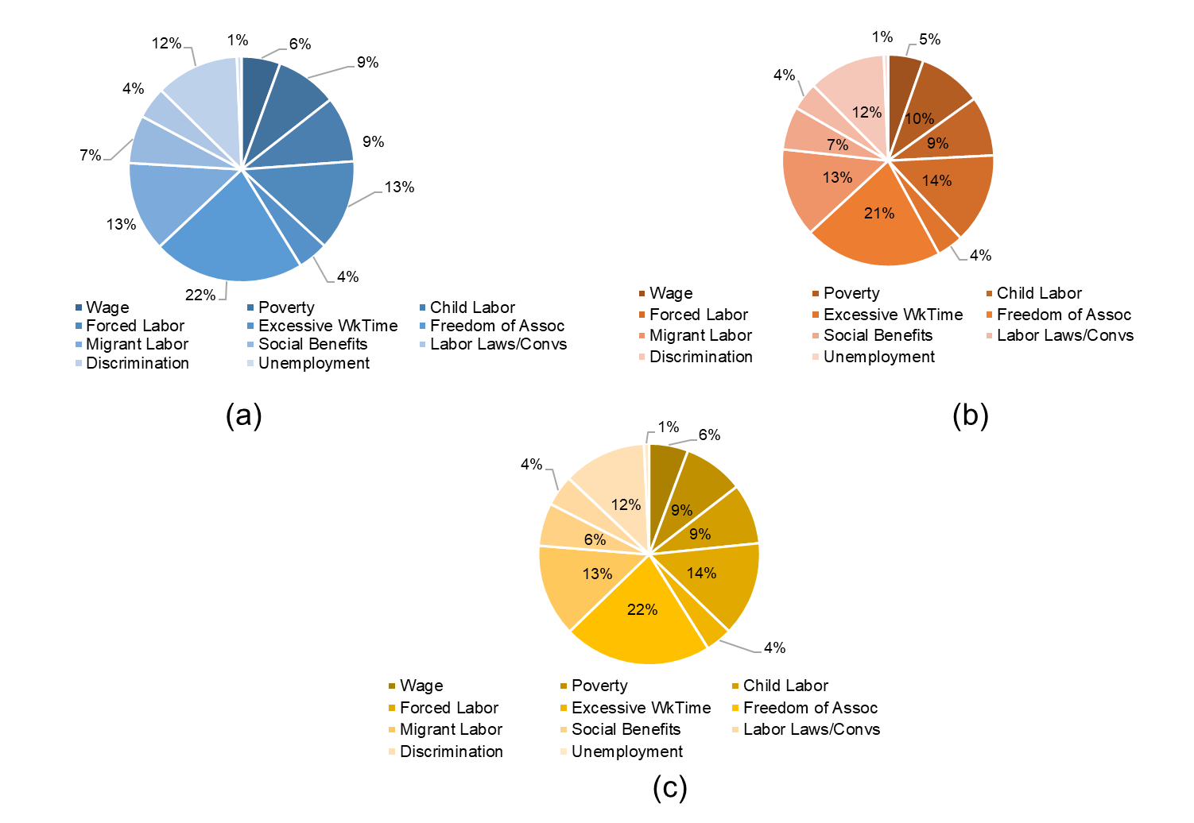
Fig. S2. Contribution of each subcategory to the impact category, Labor rights & decent work’. (a: crepe rubber; b: concentrated latex; c: ribbed smoked sheets)
References
Birnbach, M., Lehmann, A., Naranjo, E., & Finkbeiner, M. (2020). A condom’s footprint - life cycle assessment of a natural rubber condom. International Journal of Life Cycle Assessment, 25(6), 964–979. https://doi.org/10.1007/S11367-019-01701-Y/FIGURES/7
Datawheel. (2023). The Observatory of Economic Complexity | OEC - The Observatory of Economic Complexity. https://oec.world/
Dunuwila, P., Rodrigo, V. H. L., & Goto, N. (2018a). Assessing the Financial and Environmental Sustainability in Raw Rubber Processing; a Case Study with Ribbed Smoked Sheet Manufacture in Sri Lanka. Indonesian Journal of Life Cycle Assessment and Sustainability, 2(1). https://ijolcas.ilcan.or.id/index.php/IJoLCAS/article/view/55/67
Dunuwila, P., Rodrigo, V. H. L., & Goto, N. (2018b). Financial and environmental sustainability in manufacturing of crepe rubber in terms of material flow analysis, material flow cost accounting and life cycle assessment. Journal of Cleaner Production, 182, 587–599. https://doi.org/10.1016/j.jclepro.2018.01.202
Dunuwila, P., Rodrigo, V. H. L., & Goto, N. (2018c). Sustainability of natural rubber processing can be improved: A case study with crepe rubber manufacturing in Sri Lanka. Resources, Conservation and Recycling, 133, 417–427. https://doi.org/10.1016/j.resconrec.2018.01.029
Dunuwila, P., Rodrigo, V. H. L., & Goto, N. (2020). Improving financial and environmental sustainability in concentrated latex manufacture. Journal of Cleaner Production, 255, 120202. https://doi.org/10.1016/j.jclepro.2020.120202
Jawjit, W., Pavasant, P., Kroeze, C., & Tuffey, J. (2021). Evaluation of the potential environmental impacts of condom production in Thailand. Journal of Integrative Environmental Sciences, 18(1), 89–114. https://doi.org/10.1080/1943815X.2021.1949354/SUPPL_FILE/NENS_A_1949354_SM5477.DOCX
Volza. (2020). Volza.com - Global Export Import Trade Data of 209 Countries. https://www.volza.com/

