# Supplementary material

# Flash distillation process for stabilization of anaerobic digestate and synthesis of ammonium bicarbonate

Alejandro Moure Abelendaa,* and Farid Aiouachea

aSchool of Engineering, Lancaster University, Lancaster, LA1 4YW, UK

*Corresponding author: [a.moureabelenda@lancaster.ac.uk](mailto:a.moureabelenda@lancaster.ac.uk); +44 7933712762

**Table S1.** List of components [1,2] considered for the simulation of the titration of the digestate in Aspen Pus v12, following the experimental procedure of Moure Abelenda et al. [3].

| **Component name** | **Alias** | **CAS number** | **mol/L** |
| --- | --- | --- | --- |
| WATER | H2O | 7732-18-5 | 45.69365 |
| CARBON-DIOXIDE | CO2 | 124-38-9 | 0.013835 |
| AMMONIA | H3N | 7664-41-7 | 0.100484 |
| HYDROGEN-SULFIDE | H2S | 7783-06-4 | 0.001921 |
| ACETIC-ACID | C2H4O2-1 | 64-19-7 | 0.117655 |
| GLYCEROL | C3H8O3 | 56-81-5 | 0.000788 |
| OLEIC-ACID | C18H34O2 | 112-80-1 | 0.001519 |
| DEXTROSE | C6H12O6 | 50-99-7 | 0.119788 |
| PROPIONIC-ACID | C3H6O2-1 | 79-09-4 | 0.000969 |
| ETHYL-CYANOACETATE | C5H7NO2 | 105-56-6 | 4.19E-05 |
| DL-ALANINE | C3H7NO2-N9 | 302-72-7 | 0.000452 |
| ARGININE | C6H14N4O2-N2 | 7004-12-8 | 0.000433 |
| DL-ASPARTIC-ACID | C4H7NO4-N4 | 617-45-8 | 0.000462 |
| L-CYSTEINE | C3H7NO2S-N1 | 52-90-4 | 0.000645 |
| DL-GLUTAMIC-ACID | C5H9NO4-N5 | 617-65-2 | 0.000712 |
| GLYCINE | C2H5NO2-D1 | 56-40-6 | 0.002407 |
| L-ISOLEUCINE | C6H13NO2-N3 | 73-32-5 | 0.000448 |
| L-LEUCINE | C6H13NO2-N2 | 61-90-5 | 0.000674 |
| L-PHENYLALANINE | C9H11NO2 | 63-91-2 | 0.000347 |
| DL-PROLINE | C5H9NO2-N9 | 609-36-9 | 0.001069 |
| DL-SERINE | C3H7NO3-N5 | 302-84-1 | 0.001656 |
| C4H9NO3-N5 | C4H9NO3-N5 | 72-19-5 | 0.000452 |
| C5H11NO2-N17 | C5H11NO2-N17 | 516-06-3 | 0.000712 |
| GLUTARIC-ACID | C5H8O4 | 110-94-1 | 0.037695 |
| HYDROGEN | H2 | 1333-74-0 | 1.55E-06 |
| METHANE | CH4 | 74-82-8 | 0.000238 |
| MALTOSE | C12H22O11-N2 | 69-79-4 | 0.050679 |
| TRIOLEIN | C57H104O6 | 122-32-7 | 5.62E-05 |
| TRIPALMITIN | C51H98O6 | 555-44-2 | 6.18E-05 |
| 1-HEXADECANOL | C16H34O | 36653-82-4 | 6.86E-08 |
| 2-OLEODIPALMITIN | C53H100O6-N1 | 2190-25-2 | 6.18E-05 |
| TRILINOLENIN | C57H92O6 | 14465-68-0 | 8.4E-05 |
| BETA-D-XYLOPYRANOSE | C5H10O5-D3 | 2460-44-8 | 0.009424 |
| LINOLEIC-ACID | C18H32O2 | 60-33-3 | 0.000756 |
| ETHANOL | C2H6O-2 | 64-17-5 | 0.13388 |
| SODIUM-BICARBONATE | NAHCO3 | 144-55-8 | 0.044112 |
| CALCIUM-CHLORIDE | CACL2 | 10043-52-4 | 0.002876 |
| SODIUM-CHLORIDE | NACL | 7647-14-5 | 0.003601 |
| POTASSIUM-BICARBONATE | KHCO3 | 298-14-6 | 0.007789 |

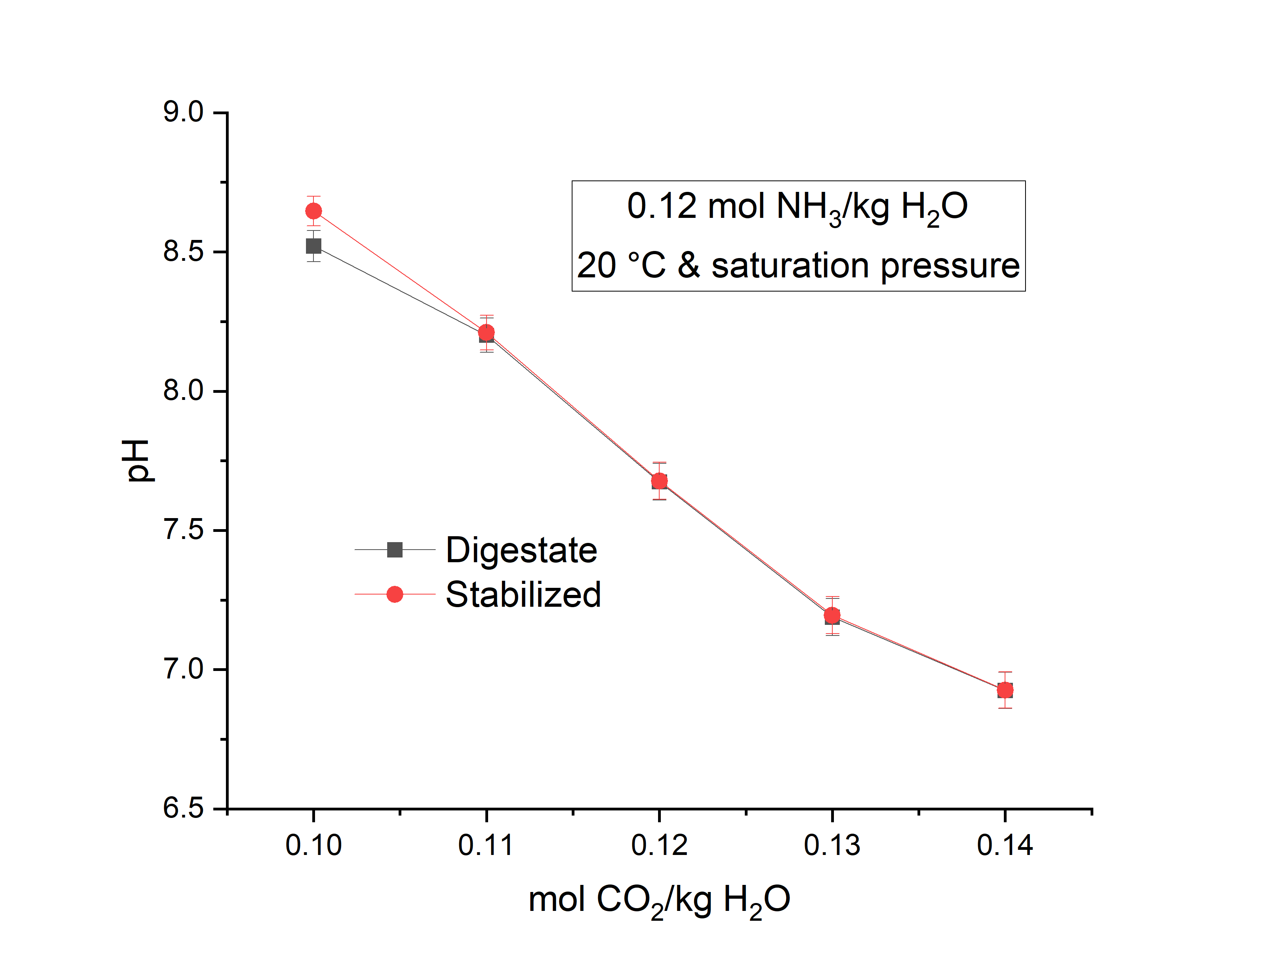

**Fig. S1.** Dependence of the pH on the composition of the anaerobic digestates and the remaining stabilized digestates (Figure 1) obtained after the flash separations performed for Fig. 2b.



**Fig. S2.** Optimization of the temperature of the flash tank at atmospheric pressure for the production of NH4HCO3: (a) 94.2 °C, (b) 94.4 °C, (c) 94.6 °C, (d) 94.8 °C, (e) 95.0 °C, (f) 95.2 °C, (g) 95.4 °C, and (h) 95.6 °C. The flowrates of NH3 (0.5 to 0.6 kmol/h or 8 to 10 g/L) and CO2 (0.3 to 0.6 kmol/h or 13 to 26 g/L) along with the 55 kmol/h of H2O (or 990 kg/h), which is the main component of anaerobic digestate, were also considered as independent variables to maximize the production of NH4HCO3.



**Fig. S3.** Concentration profile of the species of inorganic nitrogen and inorganic carbon during the fermentation of the amino acids: (a) glycine, (b) threonine, (c) arginine, (d) proline, (e) methionine, (f) serine, (g) aspartic acid, (h) glutamic acid, (i) lysine, (j) leucine, (k) valine, (l) phenylalanine, (m) tyrosine, (n) cystaine, (o) alanine, (p) histidine, (q) tryptophan, (r) glutamine. The feedstocks that were considered to perform these anaerobic digestions consisted of 90% moisture.

## References

[1] K. Rajendran, H.R. Kankanala, M. Lundin, M.J. Taherzadeh, A novel process simulation model (PSM) for anaerobic digestion using Aspen Plus, Bioresour. Technol. 168 (2014) 7–13. https://doi.org/10.1016/j.biortech.2014.01.051.

[2] A. Akhiar, A. Battimelli, M. Torrijos, H. Carrere, Comprehensive characterization of the liquid fraction of digestates from full-scale anaerobic co-digestion, Waste Manag. 59 (2017) 118–128. https://doi.org/10.1016/j.wasman.2016.11.005.

[3] A. Moure Abelenda, K.T. Semple, A.J. Lag-Brotons, B.M.J. Herbert, G. Aggidis, F. Aiouache, Strategies for the production of a stable blended fertilizer of anaerobic digestates and wood ashes, Nature-Based Solut. 2 (2022) 100014. https://doi.org/10.1016/j.nbsj.2022.100014.