**Supplemental Figures**

**Supplemental Figure 1**

**IFNGR2** **protein expression is reduced in MDA-MB-231 breast cancer cells after IFNGR1 blocking.**



**Legends:**

IFNGR2 expression levels after blocking IFNGR1 in MDA-MB-231 breast cancer cells in a dose dependent manner. Significant protein reduction is evident when using concentrations of IFNGR1 ≥ 1 µg/ml. IFNGR2 expression was calculated after background deduction and normalization against actin. IFNGR2 level-fractions are relative to 10 µg/ml matched hIgG1 isotype control.

Bars are mean values with SD. Ctr = MDA-MB-231 control cells; CM = conditioned medium; IgG1 = anti hIgG1 isotype control. Graph is representative of two independent Western blot analyses.

**Supplemental Figure 2**

**GBP1 expression is reduced following blocking of IFNGR1.**



**Legends:**GBP1 expression levels after blocking IFNGR1 in MDA-MB-231 breast cancer cells in a dose dependent manner, or after neutralizing the sIFN-γ in the media of activated T lymphocytes. Significant protein reduction is evident when using concentrations of IFNGR1 ≥ 5 µg/ml or 10 µg/ml hIFN-γ mAb. The GBP1 expression was calculated after background deduction and normalization against actin. GBP1 level-fractions are relative to 10 µg/ml matched hIgG1 or hIgA2 isotype controls.

Bars are mean values with SD. ctr = MDA-MB-231 control cells; CM = conditioned medium; IgG1 = anti hIgG1 isotype control; IFN-γ anti-hIFN-γ-IgA; IgA2, anti hIgA2 isotype control; T = T lymphocytes. Graph is representative of two independent W.B. analyses.

**Supplemental Figure 3**

**Overexpression of IFN-γ-inducible chemokines in primary breast cancer samples of patients who developed brain metastasis.**

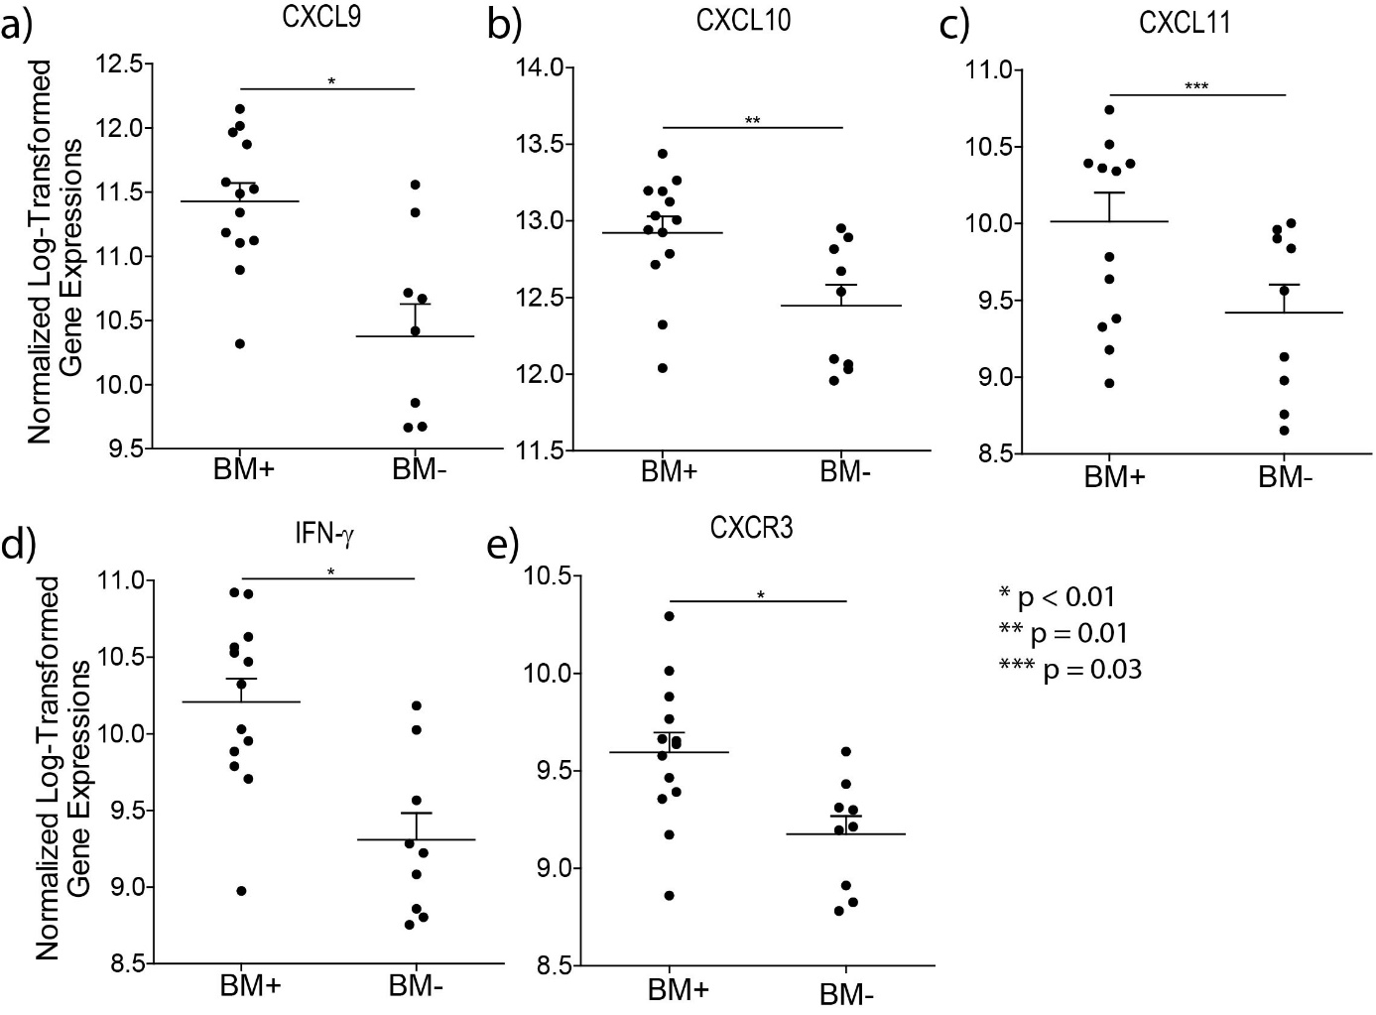

**Legends:**CXCL9, -10, -11/CXCR3 axis and IFN-γare overexpressed in primary breast cancer samples of patients who developed brain metastasis (a-e). Solid lines indicate the mean gene expression and the error bars the SEM. Normalized log 2-transformed gene expression data were used to calculate significance by the two-tailed unpaired Student’s *t*-test. (BM+, primary breast cancer sample of patients who developed brain metastasis; BM-, primary breast cancer sample of patients who developed metastasis at sites other than brain).