Supporting information

3D-printed magnesium-doped micro-nano bioactive glass composite scaffolds repair critical bone defects by promoting osteogenesis, angiogenesis, and immunomodulation

Kun Dai ^{#a,b,c,d}, Fujian Zhao ^{e} , Zhen Yang ^{a,b,c,d}, Wen Zhang ^{g}, Dafu Chen ^{f} , Fei Hang *^{a,b,c,d} and Xiaofeng Chen **^{a,b,c,d,}
ª School of Materials Science and Engineering, South China University of Technology, Guangzhou 510641, China. E-mail: chenxf@scut.edu.cn;
Fax: +86 020 31066895, +86 020 87111752; Tel: +86 020 39380267, +86 020 22236283
^{b} National Engineering Research Centre for Tissue Restoration and Reconstruction, Guangzhou 510006, China
^{c} Key Laboratory of Biomedical Engineering of Guangdong Province, South China University of Technology, Guangzhou 510006, China
^{d} Key Laboratory of Biomedical Materials and Engineering of the Ministry of Education, South China University of Technology, Guangzhou 510006, China
^{e} Stomatological Hospital, Southern Medical University, Guangzhou 510280, China
^{f} Laboratory of Bone Tissue Engineering, Beijing Laboratory of Biomedical Materials, Beijing Research Institute of Orthopaedics and Traumatology, Beijing JiShuiTan Hospital, Beijing, 100035, China
^{g} Department of Medical Biotechnology, School of Basic Medical Sciences, Guangzhou University of Chinese Medicine,Guangzhou, China.
# The first author
*Corresponding author:
Email: hfei@scut.edu.cn (Fei Hang)
**Corresponding author:
Email: chenxf@scut.edu.cn (Xiaofeng Chen)

1.
MNBG
MgMNBG

Figure 1. Energy spectrum analysis of MNBG and MgMNBG

2.
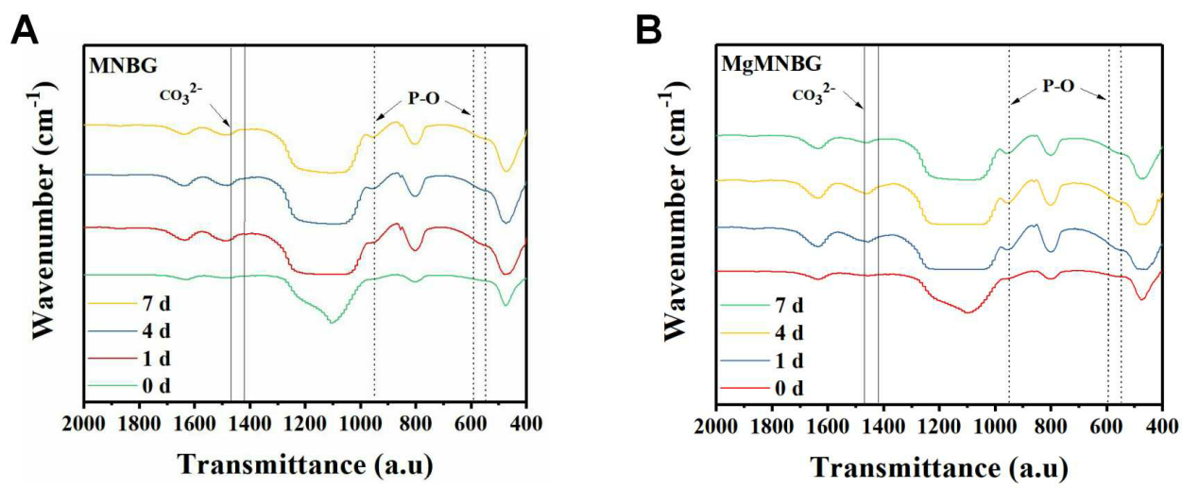

Figure 2. Infrared spectra of MNBG and MgMNBG mineralized in SBF solution for 1, 4, and 7 days

3.
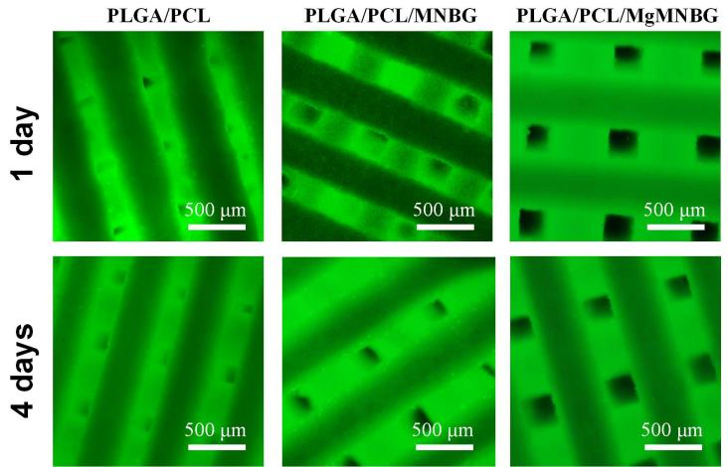
Figure 3. Living-dead staining of mBMSCs on the scaffolds for 1 and 4 days
Live–dead fluorescence staining was used to observe the cell survival of mBMSCs cultured on the scaffold surface for 1 and 4 days (Figure 3). Cells adhered and grew on the strands, which showed that the scaffolds had good biocompatibility.

Table 1 Concentration of ions in the extract of osteoblastic basic culture medium
(after diluted)

 | Si(mg/L) | Ca(mg/L) | P(mg/L) | Mg(mg/L)
DMEM | 0.00 | 57.79 | 26.83 | 19.22
MNBG/DMEM | 15.92 | 65.47 | 26.39 | 19.03
MgMNBG/DMEM | 18.46 | 68.83 | 27.21 | 32.28

Table 2 Ion concentration of endothelial cell culture medium extract (after diluted)

 | Si(mg/L) | Ca(mg/L) | Mg(mg/L)
ECM | 0.00 | 56.32 | 19.97
MNBG/ECM | 14.06 | 67.24 | 19.65
MgMNBG/ECM | 16.28 | 64.59 | 33.51

Table 3 Gene primer sequence pairs used in RT-qPCR for osteogenesis related genes

Gene | primer sequence
GAPDH | Forward： 5，-CTCCCACTCTTCCACCTTCG-3，
 | Reverse： 5，-TTGCTGTAGCCGTATTCATT-3，
ALP | Forward： 5，-TGCCTACTTGTGTGGCGTGAA-3，
 | Reverse： 5，-TCACCCGAGTGGTAGTCACAATG-3，
OCN | Forward： 5，-AGCAGCTTGGCCCAGACCTA-3，
 | Reverse： 5，-TAGCGCCGGAGTCTGTTCACTAC-3，
RUNX2 | Forward： 5，-CACTGGCGGTGCAACAAGA-3，
 | Reverse： 5，-TTTCATAACAGCGGAGGCATTTC-3，
COL1 | Forward： 5，-ATGCCGCGACCTCAAGATG-3，
 | Reverse： 5，-TGAGGCACAGACGGCTGAGTA-3，
OPN | Forward： 5，-GCAGTCTTCTGCGGCAGGCA-3，
 | Reverse： 5，-CACCGGGAGGGAGGAGGCAA-3，

Table 4 Gene primer sequence pairs used in RT-qPCR for angiogenesis related genes

Gene | primer sequence
GAPDH | Forward： 5，-CTCCCACTCTTCCACCTTCG-3，
 | Reverse： 5，-TTGCTGTAGCCGTATTCATT-3，
FGF-2 | Forward：5，-CTGTACTGCAAAAACGGG-3，
 | Reverse： 5，-AAAGTATAGCTTTCTGCC-3，
SDF | Forward：5，-TGAGAGCTCGCTTTGAGTGA-3，
 | Reverse：5，-CACCAGGACCTTCTGTGGAT-3，
Angiogenin | Forward： 5，-GTGCTGGGTCTGGGTCTGAC-3，
 | Reverse：5，-GGCCTTGATGCTGCGCTTG-3，

Table 5 Gene primer sequence pairs used in RT-qPCR for macrophage inflammation related genes
Gene | primer sequence
GAPDH | Forward：5’-CTCCCACTCTTCCACCTTCG-3’
 | Reverse：5’-TTGCTGTAGCCGTATTCATT-3’
Arginase | Forward：5’-CATATCTGCCAAGGACATCG-3’
 | Reverse： 5’-GGTCTCTTCCATCACTTTGC-3’
IL1β | Forward：5’-TGGAGAGTGTGGATCCCAAG-3’
 | Reverse：5’-GGTGCTGATGTACCAGTTGG-3’
TNFα | Forward： 5’-CTGAACTTCGGGGTGATCGG-3’
 | Reverse：5’-GGCTTGTCACTCGAATTTTGAGA-3’
IL6 | Forward：5’-ATAGTCCTTCCTACCCCAATTTCC-3’
IL10 | Forward：5’-GAGAAGCATGGCCCAGAAATC-3’
 | Reverse：5’-GAGAAATCGATGACAGCGCC-3’
IL1ra | Forward：5’-CTCCAGCTGGAGGAAGTTAAC-3’
 | Reverse：5’-CTGACTCAAAGCTGGTGGTG-3’
BMP-2 | Forward：5’-GCTCCACAAACGAGAAAAGC-3’
 | Reverse：5’-AGCAAGGGGAAAAGGACACT-3’
VEGF | Forward：5’-GTCCCATGAAGTGATCAAGTTC-3’
 | Reverse：5’-TCTGCATGGTGATGTTGCTCTCTG-3’
TGFβ1 | Forward：5’-CAGTACAGCAAGGTCCTTGC-3’
 | Reverse：5’-ACGTAGTAGACGATGGGCAG-3’
TGFβ3 | Forward：5’-CAACACCCTGAACCCAGAG-3’
 | Reverse：5’-CTTCACCACCATGTTGGACAG-3’

