Supporting information

Soybean Calmodulin-binding Transcription Activators, GmCAMTAs, Negatively Coordinate the Circadian Regulation of Developmental Processes and Drought Stress Responses in Transgenic Arabidopsis
Dongwon Baek^{2,†}, Hyun Min Cho^{1,†}, Ye Jin Cha^{1,†}, Byung Jun Jin³, Su Hyeon Lee¹, Mi Suk Park², Hyun Jin Chun^{3,*}, Min Chul Kim ^{1,2,3,*}
¹ Division of Applied Life Science (BK21 Four), Gyeongsang National University, Jinju 52828, Republic of Korea; hmcho86@gnu.ac.kr (H.M.C.), cdw3280@naver.com (Y.J.C.), leesuhyeon86@gmail.com (S.H.L.)
² Plant Molecular Biology and Biotechnology Research Center, Gyeongsang National University, Jinju 52828, Republic of Korea; dw100@hanmail.net (D.B.), misugip@hanmail.net (M.S.P.)
³ Institute of Agriculture & Life Science, Gyeongsang National University, Jinju 52828, Republic of Korea; hj_chun@hanmail.net (H.J.C.), scv5789@naver.com (B.J.J.)

† These authors contributed equally to this work
* Correspondence: hj_chun@hanmail.net (H.J.C.), Tel.: +82-55-772-1874 and mckim@gnu.ac.kr (M.C.K.), Tel.: +82-55-772-1874

Supplementary Materials:
Supplementary Figure S1. Diurnal expression of GmCAMTAs in the Diurnal web database.
Supplementary Figure S2. RT-PCR analysis in Arabidopsis transgenic plants overexpressing GmCAMTA2 and GmCAMTA8.
Supplementary Table S1. List of 15 GmCAMTA genes in Phytozome database
Supplementary Table S2. List of primers in this study

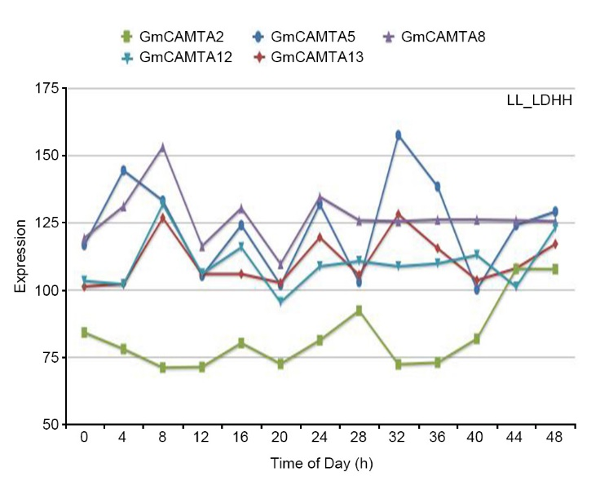
Supplementary Figure S1. Diurnal expression of GmCAMTAs in the Diurnal web database.
The diurnal expression of GmCAMTA2, GmCAMTA5, GmCAMTA8, GmCAMTA12, and GmCAMTA13 under LL_LDHH condition using Diurnal database tool (http://diurnal.mocklerlab.org/). The diurnal expression data of other GmCAMTAs were not available in the Diurnal web database. The “LL_LDHH” means a constant light for 24 h (LL), light 12h/dark 12h conditions (LD), and a constant hot temperature (31 °C; HH).

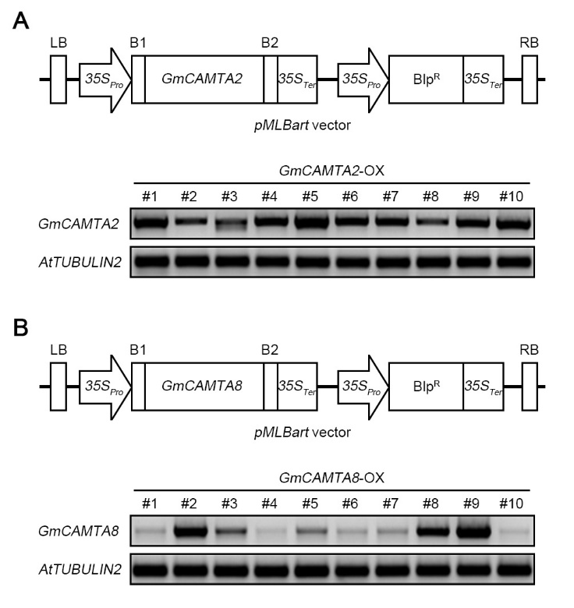
Supplementary Figure S2. RT-PCR analysis in Arabidopsis transgenic plants overexpressing GmCAMTA2 and GmCAMTA8.
Upper panels in (A) and (B); Schematic representation of the pMLBart binary vectors used for generating Arabidopsis transgenic plants overexpressing GmCAMTA2 (A) and GmCAMTA8 (B). Bottom panels in (A) and (B); Analysis of RT-PCR. Total RNAs isolated from each 10-day-old seedlings of Arabidopsis T1 transgenic plants overexpressing GmCAMTA2 (A) and GmCAMTA8 (B). The analysis of RT-PCR was performed with each GmCAMTAs-specific primer (Supplementary Table S2). The AtTUBULIN2 in Arabidopsis was used as an internal control.

Supplementary Table S1. List of 15 GmCAMTA genes in Phytozome database
Gene Name | Locus No. | Chromosome No. | Genome Length (bp) | Transcript Length (bp) | CDS Length (bp) | Protein Length (aa)
GmCAMTA1 | Glyma.05G178200 | 5 | 8,069 | 3,889 | 3,369 | 1,123
GmCAMTA2 | Glyma.08G135200 | 8 | 8,007 | 3,872 | 3,309 | 1,103
GmCAMTA3 | Glyma.15G053600 | 15 | 11,253 | 3,830 | 3,267 | 1,089
GmCAMTA4 | Glyma.08G072100 | 8 | 11,294 | 3,813 | 3,240 | 1,080
GmCAMTA5 | Glyma.05G117000 | 5 | 10,456 | 3,791 | 3,267 | 1,089
GmCAMTA6 | Glyma.08G178900 | 8 | 11,604 | 3,947 | 3,246 | 1,082
GmCAMTA7 | Glyma.17G038800 | 17 | 8,414 | 3,665 | 3,000 | 1,000
GmCAMTA8 | Glyma.15G143400 | 15 | 9,976 | 3,274 | 2,736 | 912
GmCAMTA9 | Glyma.09G038300 | 9 | 10,333 | 3,378 | 2,736 | 912
GmCAMTA10 | Glyma.05G148300 | 5 | 10,592 | 3,637 | 2,952 | 984
GmCAMTA11 | Glyma.18G005100 | 18 | 9,037 | 3,570 | 2,889 | 963
GmCAMTA12 | Glyma.17G031900 | 17 | 8,109 | 3,606 | 2,769 | 923
GmCAMTA13 | Glyma.07G242000 | 7 | 8,858 | 3,425 | 2,766 | 922
GmCAMTA14 | Glyma.11G251900 | 11 | 8,300 | 3,196 | 2,733 | 911
GmCAMTA15 | Glyma.08G105200 | 8 | 8,020 | 3,220 | 2,898 | 966

Supplementary Table S2. List of primers in this study
Gene | Primer | Direction | Sequence (5’→3’) | Purpose
GmCAMTA1  (Glyma.05G178200) | MG-2943 | Forward | GAAAAGGTAGTGGTTTGCGTG | Analysis of qRT-PCR or RT-PCR
 | MG-2944 | Reverse | CTTTGCTCTGTTTGCTTCCTG
GmCAMTA2  (Glyma.08G135200) | MG-2931 | Forward | AAGGCTGGAAGTGTGGATG
 | MG-2932 | Reverse | TTGGTTCCCTTCACTTGTCG
GmCAMTA3  (Glyma.15G053600) | MG-2957 | Forward | AGGGACGGAAACAAAAGGAAG
 | MG-2958 | Reverse | ACCCTTGTTAGATGCCTTGG
GmCAMTA4  (Glyma.08G072100) | MG-2947 | Forward | GTTCAGTATCCAGAGGCACG
 | MG-2948 | Reverse | TCCCTTGGTTTGACGGAAG
GmCAMTA5  (Glyma.05G117000) | MG-2963 | Forward | GTTCAGTATCCAGAGGCACG
 | MG-2964 | Reverse | CACCATCAACTGTCTCTTCCG
GmCAMTA6  (Glyma.08G178900) | MG-2951 | Forward | AGGGACGGAAACAAAAGGAAG
 | MG-2952 | Reverse | AACCCTCGTTAGATGCCTTG
GmCAMTA7  (Glyma.17G038800) | MG-2959 | Forward | CAGATCCACCTGTTATGCCTC
 | MG-2960 | Reverse | GCTTCTCTTACAGTCTTCCCATC
GmCAMTA8  (Glyma.15G143400) | MG-2933 | Forward | CTGCGTTGGCGTTTAAAGAG
 | MG-2934 | Reverse | AATCACTTTCCTGCGTCTCC
GmCAMTA9  (Glyma.09G038300) | MG-2953 | Forward | GTAGTCCTTTATCTTCGGGTGG
 | MG-2954 | Reverse | GTTCATCCATGTTCCAAAGCTG
GmCAMTA10  (Glyma.05G148300) | MG-2941 | Forward | TGACATCAATGGGTGGACTG
 | MG-2942 | Reverse | GGTTGGATCTTGTGCATTTGG
GmCAMTA11  (Glyma.18G005100) | MG-2961 | Forward | TGGGCAGTTGGAATCTTGG
 | MG-2962 | Reverse | CGGAACACGCTGAGAAAATC
GmCAMTA12  (Glyma.17G031900) | MG-2935 | Forward | CTCGCATACAGTGTACATACCG
 | MG-2936 | Reverse | ACGACACCAACAGACCAAAG
GmCAMTA13  (Glyma.07G242000) | MG-2945 | Forward | TCTTTGGTCTGTTGGTGTGG
 | MG-2946 | Reverse | ATCGACAGTTTTGACCTGGAG
GmCAMTA14  (Glyma.11G251900) | MG-2955 | Forward | ATTTCTCTGCCATGACTCGG
 | MG-2956 | Reverse | ATGCCGTCCTGAATTATCTCTG
GmCAMTA15  (Glyma.08G105200) | MG-2949 | Forward | GTCTTTTCTCTGTCATCCCTCG
 | MG-2950 | Reverse | TGCACAGAGTAACCTTTCCAG
GmTUBULIN  (Glyma.17G258300) | MG-2937 | Forward | TGGCCGTTACCTGACAGCAT
 | MG-2938 | Reverse | CTCGGAGGGATGTCACACAC
AtRD29A  (AT5G52310) | MG-2000 | Forward | CCTGAAGTGATCGATGCACCAG
 | MG-2001 | Reverse | TGGTGTAATCGGAAGACACGAC
AtRD29B  (AT5G52300) | MG-2002 | Forward | GTGAAGATGACTATCTCGGTGG
 | MG-2003 | Reverse | CACCACTGAGATAATCCGATCC
AtP5CS2  (AT3G55610) | MG-2018 | Forward | AGCAGCCTGTAATGCGATGG
 | MG-2019 | Reverse | AAGTGACGCCTTTGGTTTGC
AtKIN1  (AT5G15960) | MG-2016 | Forward | CCAACAAGAATGCCTTCCAAGC
 | MG-2017 | Reverse | GCTGCCGCATCCGATACACT
AtTUBULIN2  (AT5G62690) | MG4028 | Forward | TGGCATCAACTTTCATTGGA
 | MG-4029 | Reverse | ATGTTGCTCTCCGCTTCTGT
GmCAMTA2  (Glyma.08G135200) | MG-1523 | Forward | CCATGGCTGAGGCCAGACTCTAC | Gene cloning
 | MG-1281 | Reverse | CTCAGCTGTGAAATTCTAAATCACCCC
GmCAMTA8  (Glyma.15G143400) | MG-1530 | Forward | CATCCCAAATATGGGGAAACCTTGTTC
 | MG-1531 | Reverse | CATCCCAAATATGGGGAAACCTTGTTC

