Supplementary information for:
Assessing the development and intensity of the urban heat island through local weather types in the Attica region, Greece

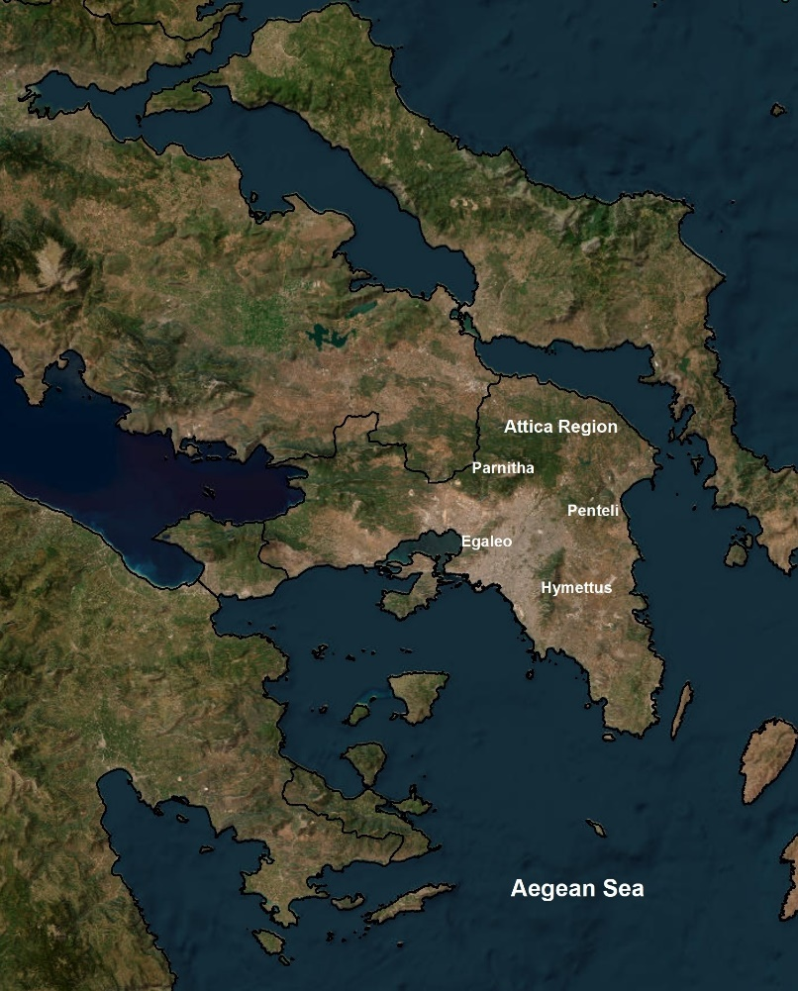
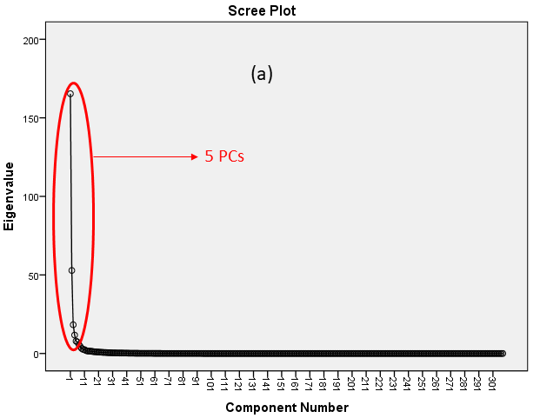
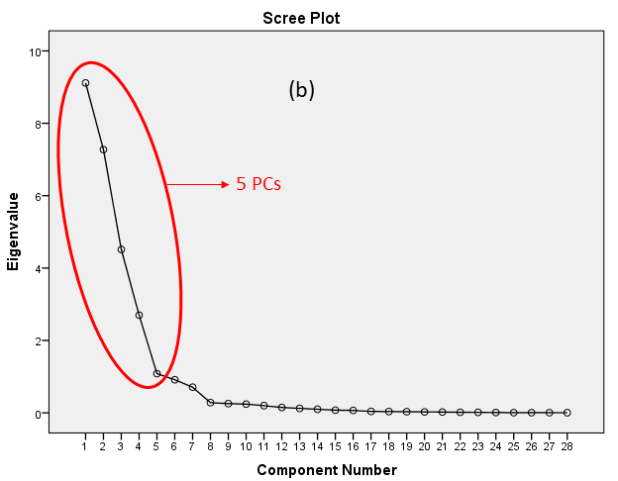
Figure S1. Geographical position and topographic context of Attica region
Figure S2. The Scree plots used for the selection of the number of PCs in wider domain (a) and sub-domain (b).

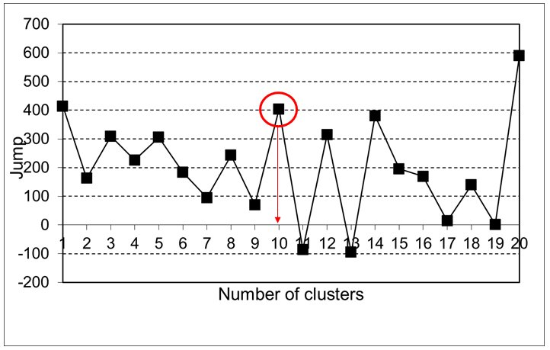
Figure S3. Τhe ‘jump’ plot based on the distortion test used for the selection of the number of clusters. Red marking the selected numbers.

