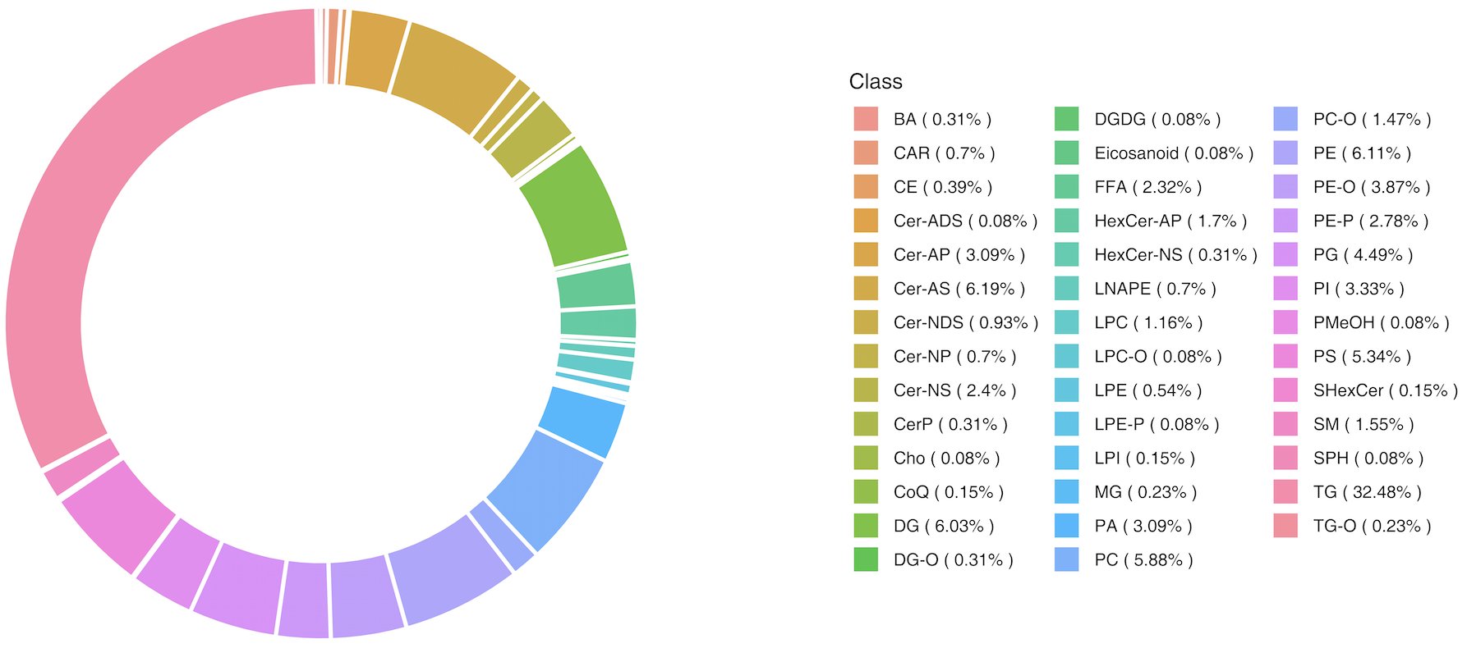

Figure S1. Ring diagram of lipid subclass composition

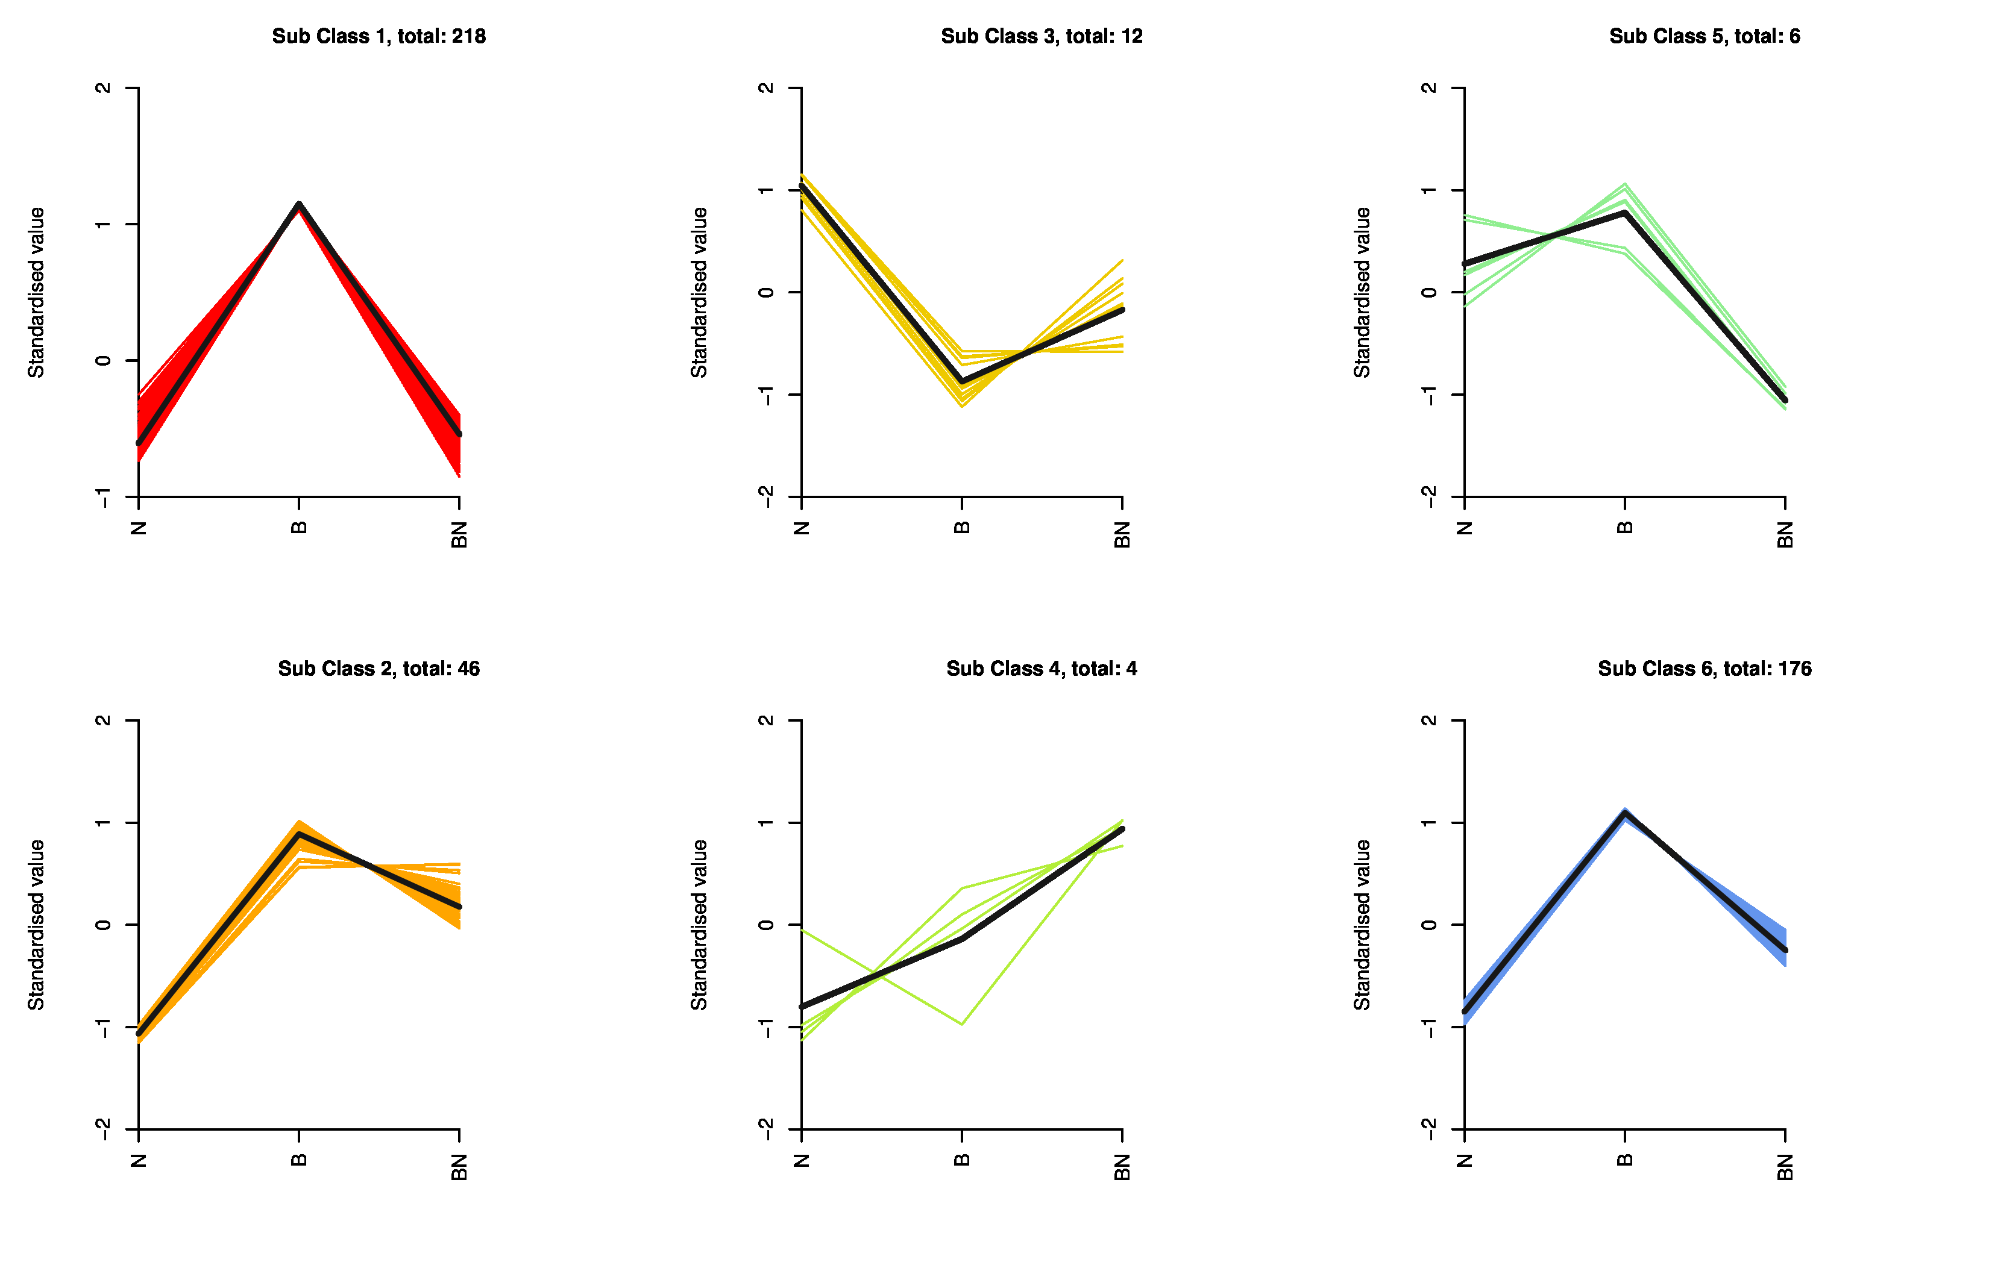

Figure S2. K-Means of SCLs. The horizontal ordinate represents sample groups, the Y-axis represents standardized relative lipid content, and Sub Class represents lipid class numbers with the same trend of change. B represents Berkshire pigs, N represents Ningxiang pigs, BN represents F₁ pigs.

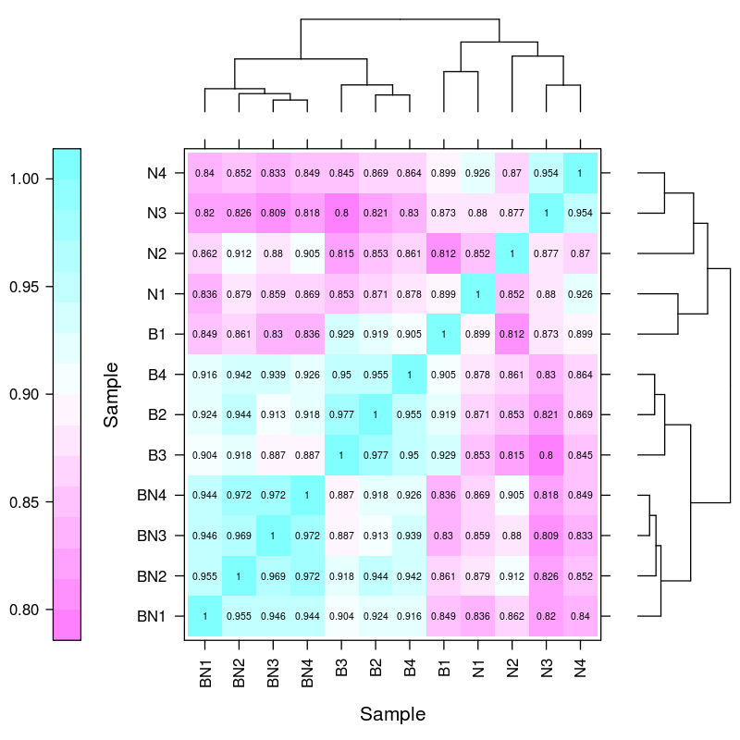
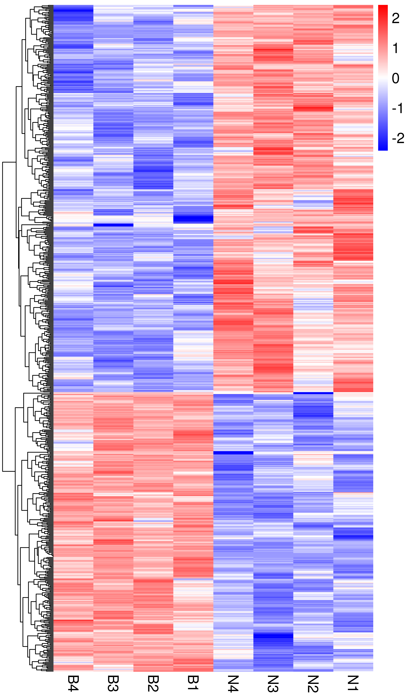
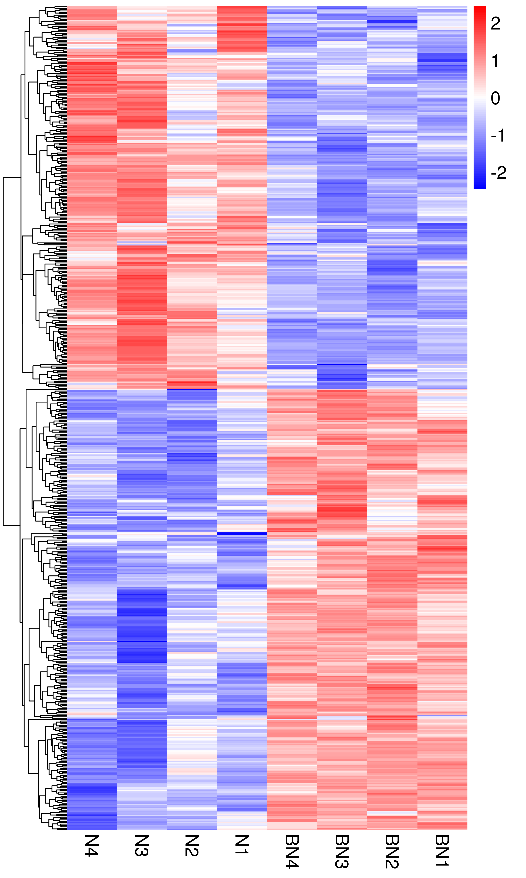
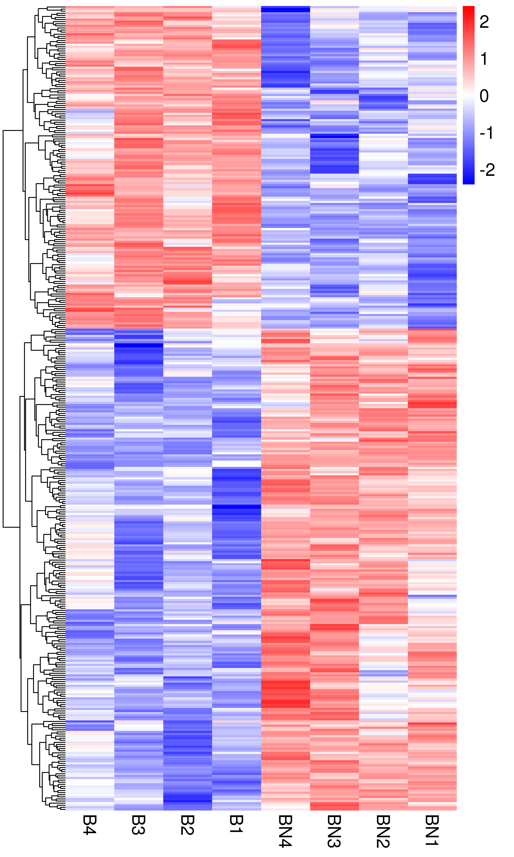
A
B
C
D

Figure S3. Transcriptome profiles diverse in the subcutaneous adipose tissue. (A) Transcriptome correlation analysis, B represents Berkshire pigs, N represents Ningxiang pigs, BN represents F₁ pigs; (B-D) Cluster heat map of DEGs for the subcutaneous adipose tissue in the groups of Berkshire pigs vs Ningxiang pigs (B), Ningxiang pigs vs F₁ pigs (C), Berkshire pigs vs F₁ pigs (D), B represents Berkshire pigs, N represents Ningxiang pigs, BN represents F₁ pigs.

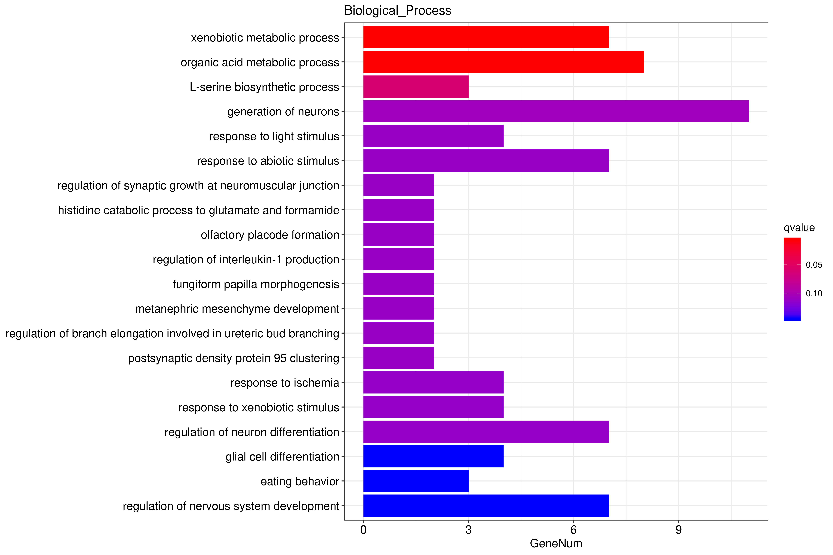
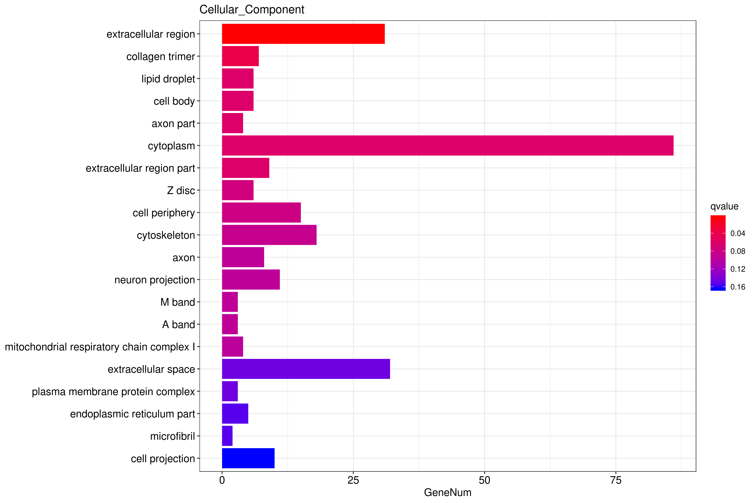
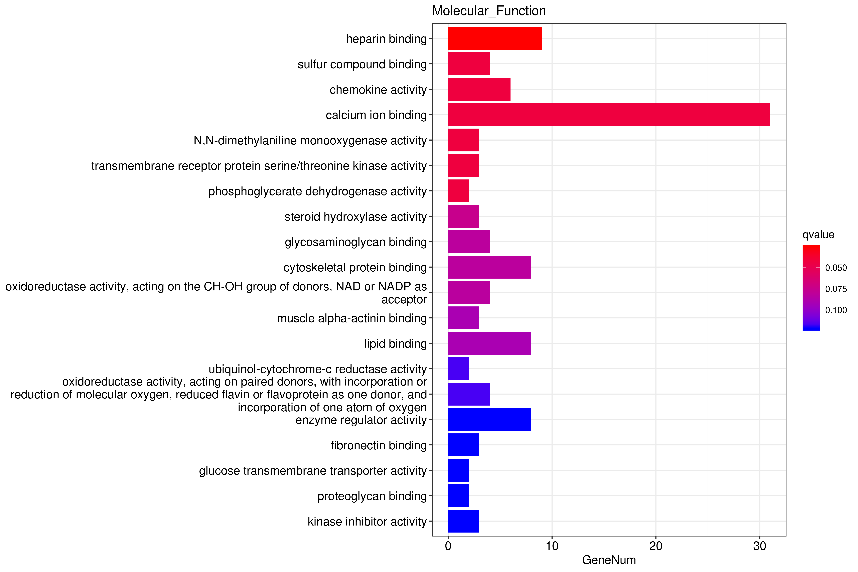
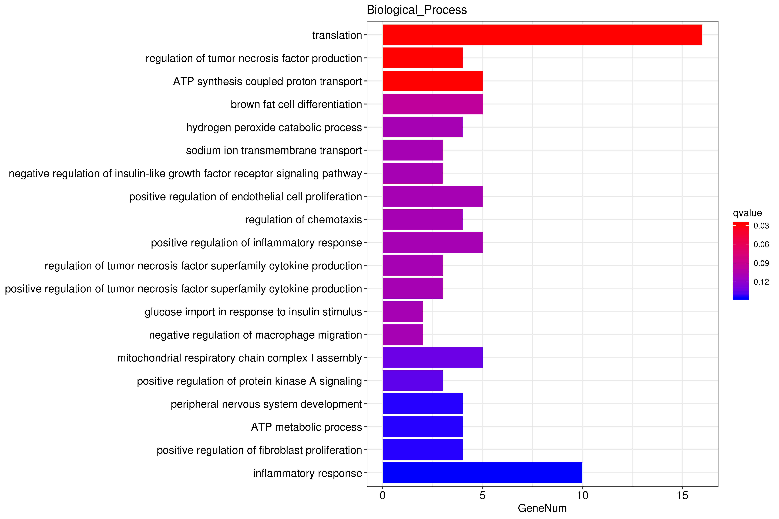
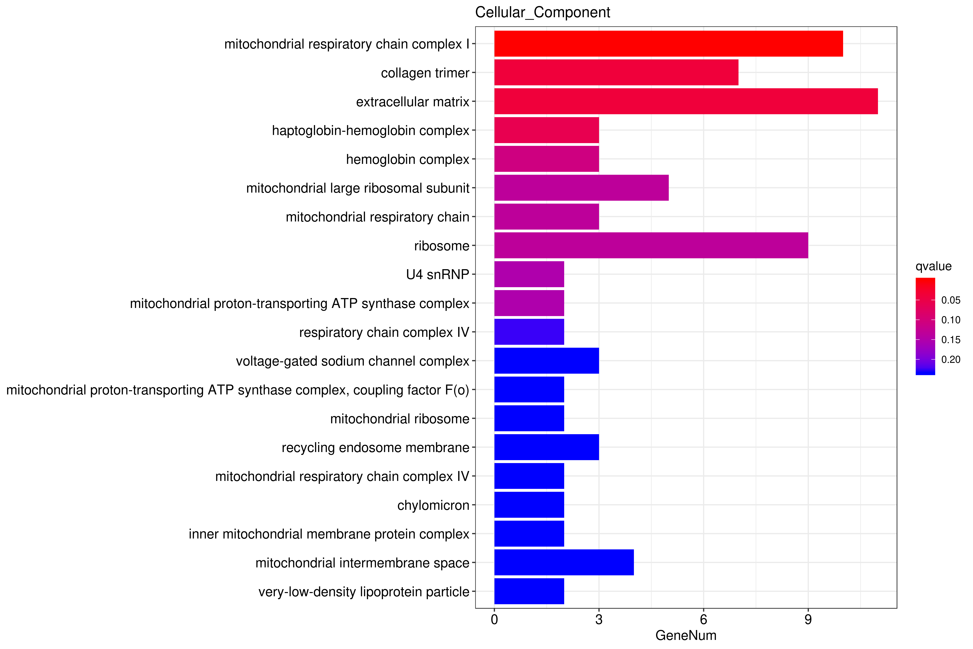
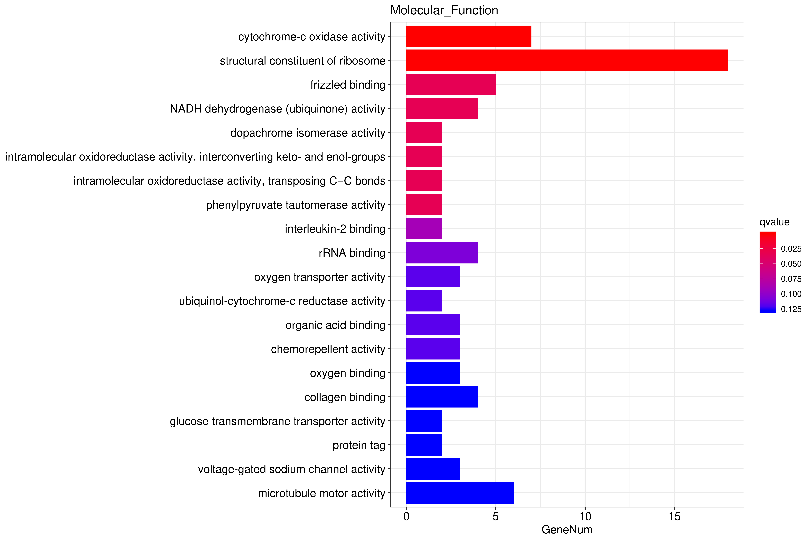
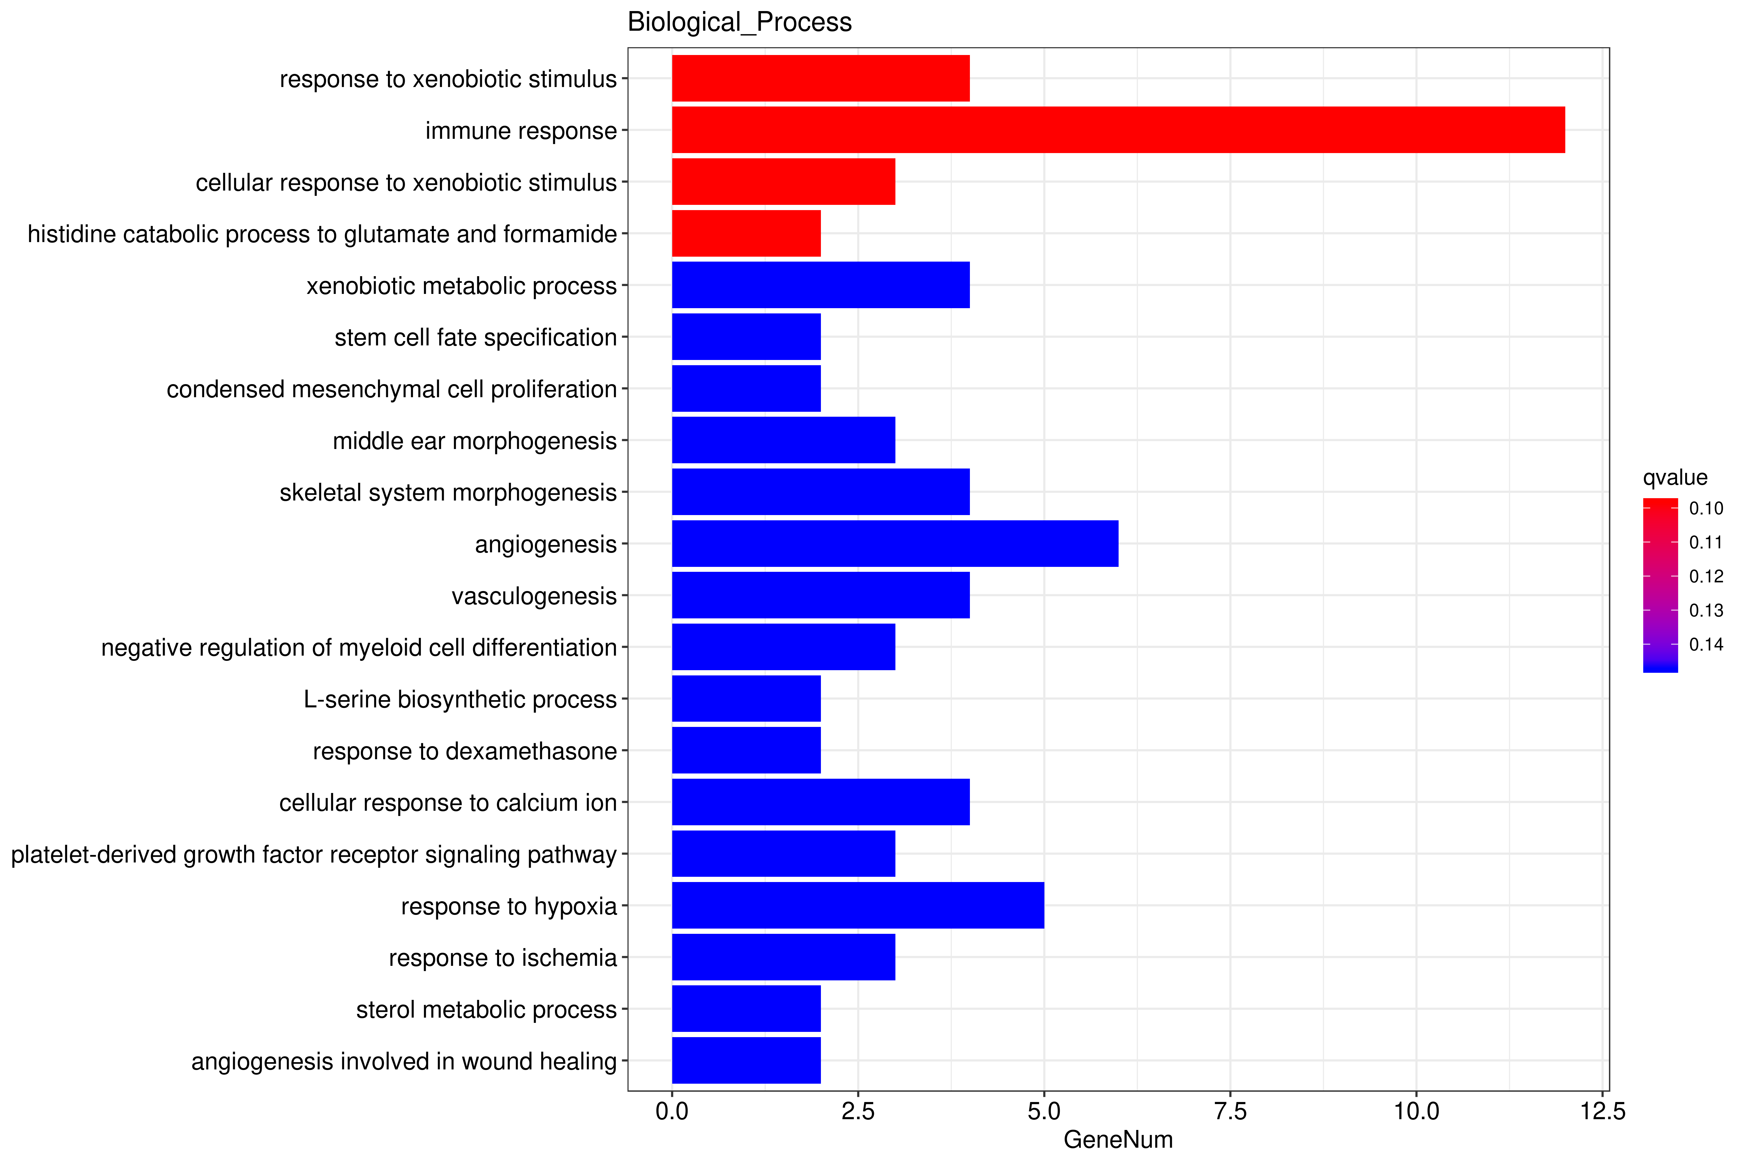
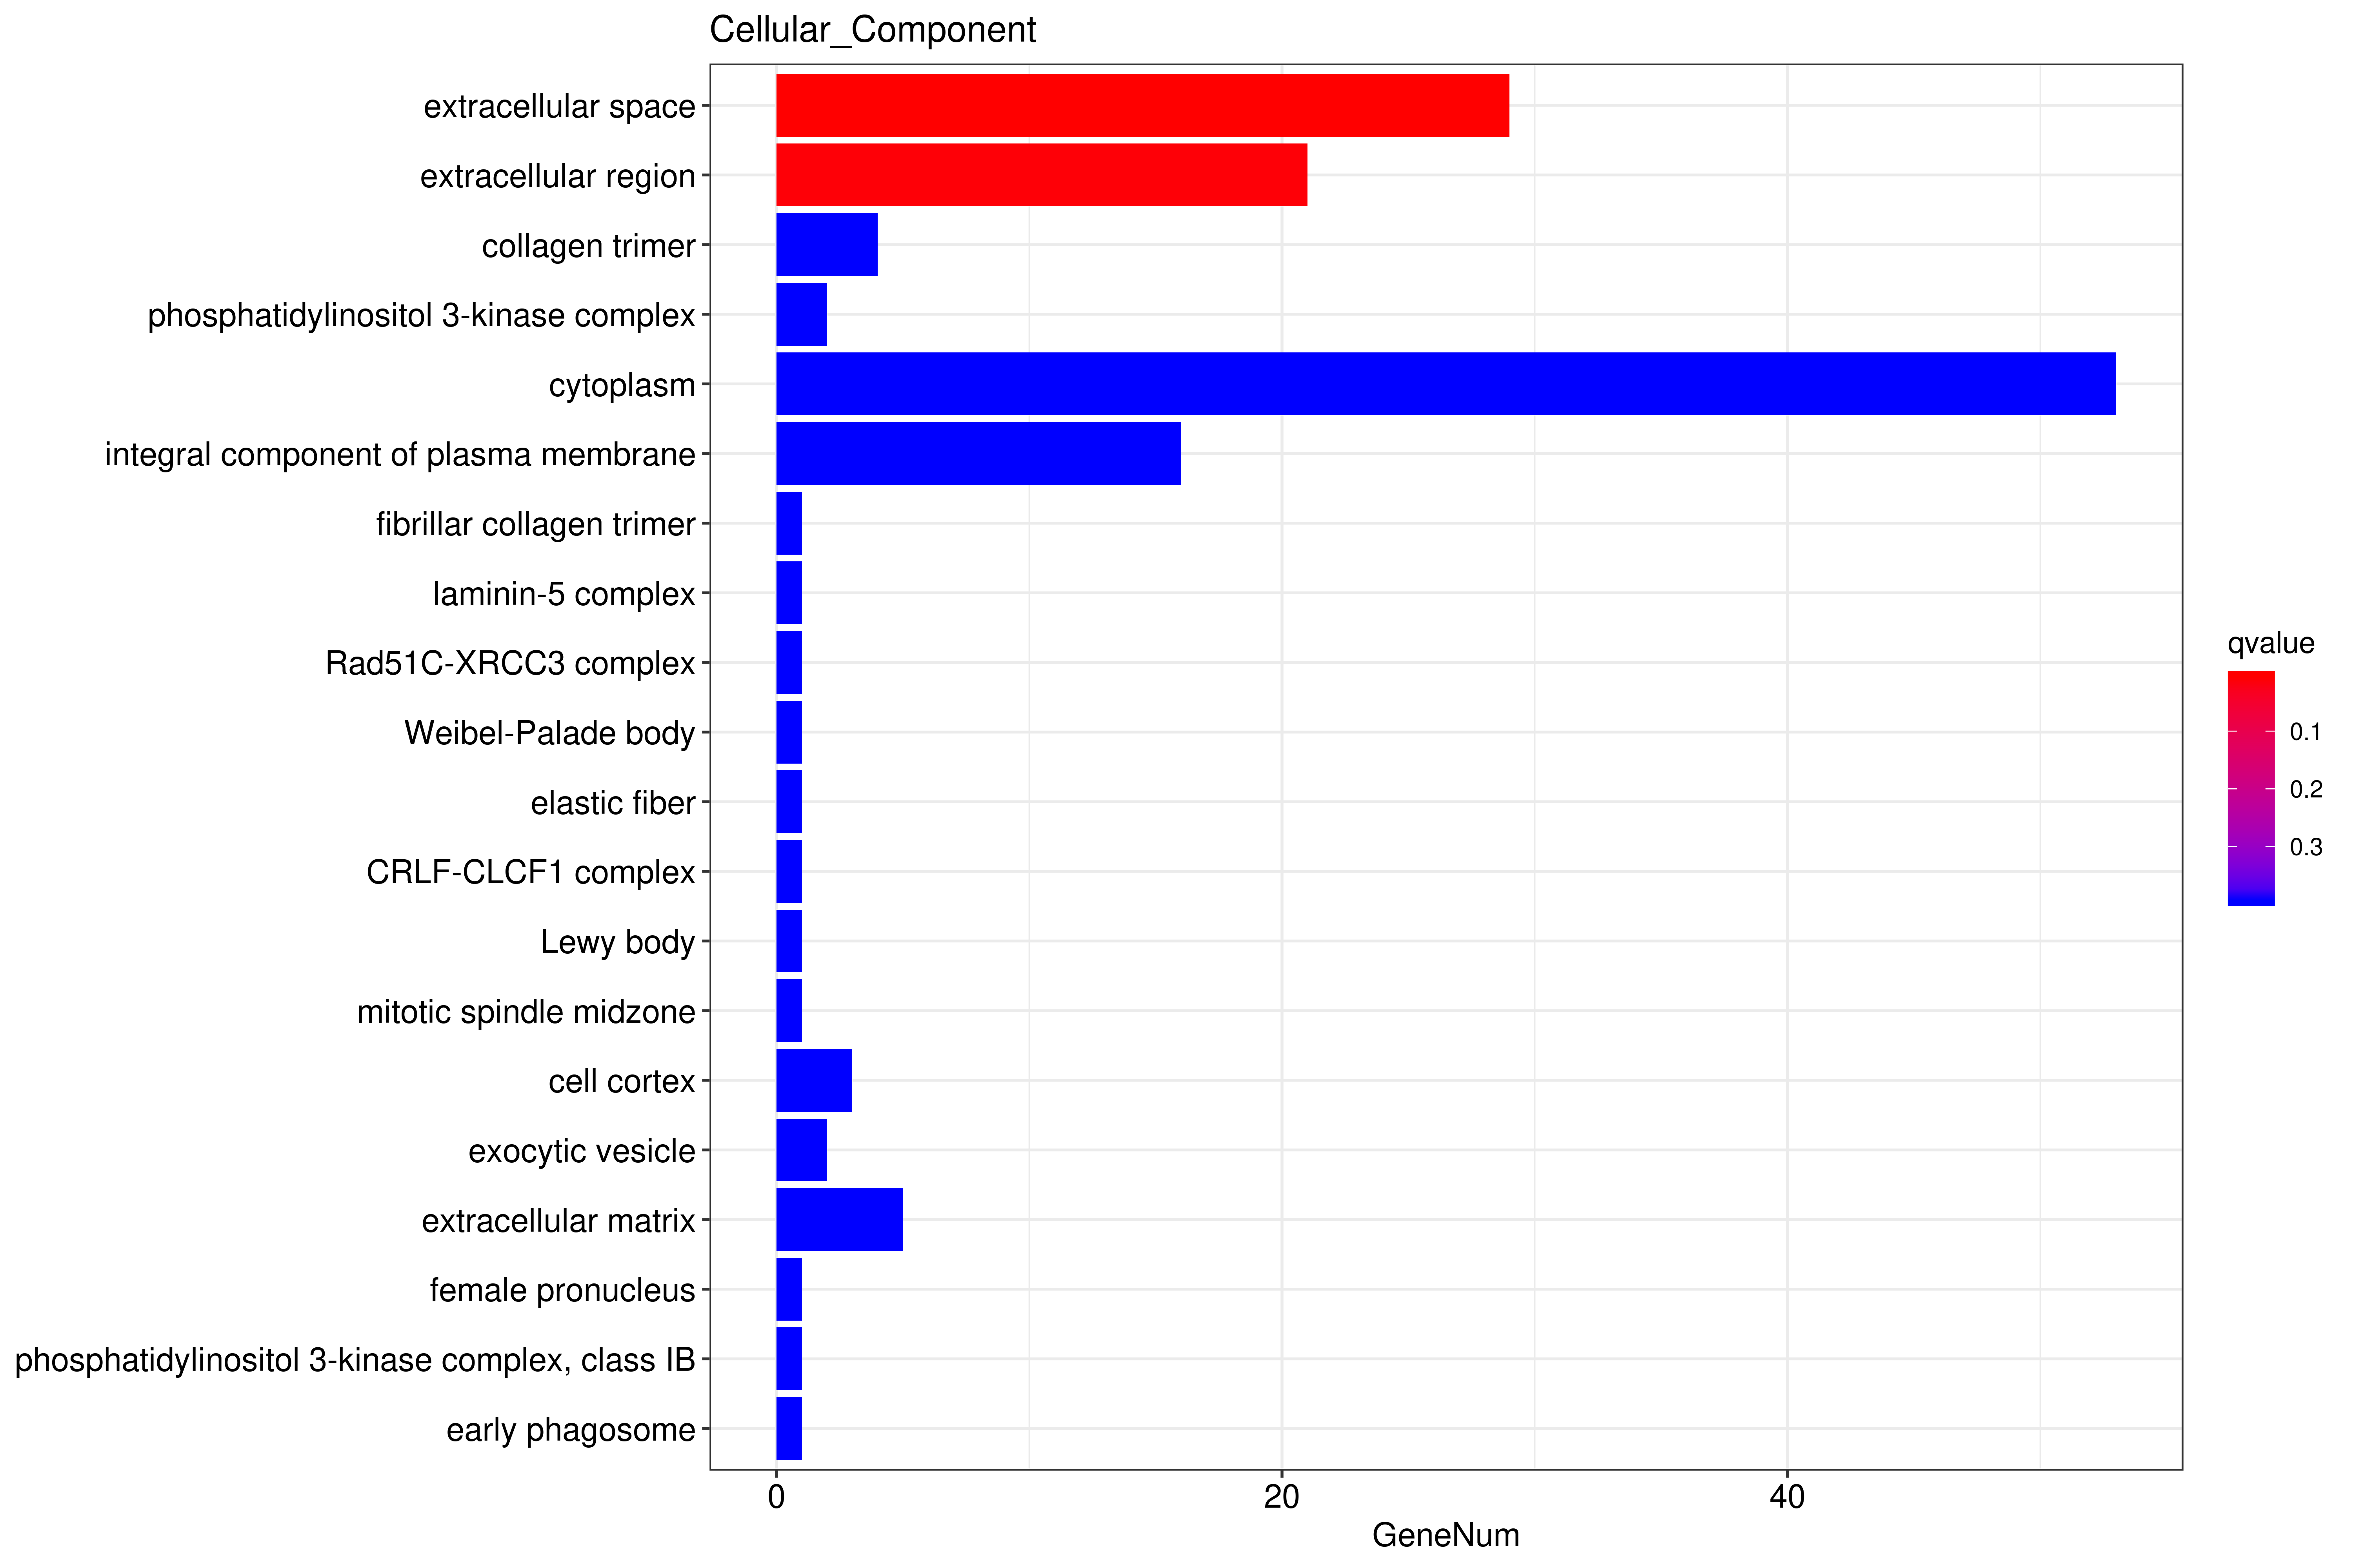
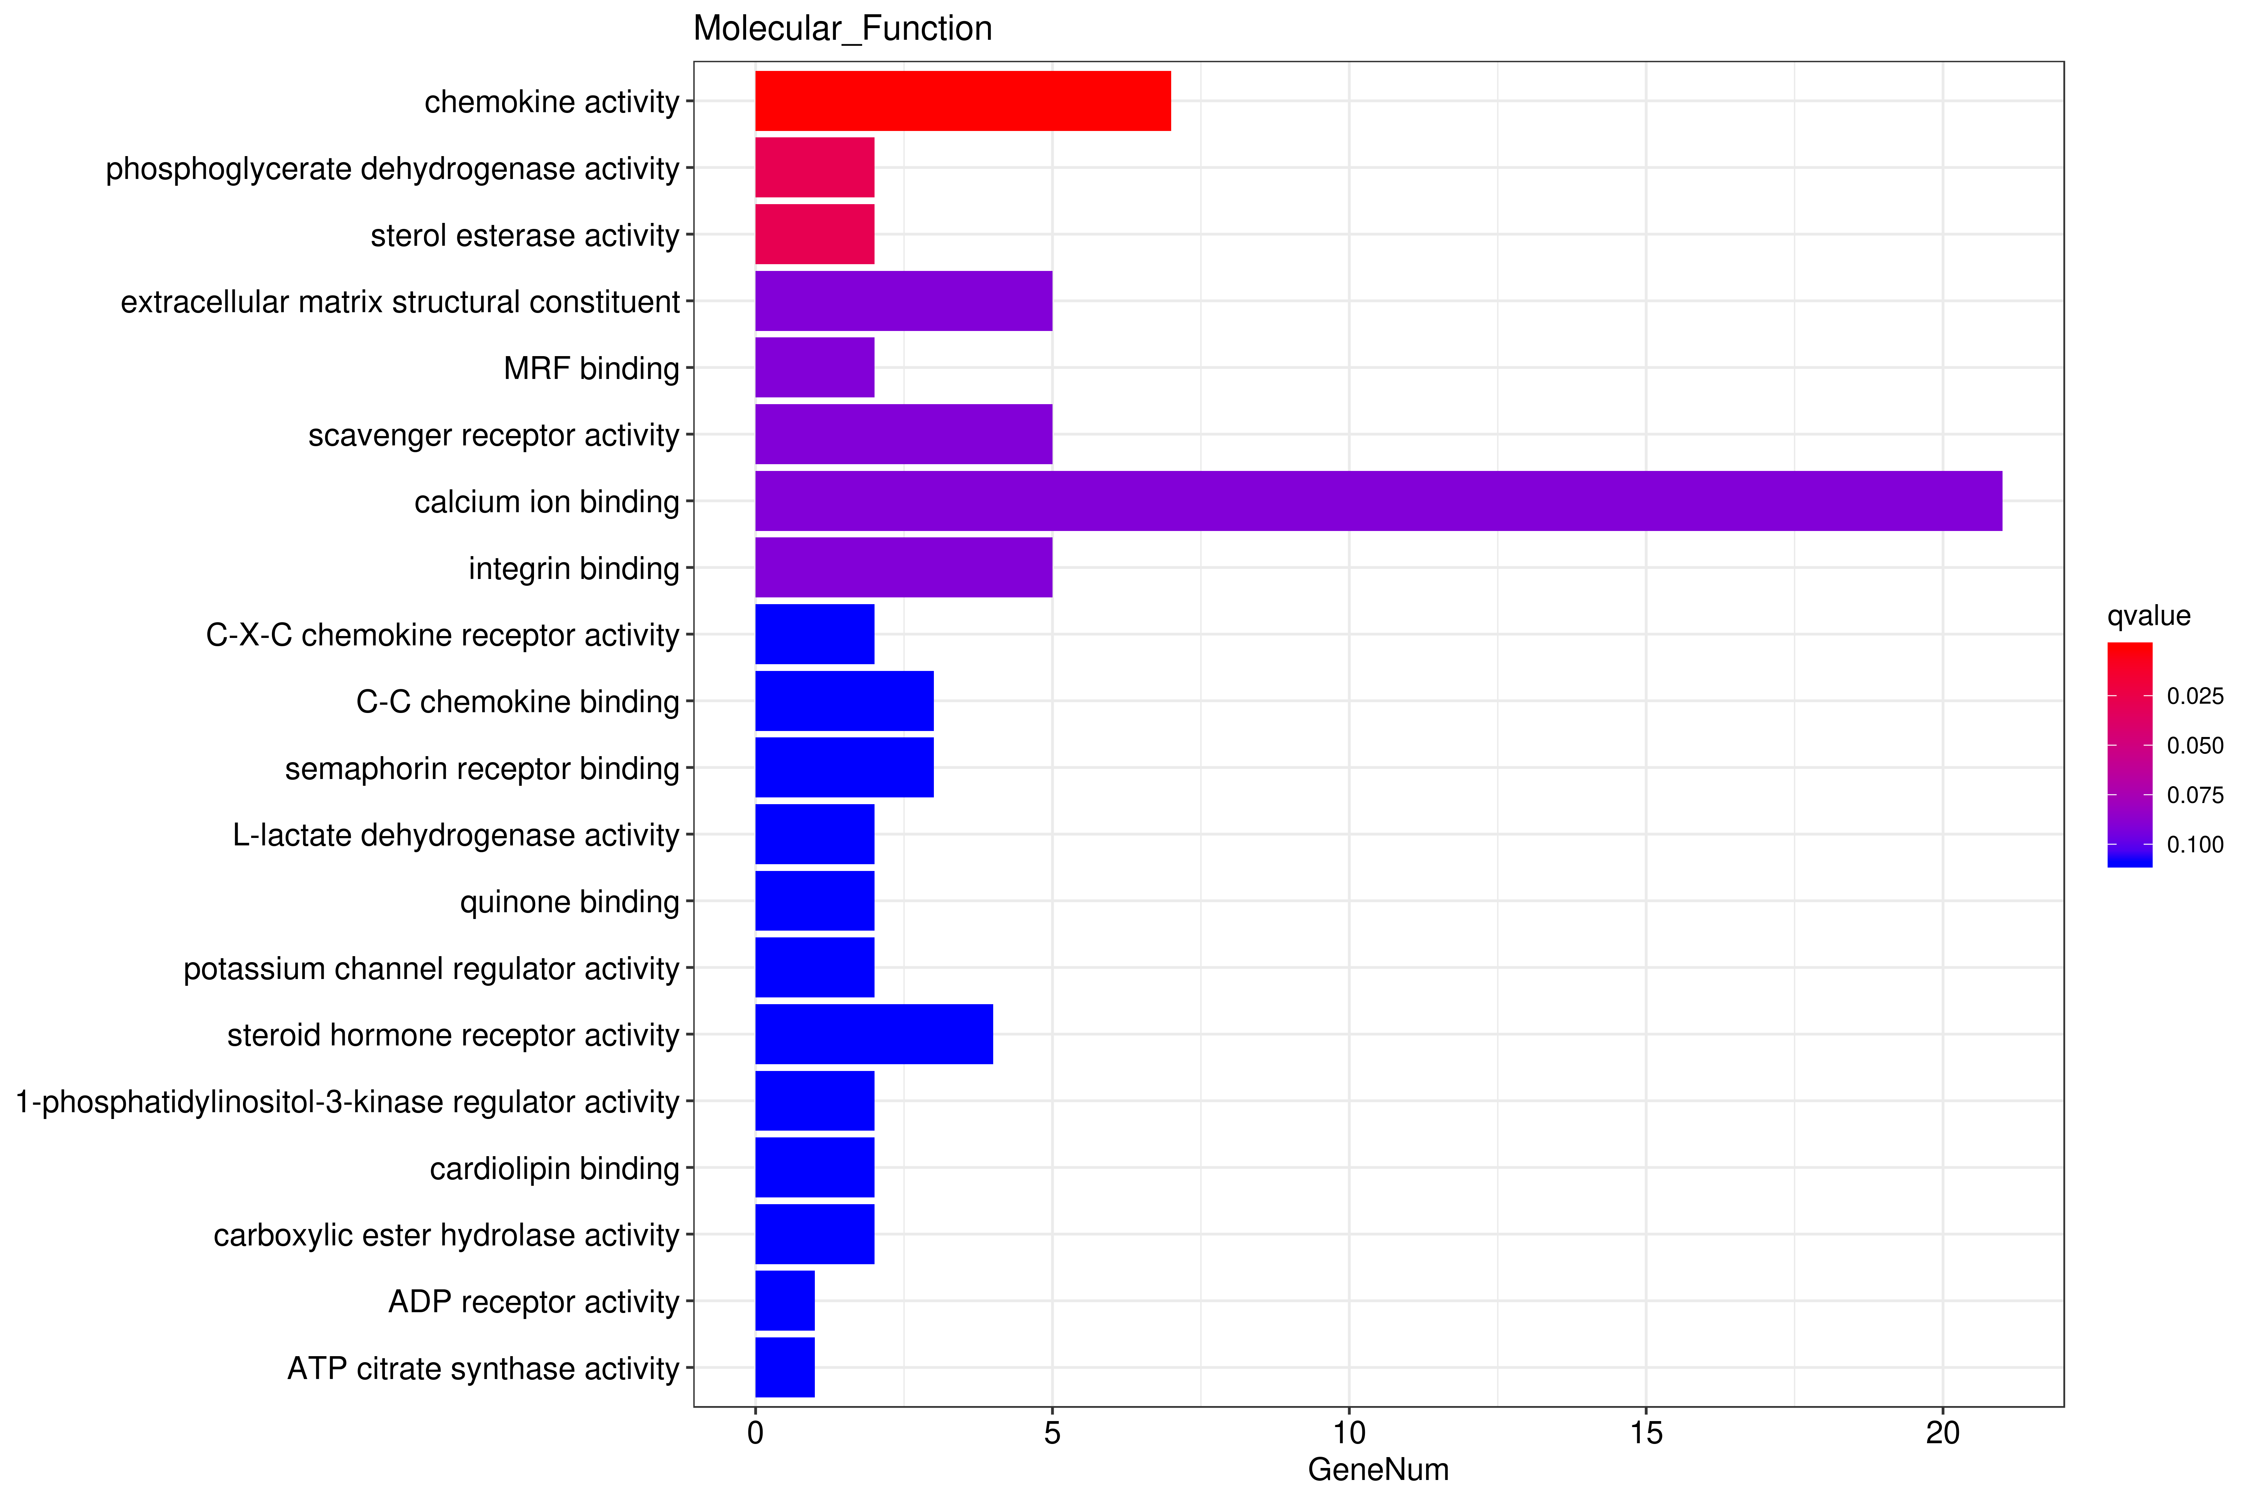
A

B
C
D
E
F
I
H
G

Figure S4. A partial list of bioinformatics analysis results using DEGs of the subcutaneous adipose tissue. (A-C) The column diagrams for the analysis of biological process (A), cellular component (B), and molecular function (C) of DEGs in Berkshire pigs vs Ningxiang pigs; (D-F) The column diagrams for the analysis of biological process (D), cellular component (E), and molecular function (F) of DEGs in Ningxiang pigs vs F₁ pigs; (G-I) The column diagrams for the analysis of biological process (G), cellular component (H), and molecular function (I) of DEGs in the group of Berkshire pigs vs F₁ pigs.

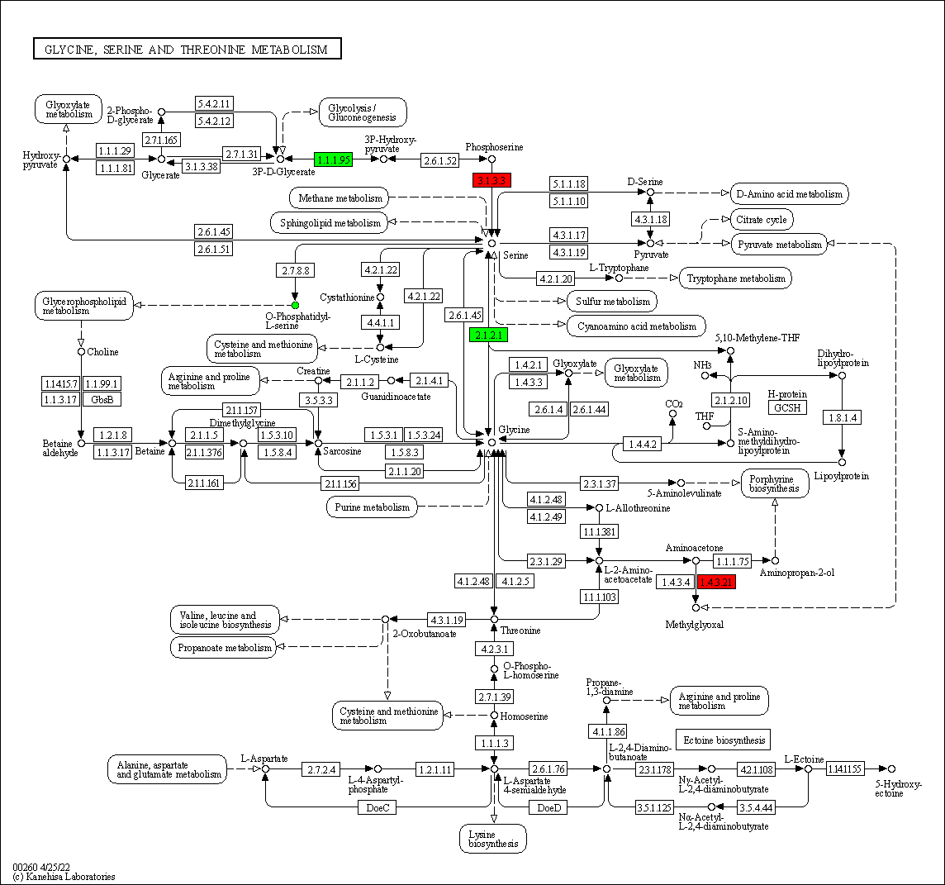
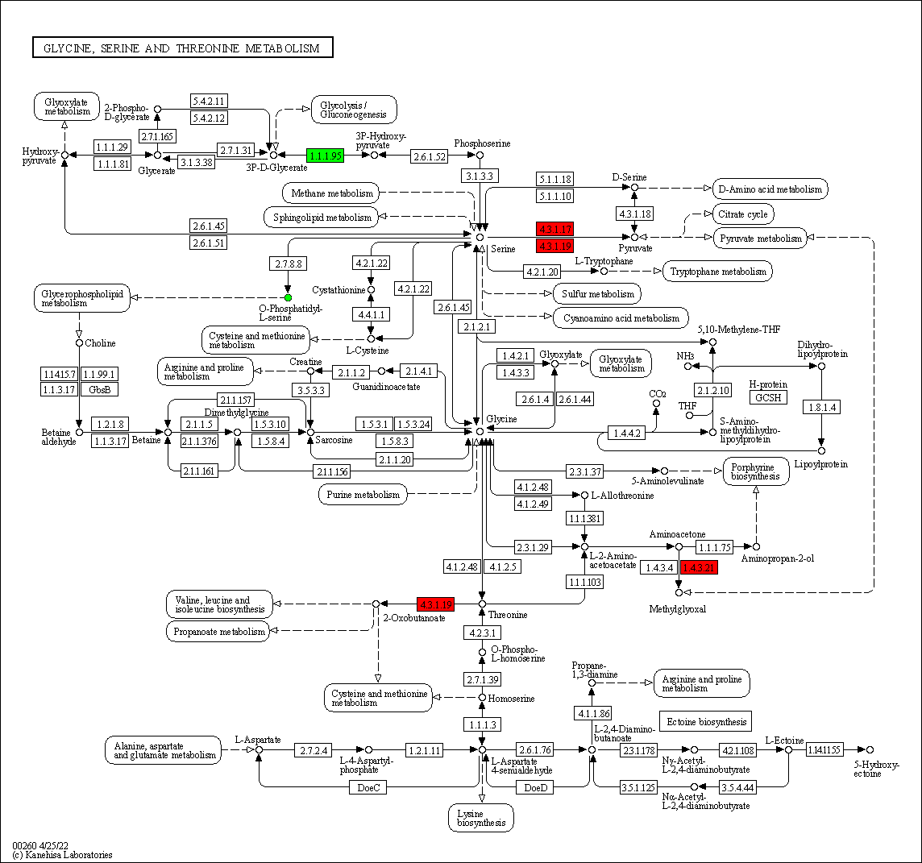
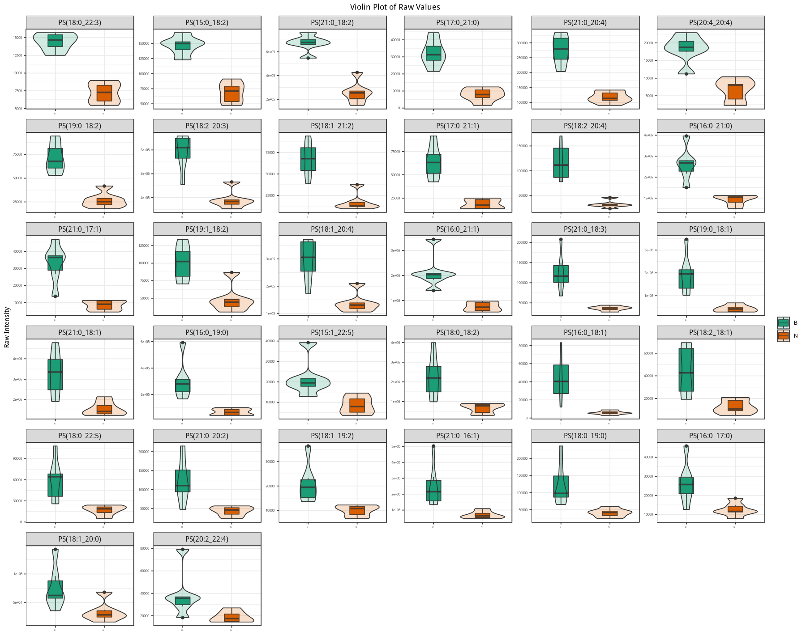
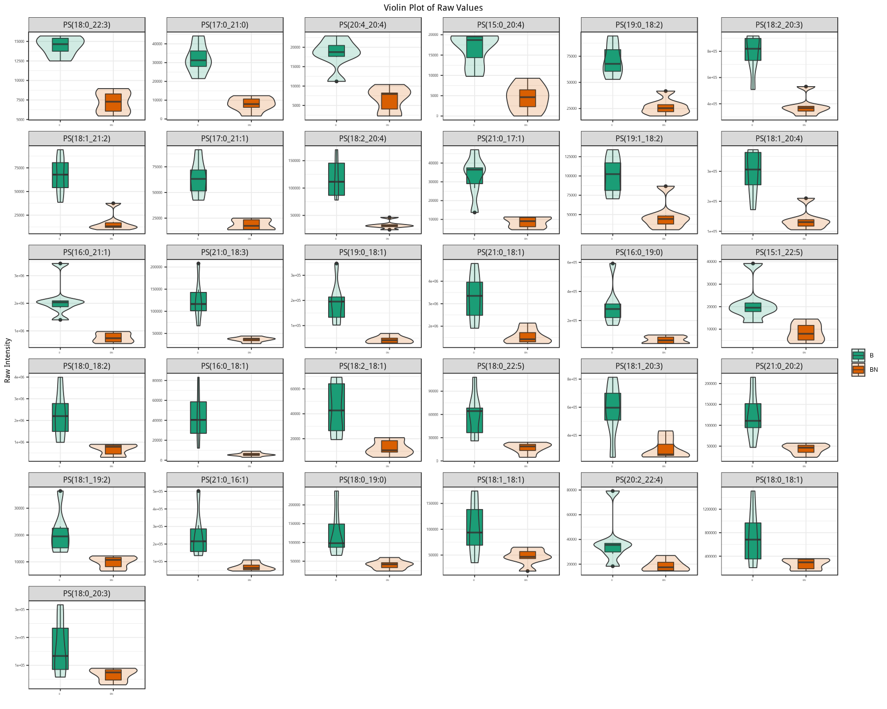
D
C
B
A
Figure S5. The KEGG pathway (kO00260) related DEGs and SCLs. (A, B) The KEGG pathway (kO00260) related DEGs and SCLs in the groups of Berkshire pigs vs Ningxiang pigs (A) and Berkshire pigs vs F₁ pigs (B), respectively, dots and square frame represent metabolites and genes separately, red represents upregulation, green represents downregulation. (C, D) The violin chart of Phosphatidylserines in the group of Berkshire pigs vs Ningxiang pigs (C) and Berkshire pigs vs F₁ pigs (D), respectively. B represents Berkshire pigs, N represents Ningxiang pigs, BN represents F₁ pigs.

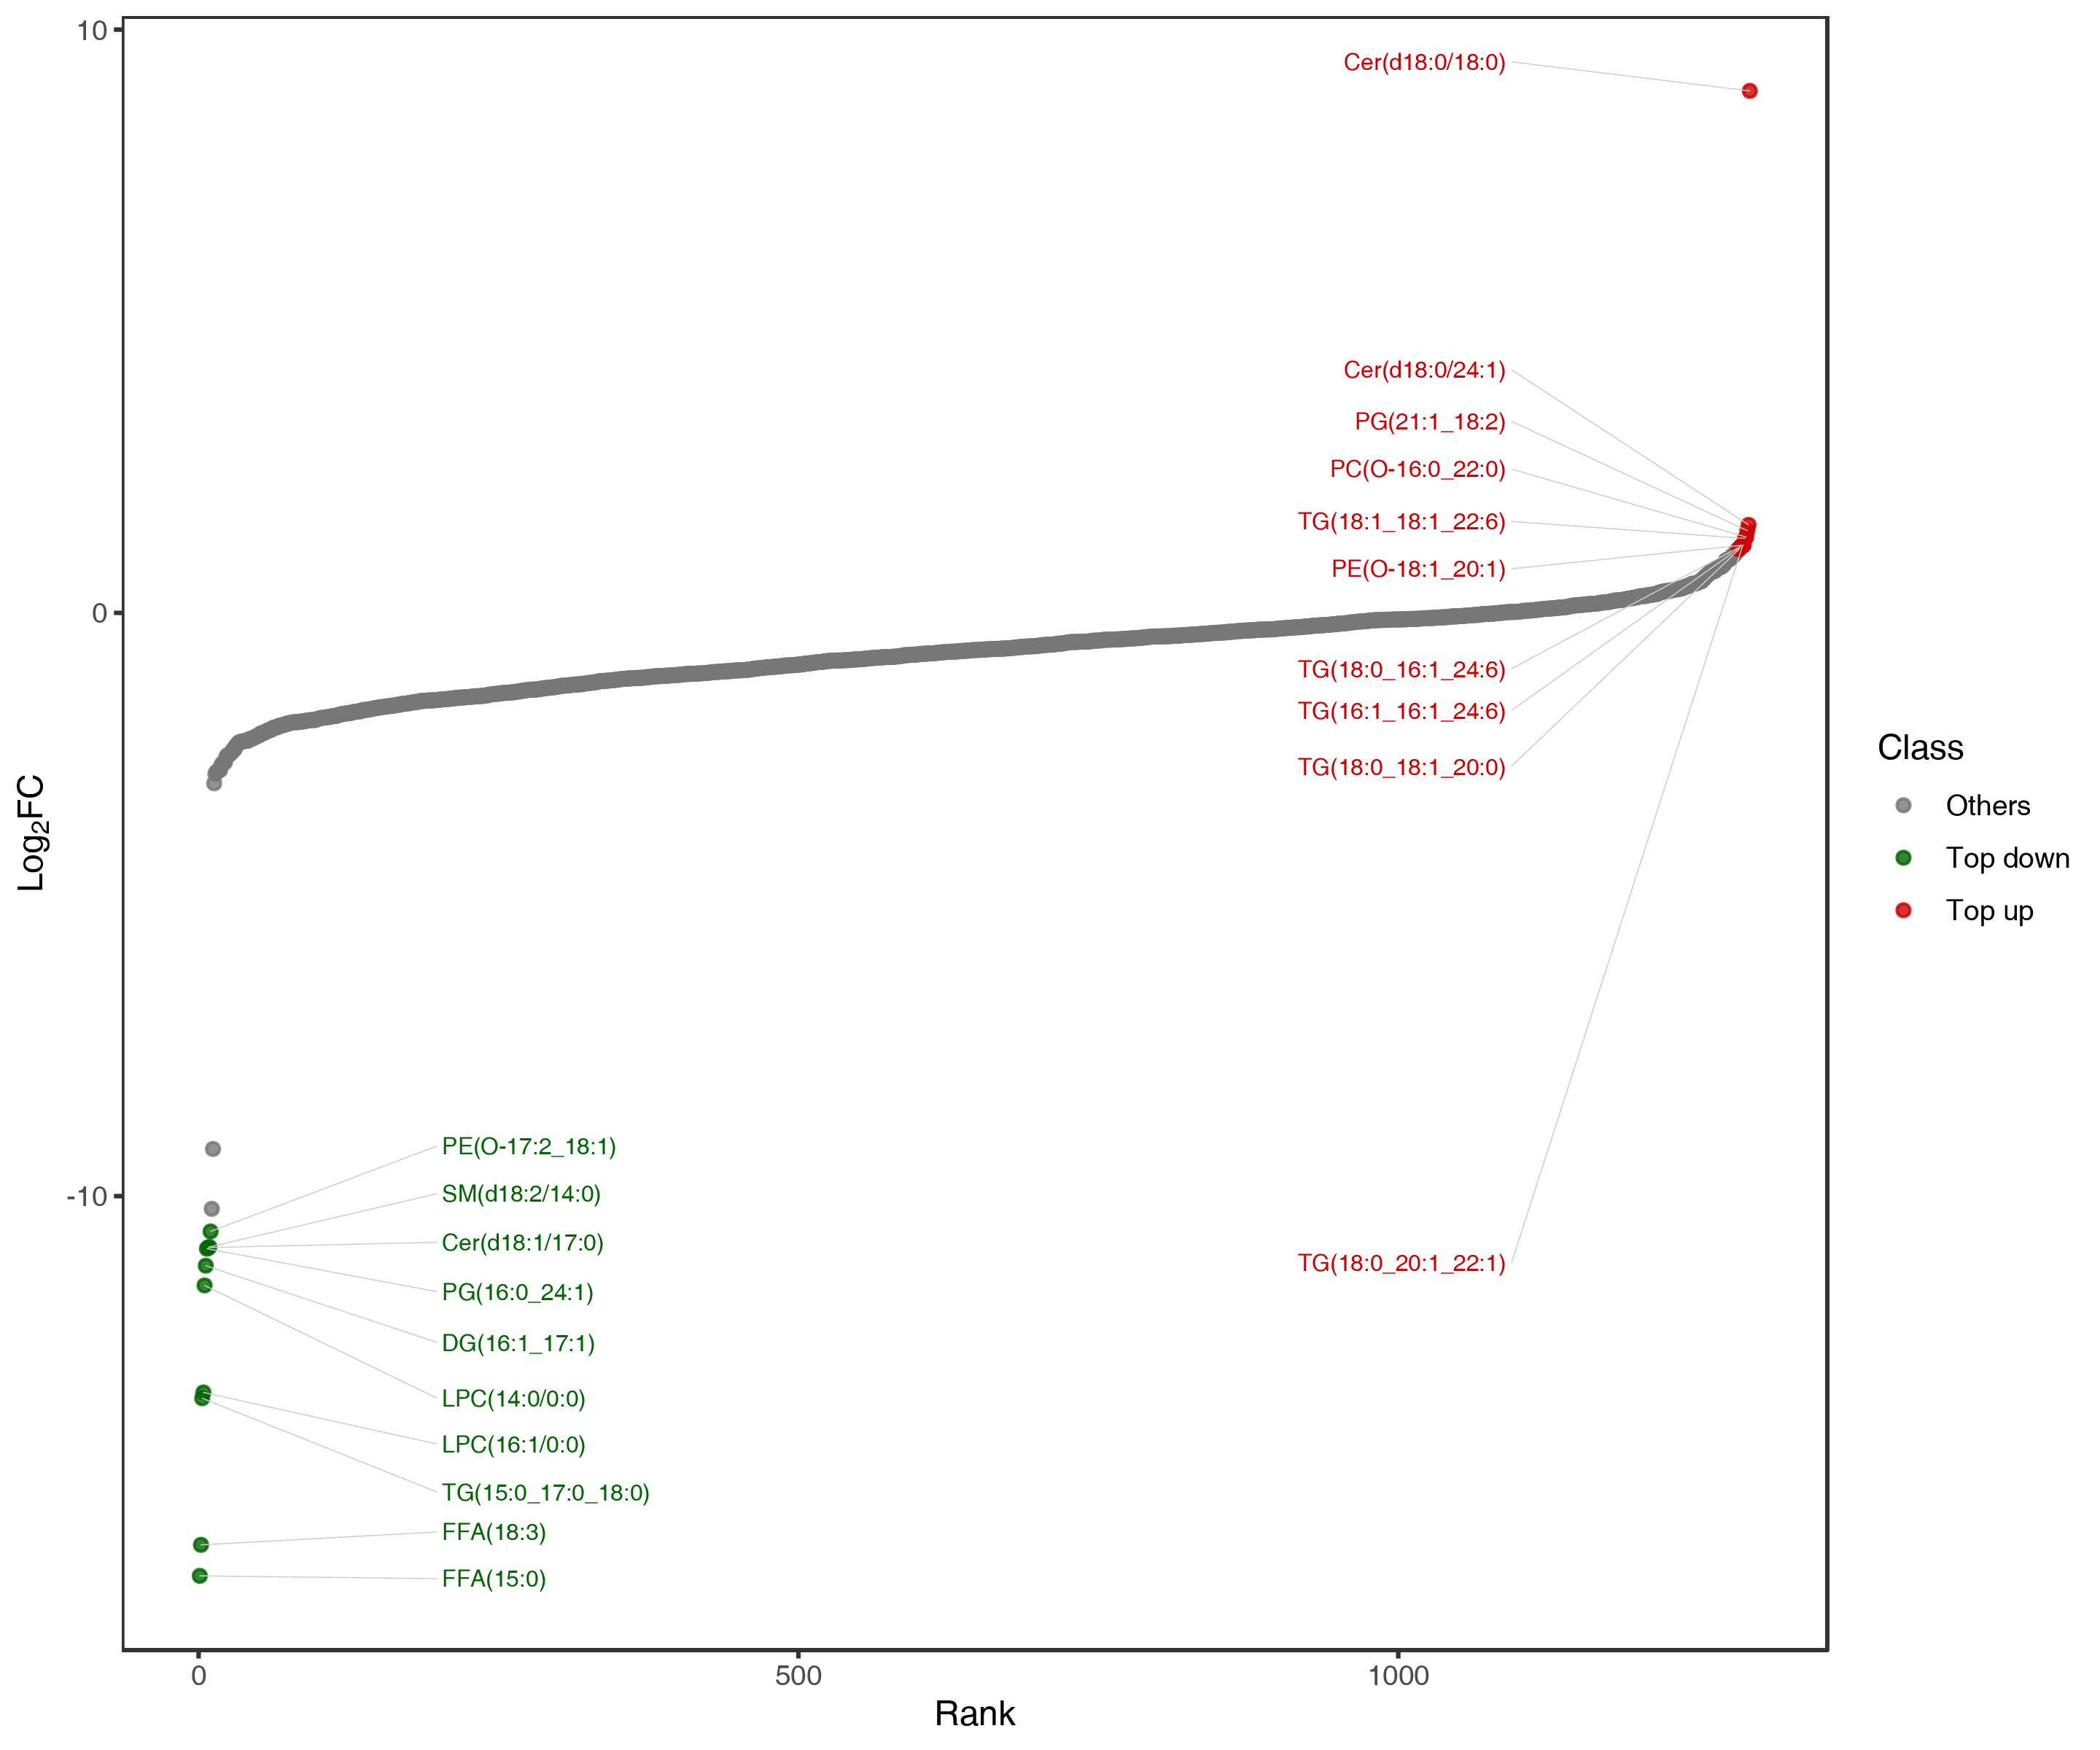

Figure S6. Dynamic distribution map of lipid content differences in the subcutaneous adipose tissue from the group of Berkshire pigs vs Ningxiang pigs. The horizontal ordinate represents the difference multiples of substances, the Y-axis represents the log₂FC. Each point represents a substance, green dots represents the substances in the top 10 of the downward ranking and red dots represents the substances in the top 10 of the upward ranking.
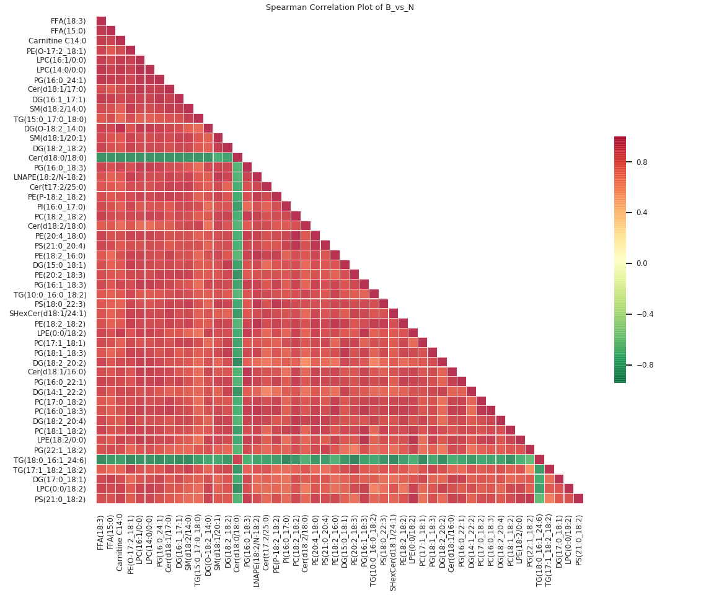

Figure S7. The correlation heat map for significantly different lipids with the top VIP value in the subcutaneous adipose tissue from the group of Berkshire pigs vs Ningxiang pigs. Red represents positive correlation, green represents negative correlation.
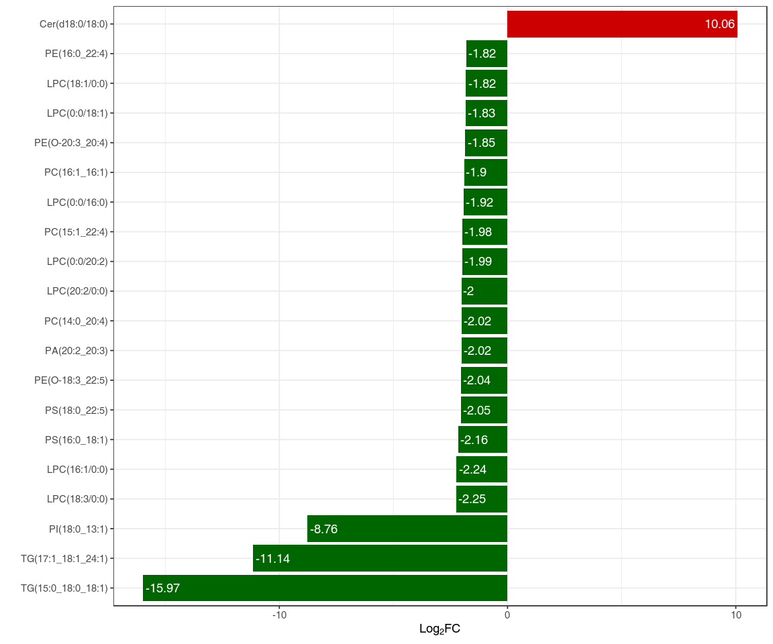
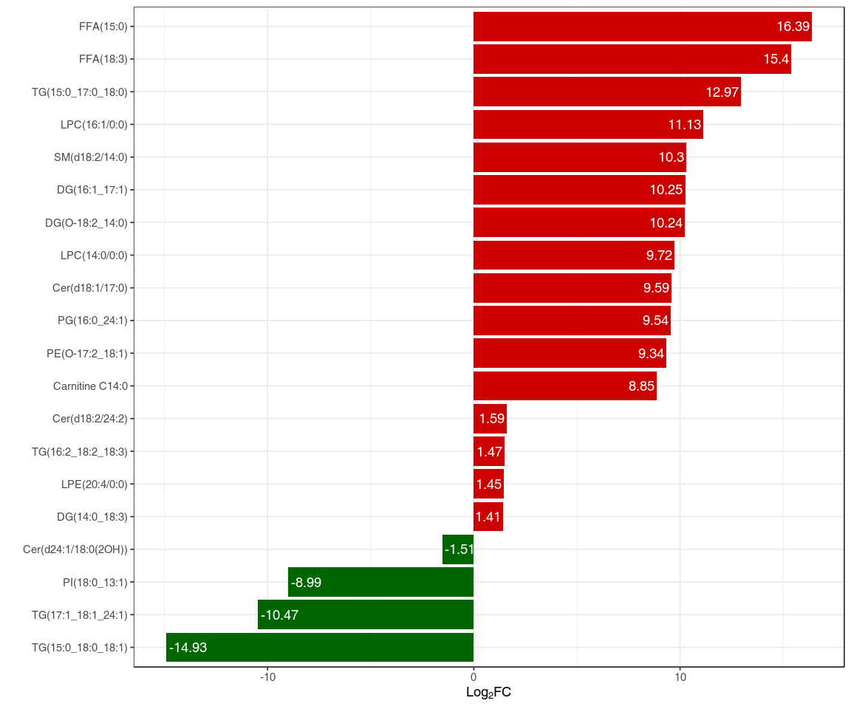
A
B

Figure S8. Bar chart of difference lipids in the subcutaneous adipose tissue from the groups of Berkshire pigs vs F₁ Ningxiang pigs (A) and Ningxiang pigs vs F₁ pigs (B). The horizontal ordinate represents the log₂FC of difference lipids. The Y-axis represents differential lipids. Red represents an increase in lipid content, while green represents a decrease in lipid content.

Table S1 DEGs in the groups of Berkshire pigs vs Ningxiang pigs enriched in partial KEGG pathways (P < 0.05)
Gene name | FPKM |  | FDR | Log₂FC | regulate | Gene annotated
 | BKX | NX
kO00260 glycine, serine and threonine metabolism
PHGDH | 28.12 | 4.17 | 2.27E⁻¹¹ | -2.64 | down | phosphoglycerate dehydrogenase
LOC100156167 | 8.84 | 1.44 | 3.84E⁻⁷ | -2.41 | down | phosphoglycerate dehydrogenase like protein
SHMT1 | 86.01 | 26.98 | 9.92E⁻⁴ | -1.56 | down | glycine hydroxymethyltransferase
PSPH | 12.56 | 52.64 | 9.42E⁻⁶ | 2.21 | up | phosphoserine phosphatase
LOC110256000 | 3.37 | 19.40 | 9.12E⁻⁰⁸ | 2.49 | up | membrane primary amine oxidase-like
KO00590 arachidonic acid metabolism
CYP2B22 | 69.83 | 17.85 | 1.32E⁻³ | -1.85 | down | cytochrome P450 family 2 subfamily B22
LOC110255237 | 6.63 | 22.28 | 2.09E⁻⁴ | 1.86 | up | cytochrome P450 4F6-like
GGT5 | 8.43 | 23.69 | 1.70E⁻³ | 1.54 | up | gamma-glutamyltranspeptidase
PTGES | 3.91 | 13.12 | 4.47E⁻⁸ | 1.86 | up | microsomal prostaglandin-E synthase 1
SAL1 | 25.78 | 134.40 | 3.37E⁻⁶ | 2.45 | up | salivary lipocalin
GPX1 | 334.05 | 1411.35 | 3.60E⁻⁷ | 2.20 | up | glutathione peroxidase 1
GPX3 | 2304.61 | 1055.47 | 4.01E⁻⁷ | -1.01 | down
KO00061 fatty acid biosynthesis
FASN | 1320.46 | 2689.93 | 1.19E⁻³ | 1.15 | up | fatty acid synthase
ACACA | 26.60 | 73.44 | 5.13E⁻⁹ | 1.58 | up | acetyl-CoA carboxylase
CBR4 | 3.87 | 7.46 | 9.83E⁻⁶ | 1.06 | up | carboxyl reductase 4
MCH | 0.19 | 0.82 | 6.33E⁻³ | 2.20 | up | medium chain acyl hydrolase
KO01212 fatty acid metabolism
EHHADH | 8.54 | 16.07 | 2.70E⁻³ | 1.03 | up | enoyl-CoA hydratase
FASN | 1320.46 | 2689.93 | 1.19E⁻³ | 1.15 | up | fatty acid synthase
ACACA | 26.60 | 73.44 | 5.13E⁻⁹ | 1.58 | up | acetyl-CoA carboxylase
CBR4 | 3.87 | 7.46 | 9.83E⁻⁶ | 1.06 | up | carboxyl reductase 4
HACD | 98.60 | 42.53 | 7.91E⁻⁶ | -1.10 | down | very long-chain (3R)-3-hydroxyacyl-CoA dehydratase
ELOV6 | 182.38 | 428.54 | 9.82E⁻⁵ | 1.36 | up | very long chain fatty acids protein 6
SCD | 1184.93 | 3625.88 | 5.31E⁻⁵ | 1.75 | up | stearoyl-CoA desaturase
kO00561 glycerolipid metabolism
GK | 23.72 | 8.19 | 5.06E⁻⁹ | -1.37 | down | glycerol kinase
MGLL | 192.95 | 383.22 | 7.45E⁻¹⁰ | 1.04 | up | monoglyceride lipase
LPIN1 | 127.44 | 44.92 | 5.42E⁻⁴ | -1.40 | down | lipin 1
DGKB | 3.62 | 1.58 | 1.28E⁻³ | -1.07 | down | diacylglycerol kinase beta
DGAT2 | 109.71 | 518.44 | 8.38E⁻²⁰ | 2.36 | up | diacylglycerol O-acyltransferase 2
ko04070 phosphatidylinositol signaling system
NTMR7 | 0.26 | 1.43 | 1.36E⁻³ | 2.54 | up | myotubularin-related protein 7
PLCB1 | 4.49 | 2.06 | 1.14E⁻⁶ | -1.01 | down | phospholipase C beta 1
PIK3C2G | 9.04 | 3.31 | 4.24E⁻¹⁴ | -1.30 | down | phosphatidylinositol-4-phosphate 3-kinase catalytic subunit type 2 gamma
DGKB | 3.62 | 1.58 | 1.28E⁻³ | -1.07 | down | diacylglycerol kinase beta
PLCE1 | 0.45 | 0.19 | 4.25E⁻³ | -1.11 | down | phospholipase C epsilon 1
CALML5 | 2.09 | 0.13 | 6.52E⁻⁶ | -3.91 | down | calmodulin like 5
LOC102157965 | 0.15 | 1.53 | 2.35E⁻⁴ | 4.36 | up | parvalbumin beta-like
kO04973 carbohydrate digestion and absorption
ATP1A | 83.22 | 34.41 | 2.93E⁻⁷ | -1.17 | down | sodium/potassium-transporting ATPase subunit alpha
HK | 4,41 | 9.39 | 6.21E⁻³ | 1.24 | up | hexokinase
SLC2A5 | 12.86 | 32.20 | 5.91E⁻³ | 1.44 | up | Solute carrier family 2 member 5
PLCB | 4.49 | 2.06 | 1.14E⁻⁶ | -1.01 | down | phosphatidylinositol phospholipase C
kO04714 thermogenesis
MGLL | 192.95 | 383.22 | 7.45E⁻¹⁰ | 1.04 | up | acylglycerol lipase
ATP5MC1 | 79.10 | 148.15 | 7.42E⁻³ | 1.02 | up | ATP synthase membrane subunit c locus 1
UQCR10 | 63.91 | 150.00 | 2.65E⁻⁴ | 1.35 | up | ubiquinol-cytochrome c complex III subunit X
NDUFA3 | 11.52 | 25.38 | 8.14E⁻³ | 1.26 | up | NADH:ubiquinone oxidoreductase subunit A3
UQCRQ | 47.93 | 108.01 | 2.28E⁻⁶ | 1.29 | up | ubiquinol-cytochrome c reductase complex III subunit VII
COX7C | 134.91 | 329.31 | 2.04E⁻³ | 1.34 | up | cytochrome c oxidase subunit 7C
NDUFA11 | 45.34 | 85.17 | 9.02E⁻⁵ | 1.03 | up | NADH:ubiquinone oxidoreductase subunit A11
NDUFB2 | 39.84 | 81.82 | 2.27E⁻³ | 1.20 | up | NADH:ubiquinone oxidoreductase subunit B2
NDUFA2 | 33.06 | 62.73 | 7.84E⁻⁸ | 1.04 | up | NADH:ubiquinone oxidoreductase subunit A2
COX17 | 41.24 | 105.00 | 4.63E⁻⁷ | 1.47 | up | cytochrome c oxidase copper chaperone COX17
UQCR11 | 1.27 | 7.07 | 2.71E⁻³ | 2.58 | up | ubiquinol-cytochrome c reductase, complex III subunit XI

