Supplement 1. Influence of 20(S)-PPT on the combination of PCSK9 and LDLR
We tested if 20(S)-PPT inhibited the binding of PCSK9 and LDLR similar to the monoclonal antibodies of PCSK9. Surface plasmon Resonance (SPR) technology was used to detect the effects of different concentrations of 20(S)-PPT (8-32 μM) on the binding of PCSK9 to LDLR. The results showed that 20(S)-PPT inhibited the binding of PCSK9 to LDLR in a concentration-dependent manner (Fig. S1).
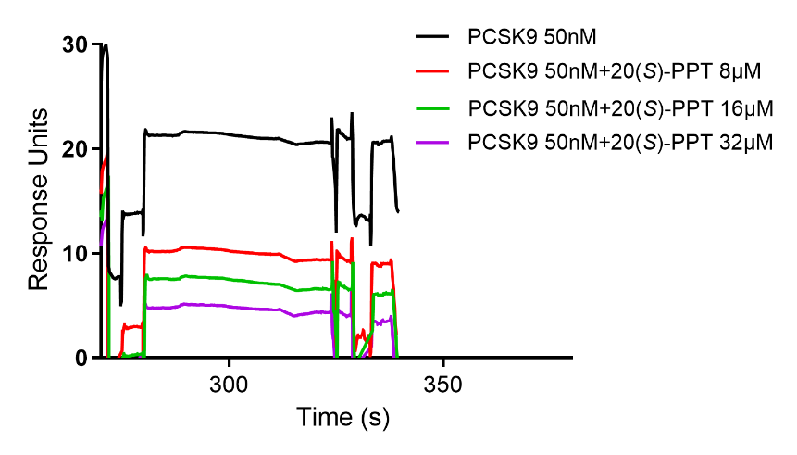
Figure S1. Influence of 20(S)-PPT on the combination of PCSK9 and LDLR
The kinetic analysis of the interactions between PCSK9 and LDLR under different concentrations of 20(S)-PPT (8-32 μM), as measured with the Biacore S200 instrument (GE Healthcare, Uppsala, Sweden). As shown, 20(S)-PPT decreases the binding of PCKS9 to LDLR in a concentration dependent manner.
In addition, Autodock docking software was used to simulate the effect of 20(S)-PPT on the combination of LDLR and PCSK9, and Pymol and Ligplot⁺ software were used to conduct visual analysis of the results, as shown in the Figure S2.
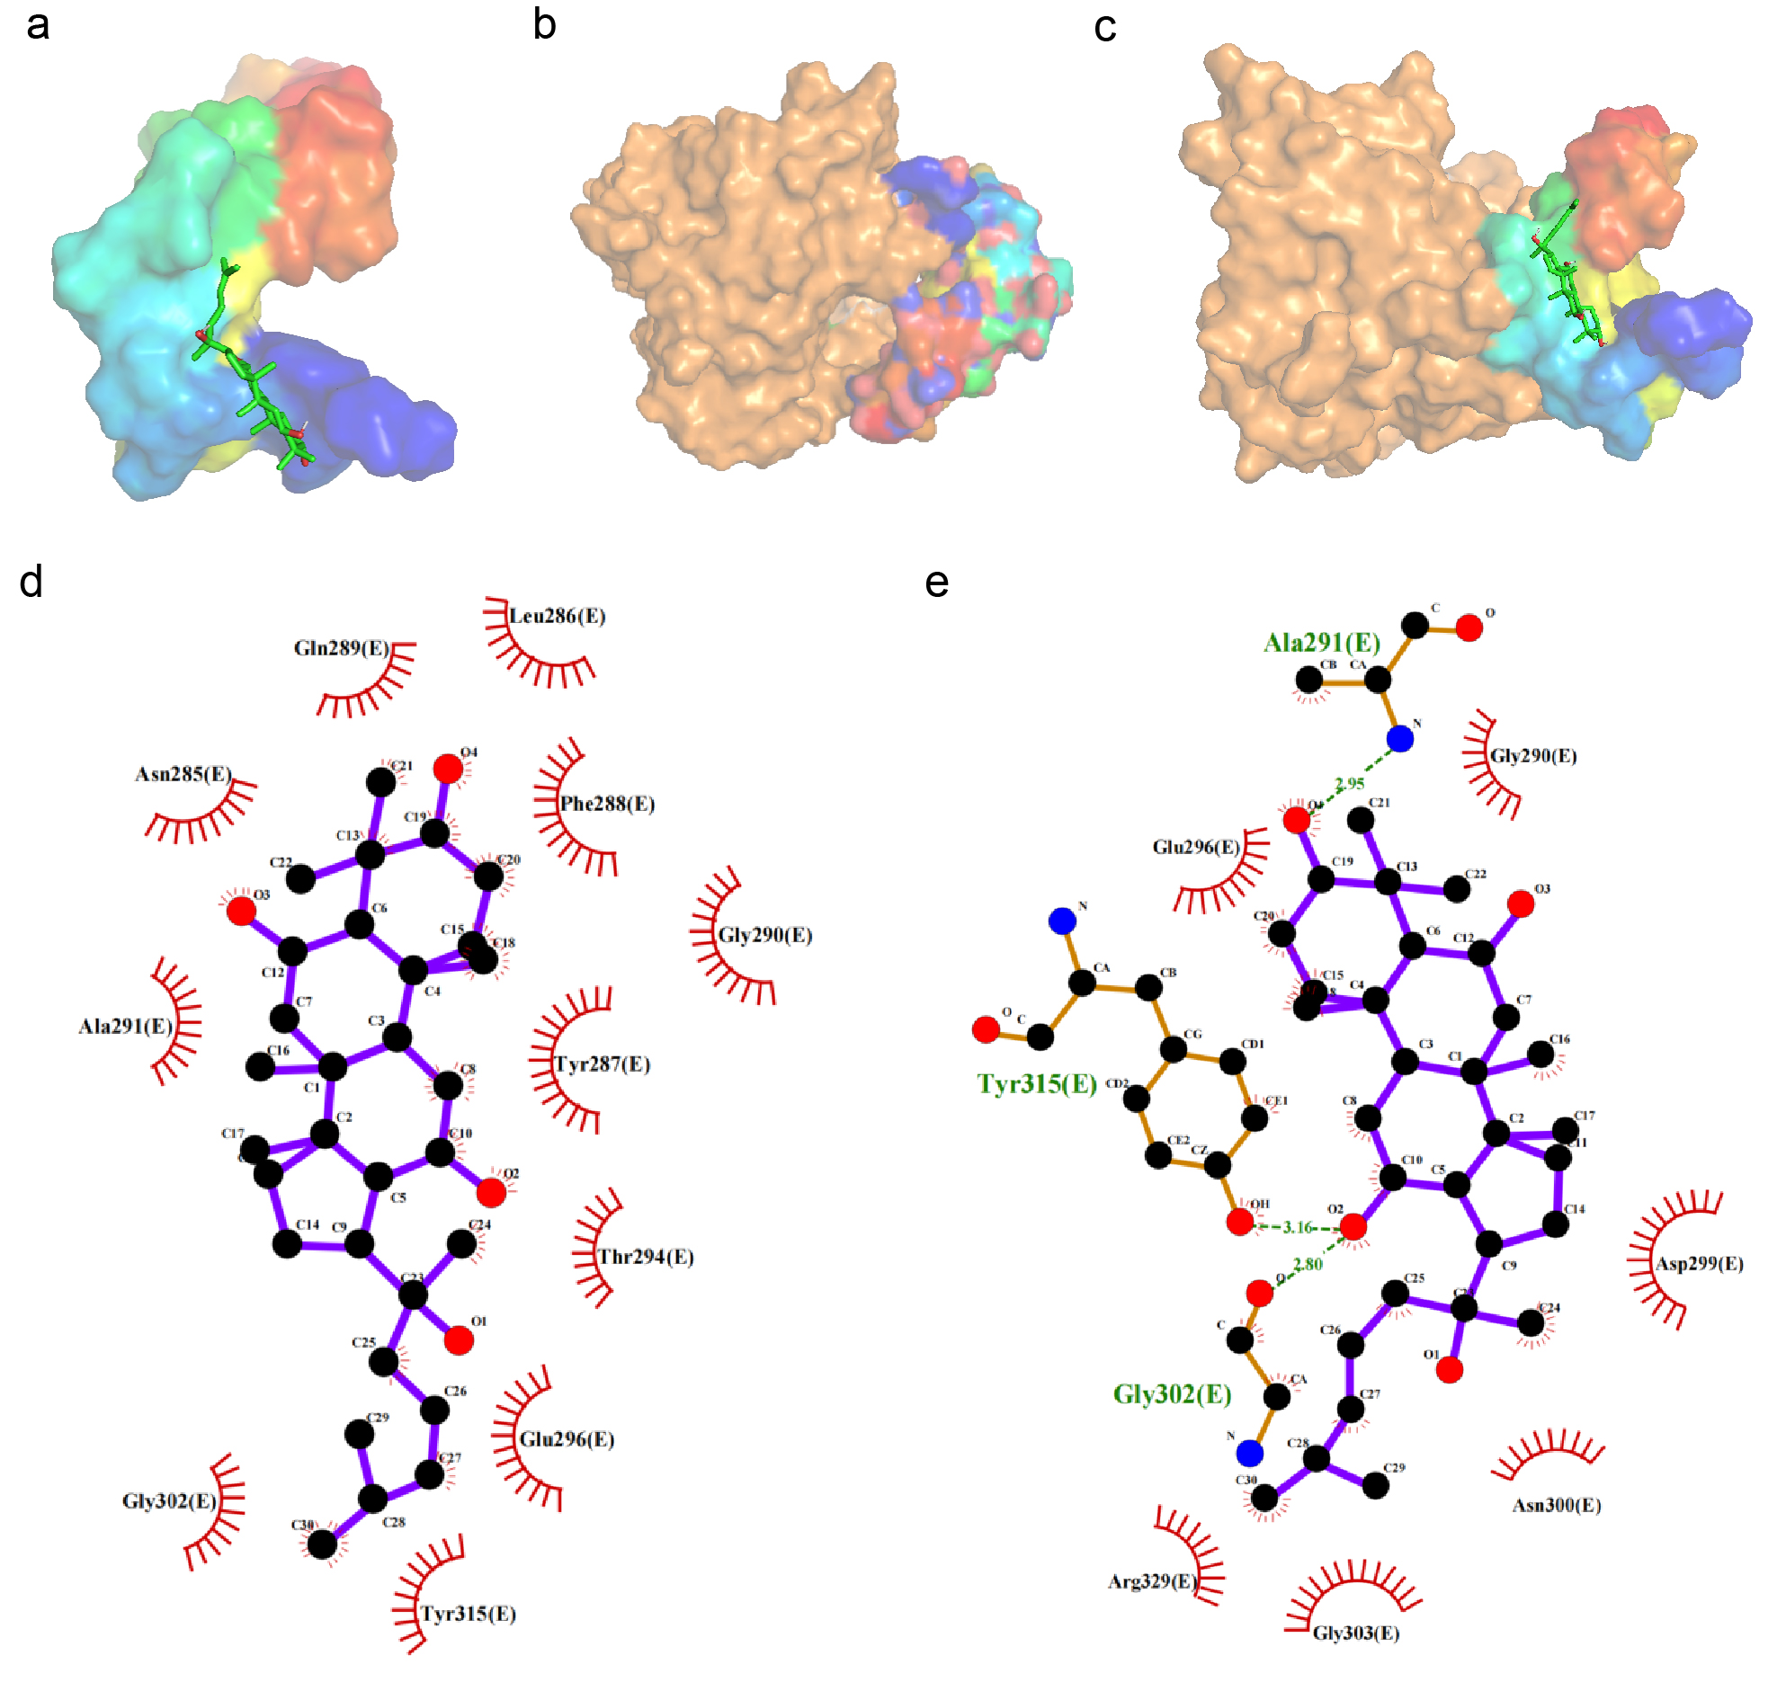
Figure S2. Molecular docking simulation 20(S)-PPT inhibited the binding of PCSK9 to LDLR
a, Pymol visual analysis of the combination of 20(S)-PPT and LDLR; b, Pymol visualized analysis of the combination of LDLR and PCSK9; c, Pymol visual analysis 20(S)-PPT inhibited the binding of LDLR and PCSK9; d, Ligplot⁺ visual analysis of the hydrophobic interaction between 20(S)-PPT and LDLR; e, Ligplot⁺ visual analysis of 20(S)-PPT hydrophobic interaction with LDLR and PCSK9.

We used the ligand-receptor docking model to simulate the molecular recognition and binding mechanism of 20(S)-PPT and LDLR. Molecular docking shows that the ABCD ring of 20(S)-PPT is inserted into the active pocket position of the LDLR (Figure S2 a). We used the same docking method to explore the combination of LDLR and PCSK9 (Figure S2 b) and the influence of 20(S)-PPT on the combination of LDLR and PCSK9 (Figure S2 c). The results showed that LDLR and PCSK9 were able to bind closely, but in the presence of 20(S)-PPT, the conformation of LDLR changed, which affected the binding with PCSK9. Through Ligplot⁺ analysis, it is found that a large number of hydrophobic bonds can be formed between 20(S)-PPT and LDLR protein (Figure S2 d), and 20(S)-PPT can directly produce hydrogen bonds with three amino acid residues (Ala291, Tyr315, Gly302) on LDLR protein. The bond lengths were 2.95 Å, 3.16 Å and 2.80 Å respectively (Figure S2 e), which resulted in a conformational change of LDLR protein.

