Supplements Kalidium

**Supplement A**

Table -Origin, source, and GenBank accession numbers of *Kalidium* sequences used for phylogenetic analyses

|  |  |  |  |  |  |  |
| --- | --- | --- | --- | --- | --- | --- |
| Accession | Name | Coordinates | Voucher | rITS | trnQ-rps16 | rpl32-trnL |
| B01 | *Kalidium caspicum* | 44.106944 N 67.056389 E | AA: 0001993 | OQ061486 | OQ077105 | OQ077120 |
| B03 | *Kalidium caspicum* | 45.875278 N 62.139167 E | AA: 0001995 | OQ061487 | OQ077106 | OQ077121 |
| B04 | *Kalidium caspicum* | 44.1775 N 78.812778 E | AA: 0001994 | OQ061488 | OQ077107 | OQ077122 |
| B07 | *Kalidium caspicum* | 45.848274 N 62.230855 E | AA: 0001992 | OQ061489 | OQ077108 | OQ077123 |
| B08 | *Kalidium caspicum* | 44.106111N 67.044444 E | AA: 0001998 | OQ061490 | OQ077109 | OQ077124 |
| B09 | *Kalidium caspicum* | 45.103361 N 64.531417 E | AA: 0002000 | OQ061491 | OQ077110 | OQ077125 |
| B10 | *Kalidium caspicum* | 44.080028 N 64.701056 E | AA: 0002001 | OQ061492 | OQ077111 | OQ077126 |
| B10.2 | *Kalidium caspicum* | 44.080028 N 64.701056 E | AA: 0002001 | OQ061493 | - | - |
| B11 | *Kalidium caspicum* | 44.109917 N 67.056361 E | AA: 0001999 | OQ061494 | OQ077112 | OQ077127 |
| B11.2 | *Kalidium caspicum* | 44.109917 N 67.056361 E | AA: 0001999 | OQ061495 | - | - |
| B12 | *Kalidium caspicum* | 43.680278 N 80.073333 E | AA: 0002002 | OQ061496 | OQ077113 | OQ077128 |
| B12.2 | *Kalidium caspicum* | 43.680278 N 80.073333 E | AA: 0002002 | OQ061497 | - | - |
| B14 | *Kalidium caspicum* | 43.759444 N 80.228889 E | AA: 0002003 | OQ061498 | OQ077114 | OQ077129 |
| B14.2 | *Kalidium caspicum* | 45.875278 N  62.139167 E | AA: 0002003 | OQ061499 | - | - |
| B14.3 | *Kalidium caspicum* | 45.875278 N  62.139167 E | AA: 0002003 | OQ061500 | - | - |
| B02 | *Kalidium foliatum* | 44.106944 N 67.056389 E | AA: 0001997 | OQ061481 | OQ077115 | OQ077130 |
| B05 | *Kalidium foliatum* | 44.1775 N 78.812778 E | AA: 0001996 | OQ061482 | OQ077116 | OQ077131 |
| B06 | *Kalidium foliatum* | 45.848274 N 62.230855 E | AA: 0001991 | OQ061483 | OQ077117 | OQ077132 |
| B13 | *Kalidium foliatum* | 43.680278 N 80.073333 E | AA: 0002004 | OQ061484 | OQ077118 | OQ077133 |
| B13.2 | *Kalidium foliatum* | 43.680278 N 80.073333 E | AA: 0002004 | OQ061485 | - | - |
| B15 | *Kalidium schrenkianum* | 43.759444 N 80.228889 E | AA: 0002005 | OQ061501 | OQ077119 | OQ077134 |
| B16 | *Halocnemum strobilaceum* | 43.796389 N 67.463611 E | AA: 0002038 | OQ062601 | OQ077135 | OQ077162 |
| B20 | *Halostachys belangeriana* | 44.106944 N 67.056389 E | AA: 0002031 | OQ062605 | OQ077138 | OQ077165 |

**Supplement B**

Table - Sample data from NCBI database (only ITS)

|  |  |  |
| --- | --- | --- |
| Name | Locality | rITS |
| *Kalidium caspicum* | 44.215833 N 86.655278 E | KX133017- KX133019 |
| *Kalidium caspicum* | 43.844444 N 90.624444 E | KX133020- KX133022 |
| *Kalidium caspicum* | 43.772500 N 91.721667 E | KX133023- KX133025 |
| *Kalidium caspicum* | 44.120556 N 87.714444 E | KX133026- KX133028 |
| *Kalidium caspicum* | 43.996649 N 81.520368 E | HM131636 |
| *Kalidium cuspidatum* | 37.777672 N 95.292038 E | DQ340148 |
| *Kalidium cuspidatum* | 42.547884 N 93.981696 E | HM131637 |
| *Kalidium cuspidatum* var. *cuspidatum* | 36.708333 N 99.045833 E | KX133029-KX133031 |
| *Kalidium cuspidatum var. cuspidatum* | 37.344167 N 104.084722 E | KX133032-KX133034 |
| *Kalidium cuspidatum var. cuspidatum* | 37.669722N 107.515556 E | KX133035-KX133037 |
| *Kalidium cuspidatum var. cuspidatum* | 38.869722 N 106.756389 E | KX133038-KX133040 |
| *Kalidium cuspidatum var. cuspidatum* | 38.872778 N 108.698333 E | KX133041-KX133043 |
| *Kalidium cuspidatum* var*. sinicium* | 36.025278 N 97.647500 E | KX133044-KX133046 |
| *Kalidium cuspidatum var. sinicium* | 36.463333 N 103.932778 E | KX133047-KX133049 |
| *Kalidium cuspidatum var. sinicium* | 38.308889 N 103.275556 E | KX133050-KX133052 |
| *Kalidium cuspidatum var. sinicium* | 35.851389 N 94.520833 E | KX133053-KX133055 |
| *Kalidium cuspidatum var. sinicium* | 39.128889 N 100.551111 E | KX133056-KX133058 |
| *Kalidium foliatum* | 39.916111 N 105.705000 E | KX133059-KX133061 |
| *Kalidium foliatum* | 38.308889 N 103.275556 E | KX133062-KX133064 |
| *Kalidium foliatum* | 43.772500 N 91.721667 E | KX133065-KX133067 |
| *Kalidium foliatum* | 44.642778 N 83.252778 E | KX133068-KX133070 |
| *Kalidium foliatum* | 44.642778 N 85.268611 E | KX133071-KX133073 |
| *Kalidium foliatum* | 44.023813 N 113.898182 E | AY489238 |
| *Kalidium foliatum* | 47.612650 N 84.954706 E | DQ340150 |
| *Kalidium foliatum* | 46.658874 N 47.805919 E | KU975201 |
| *Kalidium foliatum* | 47.358223 N 47.358223 E | KU975200 |
| *Kalidium foliatum* | 47.189457 N 50.765061 E | AY181874 |
| *Kalidium foliatum* | 47.650950 N 87.775569 E | HM131638 |
| *Kalidium gracile* | 43.635000 N 91.957778 E | KX133074-KX133076 |
| *Kalidium gracile* | 38.853056 N 106.756389 E | KX133077-KX133079 |
| *Kalidium gracile* | 39.155278 N 98.170556 E | KX133080-KX133082 |
| *Kalidium gracile* | 40.845278 N 103.609167 E | KX133083-KX133085 |
| *Kalidium gracile* | 36.449167 N 103.984167 E | KX133086-KX133088 |
| *Kalidium gracile* | 44.755554 N 100.826111 E | DQ340151 |
| *Kalidium schrenkianum* | 41.925556 N 82.854167 E | KX133089-KX133091 |
| *Kalidium schrenkianum* | 42.113056 N 83.146667 E | KX133092-KX133094 |
| *Kalidium schrenkianum* | 41.590556 N 81.335556 E | KX133095-KX133098 |
| *Kalidium schrenkianum* | 45.833052 N 62.202842 E | KU975203 |
| *Kalidium wagenitzii* | 38.366888 N 33.564323 E | DQ340146 |

Note - the sample coordinates were taken from the articles

**Supplement C**

Matrix of SCoT primer results:SСoT 11 – 1-15; SСoT 12 – 16-33; SСoT 13 – 34-48; SСoT 14 – 49-64; SСoT 21 – 65-91; SСoT 23 – 92-109

B01.1_*K_caspicum*

1001000100110001000101100011100101100111001000000110100101000000001010010100000000100100111100001101101000000

B01.2_*K_caspicum*

1001000100110001000101000011000001000111000000000111000101010000000000010000000000100100110100001101000000000

B01.3_*K_caspicum*

1001000100110001000101000011000001100111000000000111000101010010000000010000000000100100000100001101000000010

B02.1_*K_foliatum*

0011000000110101000100000011011001100100001000110111110101011010000000011100001000000001101000000111000000010

B02.2_*K_foliatum*

0001000000110001000100000011000001101100000000010110000101000010000000011100001000000001101000000111000000000

B02.3_*K_foliatum*

0001000000110001000100000011000001101100000000010111000101000010000100011100001000000001101000000111000000000

B03.1*_K_caspicum*

0110100100110001001100000011100101100111100010000111000101000000101010010100011000100000111100101001010100101

B03.2_*K_caspicum*

0100100100110001000101000111000001100111100010000111110100010000101000010100110100100000000100001001000100111

B03.3_*K_caspicum*

0100100100110001000111100111000001100111100110000111100100010000101000010100110100100000000100001001000100111

B04.1_*K_caspicum*

1001000100110001100101001011000101100100110010000111110101010000001000110100000000000110011011000011000000010

B04.2_*K_caspicum*

1001000100110001100111010011000001100100101100000111100100010000001000010100001000000100010000000111000000000

B04.3_*K_caspicum*

1001000100110001100101101011000101100100110010000111000100010000001000110100000000000110011000100001110000010

B05.1_*K_foliatum*

0001000000110001001100000011000001110100100001000111110010110100110000010100101000000000110000000010110000010

B05.2_*K_foliatum*

0001000000110001000100000011000011100100100010000111110100010000110001010100101000000000110000000010100000010

B05.3_*K_foliatum*

0001100000111010000100000011000001100100000000000110000101000010100000000100000100001000100000000011100000010

B06.1_*K_foliatum*

1001100000111011000100100011010001101100000000010111010100011000000000011010001000000001101100001001100001010

B06.2_*K_foliatum*

1001100000111011100110000111010001101100000000010010000101000000010000011010001001100001101100001001101010010

B06.3_*K_foliatum*

1001000000110001010110000111010001101101000000010111110100011000010000011010001001100000101100001001100001011

B07.1_*K_caspicum*

1100000100110001000101100111100101100101101110000111110110010000001010010100000000010100001100001001100100111

B07.2_*K_caspicum*

1100000100110001000101100111100101100101101110000111110110010000001010010100000000010100001100001001100100111

B07.3_*K_caspicum*

1100000100110001000101100111100101100101101110000111110110010000001010010100000000010100001100001001100100111

B08.1_K_caspicum

1101000100110001111110101111100101100111101010000111111101010000001010010100000000000100011100001011100000011

B08.2_*K_caspicum*

1101000100110001111110101111100101100111101010000111111101010000001010010000000000000100011100001011100000011

B08.3_*K_caspicum*

1101000100110001101110101011100101100111101011100111111101010000001010010100000000000100011100001011100000011

B09.1_*K_caspicum*

1101000100110000000100001011000001100100100010000111111101010000001010010000000000000110011000001101000000010

B09.2_*K_caspicum*

1101000100110001001100101011100001100100100010000111111101010000001010010100000000000110110000001001000000010

B09.3_*K_caspicum*

1101000100010001001100101011000001100100101010000111111101010000001010010100000000000110011000001101000000010

B10.1_*K_caspicum*

1101000100110000000100000011000001100100101010000111111111010000001010010100000000000110011100001011100000010

B10.2_*K_caspicum*

0001001100110011001100100011000001100100100010000111010101010010101010010100101000000100100000110101000000000

B10.3_*K_caspicum*

1001000100010001001101100011000001100100100010000111000100010010001010010000101000000100111100001111000000010

B11.1_*K_caspicum*

0101000100010001001100000011000001100100100010000111111111010000001010010100000000000100011000010111000000000

B11.2_*K_caspicum*

0000000100110011000100000011000001100100100010000111000111000010001010010101001100000100011000100001010000000

B11.3_*K_caspicum*

0000000100110011000100000011000001100100100010000111010111010010001010010000001000000100011000000001000000000

B12.1_*K_caspicum*

1001000100011010000100000011000001000100000000000111000101000010001010010100000000000100010000000001000000000

B12.2_*K_caspicum*

0000010000010001000101100011000001100100100000000111111101010000001010010000001000000100010000000011000000000

B12.3_*K_caspicum*

1000010100010001000111110011000101100101100000000111111101010000001010010100001000000100010100001010100000010

B13.1_*K_foliatum*

0011100000110011000110100011010001101100000000000111110101011000010000001010101000100001000000001001100000010

B13.2_*K_foliatum*

0001000000110000000100000001000001100100000000001110110101000000010000001100101000100001000000000001000000000

B13.3_*K_foliatum*

0001100000110011000100100011010001100100100000000111110101011000010000001010101000100000100000010001000000000

B14.1_*K_caspicum*

1011100101000011100101110011000001100111100000000111110101010000001010010100000000000100010100001000100000010

B14.2_*K_caspicum*

0001000010110001100100100011000001100100100111000111110101010000111001010100000001000100000100001000100000000

B14.3_*K_caspicum*

1011100010010001100101000011000001100100100000000111110101010000000010010100000000100100000100001000100000000

B15.1_*K_schrenkianum*

1001100010110101000101000011000001100100110000000110000101000001110100010100001001100010000000000001001000000

B15.2_*K_schrenkianum*

1001100010110001000110000011100001100100010000000110000101000001110100010100001011100010000000001001001000000

B15.3_*K_schrenkianum*

1001100010110001100101000011000001100100110000000110000100000001110100010010001001100010000000000001101000000

**Supplement D.** Examples of histograms of *Kalidium* specimens examined. a - diploid specimen *K. caspicum* and standard *P. crispum* 'Champion moss'; b - tetraploid specimen *K.* *caspicum* and standard *P. crispum* 'Champion moss'; c - putative specimen of hybrid origin *K. caspicum* × *K. foliatum* and *P. crispum* 'Champion moss' standard; d – di- and tetraploid *K.* *caspicum* combined; e - diploid K. sapsicum and G. max 'Polanka' standard; f - *K. foliatum* and *P. crispum* 'Champion moss' standard

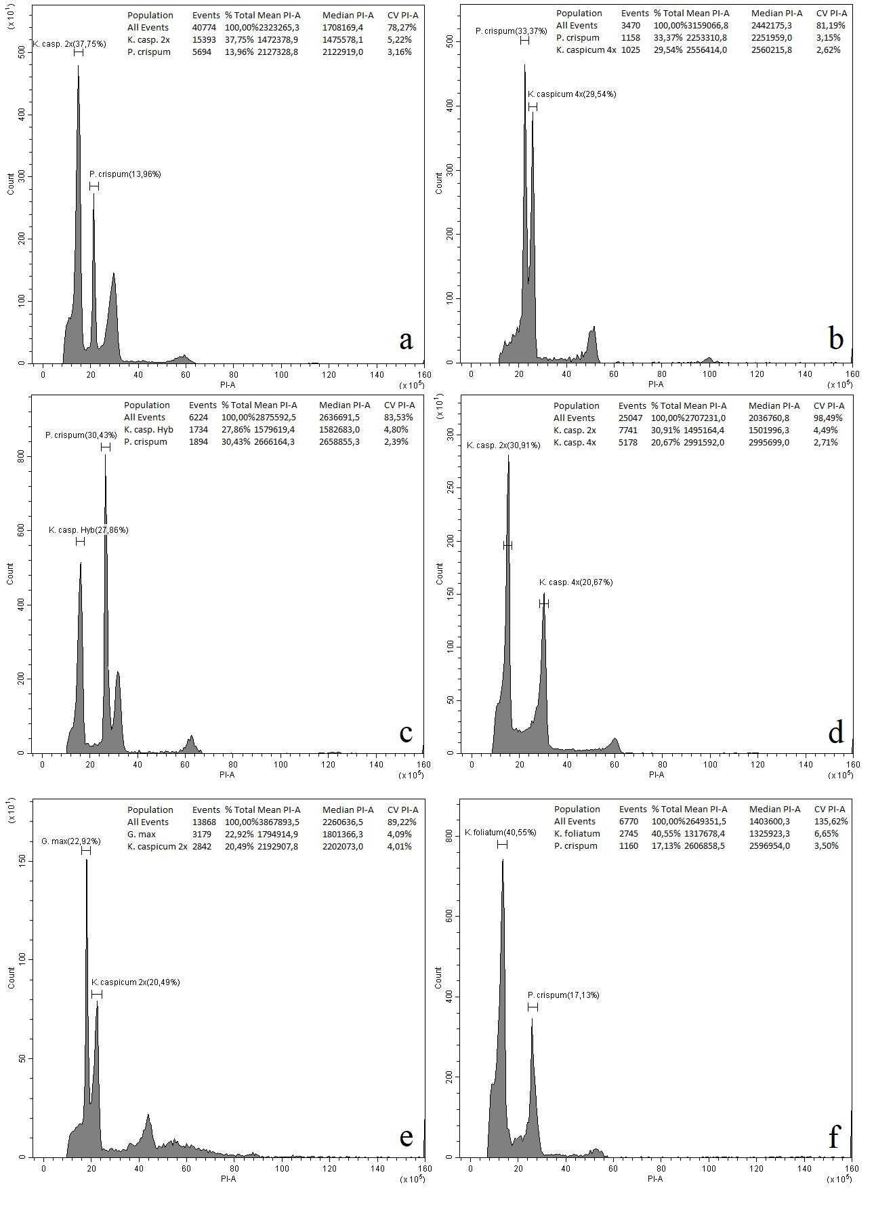

**Supplement E.** Interspecific location of the three species in the PCA (SPSS): А – Components 1 and 2; B – Components 1 and 3; C – Components 2 and 3

|  |  |
| --- | --- |
| img.emf | img.emf |
| A | B |
| img.emf | |
| C | |

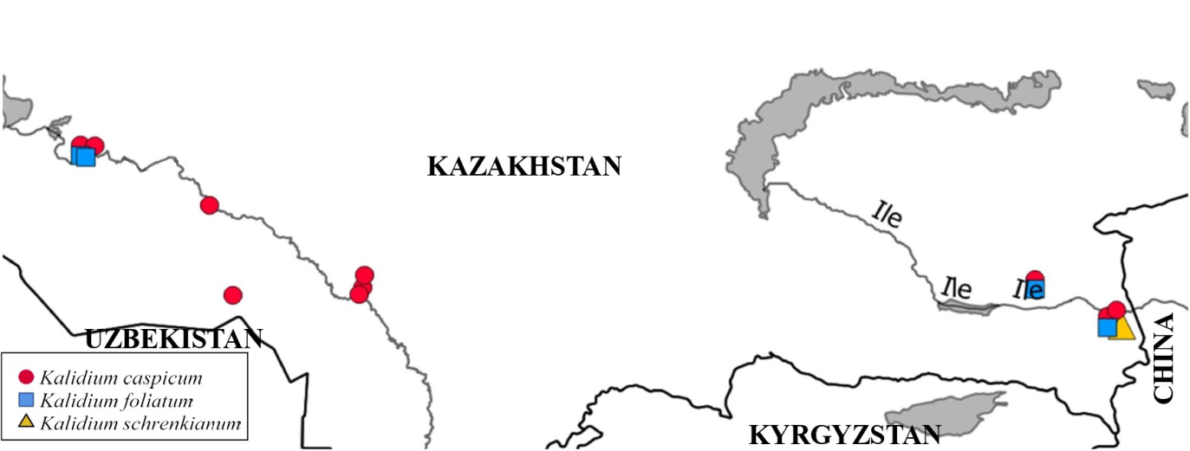

Map of the geographical distribution of the three species of the genus *Kalidium*

**Supplement F.** Intraspecific location of *Kalidium caspicum* populations in the histogram (SPSS): А – Components 1 and 2; B – Components 1 and 3; C – Components 2 and 3

|  |  |
| --- | --- |
| img.emf | img.emf |
| A | B |
| img.emf | |
| C | |

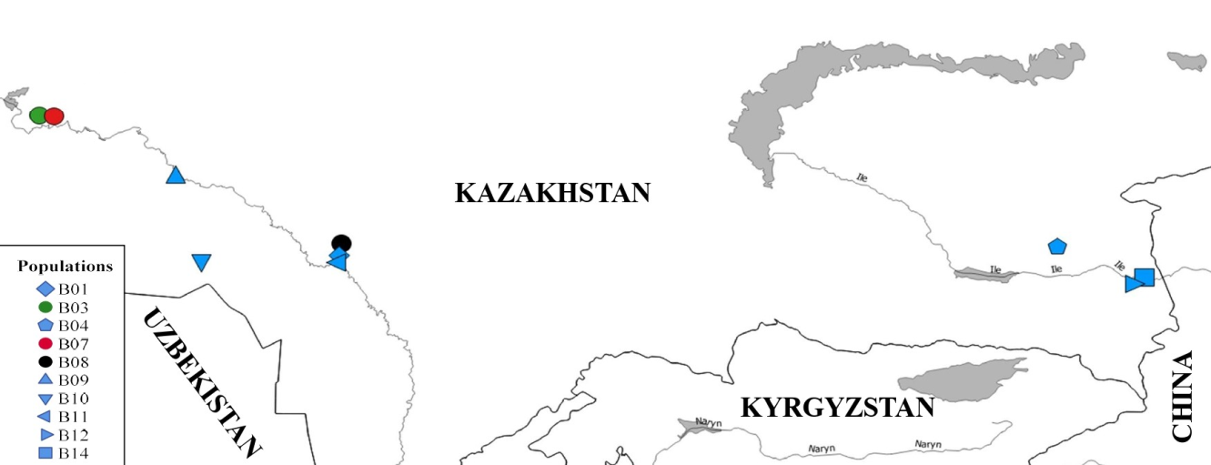

Map of the geographical location of *Kalidium caspicum* populations

**Supplement G.** Intraspecific location of *Kalidium foliatum* populations in the histogram (SPSS): А – Components 1 and 2; B – Components 1 and 3; C – Components 2 and 3

|  |  |
| --- | --- |
| img.emf | img.emf |
| A | B |
| img.emf | |
| C | |

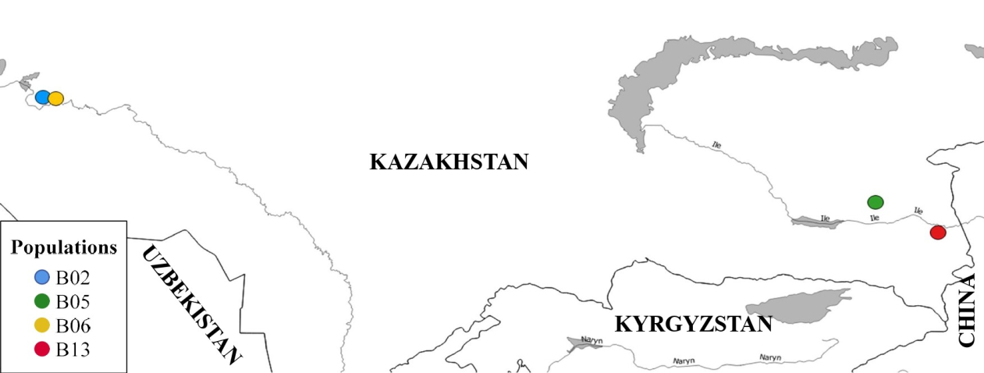

Map of the geographical location of *Kalidium foliatum* populations