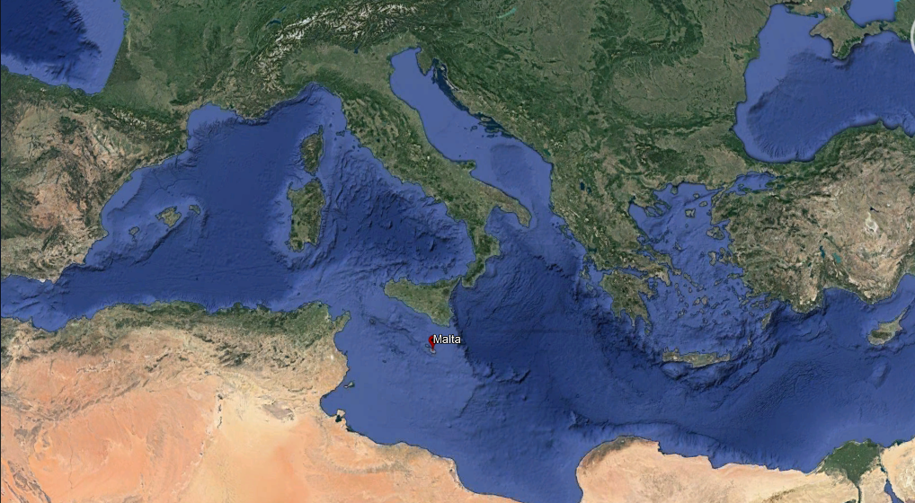
Figure S1. The geographical location of Malta in the centre of the Mediterranean.

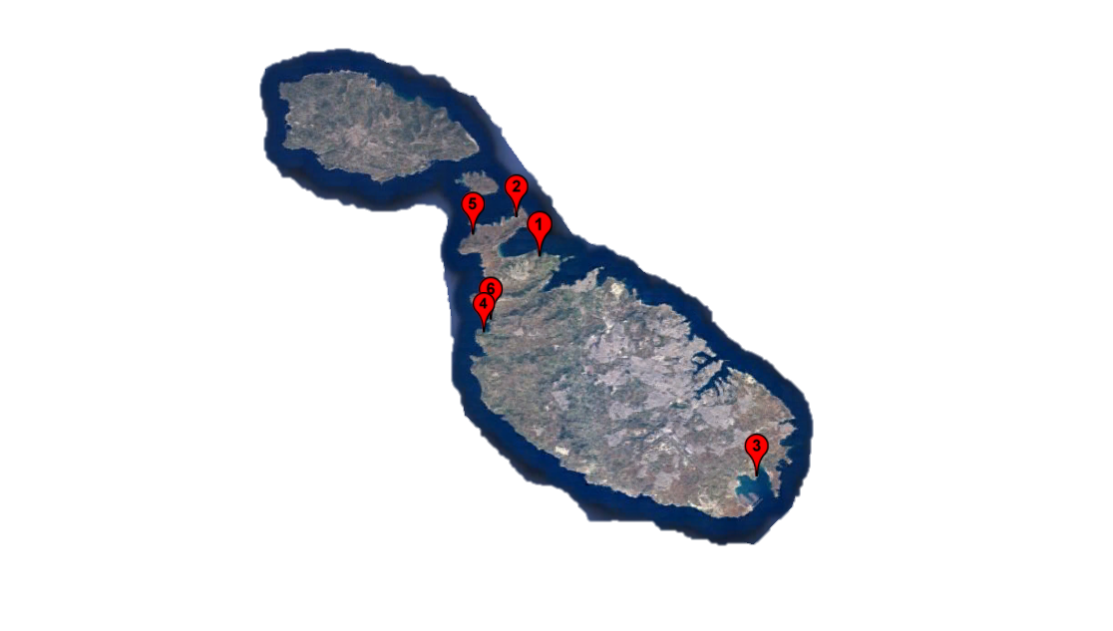
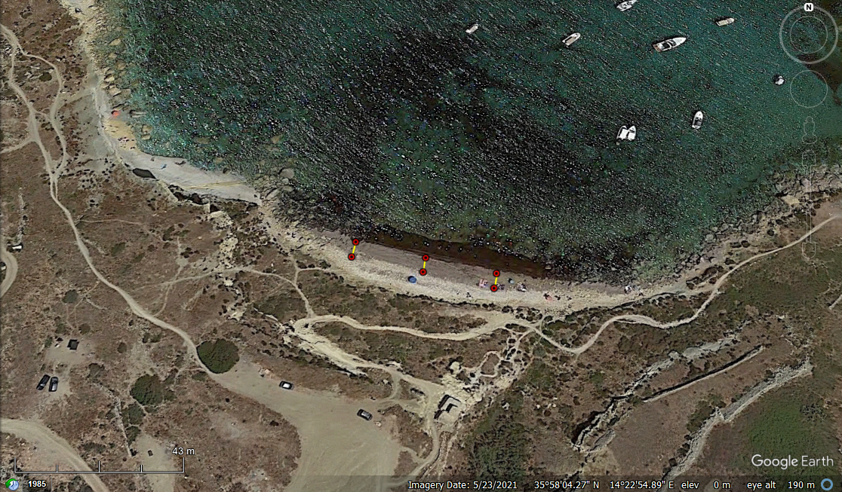
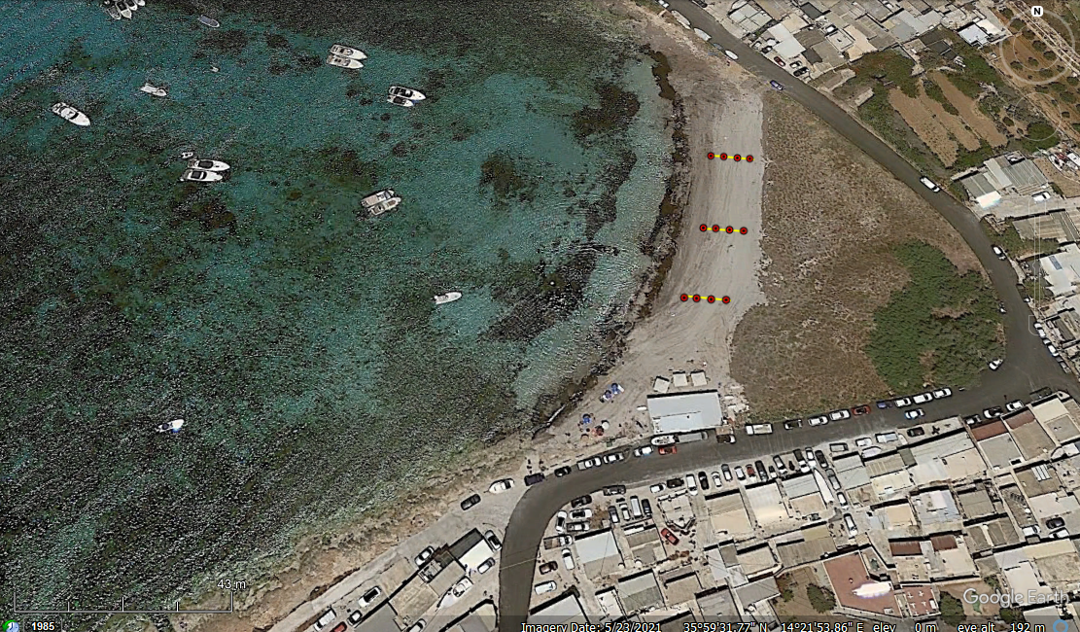
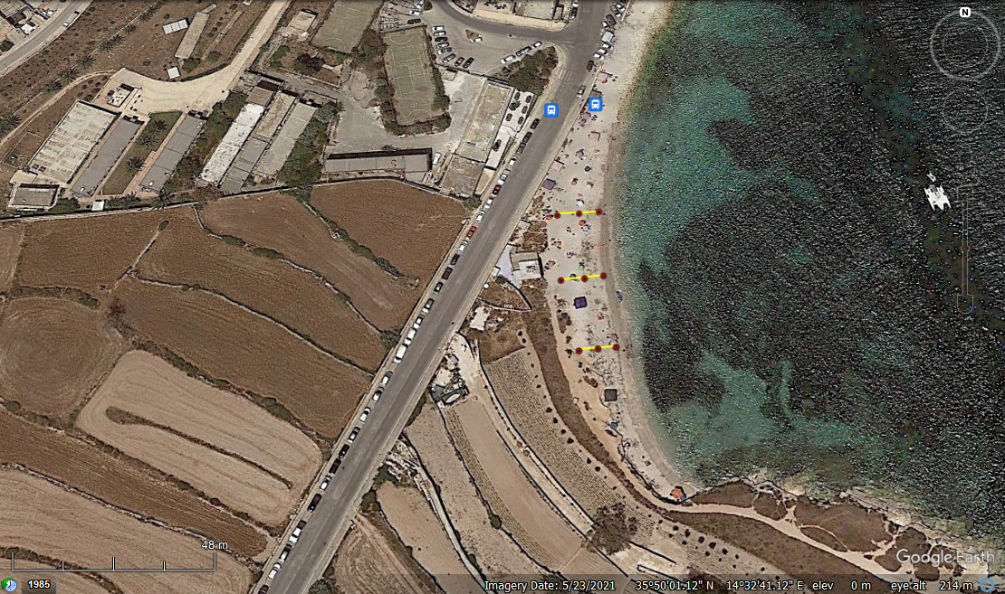
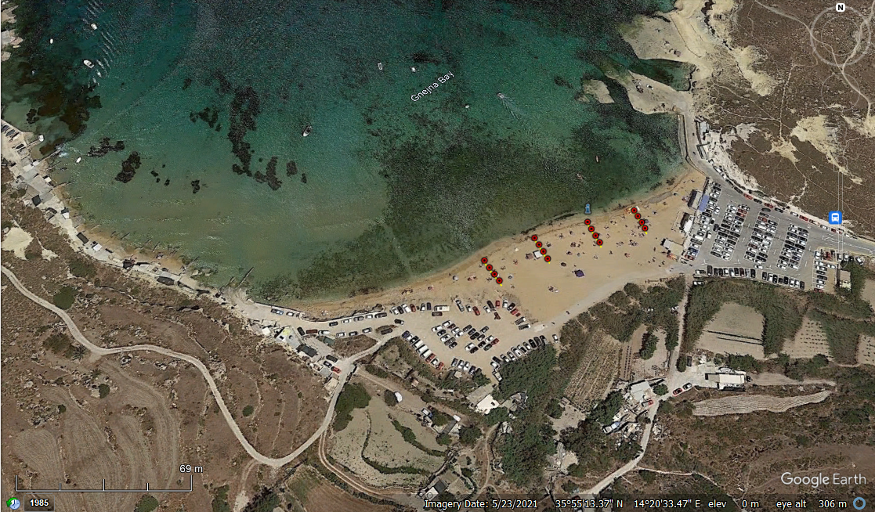
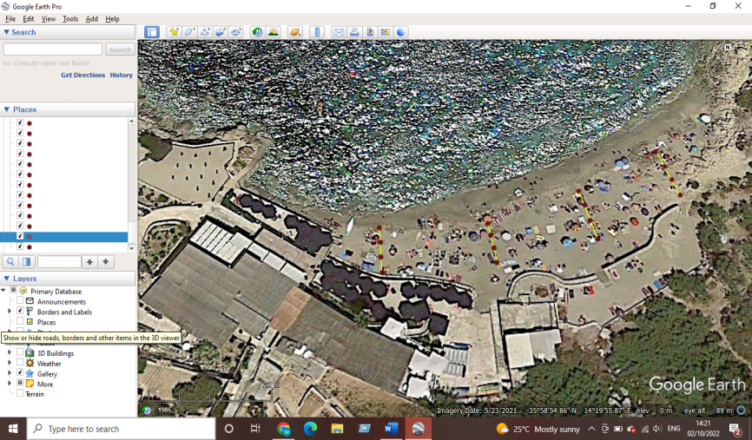
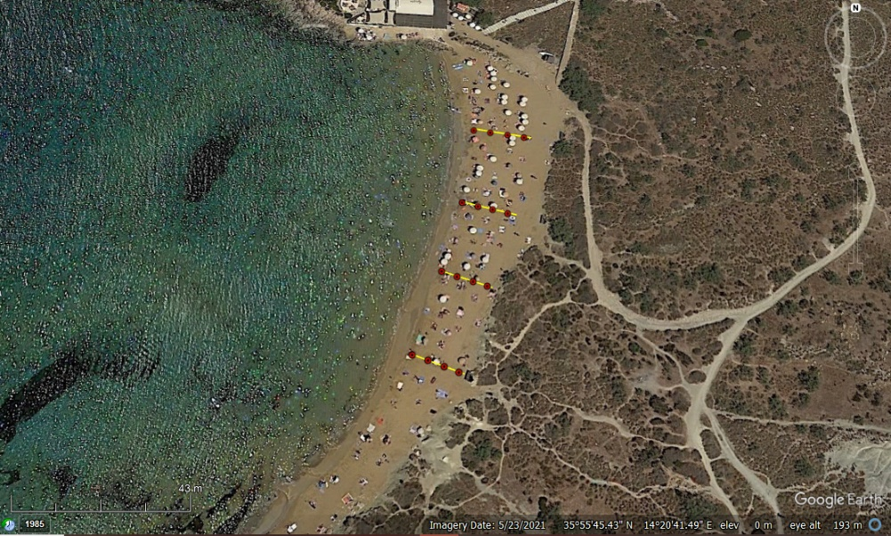

Figure S2. The location of the Maltese beaches sampled; (Key: 1-Imġiebaħ 2- White Tower, 3- Għar Aħmar, 4- Ġnejna, 5- Paradise Bay, 6- Riviera ; represents the quadrats; represents the sampling stations assembled)

