Vapor composition and vaporization thermodynamics of
1‐ethyl‐3‐methylimidazolium hexafluorophosphate ionic liquid

A.M. Dunaev, V.B. Motalov, M.A. Korobov, D.N. Govorov, V.V. Aleksandriiskii, L.S. Kudin

Supplementary materials

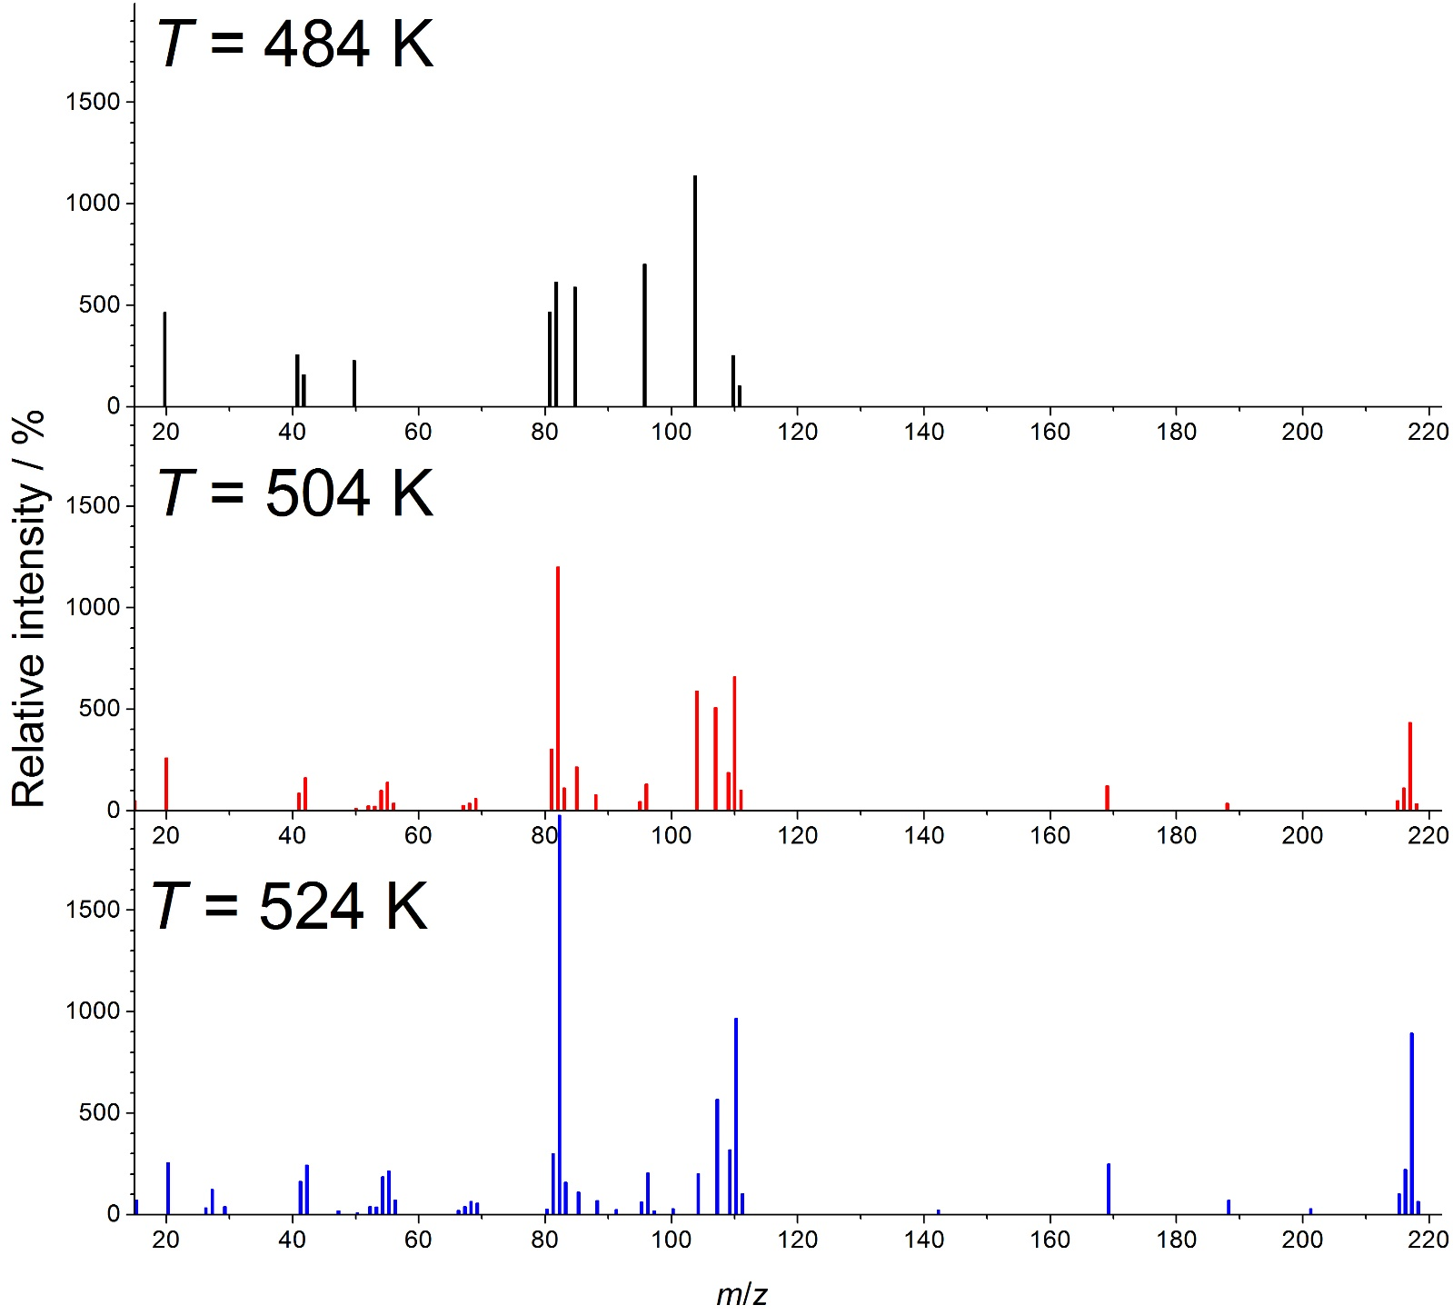
Fig. S1. Full-scale background subtracted electron ionization mass spectra of EMImPF₆ under EC-I conditions relative to the intensity of the parent cation (m/z = 111)

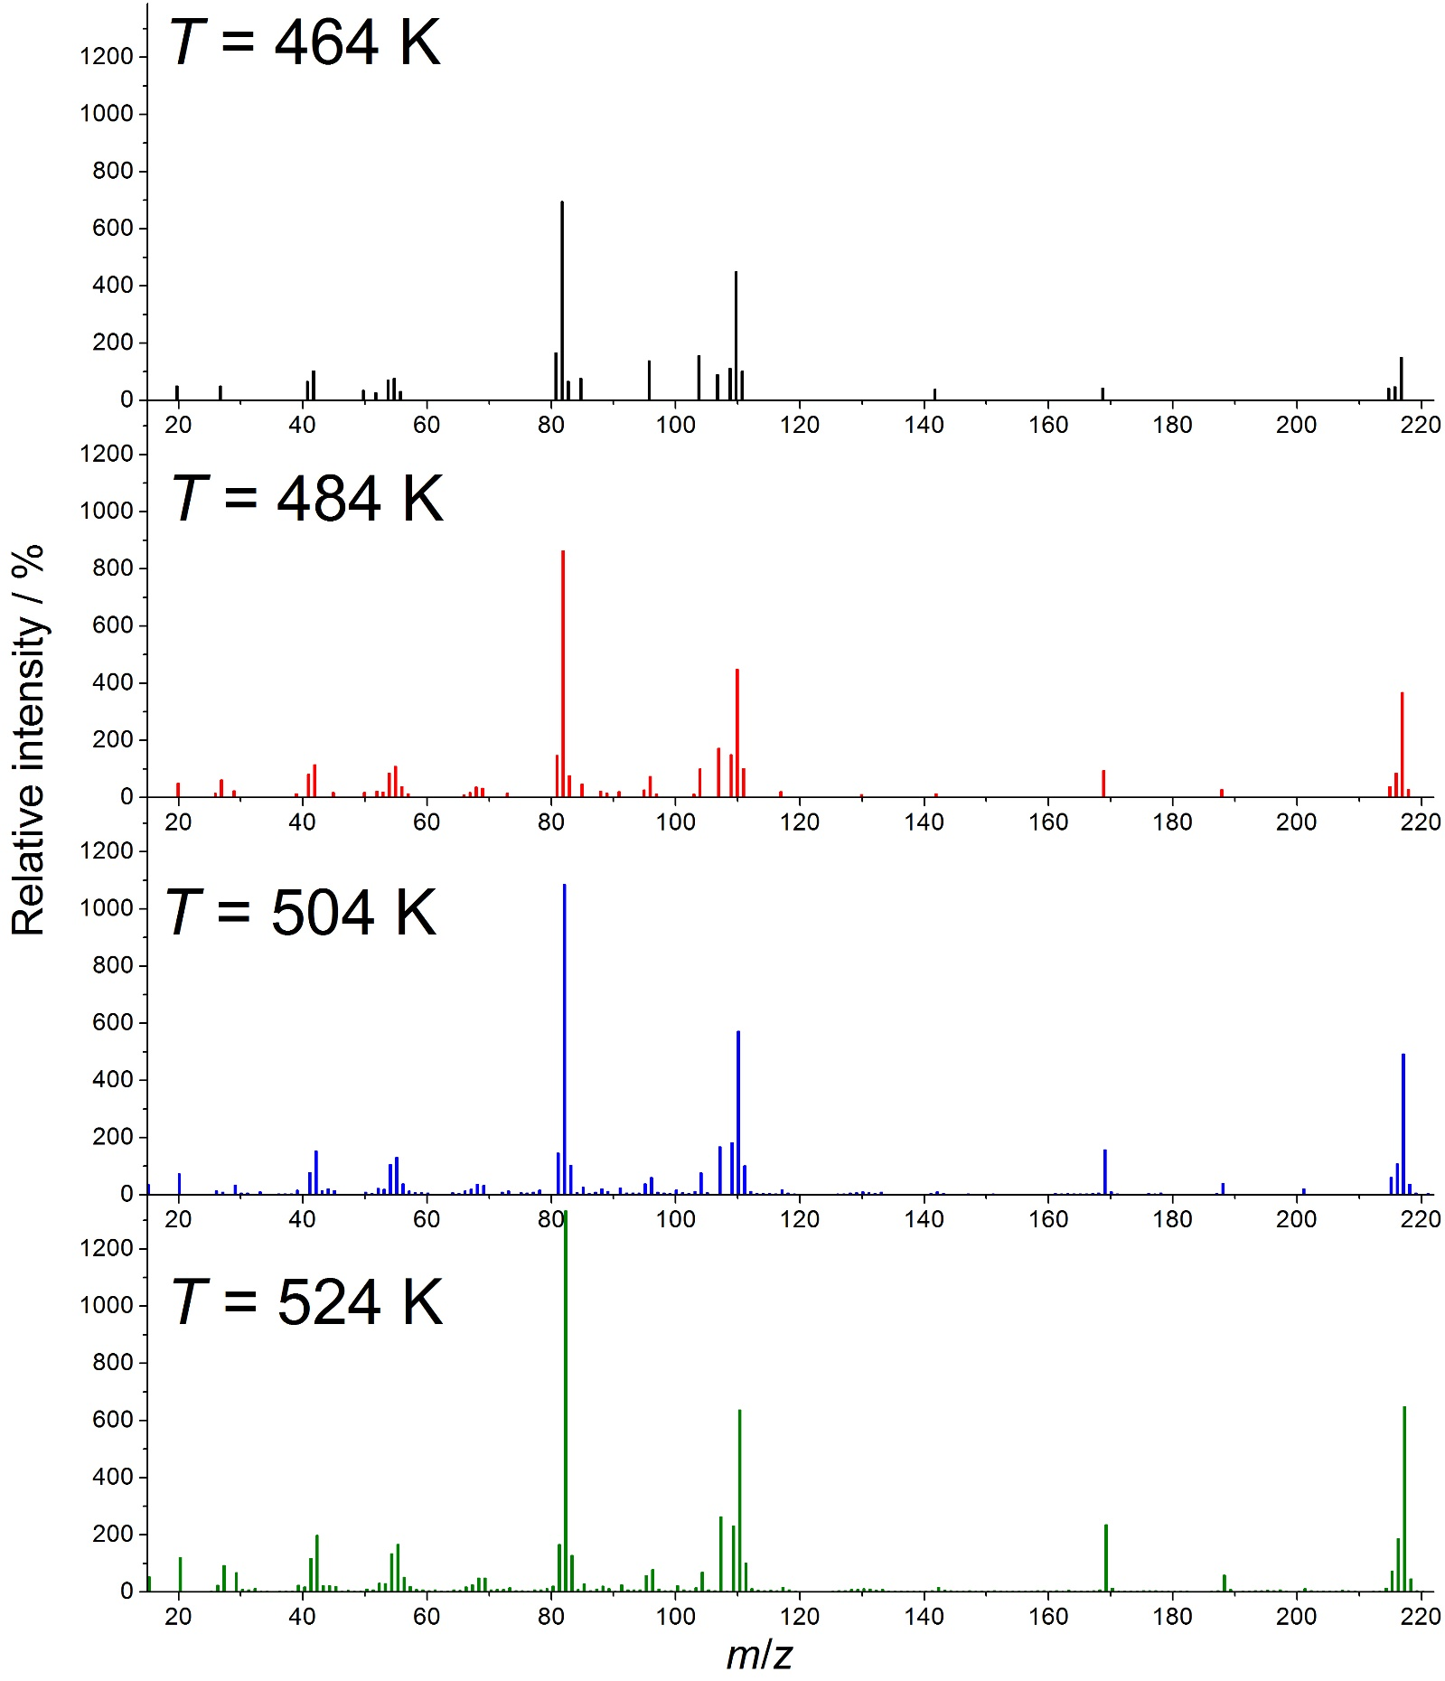
Fig. S2. Full-scale background subtracted electron ionization mass spectra of EMImPF₆ under EC-II conditions relative to the intensity of the parent cation (m/z = 111)
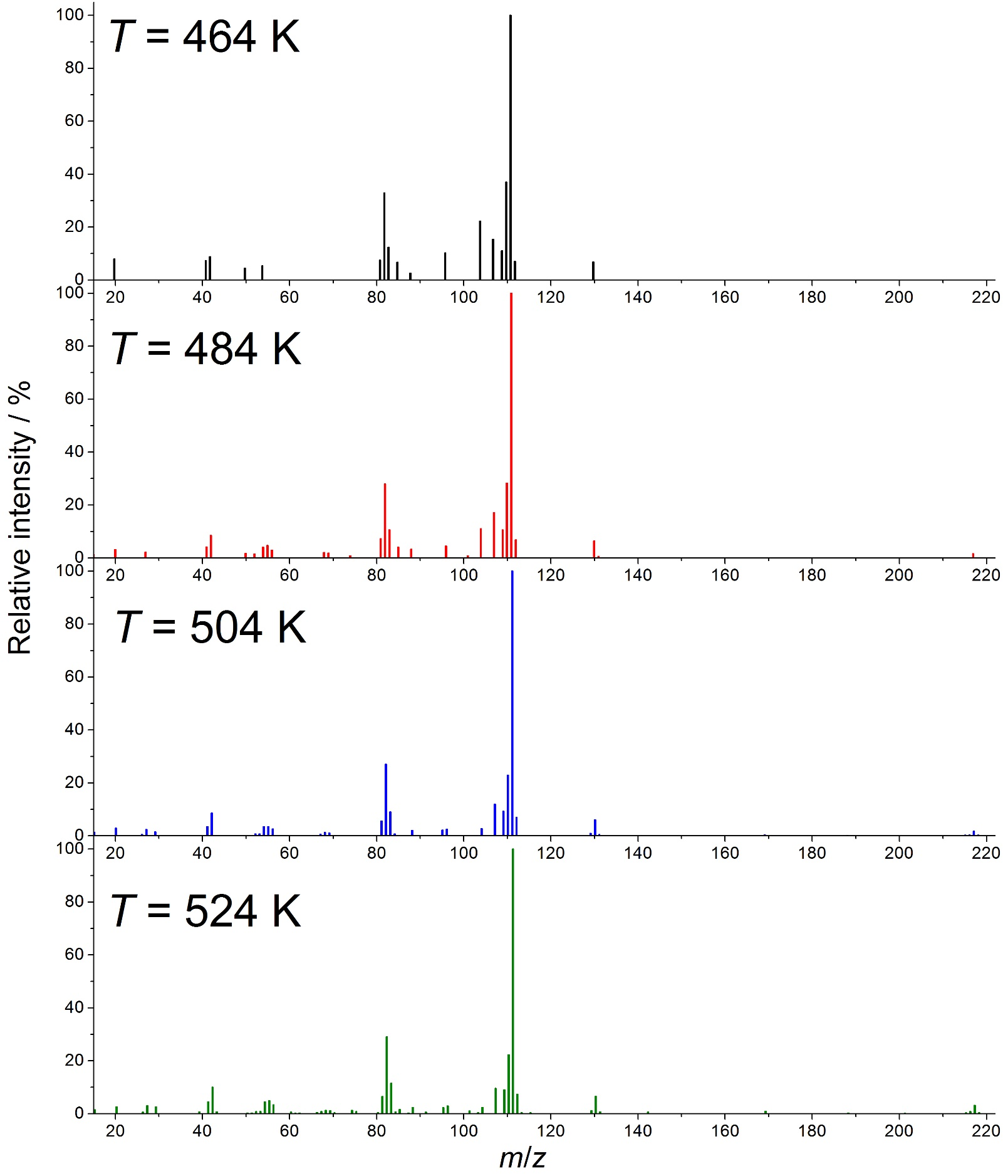
Fig. S3. Full-scale background subtracted electron ionization mass spectra of EMImPF₆ under OC conditions relative to the intensity of the parent cation (m/z = 111)
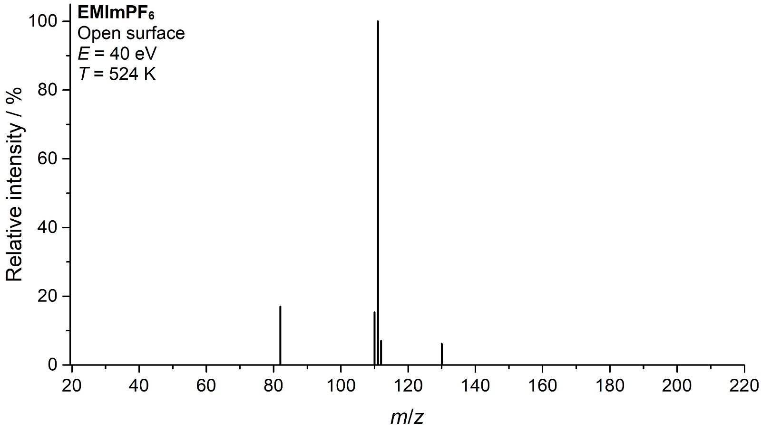
Fig. S4. Full-scale background subtracted electron ionization mass spectra of EMImPF₆ under OS conditions relative to the intensity of the parent cation (m/z = 111)

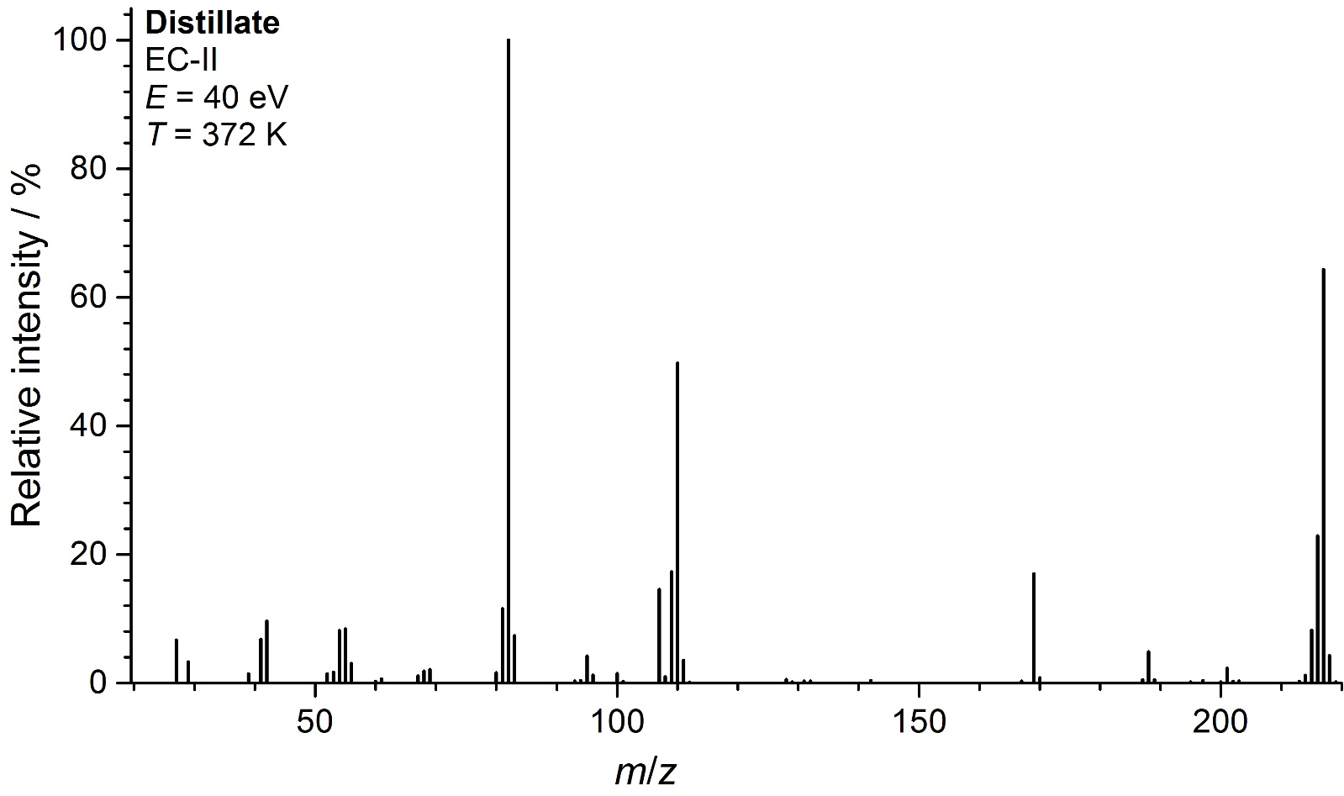
Fig. S5. Full-scale background subtracted electron ionization mass spectra of IL distillate under EC-II conditions relative to the intensity of an ion with m/z = 82

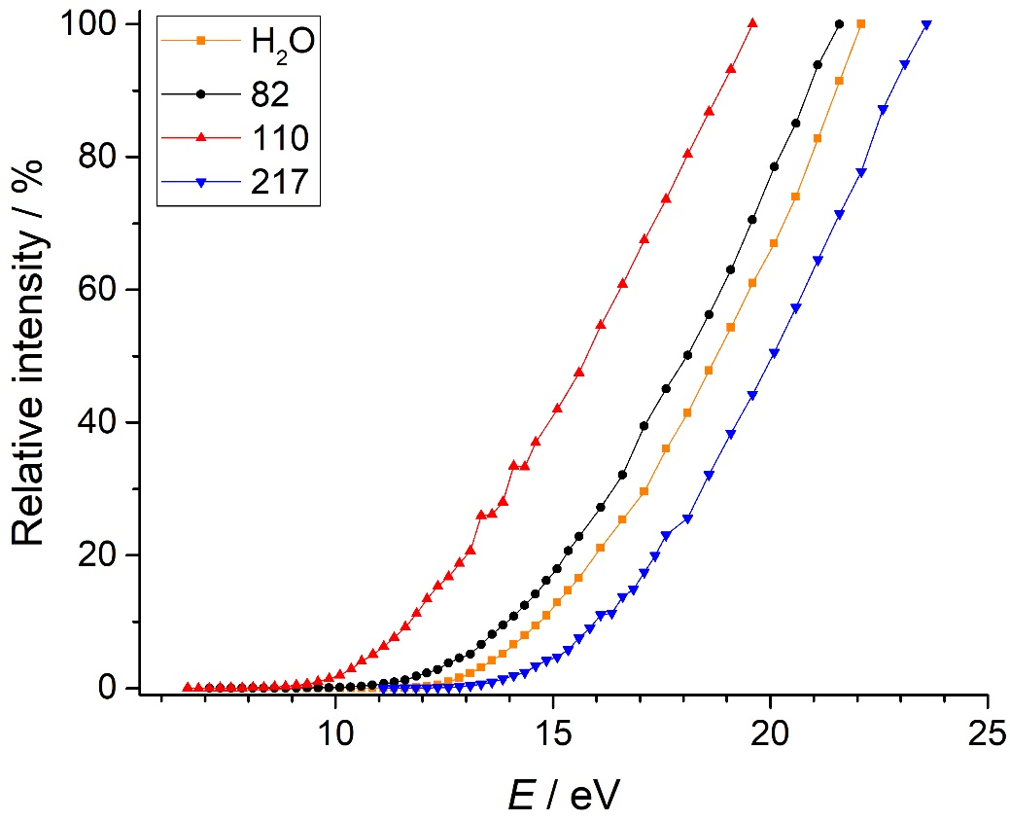
Fig. S6. Ionization efficiency curves of the ions of IL distillate (90% is C₆N₂H₁₀PF₅) under EC-II conditions at 374 K

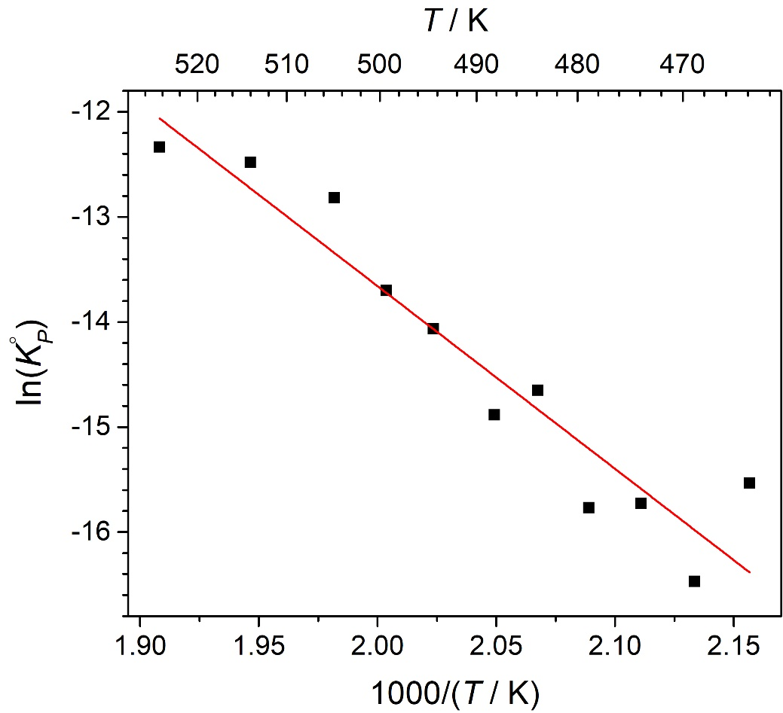
Fig. S7. Temperature dependence of equilibrium constant of reaction I

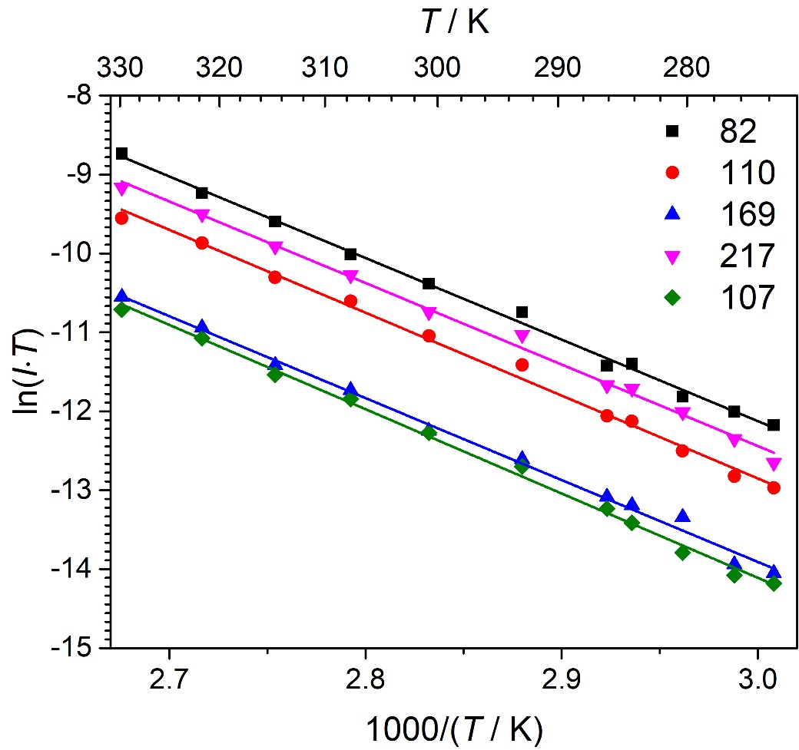
Fig. S8. Temperature dependencies of ion currents over IL distillate (90% is C₆N₂H₁₀PF₅) obtained under EC-II conditions

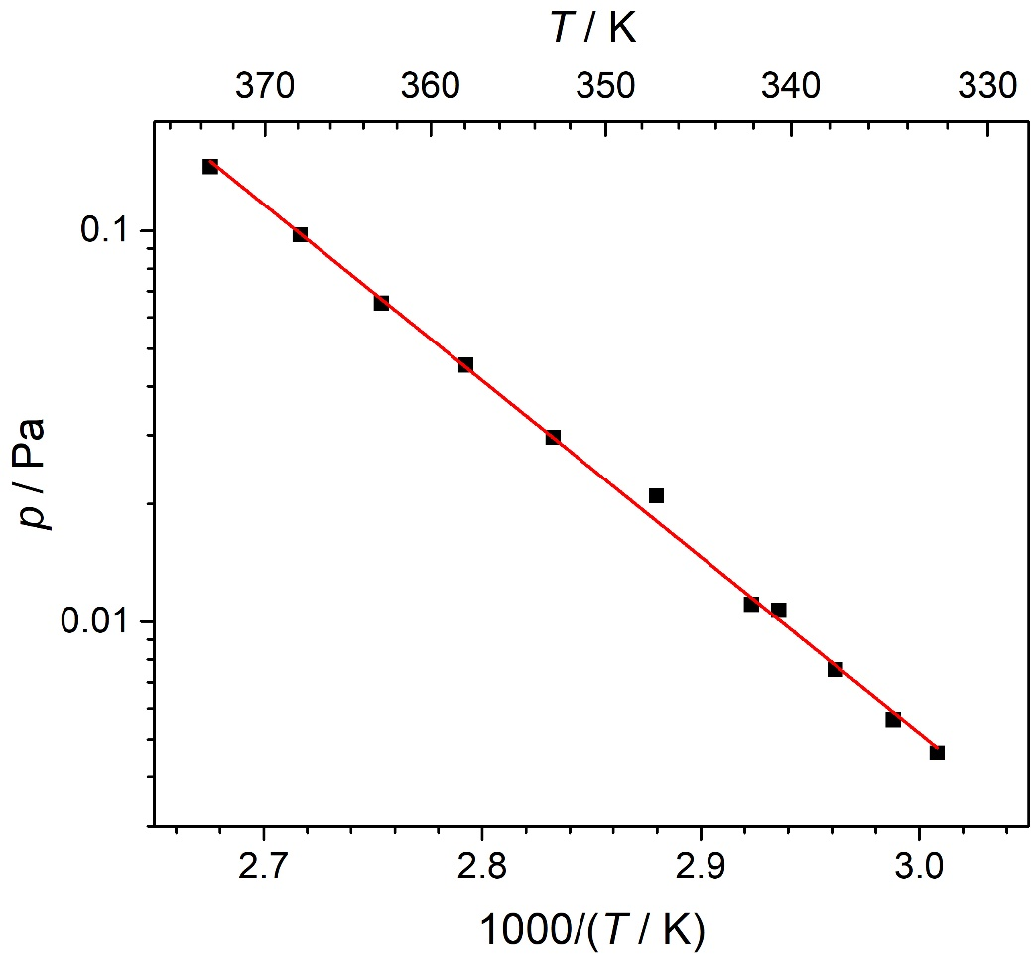
Fig. S9. Temperature dependence of C₆N₂H₁₀PF₅ vapor pressure over IL distillate (90% is C₆N₂H₁₀PF₅) under EC-II conditions

Table S1. List of isogyric reactions used for determination of
Δ_{f}H°(EMImPF_{6, g}, 298.15 K)
Reaction | Δ_{r}H° / kJ·mol^{–1} | Δ_{f}H° / kJ·mol^{–1}
EMImPF₆=EMIm⁺+PF₆– | 343.6 | -1933.4
EMImPF₆+H₂+H–=Im+CH₄+C₂H₆+PF₆– | -494.7 | -1934.1
EMImPF₆+H–=Im+CH₃·+C₂H₅·+ PF₆– | -73.6 | -1943.2
EMImPF₆+HF=Im+CH₃F+C₂H₅F+PF₅ | 241.7 | -1938.8
EMImPF₆+H₂=Im+CH₄+C₂H₅F+PF₅ | 131.6 | -1929.6
EMImPF₆+H₂=Im+CH₃F+C₂H₅F+PF₃+HF | 329.1 | -1937.9
EMImPF₆+H₂+H–=Pyr+CH₄+C₂H₆+PF₆– | -448.7 | 1935.5
EMImPF₆+H–=MIm+C₂H₆+PF₆– | -465.2 | -1932.0
EMImPF₆+H=MIm+C₂H₆+PF₅+F | 210.2 | -1936.3
EMImPF₆+H=MIm+C₂H₅·+HF+PF₅ | 60.8 | -1948.6
EMImPF₆=MIm+C₂H₄+HF+PF₅ | 211.0 | -1935.4
EMImPF₆=MIm+C₂H₅F+PF₅ | 161.0 | -1927.5
EMImPF₆+H–=EIm+CH₄+ PF₆– | -475.4 | -1933.9
EMImPF₆+H=EIm+CH₄+PF₅+F | 200.1 | -1938.3
EMImPF₆+H=EIm+CH₃·+HF+PF₅ | 66.6 | -1936.6
EMImPF₆=EIm+CH₃F+PF₅ | 176.8 | -1948.8
EMImPF₆=EMIm+HF+PF₅ | 100.7 | -1941.5
 | AVERAGE: | -1937±3

Table S2. Calculated partial vapor pressures under EC conditions and sublimation enthalpies obtained in the framework of the third law method
T / K | p / ×10⁴ Pa | Δ_{s}Hº(NIP, 298.15 K)
524 | 16.0 | 152.5
514 | 10.3 | 152.0
505 | 6.60 | 151.7
494 | 3.51 | 151.8
484 | 1.73 | 152.1
474 | 0.93 | 152.1
464 | 0.37 | 153.0
469 | 0.63 | 152.3
479 | 1.30 | 152.0
488 | 2.51 | 151.7
499 | 4.44 | 152.1
478 | 4.54 | 134.91
463 | 1.55 | 135.33

Corresponding author: amdunaev@ro.ru

